The viral protein NSP1 acts as a ribosome gatekeeper for shutting down host translation and fostering SARS-CoV-2 translation

Antonin TIDU¹, Aurélie JANVIER¹, Laure SCHAEFFER¹, Piotr SOSNOWSKI¹, Lauriane KUHN², Philippe HAMMANN², Eric WESTHOF¹, Gilbert ERIANI¹, Franck MARTIN¹*

¹Université de Strasbourg, Institut de Biologie Moléculaire et Cellulaire, “Architecture et Réactivité de l’ARN” CNRS UPR9002, 2, allée Konrad Roentgen, F-67084 Strasbourg (France)

²Institut de Biologie Moléculaire et Cellulaire, Plateforme Protéomique Strasbourg – Esplanade, CNRS FRC1589, Université de Strasbourg, 2, allée Konrad Roentgen, F-67084 Strasbourg (France)

*Corresponding author
Email for correspondence:
f.martin@ibmc-cnrs.unistra.fr

Running title: SL1 controls NSP1 for SARS-CoV-2 viral translation

Supplementary material

Supplemental figure 1

Pre-initiation complex formation analysis on 10-30% sucrose gradients using RNAs radiolabelled at their 5’ ends. The SARS-CoV-2 RNA transcripts were radiolabeled with a radioactive m7G cap at their 5’ ends. The pre-initiation complexes were fractionated on 10-30 % sucrose gradients. The presence of radioactive RNA was monitor by Cerenkov counting of all the fractions. The plots represent the percentage of radioactive RNA that was used for complex formation. The curve in red represents the pre-initiation complexes assembled on the SARS-CoV-2 without any inhibitor. The curve in blue represents the pre-initiation complexes assembled on the SARS-CoV-2 in the presence of 2 mM of GMP-PNP. The curve in green represents the pre-initiation complexes assembled on the SARS-CoV-2 in the presence of 1 mM edeine.

Supplemental figure 2

Pre-initiation complex formation analysis on 10-30% sucrose gradients using RNAs radiolabelled at their 5’ ends. The SARS-CoV-2 RNA transcripts were radiolabeled with a radioactive m7G cap at their 5’ ends. The pre-initiation complexes were fractionated on 10-30 % sucrose gradients. The presence of radioactive RNA was monitor by Cerenkov counting of all the fractions. The plots represent the percentage of radioactive RNA that was used for complex formation. The preinitiation complexes were formed in presence of 0.8 μM of recombinant viral NSP1. The positions of 80S and disomes are indicated above the curves. The full-length SARS-CoV-2 5’UTR (green) and truncated versions Δ40 (blue), Δ60 (yellow), Δ80 (orange) and Δ150 (dark blue) were tested.

Supplemental figure 3

Inline probing of SARS-CoV-2 5’UTR and SARS-CoV-2 SL1mut 5’UTR. The secondary structure of wild type SARS-CoV-2 5’UTR and the SARS-CoV-2 SL1mut 5’UTR were probed by inline probing as previously described (30).

Supplemental figure 4

Pre-initiation complex formation analysis on 10-30% sucrose gradients using RNAs radiolabelled at their 5’ ends. The SARS-CoV-2 RNA transcripts were radiolabeled with a radioactive m7G cap at their 5’ ends. The pre-initiation complexes were fractionated on 10-30 % sucrose gradients. The presence of radioactive RNA was monitor by Cerenkov counting of all the fractions. The plots represent the percentage of radioactive RNA that was used for complex formation. The preinitiation complexes were formed in the absence (red) or in presence of 0.8 μM of recombinant viral wild type NSP1 (dark blue) or mutant NSP1 K154A-H155A (green) or mutant NSP1 R124A-K125A (yellow). The experiment was performed with a radiolabelled reporter mRNA containing the wild type SARS-CoV-2 5’UTR (left panel) and the SARS-CoV-2 5’UTR containing a mutated SL1 (right panel).

Supplemental Table 1: Mass spectrometry analysis of proteins in the pre-initiation complexes programmed with SARS-CoV-2 5’UTR in the absence or in the presence of recombinant NSP1 (separate Excel file).

Supplemental Table 2: Primers used in this study (separate Excel file).

Supplemental Figure 1

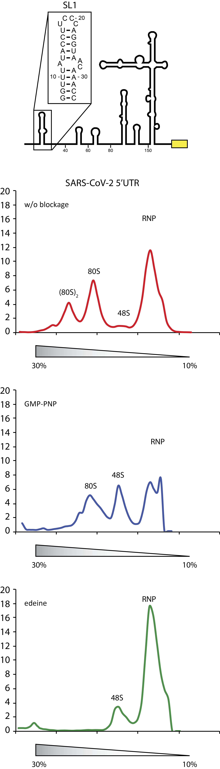
Supplemental Figure 2

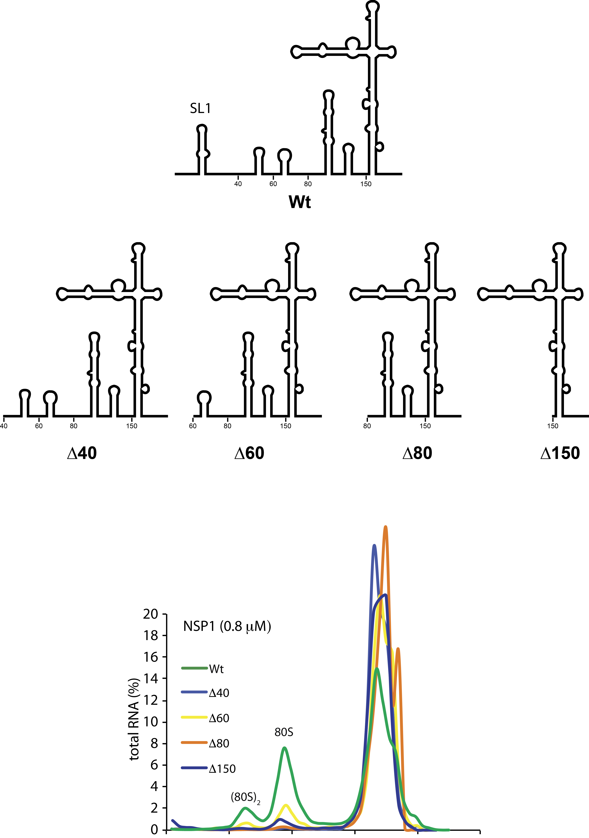

Supplemental Figure 3

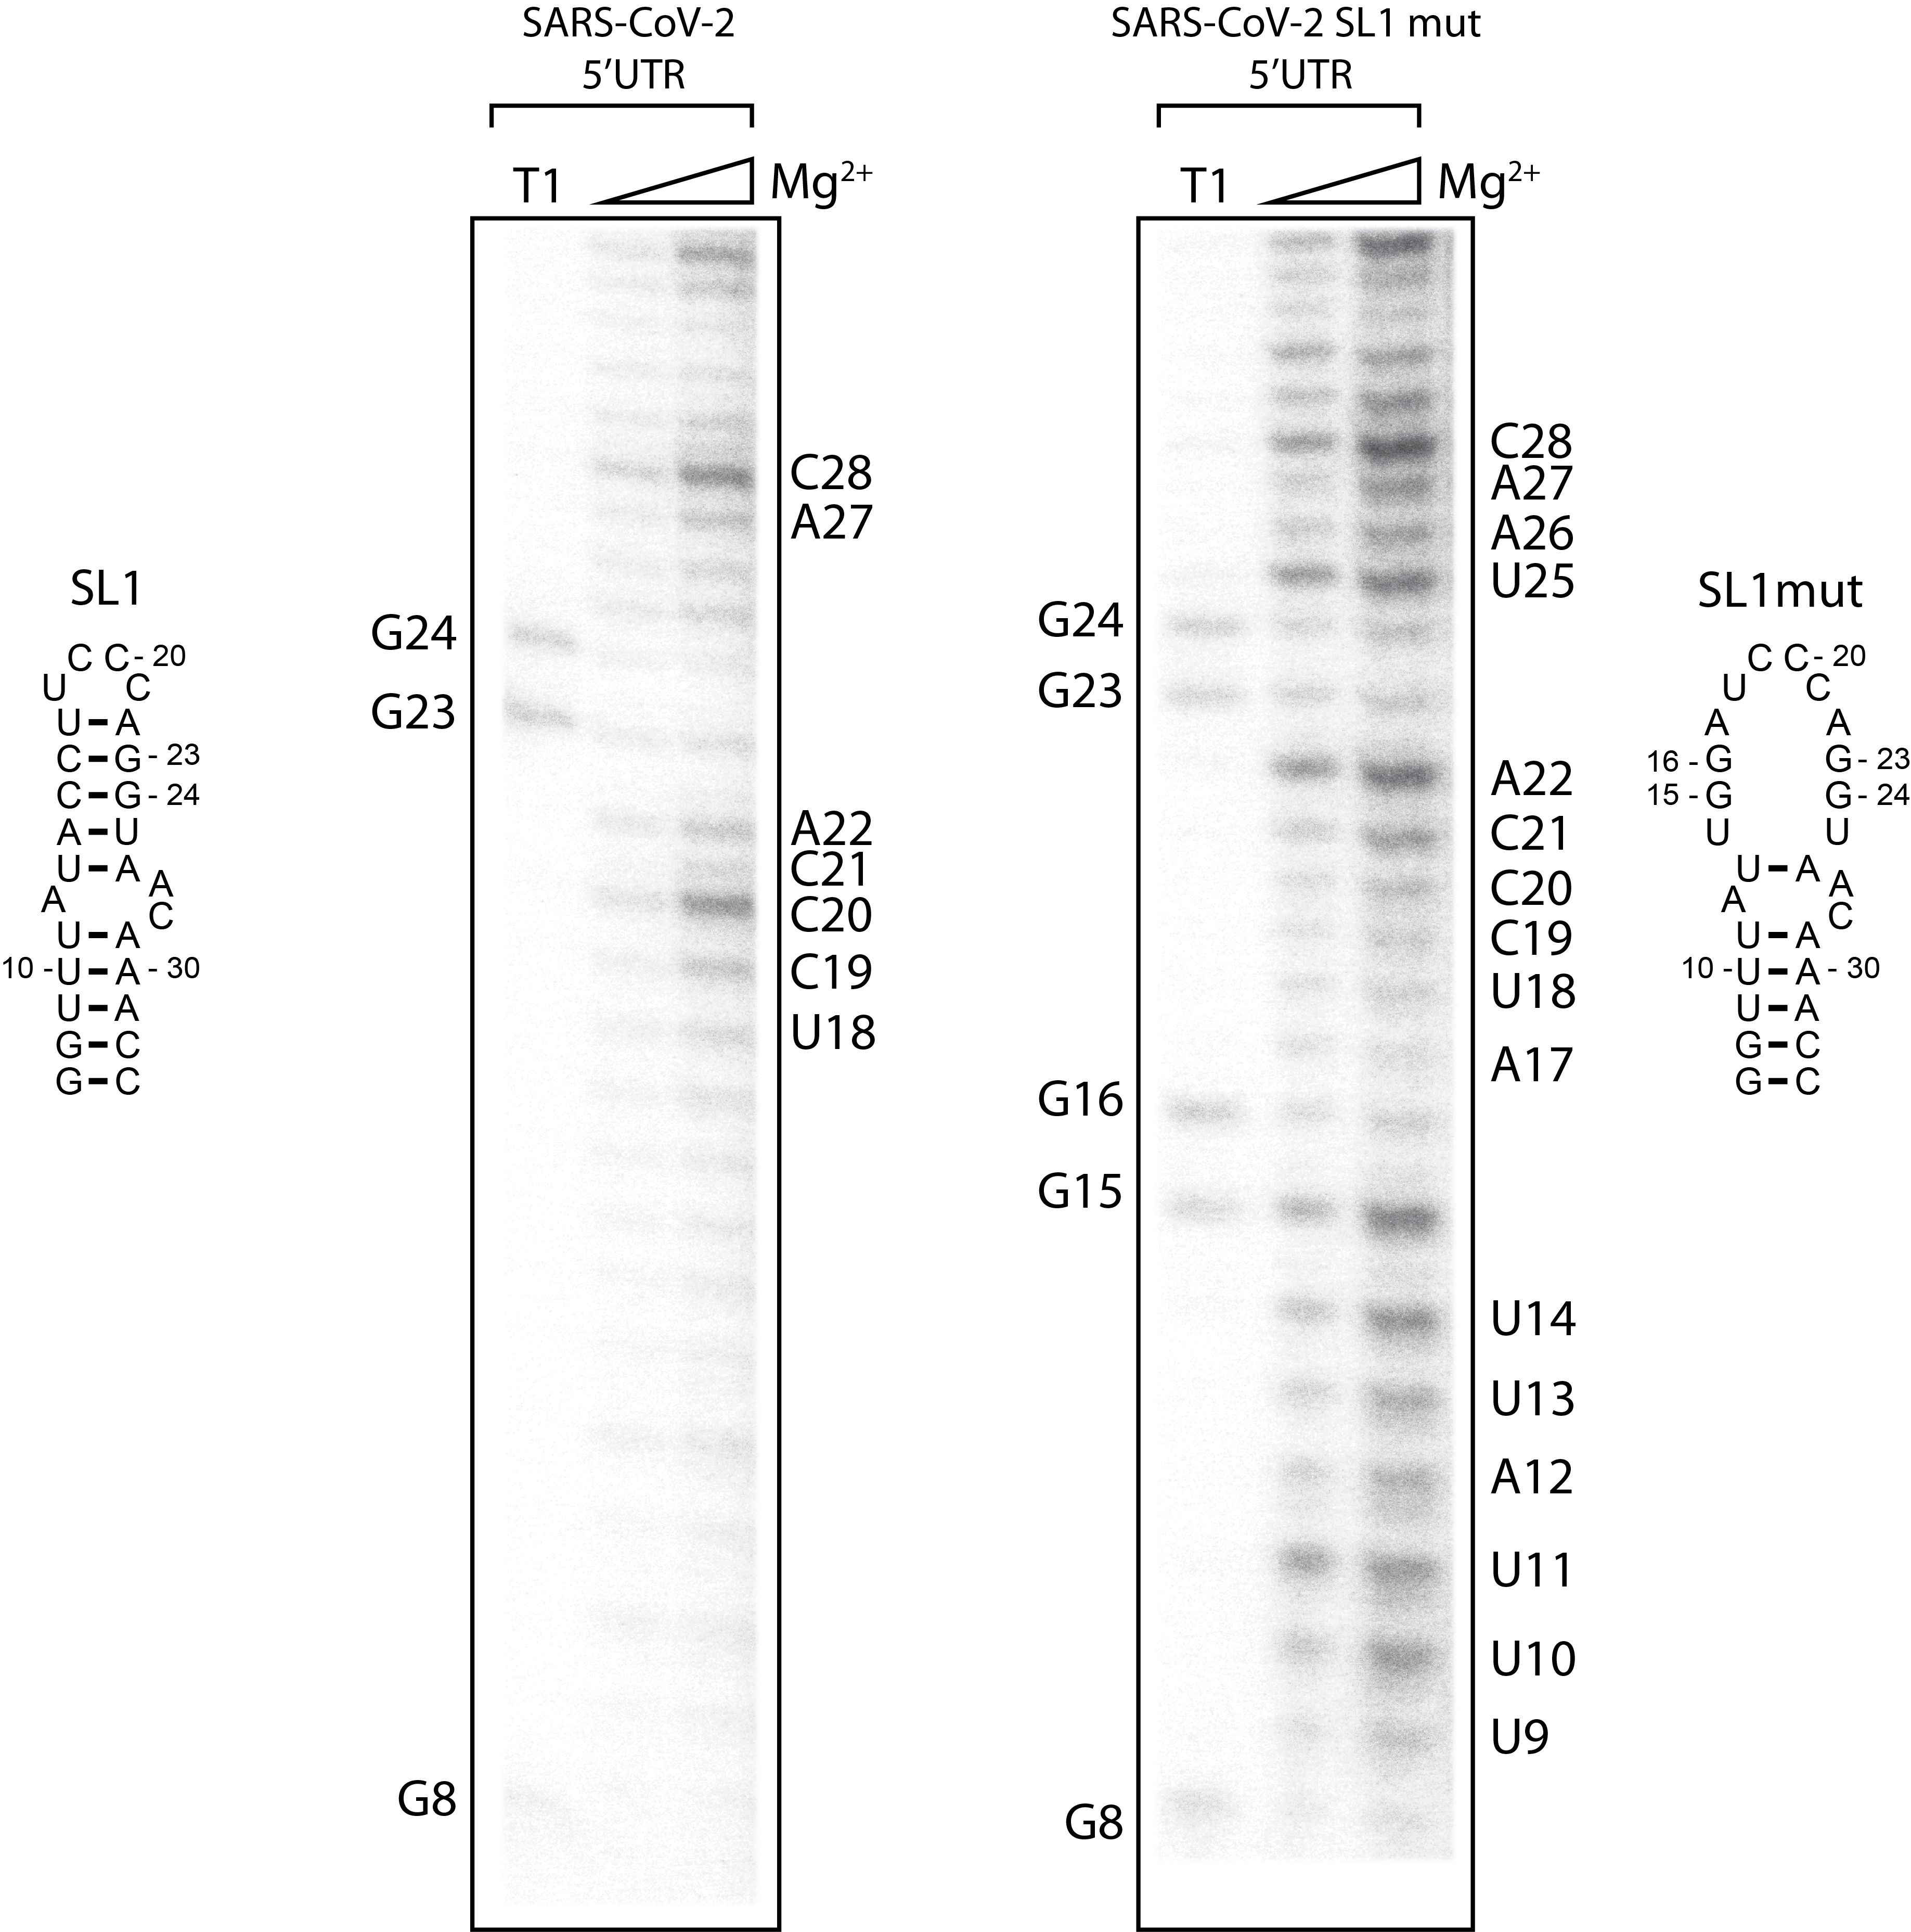

Supplemental Figure 4

