Supplementary Information

Deflating the RNA Mg²⁺ bubble. Stereochemistry to the rescue!

Pascal Auffinger¹*, Eric Ennifar¹ and Luigi d’Ascenzo²

¹ Architecture et Réactivité de l’ARN, Université de Strasbourg, Institut de Biologie Moléculaire et Cellulaire du CNRS, Strasbourg, 67084, France
² Department of Integrative Structural and Computational Biology, The Scripps Research Institute, La Jolla, CA 92037, USA

* To whom correspondence should be addressed.
Phone: +33 388 41 70 49; Fax: +33 388 60 22 18;
Email: p.auffinger@ibmc-cnrs.unistra.fr

Table of content:
1) Table S1 Coordination criteria used in this study
2) Figure S1 Two views of assigned Mg²⁺ and K⁺ close to G530 in the 5E81 and 6QNR ribosomal decoding center
3) Figure S2 Illustration of densities corresponding to hexacoordinated Mg²⁺ at high and medium resolutions
4) Figure S3 Extract of the 6QNR ‘in-house’ analysis program output related to the Mg²⁺ ion shown in Fig. 3.
5) Figure S4 Mg²⁺ occupying an anion binding site in 6QNR.
6) References

Table S1. Coordination criteria used in this study. Some of the values given in the table are derived from earlier studies (D'Ascenzo and Auffinger 2015; Leonarski et al. 2016; Leonarski et al. 2017; Kruse et al. 2019; Leonarski et al. 2019) and from Figure 1. Converging views on the coordination of metals to biomolecular systems are provided in the following reference list (Harding et al. 2010; Zheng et al. 2014). These criteria point to coordination distance ranges where stereochemistry, ion binding site features and, therefore, ion identity should cautiously be reexamined. These criteria take roughly into account crystallographic coordinate errors (Harding et al. 2010).

 | Relaxed coordination  criteria (Å)* | Stringent coordination  criteria (Å)** | CSD average coordination  distance (Å)
1st coordination shell
Mg²⁺…O | 1.8–2.4 | 1.9–2.3 | 2.06±0.03
Mg²⁺…N | 1.8–2.4 | 1.9–2.4 | 2.10±0.07
Na⁺…O | 2.4–2.6 | 2.3–2.6 | 2.41±0.10
Na⁺…N | 2.4–2.6 | 2.4–2.6 | 2.45±0.05
K⁺…O | 2.6–3.4 | 2.6–3.2 | 2.8±0.1
K⁺…N | 2.6–3.4 | 2.6–3.2 | 2.85±0.06
Mg²⁺ exclusion zone
 | 2.4–3.4 | 2.3–3.8 | 2.2–3.8
Na⁺ exclusion zone
 | 2.8–3.6 | 2.6–3.6 | 2.3–3.6
2nd coordination shell
Mg²⁺…O | 3.4–4.6 | 3.8–4.6 | 3.8–4.6
Na⁺…O | 3.6–4.9 | 3.6-4.9 | 3.6–4.9
K⁺…O | n.a. | n.a. | n.a.
Hydrogen bond
O…O_{w} | 2.4–3.0 | 2.5–3.0 | 2.5–3.0
N…O_{w} | 2.4–3.2 | 2.5–3.2 | 2.5–3.2
* criteria suggested for medium to poor resolutions (> 2.6 Å);
** criteria suggested for resolutions ≤ 2.6 Å;

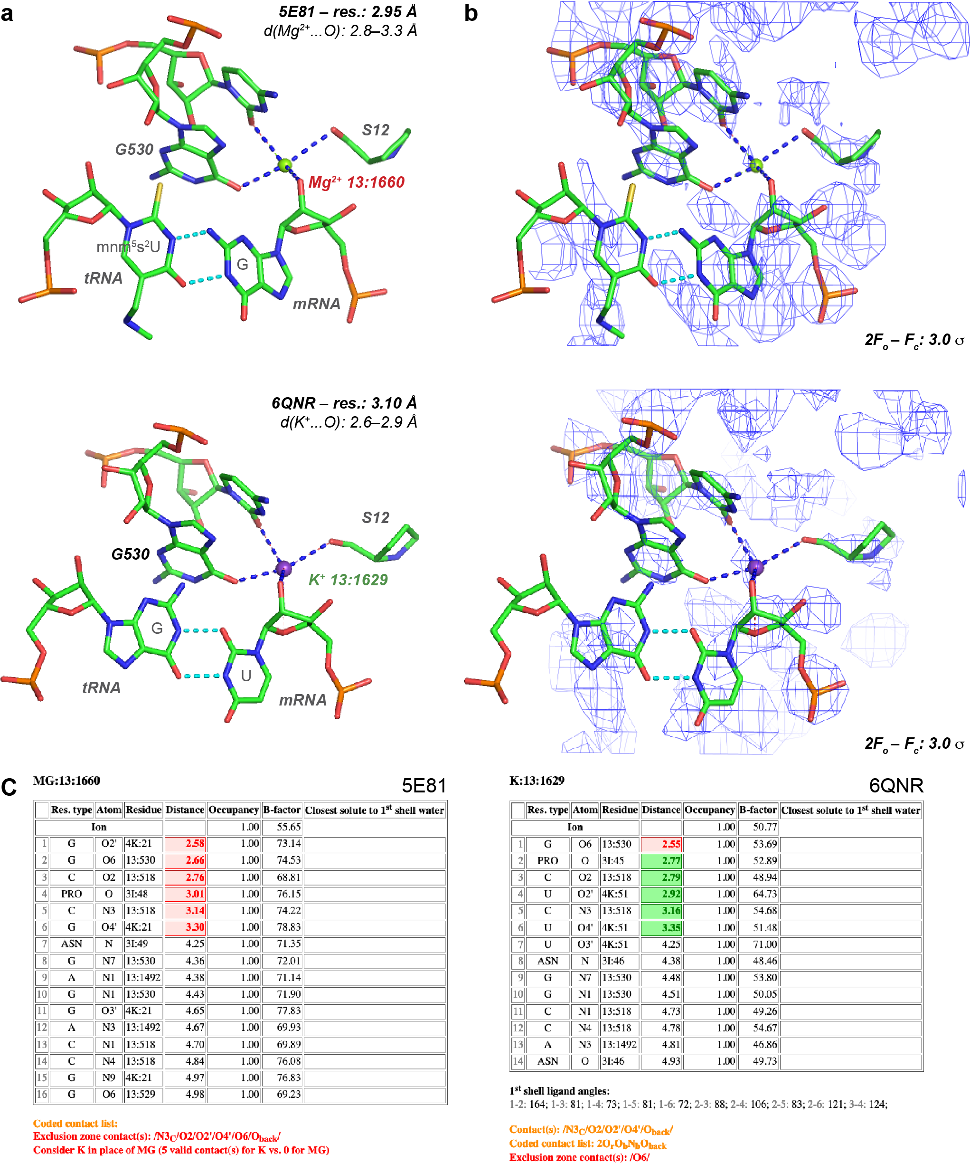

Figure S1. Two views of assigned Mg²⁺ and K⁺ close to G530 in the 5E81 and 6QNR ribosomal decoding center. (a, top) View derived from the 5E81 structure from ‘2016’ (Rozov et al. 2016; Leonarski et al. 2019); see Figure 1d for the ‘2010’ 4V6F structure (Jenner et al. 2010). (a, bottom) Similar view from the ‘2019’ 6QNR (Rozov et al. 2019) decoding center structure. In these structures, the modeled Mg²⁺ (5E81/4V6F) and K⁺ ions (6QNR) display very similar coordination patterns and coordination distances (≈2.8 Å). The ion labels in red and green highlight unfavorable and favorable attributions, respectively. The 5E81 structure (resolution: 2.95 Å) displays a slightly better resolution than the 6QNR and 4V6F (Jenner et al. 2010) structures (resolution: 3.1 Å) and corresponds currently to the best resolution among the Thermus thermophilus structures embedding tRNA and mRNA fragments. Note the different tRNA-mRNA pair in 5E81 and 6QNR. (b) The 2F_{o}-F_{c} density patterns contoured at 3.0 σ for 5E81 and 6QNR are almost identical. (a,b) The blue dotted lines show ion coordination distances in the 2.6–3.3 Å range. (c) Extract of the 5E81 and 6QNR ‘in-house’ diagnosis program output that lists the closest contact distance of the ion bound to G530. Red and green colors mark conflicts and agreements between ion identity and stereochemistry, respectively.

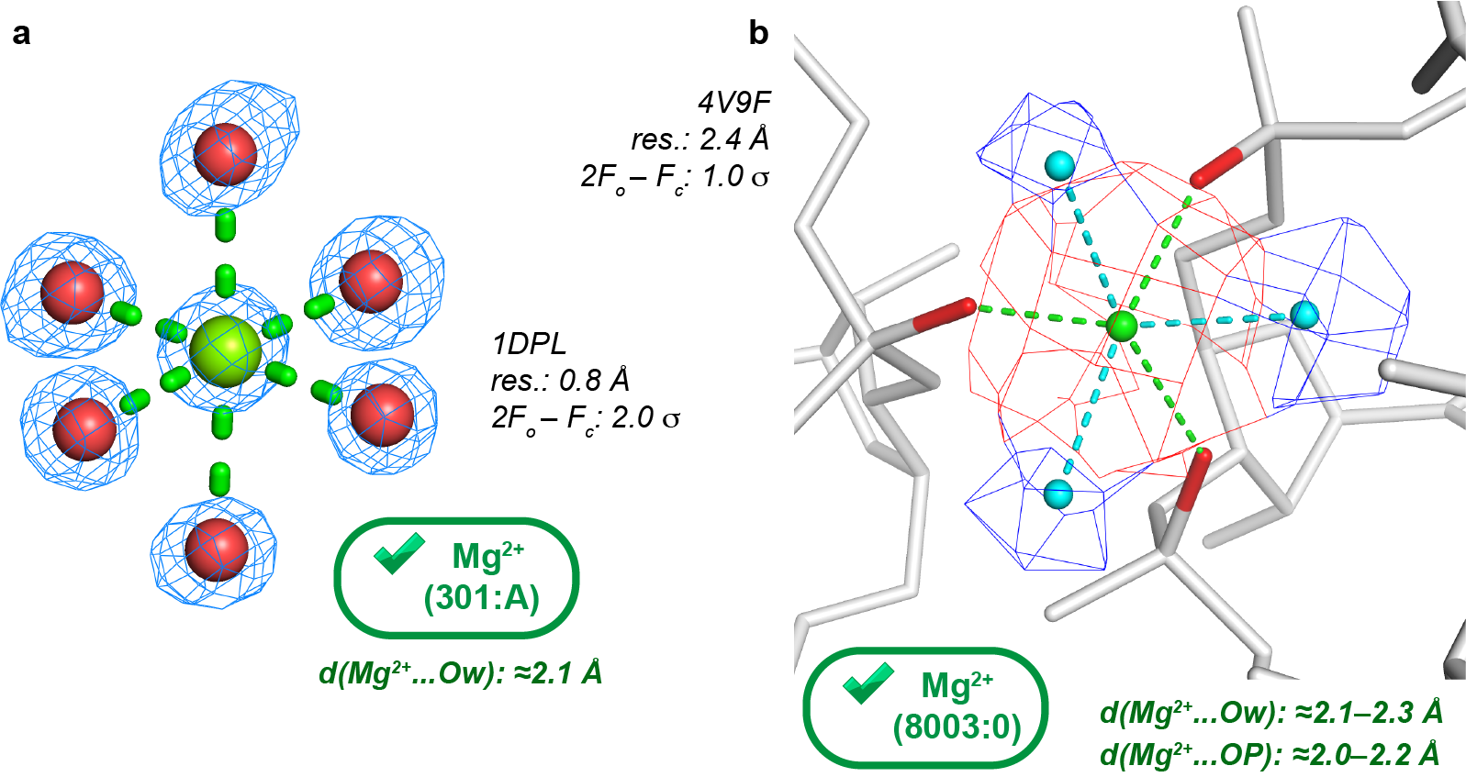

Figure S2. Illustration of densities corresponding to hexacoordinated Mg²⁺ at high and medium resolutions. (a) At resolutions around 1.0 Å, well-separated density blobs allow for a straightforward placement of the 1st coordination shell atoms of Mg²⁺ (Leonarski et al. 2019). (b) At medium resolution (≈2.4 Å), the density blobs of the coordinating atoms are often fused with that of the ion. In this view, Mg²⁺ (red density) is octahedrally coordinated to three phosphate anionic oxygen atoms (red) and three water molecules (cyan densities). For a density pattern comparison with a structure at 3.1 Å resolution, see Figure 3c.

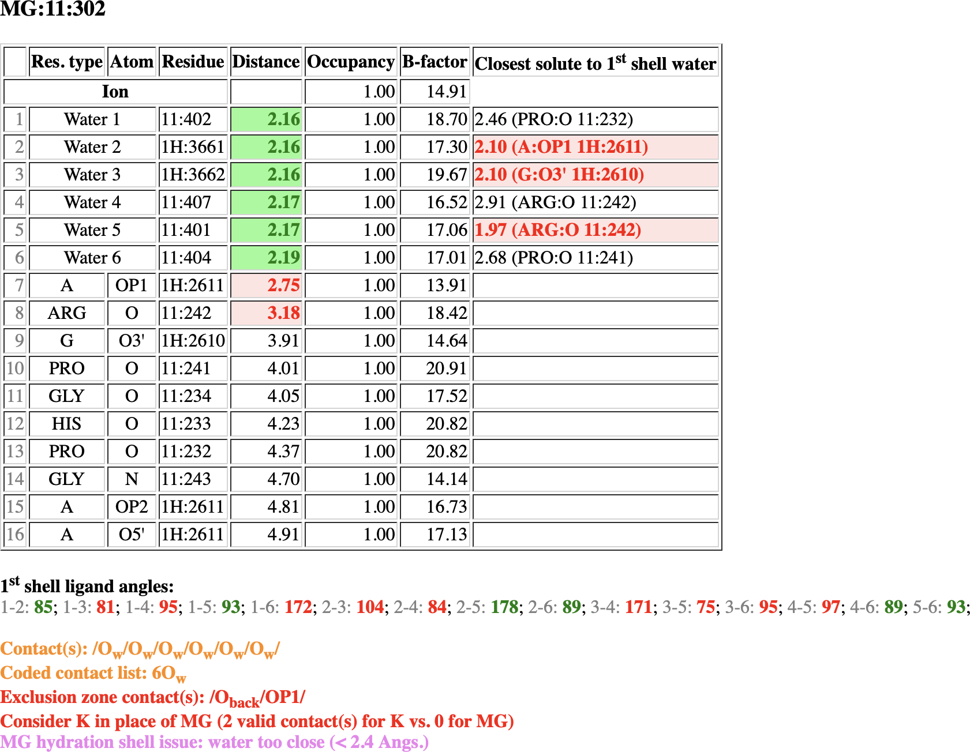

Figure S3. Extract of the 6QNR ‘in-house’ analysis program output related to the Mg²⁺ ion shown in Fig. 3. The short 2nd shell contact distances, highlighted in red, suggest a poor hydration shell modeling. Instead, the two coordination distances to OP1 and O atoms point to the presence of K⁺. Note the Mg²⁺…O_{w} coordination distances around 2.18 instead of 2.07 Å (see Figure 4).

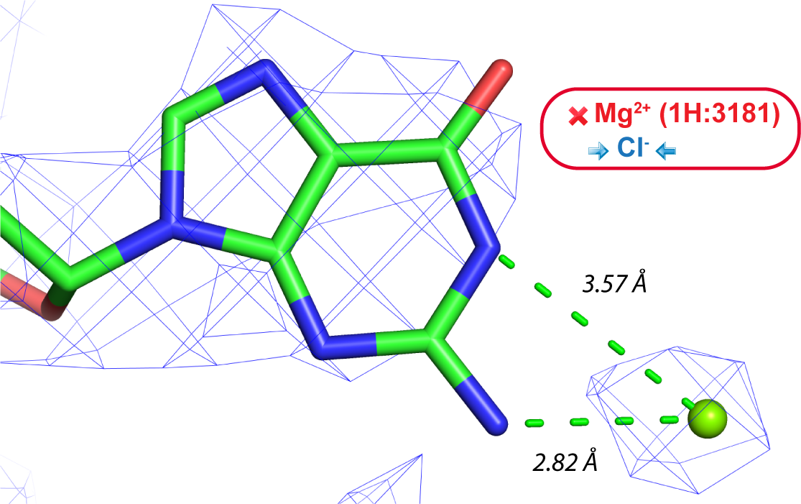
Figure S4. Mg²⁺ occupying an anion binding site in 6QNR. Anion binding to the guanine Watson-Crick edge has been well documented (Auffinger et al. 2004; D'Ascenzo and Auffinger 2016). Given its position and a ≈2.8 Å coordination distance, the ion shown in this figure is not Mg²⁺ but more likely Cl⁻.

References
Auffinger P, Bielecki L, Westhof E. 2004. Anion binding to nucleic acids. Structure 12: 379-388.
D'Ascenzo L, Auffinger P. 2015. A comprehensive classification and nomenclature of carboxyl-carboxyl(ate) supramolecular motifs and related catemers: implications for biomolecular systems. Acta Cryst. B71: 164-175.
-. 2016. Anions in nucleic acid crystallography. Methods Mol. Biol. 1320: 337-351.
Harding MJ, Nowicki MW, Walkinshaw MD. 2010. Metals in protein structures: a review of their principal features. Cryst. Rev. 16: 247-302.
Jenner LB, Demeshkina N, Yusupova G, Yusupov M. 2010. Structural aspects of messenger RNA reading frame maintenance by the ribosome. Nat. Struct. Mol. Biol. 17: 555-560.
Kruse H, Sponer J, Auffinger P. 2019. Comment on "Evaluating Unexpectedly Short Non-covalent Distances in X-ray Crystal Structures of Proteins with Electronic Structure Analysis". J. Chem. Inf. Model. 59: 3605-3608.
Leonarski F, D'Ascenzo L, Auffinger P. 2016. Binding of metal ions to purine N7 atoms and implications for nucleic acids: A CSD survey. Inorg. Chim. Acta 452: 82-89.
-. 2017. Mg²⁺ ions: do they bind to nucleobase nitrogens? Nucleic Acids Res. 45: 987-1004.
-. 2019. Nucleobase carbonyl groups are poor Mg²⁺ inner-sphere binders but excellent monovalent ion binders - A critical PDB survey. RNA 25: 173-192.
Rozov A, Demeshkina N, Khusainov I, Westhof E, Yusupov M, Yusupova G. 2016. Novel base-pairing interactions at the tRNA wobble position crucial for accurate reading of the genetic code. Nat. Commun. 7: 10457.
Rozov A, Khusainov I, El Omari K, Duman R, Mykhaylyk V, Yusupov M, Westhof E, Wagner A, Yusupova G. 2019. Importance of potassium ions for ribosome structure and function revealed by long-wavelength X-ray diffraction. Nat. Commun. 10: 2519.
Zheng H, Chordia MD, Cooper DR, Chruszcz M, Muller P, Sheldrick GM, Minor W. 2014. Validation of metal-binding sites in macromolecular structures with the CheckMyMetal web server. Nat. Protoc. 9: 156-170.

