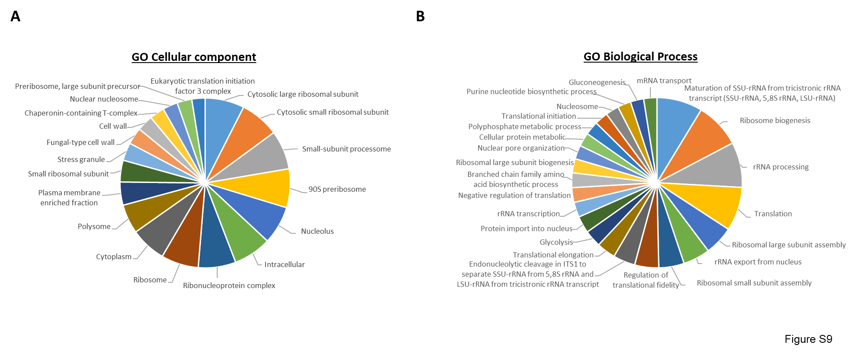

Figure S9. Biological GO categories analyses of the ChIP-Seq data for Bud2-TAP. The biological GO categories were determined by FunSpec software for the list of genes occupied by Bud27 in the wild-type cells grown in YPD at 30 ºC.

