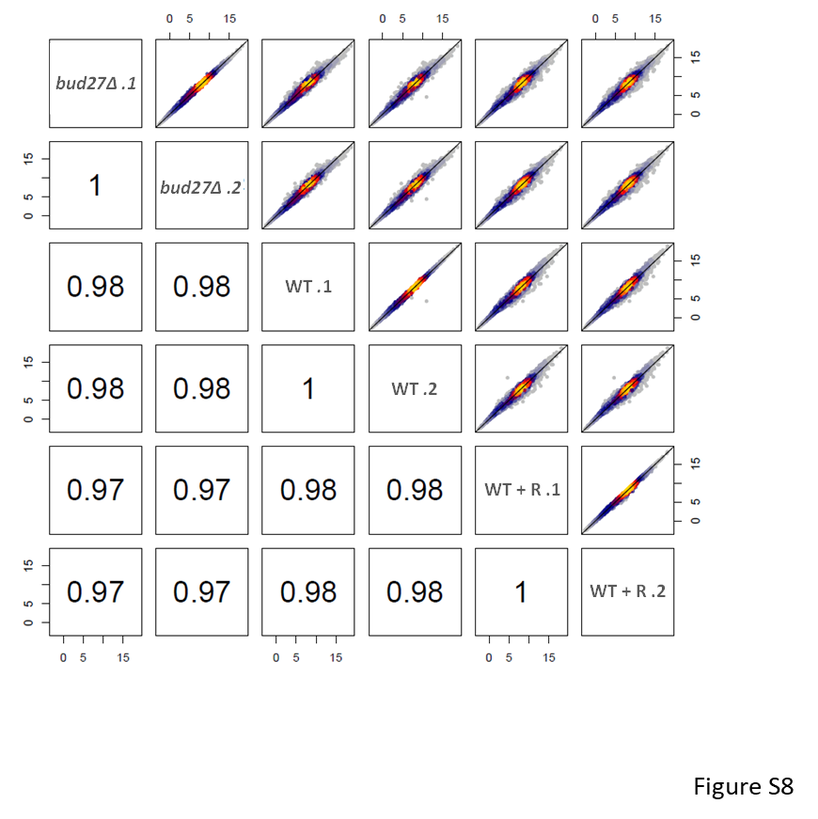

Figure S8. RNA-Seq analysis. Comparison of the average normalized RNA-Seq signal for the three different datasets herein used. Warmer colors indicate the higher density of the overlapping genes. Spearman rank correlation values are indicated. bud27∆, bud27∆ cells; WT, wild-type cells not treated with rapamycin; WT + R, rapamycin-treated wild-type cells. 1 and 2 indicate two independent biological replicates.

