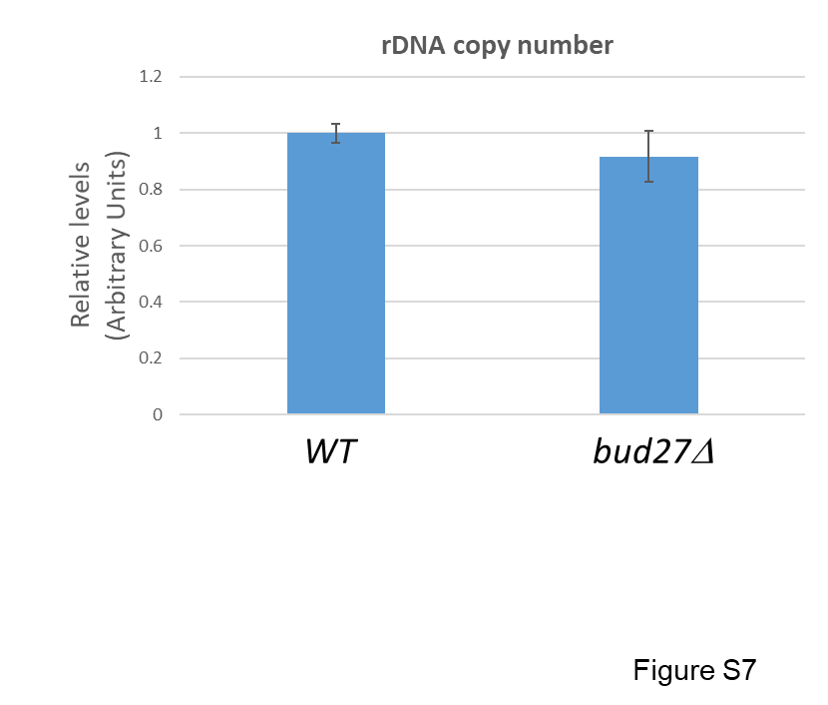

Figure S7. rDNA copy number analysis. The rDNA copy number was analyzed by qPCR in DNA samples from bud27∆ and wild-type cells. Oligonucleotides 18S-501 and 18S-301 (see Table S1), which recognize an amplicon of the rDNA unit corresponding to the region of the 25S rRNA, were used. The ratio for the rDNA amplicon to a non-transcribed region of chromosome V was calculated. The average and standard deviations of three biological replicates are shown. Statistical significance by the t-Student test, p=0.0256.

