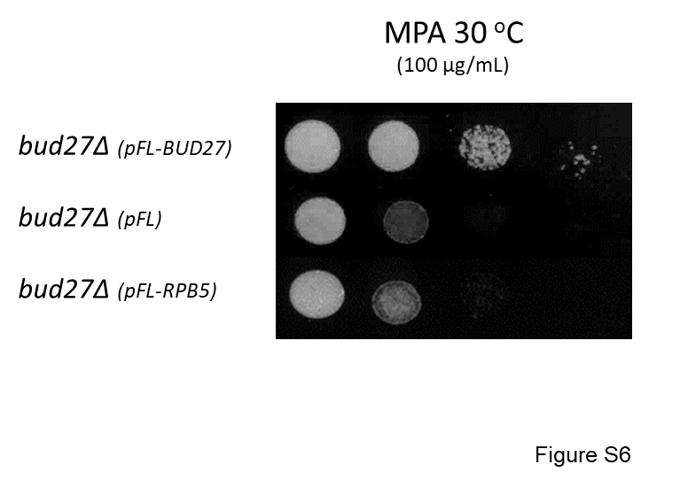

Figure S6. RPB5 overexpression does not overcome hypersensitivity to mycophenolic acid of bud27∆ cells. Growth analysis of the bud27∆ mutant cells that harbor the indicated plasmids to overexpress RPB5 or BUD27. Cells were grown at 30 ºC in complete SD medium that contained mycophenolic acid (MPA) at the indicated concentration.

