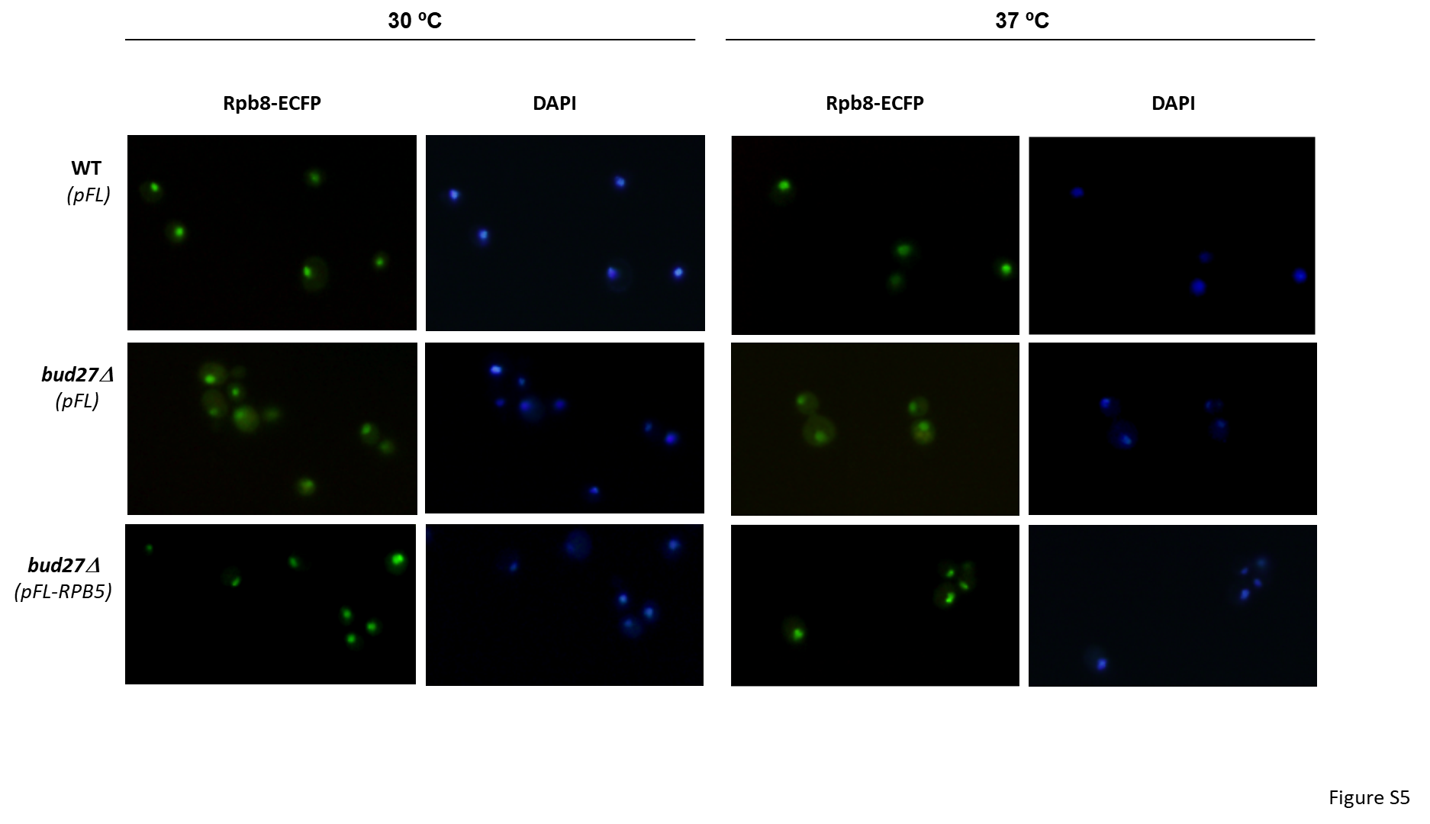

Figure S5. Cytoplasmic RNA pols mislocalization in bud27Δ mutant cells is corrected by overexpression of RPB5. Live cell imaging of Rpb8-ECFP in wild-type and bud27∆ mutant cells at 30 ºC or 37 ºC, containing empty vector (pFL) or overexpressing RPB5 (pFL-RPB5).

