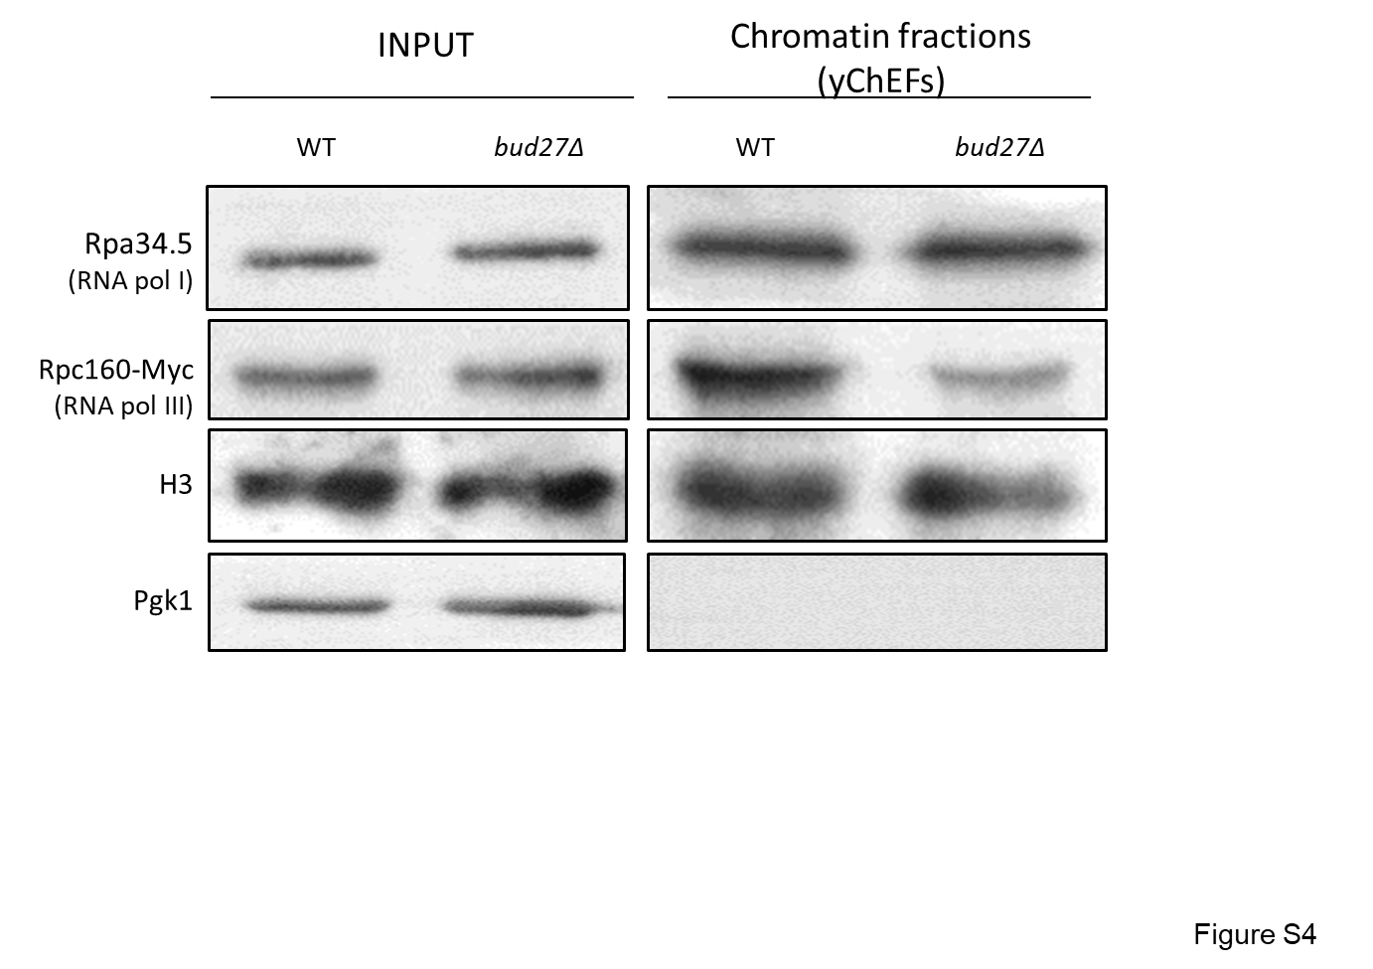
Figure S4. Presence of RNA pol I and III in chromatin-enriched fractions. Chromatin-enriched fractions were obtained from MYC-tagged Rpc106 cells in the isogenic wild-type and bud27∆ backgrounds. Cells were grown in YPD medium at 30 ºC and chromatin was obtained by the yChEFs procedure (Cuevas-Bermúdez et al. 2019; Cuevas-Bermúdez et al. 2020). RNA pol I and III were analyzed with antibodies against Rpa34.5 and anti-MYC, respectively. Anti-histone H3 and anti-Pgk1 antibodies were used as controls for chromatin and cytoplasmic contamination, respectively.

