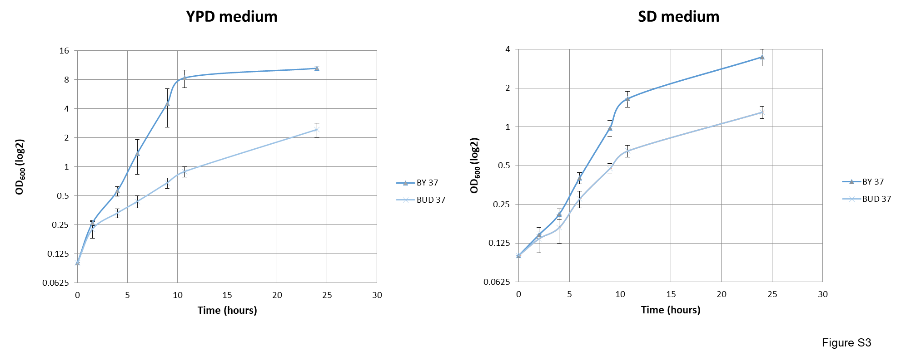

Figure S3. Growth curves of wild-type and bud27∆ cells. Yeast strains were grown in liquid YPD or SD media containing 2% glucose, at 30 ºC (time 0), and then shifted to 37 ºC for the indicated time period.

