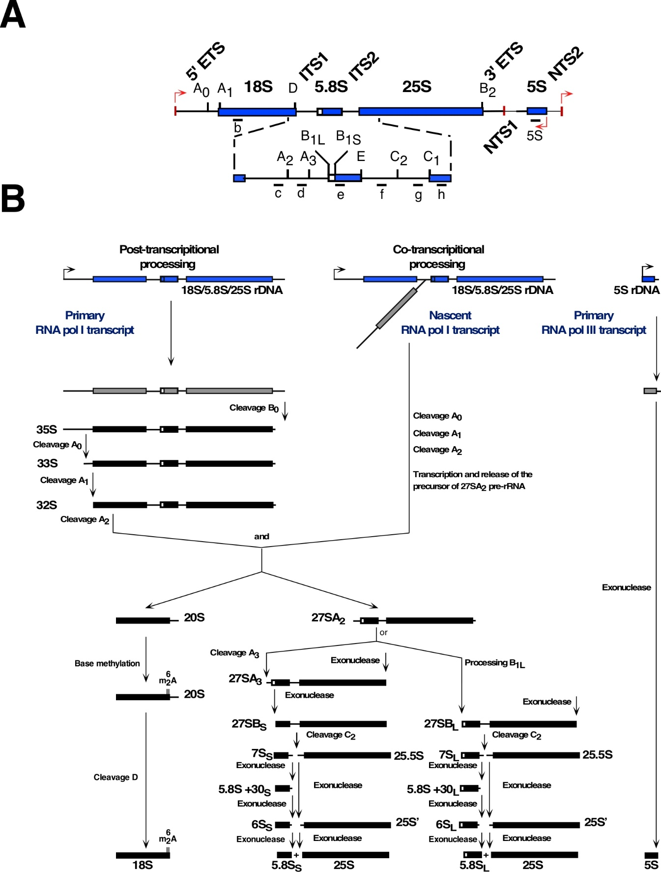
Figure S2
Figure S2. Pre-rRNA processing in S. cerevisiae. (A) Structure of an rDNA repeat unit. Each unit contains two independently transcribed elements, the long one is transcribed by RNA polymerase I (RNA pol I) into a polycistronic pre-rRNA encoding the 18S, 5.8S and 25S rRNAs and the short one is transcribed by RNA polymerase III (RNA pol III) into a pre-5S rRNA. Non-transcribed, external and internal spacers (NTSs, ETSs and ITSs) are indicated. The mature rRNA species are shown as bars and the spacers as lines. The transcription start sites are highlighted by red arrows. The processing sites and the location of the hybridization probes, listed in Table S2, are shown. (B) Scheme of the pre-rRNA processing pathway. The RNA pol I transcript can undergo either post- or co-transcriptional processing, leading to the generation of the 20S and 27SA₂ pre-rRNAs, which are components of early pre-40S and pre-60S ribosomal particles, respectively. These pre-rRNAs are then further processed into the mature 18S and 5.8S and 25S rRNAs. The flanking 5S rRNA is transcribed by RNA pol III in the opposite direction as a pre-5S rRNA. All cleavages and trimming reactions are indicated. This figure has been adapted from that shown in García-Gómez et al. (García-Gómez et al. 2014). For further description of the yeast pre-rRNA processing pathway, see (Fernández-Pevida et al. 2015; Henras et al. 2015).

