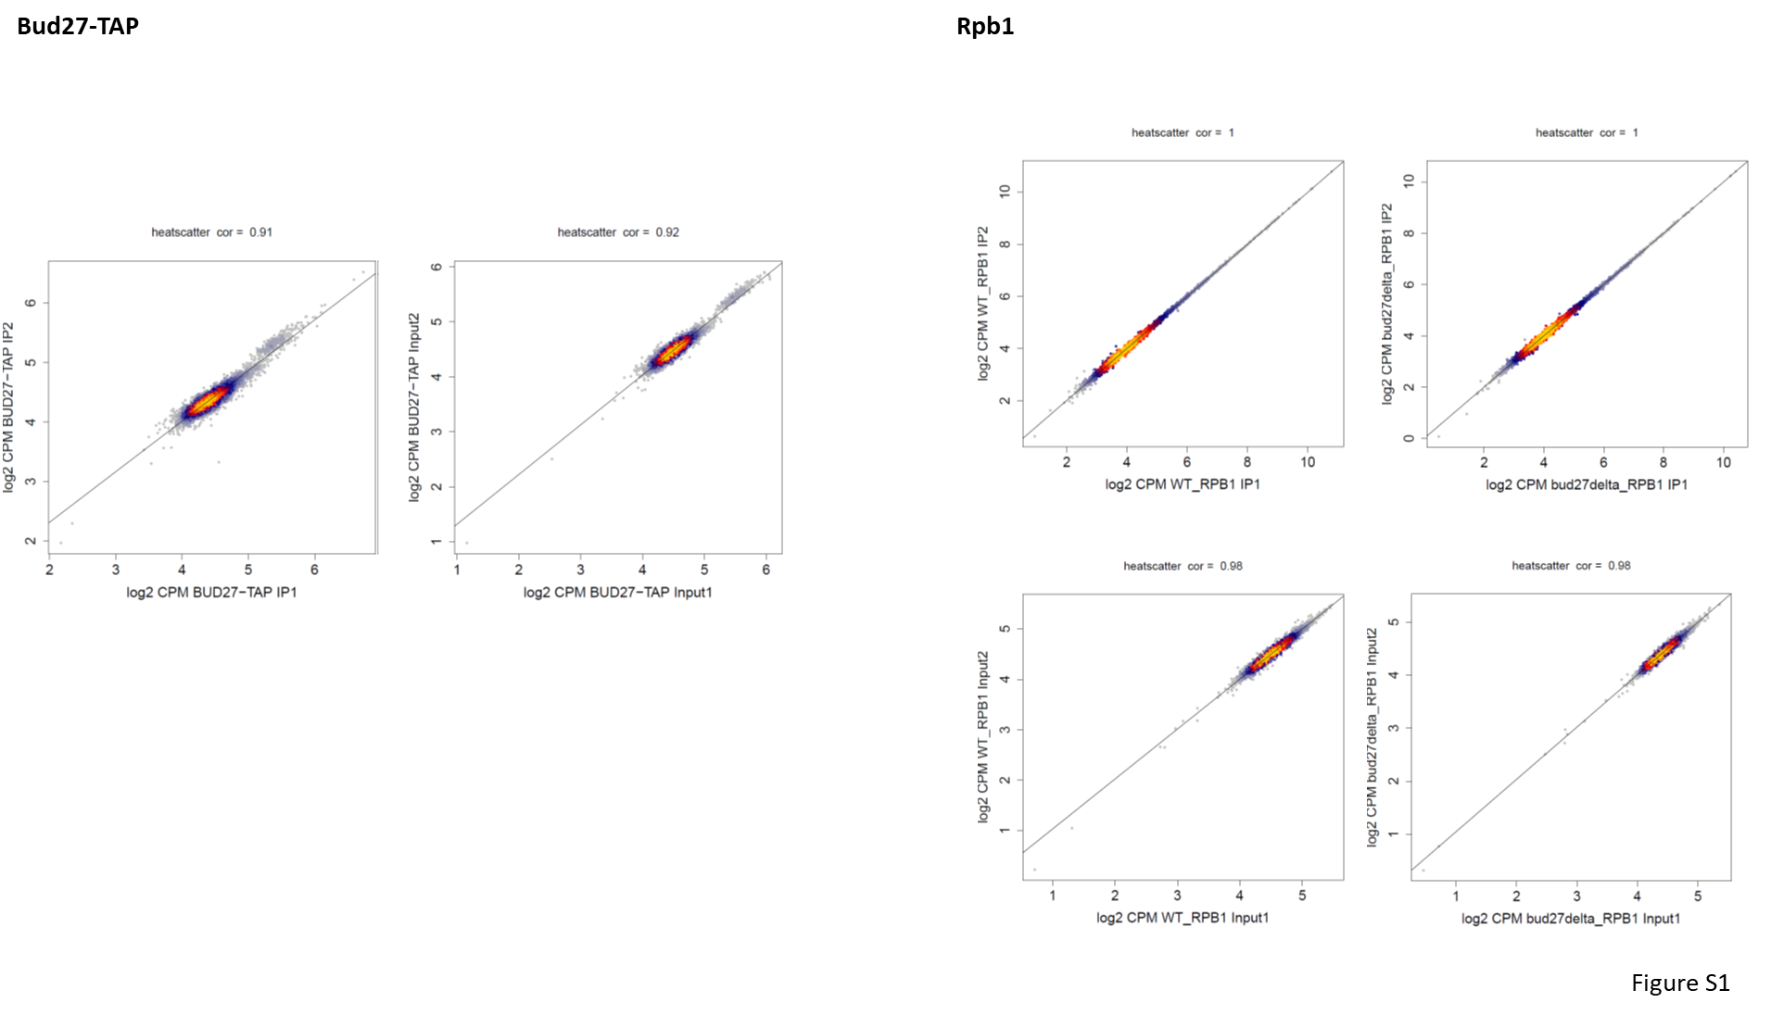

Figure S1. ChIP-Seq analysis. Comparison of the average normalized ChIP-Seq signal (Bud27-TAP and Rpb1) on protein-coding genes (n=5143) for the two dataset types herein used. Warmer colors indicate the higher density of the overlapping genes. Spearman rank correlation values are indicated.

