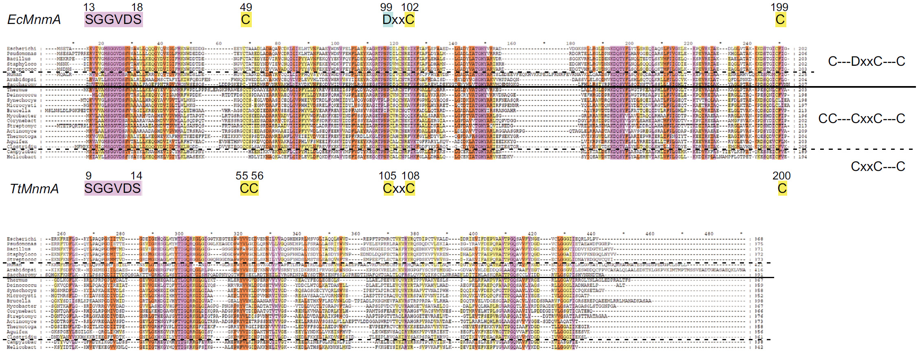
Supplementary Figure S1. Sequence alignment of MnmAs from several bacteria and eukaryotes.
MnmA orthologs were retrieved by a BLAST search with TtMnmA as the query. These sequences were aligned with the CLUSTAL X2 program and visualized with the GeneDoc program. Schematic representation of conserved motifs in the E. coli and T. thermophilus MnmAs is depicted above and below the alignment, respectively. MnmAs from the following species were included: E. coli K-12, Pseudomonas aeruginosa PAO1, Bacillus subtilis 168, Staphylococcus aureus RF122, Streptococcus pneumoniae D39, Homo sapiens, Arabidopsis thaliana, Saccharomyces cerevisiae S288C, T. thermophiles HB27, Deinococcus radiodurans R1, Synechocystis PCC6803, Microcystis aeruginosa NIES-843, Brucella abortus 63/168, Mycobacterium tuberculosis H37Rv, Corynebacterium diphtheriae rz356, Streptomyces coelicolor A3(2), Actinomyces israeli DSM 43320, Thermotoga maritima MSB8, Aquifex aeolicus VF5, Clostridioides difficile 630, Campylobacter jejuni W1, and Helicobacter pylori GAM121Aii. Note that the N-terminal signal sequences of the A. thaliana and S. cerevisiae MnmAs are not included in this alignment.

Supplementary Figure S2. LC/MS detection of mnm⁵s²U and mnm⁵U in T. thermophilus tRNAs (A) and E. coli total RNA (B).
UV chromatograms (254 nm) and mass chromatograms (m/z = 304.1 and 288.1) (upper panels), collision-induced dissociation (CID) mnm⁵s²U spectra (middle panels), and CID mnm⁵U spectra (lower panels) are shown. In the mass spectra for both mnm⁵s²U and mnm⁵U, the parent ion (MH⁺), the base ion (BH²⁺), and their derivatives were detected. The “-31” ions were derived from the side groups of methylaminomethyl moieties (loss of CH₃NH₂), and the “-49” ions resulted from further loss of H₂O from the “-31” species. Asterisks (*) indicate non-specific signals derived from the detector.
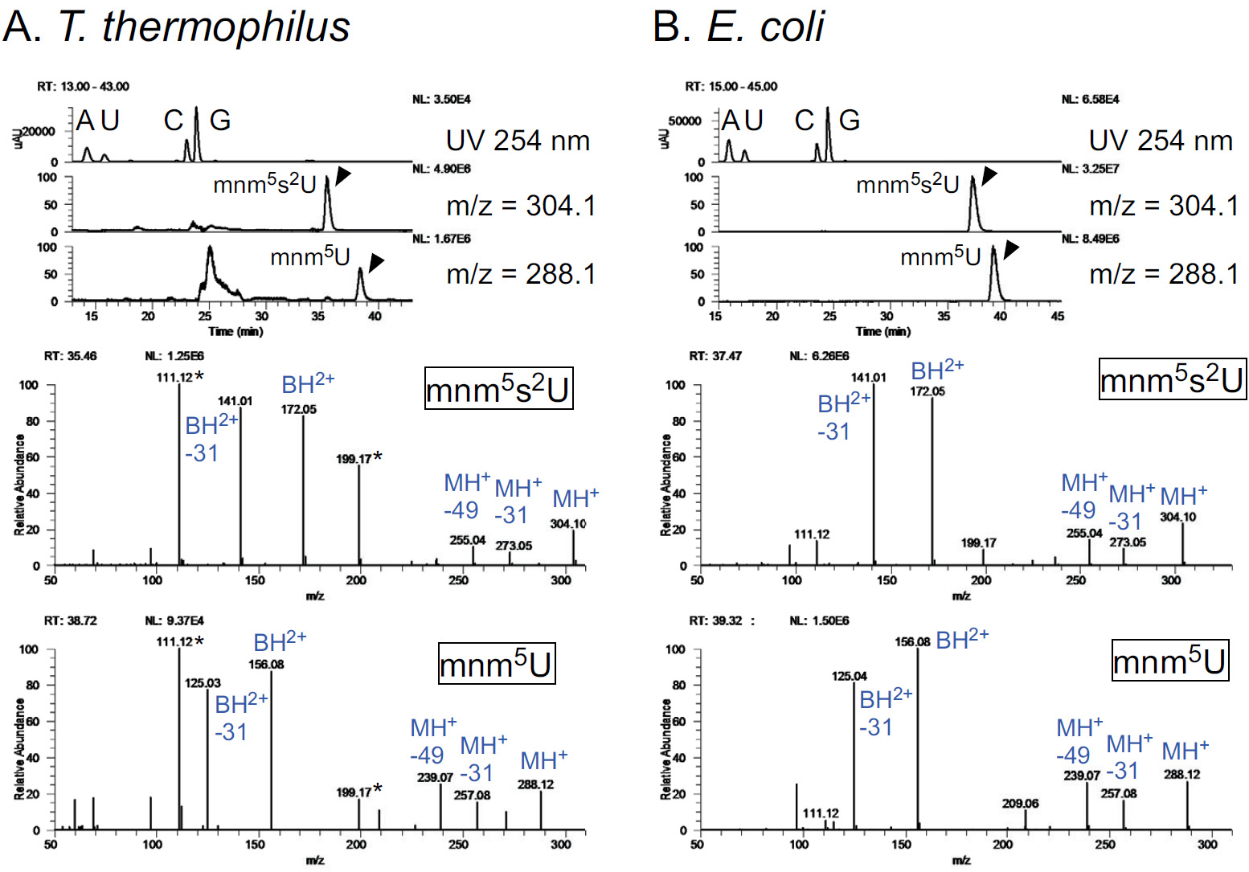

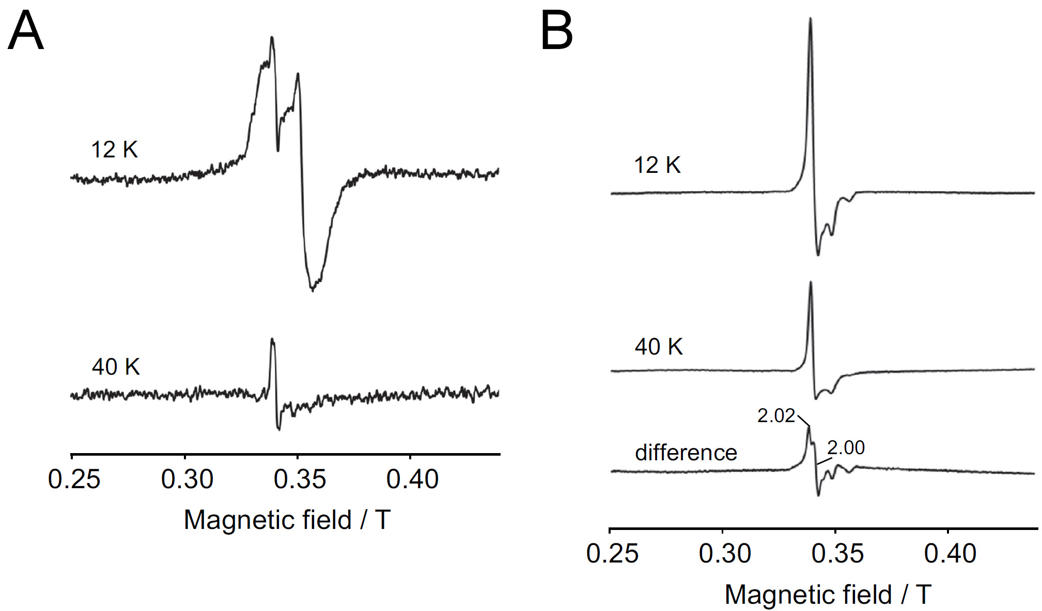
Supplementary Figure S3. EPR spectra of reduced (A) and oxidized (B) MnmA at 12 and 40 K.
The experimental conditions were the same as those in Fig. 2, except for the temperatures. The difference spectrum in B was obtained by subtracting the 40K spectrum from the 12K spectrum with an appropriate coefficient.

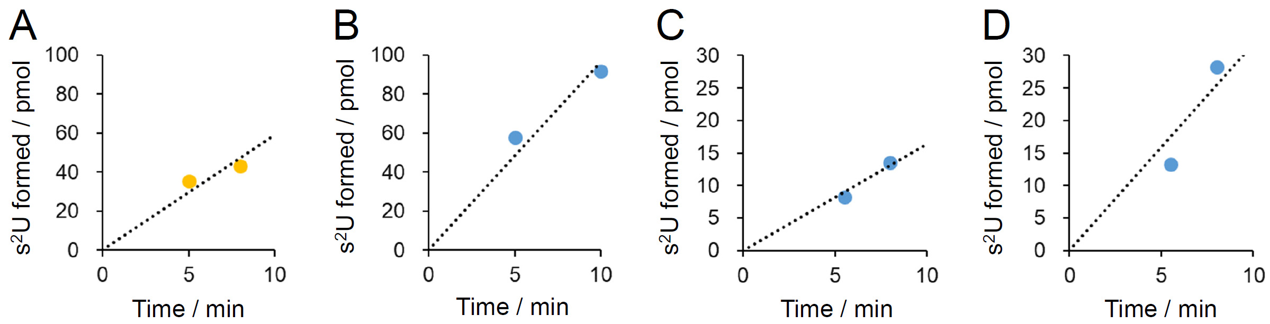
Supplementary Figure S4. Details of the determination of initial velocities of s²U formation by TtMnmA.
The standard assay was performed at 60 °C for 5–30 min in 60 µl of H buffer containing 2.5 mM ATP, 0.1 mM Na₂S, 450 pmol of tRNA, and 9.4–75 pmol of holo-MnmA. After the reactions, the amount of s²U formed was quantified as described in the MATERIALS AND METHODS section.
To determine the initial velocity of wild-type MnmA, we plotted time curves of s²U formation for tRNA^{Gln} (A) and tRNA^{Lys} (B) with 12.5 pmol of MnmA. The assay with tRNA^{Gln} for 8 min was repeated in triplicate, the amount of s²U formed was quantified, and the initial velocity was determined. For determination of the initial velocities of wild-type and mutant (C55A, C56A, and C55AC56A) MnmAs, 9.4 pmol of MnmA and tRNA^{Lys} were incubated for 10 min in triplicate and the amount of s²U formed was quantified. For the C200A mutant, the amount of s²U formed by 19 pmol of MnmA in 10 min was quantified in triplicate, and for the C105A mutants, the amount of s²U formed by 75 pmol of MnmA in 30 min was quantified in triplicate because the activity of these mutants is too weak to accurately quantify s²U otherwise. For D13A, C108A, and C105AC108AC200A mutants, no s²U formation was detected in assays containing 75 pmol of MnmA for 30min.
For cysteine desulfurase-coupled reactions, we plotted time curves of s²U formation for tRNA^{Lys} with 12.5 pmol of MnmA and 75 pmol of IscS (C) or SufS (D) under non-reducing conditions. Assays lasting 8 min were repeated in triplicate, the amount of s²U formed was quantified, and the initial velocity was determined.
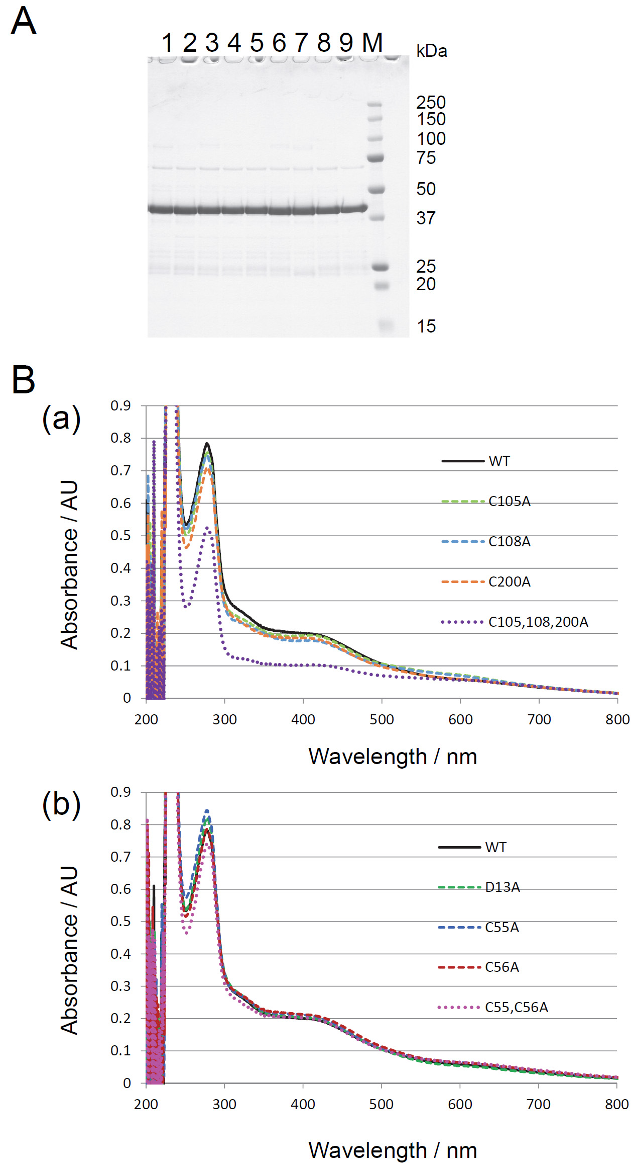
Supplementary Figure S5. Recombinant MnmAs.
A. SDS-PAGE analysis of MnmAs. Four micrograms of each MnmA were separated by 10−20% PAGE and stained with CBB. Wild type (lane 1), D13A (lane 2), C55A (lane 3), C56A (lane 4), C55,56A (lane 5), C105A (lane 6), C108A (lane 7), C200A (lane 8), C105,108,200A (lane 9), and Marker (lane M) are shown.
B. UV-VIS spectra of reconstituted MnmA proteins with mutations in the three Cys residues in the catalytic center (a) or in other residues (b) are shown. The samples were diluted to 0.7 mg/ml in A buffer, and the spectra were recorded.
Supplementary Table S1. Primer list for TtMnmA and Tt-tRNA-Lys(K)/Gln(Q) cloning

For the TtMnmA cloning (restriction sites are underlined):
TtMnmA-Nde-F | agccagctcatatgaagcgggttctcgtggccatgtcc
TtMnmA-Hind-R | gagctaagcttggagaaggtcaaggcccggggatcc

For the TtMnmA mutant construction (mutations introduced are shown in capital letters):
MnmA-QC-D13A-F | ccatgtccgggggggtggCctcctccgtggccgcc
MnmA-QC-D13A-R | ggcggccacggaggagGccacccccccggacatgg
MnmA-QC-C55A-F | cgggcctgggagagcGCctgcaccccggacgccgc
MnmA-QC-C55A-R | gcggcgtccggggtgcagGCgctctcccaggcccg
MnmA-QC-C56A-F | cgggcctgggagagctgcGCcaccccggacgccgc
MnmA-QC-C56A-R | gcggcgtccggggtgGCgcagctctcccaggcccg
MnmA-QC-C55AC56A-F | cgggcctgggagagcGCcGCcaccccggacgccgc
MnmA-QC-C55AC56A-R | gcggcgtccggggtgGCgGCgctctcccaggcccg
MnmA-QC-C105A-F | cgcaccccgaaccccGCcgcccggtgcaacaccttcgtcaagttc
MnmA-QC-C105A-R | gaacttgacgaaggtgttgcaccgggcgGCggggttcggggtgcg
MnmA-QC-C108A-F | cgcaccccgaacccctgcgcccggGCcaacaccttcgtcaagttc
MnmA-QC-C108A-R | gaacttgacgaaggtgttgGCccgggcgcaggggttcggggtgcg
MnmA-QC-C105AC108A-F | cgcaccccgaaccccGCcgcccggGCcaacaccttcgtcaagttc
MnmA-QC-C105AC108A-R | gaacttgacgaaggtgttgGCccgggcgGCggggttcggggtgcg
MnmA-QC-C200A-F | cccgaaagccagaacctcGCcttcgtggccggcgacctc
MnmA-QC-C200A-R | gaggtcgccggccacgaagGCgaggttctggctttcggg

For the tRNA cloning (restriction sites are underlined):
Tt-tRNA-K-F | ggccgaattctaatacgactcactatagggccgttagctcagctggcagagcaaccgacttttaatcgg
Tt-tRNA-K-R | cgcgcaagcttcctggtgggccgtgcaggattcgaacctgcgacctaccgattaaaagtcggttgctctg
Tt-tRNA-Q-U1G-F | ggccgaattctaatacgactcactatagggggcgtcgtctaacggcaggacagcggactttgg
Tt-tRNA-Q-R | cgcgcaagcttcctggctggggcgggtggactcgaaccaccaccggcggatccaaagtccgctgtcctg

For the tRNA mutant construction (mutations introduced are shown in capital letters):
Tt-tRNA-K-QC-U34A-F | gctggcagagcaaccgactAttaatcggtaggtcgcaggttcg
Tt-tRNA-K-QC-U34A-R | cgaacctgcgacctaccgattaaTagtcggttgctctgccagc
Tt-tRNA-Q-U1G-U34A-F | ggcaggacagcggactAtggatccgccggtggtgg
Tt-tRNA-Q-U1G-U34A-R | ccaccaccggcggatccaTagtccgctgtcctgcc

For PCR amplification of templates for in vitro transcription:
tRK-F | taatacgactcactatagggccgttagc
tRK-disc-R | tgggccgtgcaggattcgaacc
tRQ-U1G-F | taatacgactcactatagggggcg
tRQ-U1G-disc-R | tggggcgggtggactcg

