RNA-article

Supplementary Information

Adenine·cytosine substitutions are an alternative pathway of compensatory mutation in angiosperm ITS2
XINWAN ZHANG^{1,3}, YONG CAO^{1,3}, WEI ZHANG^{1,2}, MARK P. SIMMONS²

¹Marine College, Shandong University, Weihai 264209, China
²Department of Biology, Colorado State University, Fort Collins 80523, USA
³These authors contributed equally to this work
Corresponding author: wzhang@sdu.edu.cn

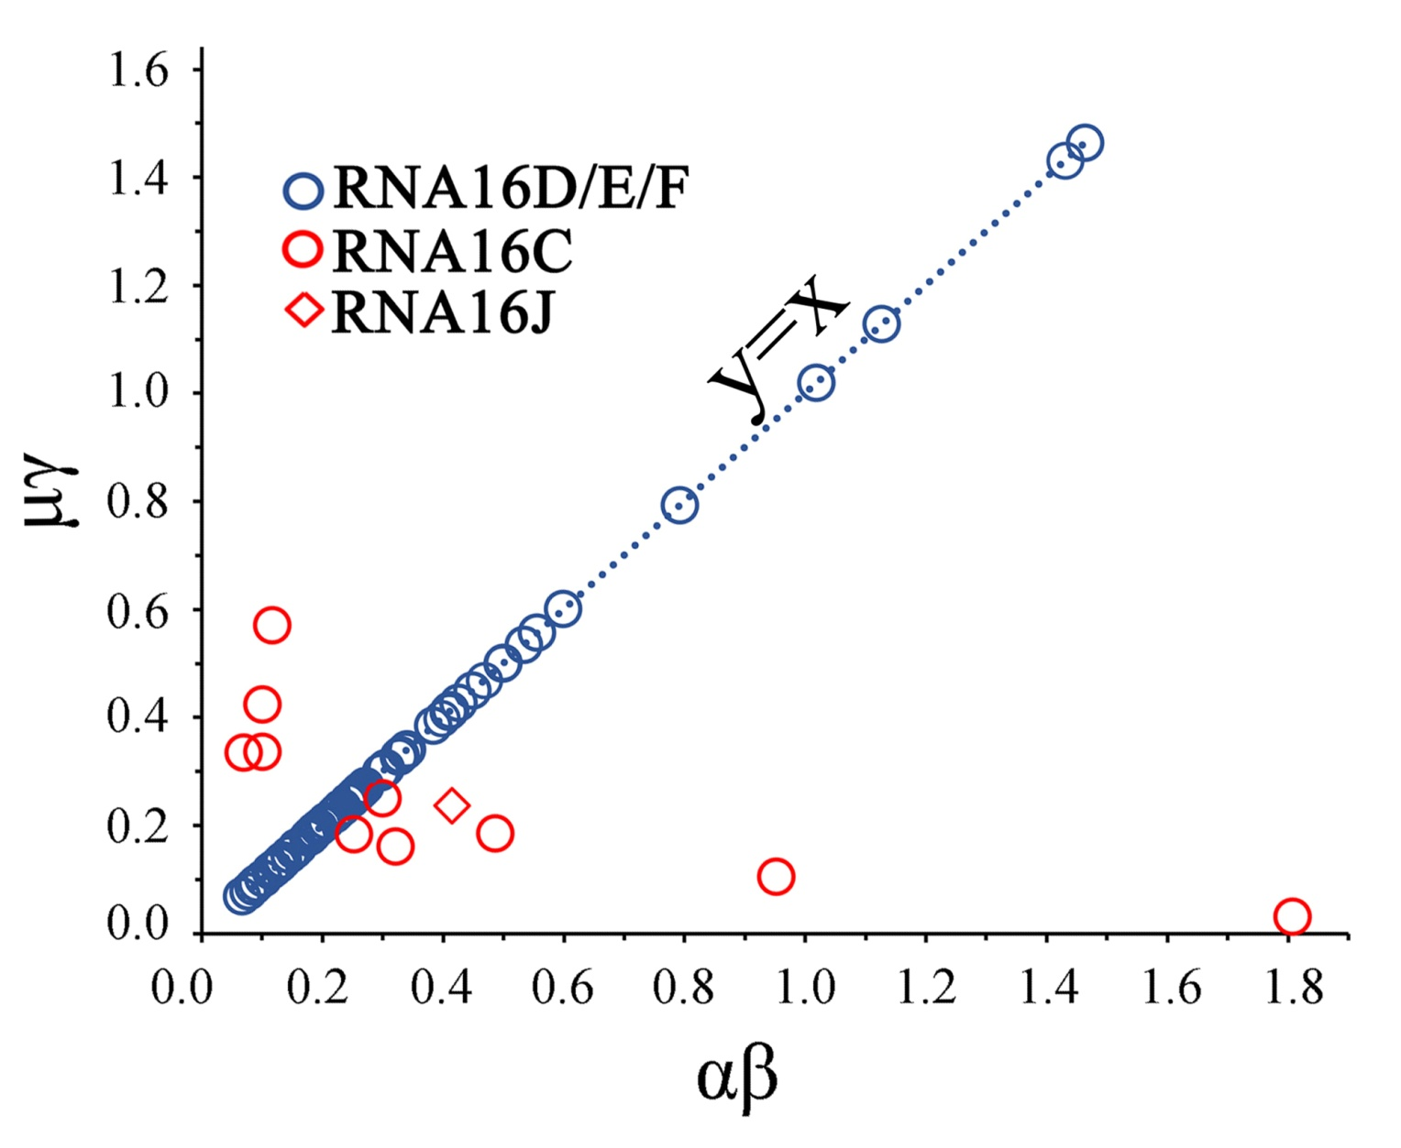

FIGURE S1 Substitution rates inferred from the RNA16D/E/F model, which is subject to the equation α*β=μ*γ, which accounts for the y=x line of blue points. The results are shown based on AU→GC compensatory substitutions.

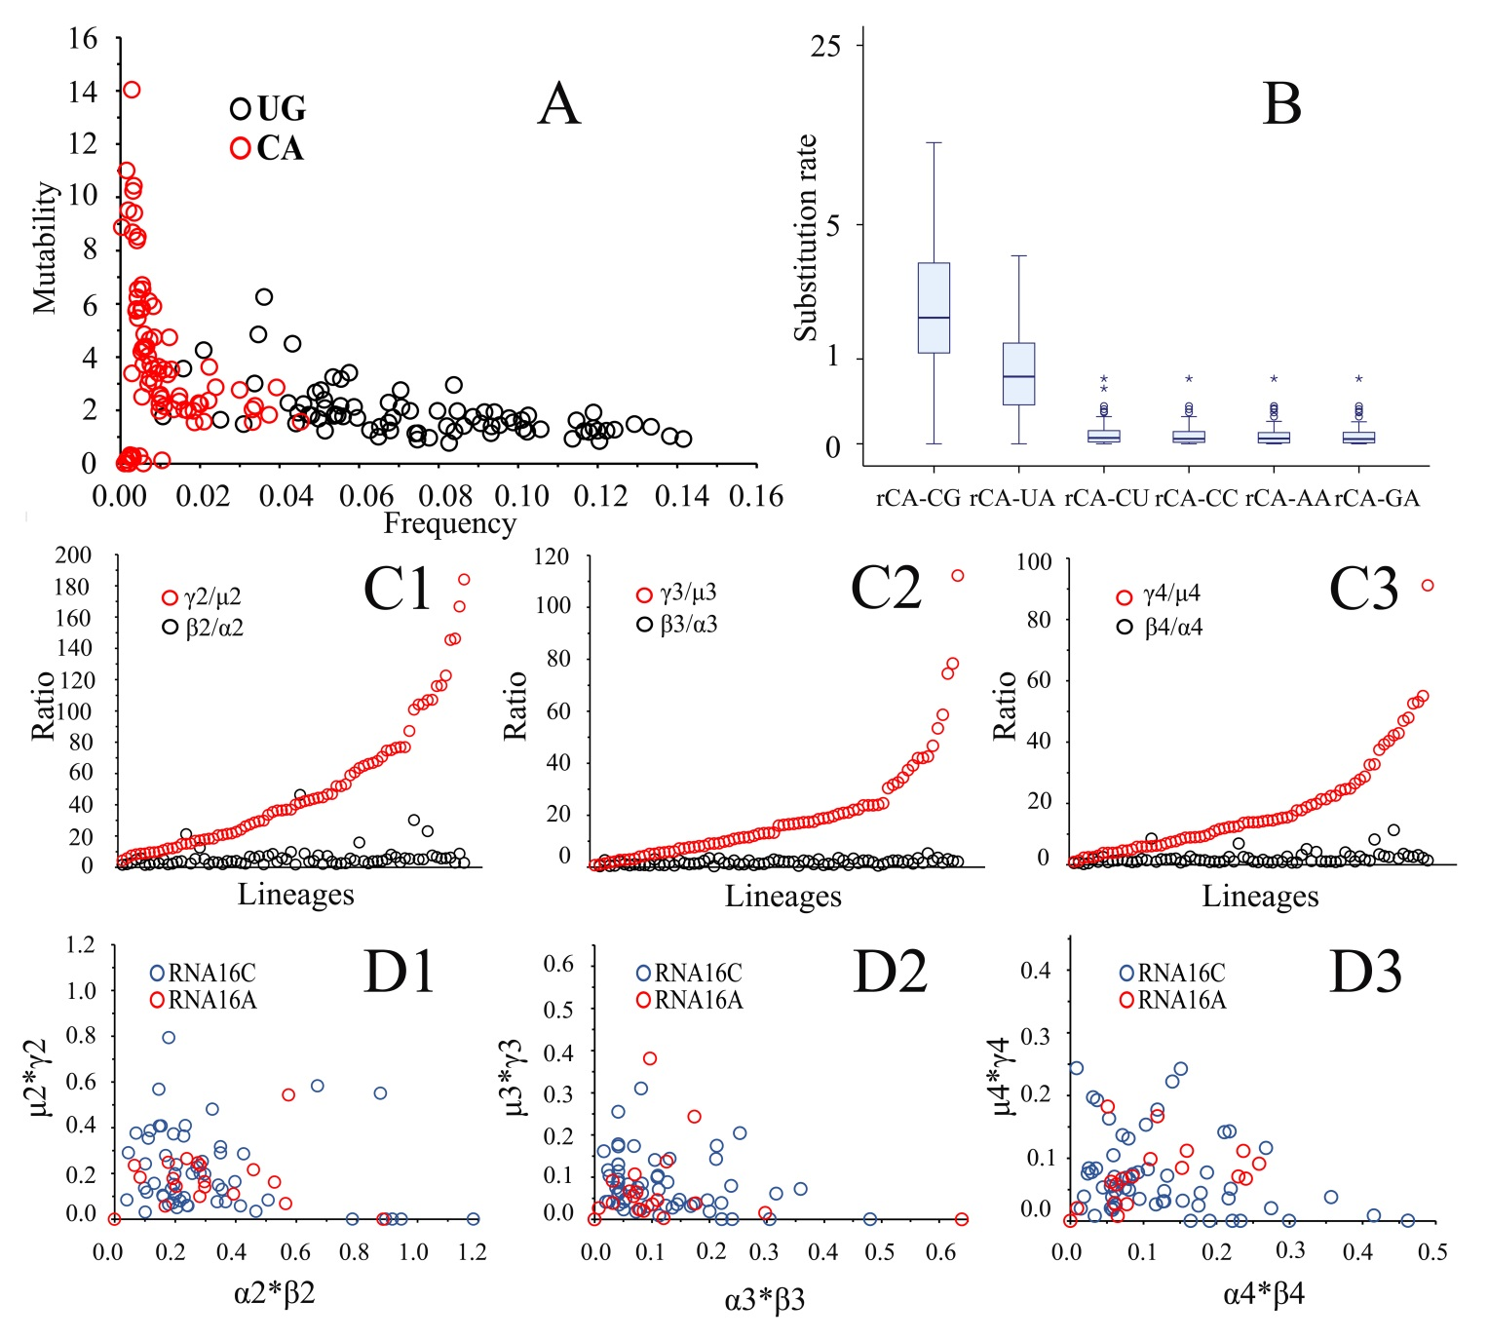

FIGURE S2. Complement comparisons of substitution rates and base-pair frequencies between AC (CA) and GU (UG) intermediate base pairs for three alternative CBCs. Subscript numbers 2-4 represent UA→CG, GC→AU and CG→UA, respectively (Fig. 1, Table 1). All results are shown based on the best-fit double-substitution rate matrix for each of the 80 sampled lineages. (A) Frequency-mutability scatter plot of CA and UG pairs. (B) Box-plots for single-substitution rates from CA to six other base-pairs. (C) Comparisons of rate heterogeneity between AC- and GU-mediated CBCs. The two substitution-rate ratios for AC(CA)-mediated CBCs are generally higher than those for GU(UG)-mediated CBCs. (D) Comparisons of the total probabilities of change from AU (UA) to GC (CG) based on multiplying the pairs of single-substitution rates. α_{n}*β_{n} and μ_{n}*γ_{n} represent the probability of GU(UG)- and AC(CA)-mediated CBCs, respectively (Fig. 1).

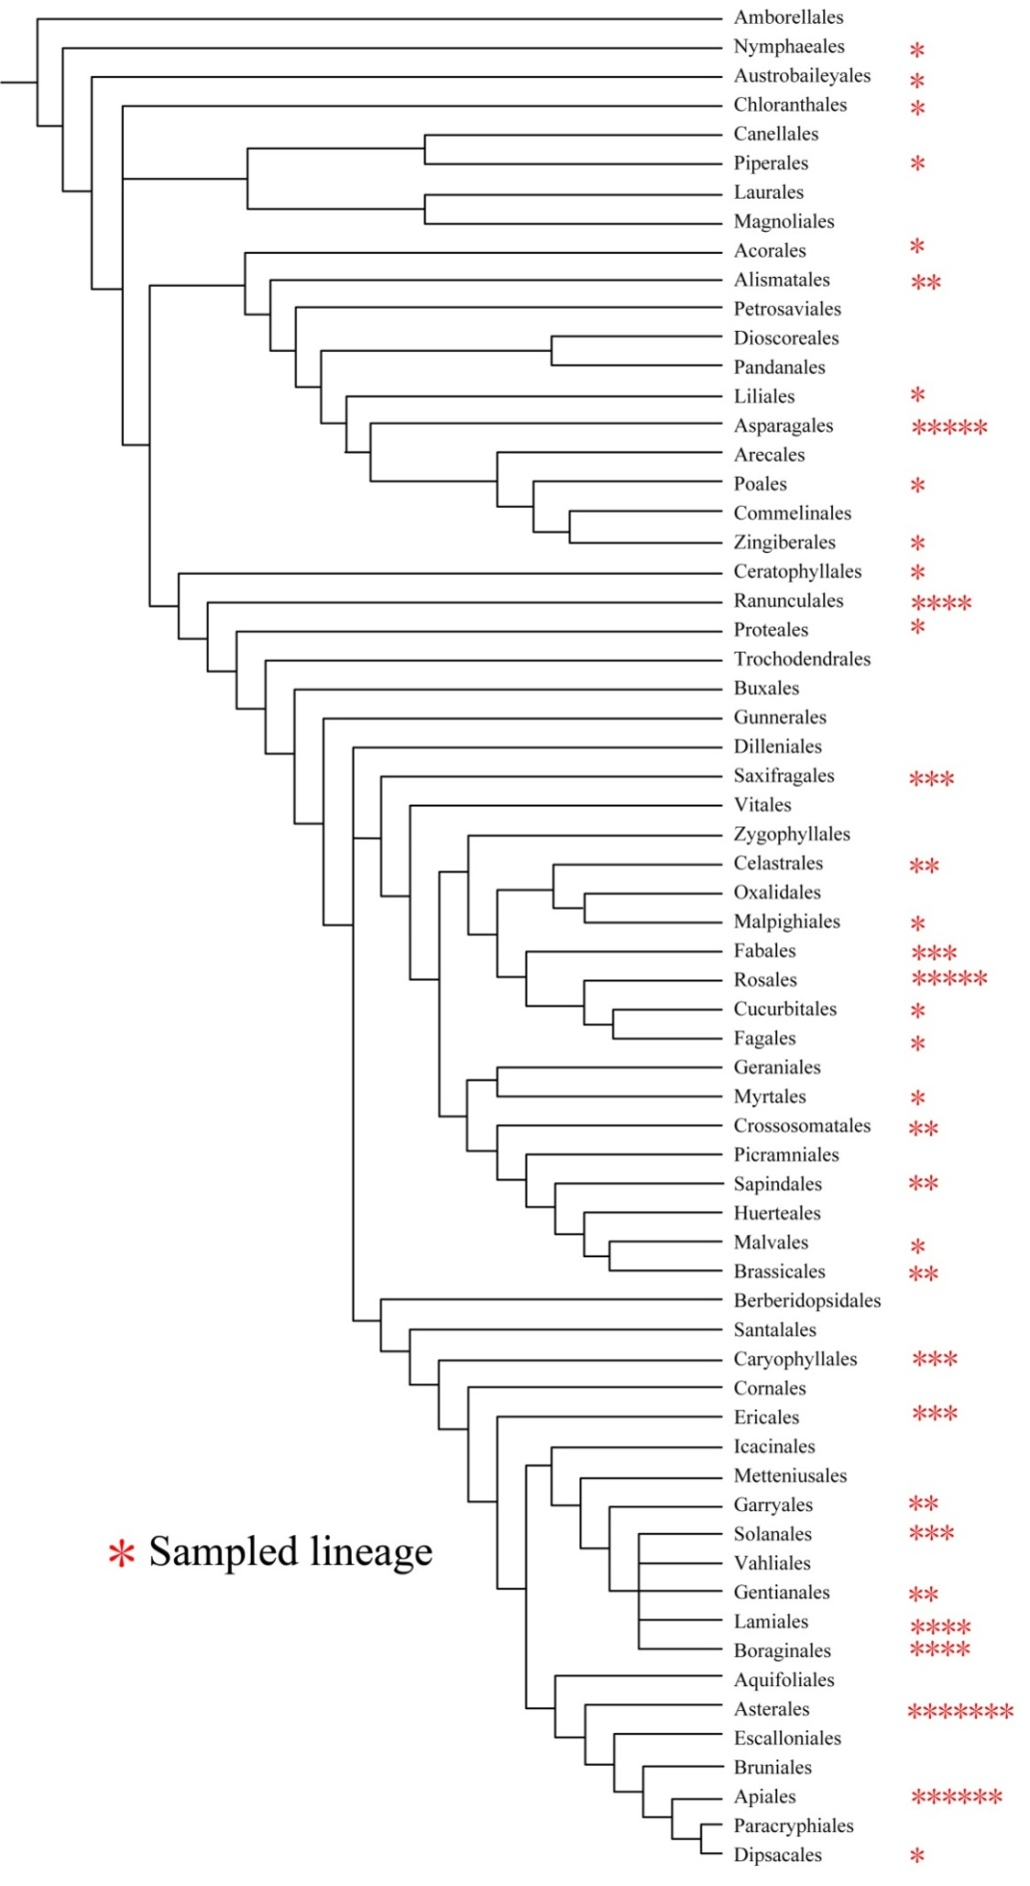
FIGURE S3. Phylogenetic relationships among the 80 sampled lineages based on The Angiosperm Phylogeny Group (APG; Chase et al., 2016) classification and their figure-1 phylogenetic tree.

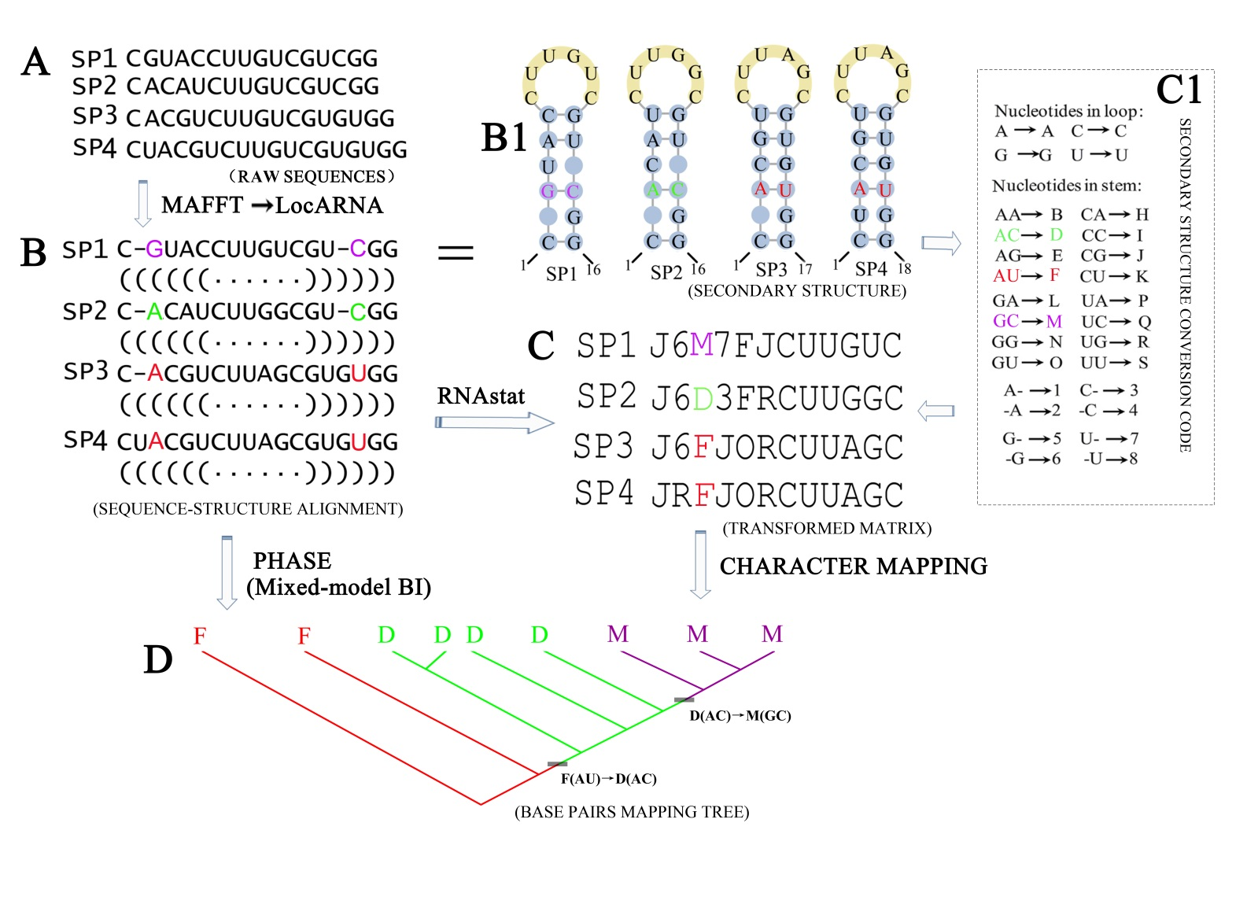
FIGURE S4. A workflow illustrating how base-pair information was mapped onto the Bayesian consensus trees to infer the AC- and CA-mediated compensatory base changes (CBCs). (A) Raw sequences of three ingroup species and one outgroup species (SP4). (B) Alignment of sequences and their corresponding consensus secondary structures. The paired and unpaired nucleotides are indicated in parentheses and dots, respectively. An example of two nucleotides that together form a base pair is colored; the secondary structure is also shown in subfigure B1. (C) The secondary-structure base-pair information was coded by RNAstat and transformed into character states by using the secondary-structure conversion code in subfigure C1. The paired bases highlighted in subfigure B were merged into a single character that is shown in the transformed matrix. (D) A Bayesian consensus tree with character states from the example base-pair mapped on it (for nine species in this case rather than the original four shown in subfigure A). The Bayesian consensus tree is generated from the sequence-structure alignment by using a mixed model implemented in the PHASE package.

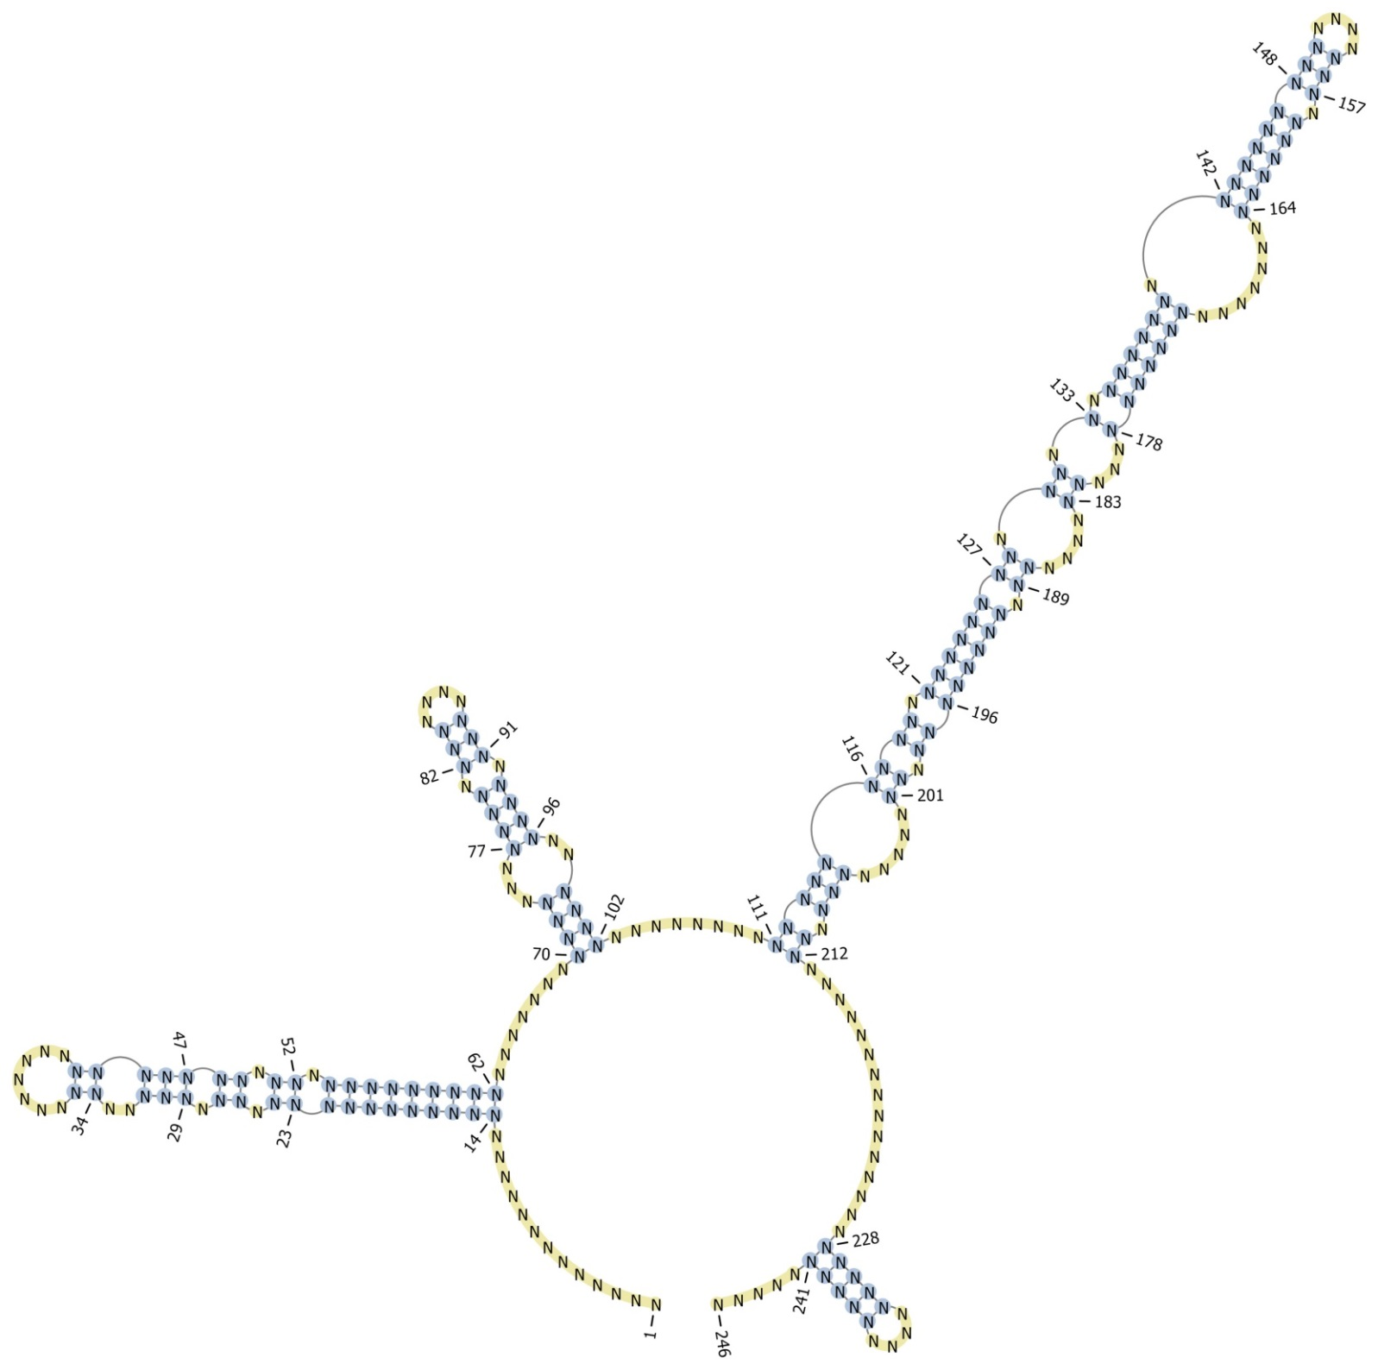
FIGURE S5. An example of ITS2 consensus secondary structure from Actinida. The blue and yellow shades indicate the paired and unpaired bases, respectively. Ns indicate one of the four Watson-Crick bases and the number indicates the base position.

Table S1. An example of the RNA16D model-parameter values from Acer, showing base pair changes, substitution rates and equilibrium frequency of each base
Base  pair | Elements of the rate matrix
Base  pair | GC | CG | AU | UA | GU | UG | CC | GG | AG | GA | AA | CU | UC | UU | AC | CA | Mutability | Frequency
GC | ------ | 0.0000 | 0.0000 | 0.0000 | 0.2234 | 0.0000 | 0.0513 | 0.0513 | 0.0000 | 0.0310 | 0.0000 | 0.0000 | 0.0285 | 0.0000 | 0.1185 | 0.0000 | 0.5040 | 0.2565
CG | 0.0000 | ------ | 0.0000 | 0.0000 | 0.0000 | 0.2234 | 0.0513 | 0.0513 | 0.0310 | 0.0000 | 0.0000 | 0.0285 | 0.0000 | 0.0000 | 0.0000 | 0.1185 | 0.5040 | 0.2565
AU | 0.0000 | 0.0000 | ------ | 0.0000 | 0.4022 | 0.0000 | 0.0000 | 0.0000 | 0.0513 | 0.0000 | 0.0310 | 0.0513 | 0.0000 | 0.0285 | 0.1963 | 0.0000 | 0.7606 | 0.0860
UA | 0.0000 | 0.0000 | 0.0000 | ------ | 0.0000 | 0.4022 | 0.0000 | 0.0000 | 0.0000 | 0.0513 | 0.0310 | 0.0000 | 0.0513 | 0.0285 | 0.0000 | 0.1963 | 0.7606 | 0.0860
GU | 0.8471 | 0.0000 | 0.5113 | 0.0000 | ------ | 0.0000 | 0.0000 | 0.0745 | 0.0000 | 0.0449 | 0.0000 | 0.0744 | 0.0000 | 0.0414 | 0.0000 | 0.0000 | 1.5936 | 0.0676
UG | 0.0000 | 0.8471 | 0.0000 | 0.5113 | 0.0000 | ------ | 0.0000 | 0.0745 | 0.0449 | 0.0000 | 0.0000 | 0.0000 | 0.0744 | 0.0414 | 0.0000 | 0.0000 | 1.5936 | 0.0676
CC | 0.4533 | 0.4533 | 0.0000 | 0.0000 | 0.0000 | 0.0000 | ------ | 0.0000 | 0.0000 | 0.0000 | 0.0000 | 0.3242 | 0.3242 | 0.0000 | 0.0920 | 0.0920 | 1.7390 | 0.0290
GG | 0.4532 | 0.4532 | 0.0000 | 0.0000 | 0.1735 | 0.1735 | 0.0000 | ------ | 0.3522 | 0.3522 | 0.0000 | 0.0000 | 0.0000 | 0.0000 | 0.0000 | 0.0000 | 1.9578 | 0.0290
AG | 0.0000 | 0.4532 | 0.2518 | 0.0000 | 0.0000 | 0.1735 | 0.0000 | 0.5838 | ------ | 0.0000 | 0.3522 | 0.0000 | 0.0000 | 0.0000 | 0.1525 | 0.0000 | 1.9670 | 0.0175
GA | 0.4532 | 0.0000 | 0.0000 | 0.2518 | 0.1735 | 0.0000 | 0.0000 | 0.5838 | 0.0000 | ------ | 0.3522 | 0.0000 | 0.0000 | 0.0000 | 0.0000 | 0.1525 | 1.9670 | 0.0175
AA | 0.0000 | 0.0000 | 0.2518 | 0.2518 | 0.0000 | 0.0000 | 0.0000 | 0.0000 | 0.5838 | 0.5838 | ------ | 0.0000 | 0.0000 | 0.0000 | 0.1525 | 0.1525 | 1.9762 | 0.0106
CU | 0.0000 | 0.4533 | 0.2735 | 0.0000 | 0.3123 | 0.0000 | 0.5836 | 0.0000 | 0.0000 | 0.0000 | 0.0000 | ------ | 0.0000 | 0.3242 | 0.0000 | 0.0920 | 2.0389 | 0.0161
UC | 0.4533 | 0.0000 | 0.0000 | 0.2735 | 0.0000 | 0.3123 | 0.5836 | 0.0000 | 0.0000 | 0.0000 | 0.0000 | 0.0000 | ------ | 0.3242 | 0.0920 | 0.0000 | 2.0389 | 0.0161
UU | 0.0000 | 0.0000 | 0.2735 | 0.2735 | 0.3123 | 0.3123 | 0.0000 | 0.0000 | 0.0000 | 0.0000 | 0.0000 | 0.5836 | 0.5836 | ------ | 0.0000 | 0.0000 | 2.3388 | 0.0090
AC | 1.7354 | 0.0000 | 0.9639 | 0.0000 | 0.0000 | 0.0000 | 0.1525 | 0.0000 | 0.1525 | 0.0000 | 0.0920 | 0.0000 | 0.0847 | 0.0000 | ------ | 0.0000 | 3.1810 | 0.0175
CA | 0.0000 | 1.7354 | 0.0000 | 0.9639 | 0.0000 | 0.0000 | 0.1525 | 0.0000 | 0.0000 | 0.1525 | 0.0920 | 0.0847 | 0.0000 | 0.0000 | 0.0000 | ------ | 3.1810 | 0.0175

Table S2. Comparison of substitution elements involving AC and GU intermediate base pairs in the best-fit double-substitution rate matrix of AU to GC compensatory substitutions
Matrix | Best fit model | GU elementsª |  |  |  |  |  |  |  | AC elements
Matrix | Best fit model | Frequency | Mutability | α(AU→GU) | β(GU→GC) | α*β | β/α |  | Frequency |  | Mutability | μ（AU→AC） | γ（AC→GC) | μ*γ | γ/μ
Acer | 16C | 0.0545 | 2.0823 | 0.2685 | 1.1664 | 0.3132 | 4.3441 |  | 0.0161 |  | 2.0305 | 0.0672 | 0.9893 | 0.0665 | 14.7217
Acorus | 16C | 0.0564 | 1.4273 | 0.1297 | 0.7831 | 0.1016 | 6.0378 |  | 0.0044 |  | 8.7943 | 0.0739 | 5.7296 | 0.4234 | 77.5318
Actaea | 16C | 0.0670 | 2.5823 | 0.3349 | 1.2798 | 0.4286 | 3.8214 |  | 0.0098 |  | 2.9140 | 0.0572 | 1.5022 | 0.0859 | 26.2622
Actinidia | 16C | 0.0809 | 1.9914 | 0.3924 | 0.9326 | 0.3660 | 2.3767 |  | 0.0101 |  | 2.2330 | 0.0607 | 1.1543 | 0.0701 | 19.0165
Ajania | 16C | 0.0418 | 1.3926 | 0.1427 | 0.6074 | 0.0867 | 4.2565 |  | 0.0034 |  | 6.2896 | 0.0643 | 3.3975 | 0.2185 | 52.8383
Allium | 16C | 0.1083 | 1.5252 | 0.5341 | 0.8736 | 0.4666 | 1.6356 |  | 0.0105 |  | 0.0895 | 0.0031 | 0.0529 | 0.0002 | 17.0645
Amomum | 16C | 0.1338 | 1.1848 | 0.4622 | 0.5183 | 0.2396 | 1.1214 |  | 0.0187 |  | 1.1311 | 0.0747 | 0.5994 | 0.0448 | 8.0241
Angelica | 16C | 0.0558 | 4.8572 | 0.5919 | 3.0691 | 1.8166 | 5.1852 |  | 0.0022 |  | 0.2641 | 0.0013 | 0.1673 | 0.0002 | 128.6923
Aquilaria | 16C | 0.0644 | 1.4251 | 0.1513 | 0.5689 | 0.0861 | 3.7601 |  | 0.0043 |  | 8.4426 | 0.0762 | 4.3137 | 0.3287 | 56.6102
Aralia | 16C | 0.0463 | 2.6126 | 0.2784 | 1.5974 | 0.4447 | 5.7378 |  | 0.0099 |  | 2.4917 | 0.0540 | 1.4405 | 0.0778 | 26.6759
Asarum | 16C | 0.1023 | 1.1220 | 0.0020 | 0.0051 | 0.0000 | 2.5500 |  | 0.0046 |  | 0.0001 | 0.0000 | 0.0001 | 0.0000 | None
Astilbe | 16C | 0.0380 | 2.6214 | 0.1931 | 1.6657 | 0.3216 | 8.6261 |  | 0.0070 |  | 4.0536 | 0.0586 | 2.7319 | 0.1601 | 46.6195
Astragalus | 16C | 0.0942 | 1.5949 | 0.4090 | 1.0231 | 0.4184 | 2.5015 |  | 0.0040 |  | 3.8332 | 0.0468 | 2.7815 | 0.1302 | 59.4338
Betula | 16C | 0.0740 | 2.4928 | 0.6004 | 1.5876 | 0.9532 | 2.6442 |  | 0.0020 |  | 4.7844 | 0.0327 | 3.1882 | 0.1043 | 97.4985
Buglossoides | 16C | 0.0831 | 0.8358 | 0.1429 | 0.2905 | 0.0415 | 2.0329 |  | 0.0083 |  | 3.4135 | 0.0895 | 1.8152 | 0.1625 | 20.2816
Bupleurum | 16C | 0.0881 | 2.6912 | 0.5897 | 1.7011 | 1.0031 | 2.8847 |  | 0.0031 |  | 0.2419 | 0.0020 | 0.1633 | 0.0003 | 81.6500
Calystegia | 16C | 0.0652 | 1.4094 | 0.2133 | 0.8632 | 0.1841 | 4.0469 |  | 0.0095 |  | 2.6372 | 0.0737 | 2.0418 | 0.1505 | 27.7042
Caragana | 16C | 0.0319 | 1.1009 | 0.0896 | 0.5731 | 0.0513 | 6.3962 |  | 0.0110 |  | 2.2153 | 0.0758 | 1.4031 | 0.1064 | 18.5106
Carex | 16C | 0.0862 | 1.9376 | 0.3508 | 1.3868 | 0.4865 | 3.9532 |  | 0.0056 |  | 4.7320 | 0.0549 | 3.3514 | 0.1840 | 61.0455
Celastrus | 16C | 0.0688 | 1.3604 | 0.1909 | 0.8220 | 0.1569 | 4.3059 |  | 0.0066 |  | 4.2131 | 0.0713 | 3.2190 | 0.2295 | 45.1473
Ceratophyllum | 16C | 0.0820 | 1.4470 | 0.3104 | 0.9674 | 0.3003 | 3.1166 |  | 0.0042 |  | 5.2007 | 0.0640 | 3.9073 | 0.2501 | 61.0516
Chaetanthera | 16C | 0.0913 | 1.5403 | 0.4058 | 1.1088 | 0.4500 | 2.7324 |  | 0.0105 |  | 2.1230 | 0.0378 | 0.9019 | 0.0341 | 23.8598
Chloranthus | 16A | 0.1045 | 1.0739 | 0.2911 | 0.5629 | 0.1639 | 1.9337 |  | 0.0436 |  | 2.8878 | 0.3730 | 1.7285 | 0.6447 | 4.6340
Circaea | 16C | 0.0617 | 1.3965 | 0.1600 | 0.7333 | 0.1173 | 4.5831 |  | 0.0029 |  | 9.9989 | 0.0760 | 7.5018 | 0.5701 | 98.7079
Citrus | 16A | 0.0746 | 1.3429 | 0.2549 | 0.9573 | 0.2440 | 3.7556 |  | 0.0194 |  | 2.4067 | 0.1430 | 2.0679 | 0.2957 | 14.4608
Cuscuta | 16C | 0.1489 | 0.8292 | 0.3293 | 0.3631 | 0.1196 | 1.1026 |  | 0.0197 |  | 2.2449 | 0.0596 | 0.4973 | 0.0296 | 8.3440
Dahlia | 16C | 0.1428 | 0.9135 | 0.3333 | 0.5328 | 0.1776 | 1.5986 |  | 0.0060 |  | 3.6706 | 0.0619 | 2.3585 | 0.1460 | 38.1018
Dendropanax | 16C | 0.0602 | 1.4972 | 0.1913 | 0.8274 | 0.1583 | 4.3251 |  | 0.0076 |  | 3.6742 | 0.0679 | 2.3217 | 0.1576 | 34.1929
Draba | 16C | 0.1196 | 1.4869 | 0.3442 | 0.8913 | 0.3068 | 2.5895 |  | 0.0058 |  | 4.6004 | 0.0599 | 3.2160 | 0.1926 | 53.6895
Dysosma | 16C | 0.0661 | 1.2679 | 0.2244 | 0.7221 | 0.1620 | 3.2179 |  | 0.0044 |  | 4.5446 | 0.0688 | 3.3371 | 0.2296 | 48.5044
Epimedium | 16A | 0.1042 | 1.3932 | 0.4321 | 0.8554 | 0.3696 | 1.9796 |  | 0.0028 |  | 1.1030 | 0.0102 | 0.7510 | 0.0077 | 73.6275
Erysimum | 16C | 0.0758 | 1.9446 | 0.2639 | 0.9559 | 0.2523 | 3.6222 |  | 0.0084 |  | 4.2768 | 0.0747 | 2.4434 | 0.1825 | 32.7095
Flaveria | 16C | 0.0975 | 1.1879 | 0.2644 | 0.4346 | 0.1149 | 1.6437 |  | 0.0074 |  | 2.9540 | 0.0608 | 1.3091 | 0.0796 | 21.5313
Fraxinus | 16C | 0.0535 | 1.1732 | 0.0004 | 0.0021 | 0.0000 | 5.2500 |  | 0.0011 |  | 0.0001 | 0.0000 | 0.0001 | 0.0000 | None
Garrya | 16C | 0.0428 | 4.6652 | 0.4969 | 3.6392 | 1.8083 | 7.3238 |  | 0.0004 |  | 6.5363 | 0.0059 | 5.2616 | 0.0310 | 891.7966
Goodyera | 16C | 0.0895 | 1.1878 | 0.2618 | 0.3989 | 0.1044 | 1.5237 |  | 0.0056 |  | 4.3429 | 0.0688 | 1.6673 | 0.1147 | 24.2340
Gossypium | 16C | 0.0297 | 1.3946 | 0.0882 | 0.7941 | 0.0700 | 9.0034 |  | 0.0035 |  | 7.0412 | 0.0664 | 5.0413 | 0.3347 | 75.9232
Habenaria | 16C | 0.1343 | 1.1116 | 0.3562 | 0.2756 | 0.0982 | 0.7737 |  | 0.0053 |  | 3.7570 | 0.0583 | 1.1343 | 0.0661 | 19.4563
Hemsleya | 16A | 0.0158 | 3.6021 | 0.1281 | 2.5106 | 0.3216 | 19.5988 |  | 0.0019 |  | 4.4533 | 0.0216 | 3.4499 | 0.0745 | 159.7176
Holcoglossum | 16C | 0.0447 | 1.3002 | 0.1361 | 0.7402 | 0.1007 | 5.4386 |  | 0.0055 |  | 4.1567 | 0.0670 | 2.9817 | 0.1998 | 44.5030
Hypericum | 16C | 0.0398 | 1.4102 | 0.1259 | 0.6912 | 0.0870 | 5.4901 |  | 0.0149 |  | 2.4862 | 0.0725 | 1.0607 | 0.0769 | 14.6303
Kadsura | 16A | 0.1050 | 0.9136 | 0.4183 | 0.6733 | 0.2816 | 1.6096 |  | 0.0412 |  | 1.3039 | 0.2342 | 0.9613 | 0.2251 | 4.1046
Ligustrum | 16C | 0.0841 | 1.5828 | 0.3205 | 0.7441 | 0.2385 | 2.3217 |  | 0.0016 |  | 9.5327 | 0.0394 | 4.9497 | 0.1950 | 125.6269
Lithospermum | 16C | 0.0971 | 1.2229 | 0.2726 | 0.6843 | 0.1865 | 2.5103 |  | 0.0044 |  | 4.9581 | 0.0587 | 3.2602 | 0.1914 | 55.5400
Malus | 16A | 0.0473 | 1.3046 | 0.1535 | 0.7053 | 0.1083 | 4.5948 |  | 0.0277 |  | 2.8169 | 0.1446 | 1.1353 | 0.1642 | 7.8513
Meconopsis | 16C | 0.1050 | 1.0012 | 0.3056 | 0.4434 | 0.1355 | 1.4509 |  | 0.0210 |  | 1.2960 | 0.0729 | 0.5289 | 0.0386 | 7.2551
Melampodium | 16A | 0.0858 | 1.3346 | 0.2606 | 0.6234 | 0.1625 | 2.3922 |  | 0.0141 |  | 2.2760 | 0.0681 | 0.9943 | 0.0677 | 14.6006
Meliosma | 16A | 0.0563 | 1.8782 | 0.2317 | 0.9512 | 0.2204 | 4.1053 |  | 0.0199 |  | 3.8506 | 0.1628 | 1.8930 | 0.3082 | 11.6278
Morus | 16C | 0.0546 | 0.8102 | 0.1020 | 0.2438 | 0.0249 | 2.3902 |  | 0.0072 |  | 3.0895 | 0.0820 | 1.4925 | 0.1224 | 18.2012
Myricaria | 16C | 0.1123 | 1.1827 | 0.2963 | 0.4803 | 0.1423 | 1.6210 |  | 0.0074 |  | 3.4404 | 0.0737 | 1.8009 | 0.1327 | 24.4355
Nepenthes | 16C | 0.0913 | 1.4117 | 0.3203 | 0.8233 | 0.2637 | 2.5704 |  | 0.0148 |  | 1.9381 | 0.0748 | 1.1840 | 0.0886 | 15.8289
Nymphaea | 16C | 0.0979 | 1.5318 | 0.3288 | 0.9204 | 0.3026 | 2.7993 |  | 0.0099 |  | 2.6587 | 0.0534 | 1.4853 | 0.0793 | 27.8146
Oreocharis | 16A | 0.0840 | 0.9270 | 0.1455 | 0.2387 | 0.0347 | 1.6405 |  | 0.0175 |  | 1.8153 | 0.1127 | 0.8877 | 0.1000 | 7.8767
Paeonia | 16C | 0.0531 | 1.3655 | 0.1929 | 0.5023 | 0.0969 | 2.6039 |  | 0.0085 |  | 2.8443 | 0.0735 | 1.1982 | 0.0881 | 16.3020
Panax | 16C | 0.1020 | 0.7129 | 0.1425 | 0.2815 | 0.0401 | 1.9754 |  | 0.0123 |  | 4.5222 | 0.0643 | 1.0523 | 0.0677 | 16.3655
Paphiopedilum | 16C | 0.0846 | 3.5009 | 0.6771 | 1.8713 | 1.2671 | 2.7637 |  | 0.0025 |  | 0.3389 | 0.0020 | 0.1822 | 0.0004 | 91.1000
Paris | 16C | 0.1305 | 1.0366 | 0.3111 | 0.5396 | 0.1679 | 1.7345 |  | 0.0060 |  | 4.4309 | 0.0575 | 2.1828 | 0.1255 | 37.9617
Parnassia | 16C | 0.0963 | 1.3980 | 0.3175 | 0.6592 | 0.2093 | 2.0762 |  | 0.0170 |  | 2.0120 | 0.0662 | 0.7772 | 0.0515 | 11.7402
Persicaria | 16A | 0.0371 | 2.1903 | 0.2229 | 1.5453 | 0.3444 | 6.9327 |  | 0.0280 |  | 1.8081 | 0.1151 | 1.0553 | 0.1215 | 9.1685
Peucedanum | 16C | 0.0845 | 1.5421 | 0.3269 | 0.7052 | 0.2305 | 2.1572 |  | 0.0119 |  | 2.9812 | 0.0587 | 0.9020 | 0.0529 | 15.3663
Pinellia | 16A | 0.0565 | 2.7948 | 0.4056 | 2.2109 | 0.8967 | 5.4509 |  | 0.0191 |  | 3.3874 | 0.1091 | 1.7617 | 0.1922 | 16.1476
Plantago | 16C | 0.0750 | 1.5818 | 0.3143 | 0.8684 | 0.2729 | 2.7630 |  | 0.0134 |  | 1.6024 | 0.0598 | 0.9211 | 0.0551 | 15.4030
Potentilla | 16C | 0.0635 | 2.1102 | 0.3665 | 1.4327 | 0.5251 | 3.9091 |  | 0.0032 |  | 0.1433 | 0.0013 | 0.0981 | 0.0001 | 75.4615
Pulmonaria | 16C | 0.0754 | 0.7426 | 0.1005 | 0.2350 | 0.0236 | 2.3383 |  | 0.0055 |  | 4.6643 | 0.0852 | 2.7374 | 0.2332 | 32.1291
Rhodiola | 16C | 0.0851 | 0.9156 | 0.0082 | 0.0282 | 0.0002 | 3.4390 |  | 0.0022 |  | 0.0025 | 0.0000 | 0.0015 | 0.0000 | None
Rhododendron | 16C | 0.1062 | 1.5447 | 0.3822 | 0.6270 | 0.2396 | 1.6405 |  | 0.0031 |  | 6.7786 | 0.0590 | 3.2763 | 0.1933 | 55.5305
Sagittaria | 16C | 0.1734 | 1.0135 | 0.6112 | 0.5224 | 0.3193 | 0.8547 |  | 0.0055 |  | 1.4560 | 0.0331 | 0.8912 | 0.0295 | 26.9245
Senecio | 16A | 0.1037 | 0.9350 | 0.3471 | 0.4798 | 0.1665 | 1.3823 |  | 0.0316 |  | 1.0136 | 0.1058 | 0.4808 | 0.0509 | 4.5444
Sinosenecio | 16A | 0.0881 | 1.0281 | 0.2674 | 0.4473 | 0.1196 | 1.6728 |  | 0.0262 |  | 1.9944 | 0.1520 | 0.8568 | 0.1302 | 5.6368
Solanum | 16A | 0.0282 | 2.2032 | 0.1538 | 1.5240 | 0.2344 | 9.9090 |  | 0.0543 |  | 1.7102 | 0.2220 | 1.1417 | 0.2535 | 5.1428
Stachyurus | 16C | 0.0748 | 1.6186 | 0.2646 | 1.0655 | 0.2819 | 4.0268 |  | 0.0184 |  | 1.9471 | 0.0891 | 1.4566 | 0.1298 | 16.3479
Staphylea | 16C | 0.0418 | 2.8928 | 0.2634 | 1.7300 | 0.4557 | 6.5680 |  | 0.0070 |  | 3.8748 | 0.0623 | 2.4363 | 0.1518 | 39.1059
Stewartia | 16C | 0.0612 | 1.6471 | 0.2060 | 0.8888 | 0.1831 | 4.3146 |  | 0.0041 |  | 6.2753 | 0.0614 | 3.9847 | 0.2447 | 64.8974
Swertia | 16A | 0.0991 | 1.2406 | 0.2965 | 0.8143 | 0.2414 | 2.7464 |  | 0.0205 |  | 2.3887 | 0.1260 | 1.6732 | 0.2108 | 13.2794
Symphytum | 16A | 0.0920 | 1.8497 | 0.3387 | 0.6536 | 0.2214 | 1.9297 |  | 0.0008 |  | 3.8031 | 0.0072 | 1.5490 | 0.0112 | 215.1389
Tripterospermum | 16C | 0.0761 | 1.1996 | 0.1907 | 0.5291 | 0.1009 | 2.7745 |  | 0.0032 |  | 8.4288 | 0.0708 | 4.7370 | 0.3354 | 66.9068
Urtica | 16C | 0.0682 | 3.1169 | 0.5063 | 2.4763 | 1.2538 | 4.8910 |  | 0.0049 |  | 0.2494 | 0.0031 | 0.2116 | 0.0007 | 68.2581
Viburnum | 16A | 0.0366 | 1.0982 | 0.0004 | 0.0030 | 0.0000 | 7.5000 |  | 0.0101 |  | 0.0003 | 0.0000 | 0.0002 | 0.0000 | None
Vicia | 16A | 0.1031 | 2.3825 | 0.6815 | 1.4340 | 0.9773 | 2.1042 |  | 0.0005 |  | 0.1085 | 0.0001 | 0.0656 | 0.0000 | 656.0000
Zelkova | 16A | 0.0499 | 0.9391 | 0.1028 | 0.6277 | 0.0645 | 6.1060 |  | 0.0469 |  | 1.9665 | 0.1874 | 1.2172 | 0.2281 | 6.4952
Average |  | 0.0786±0.0302 | 1.6389±0.8052 | 0.2828±0.1530 | 0.9064±0.6549 | 0.3066±0.3576 | 3.6924±2.6677 |  | 0.0111±0.0108 |  | 3.2122±2.2888 | 0.0701±0.0581 | 1.8800±1.5244 | 0.1367±0.1233 | 56.6390±123.1190

ª α and β represent the substitution rate between AU (UA) and GU (UG) and GU (UG) and GC (CG), respectively, in GU (UG)-mediated compensatory base changes (CBCs). α*β represents total probabilities of GU-mediated CBCs between AU and GC, β/α represents the degree of rate variation between the single substitutions. Likewise, μ and γ represent the substitution rate between AU (UA) and AC (CA) and between AC (CA) and GC (CG), respectively, in the AC (CA)-mediated CBCs. μ*γ represents the total probability for CBCs between AU (UA) and GC (CG), whereas γ/μ represents the degree of rate variation between the single substitutions. The lineages highlighted in bold and underlined font have extreme minimum and maximum values, respectively, and are not included in Fig.1C.

Table S3. The CBC-base-pair distribution among the 65 lineages with inferred CBCs
Matrix | # of sampled species | # of stem characters | # of characters including two CBC states |  |  | # of positions also including AC or CA |  |  | # of positions also including GU or UG |  |  | # of positions also including both AC or CA and GU or UG
Matrix | # of sampled species | # of stem characters | AU-GC  or  UA-CG | AU-GC  and  UA-CG |  | AU-AC-GC or UA-CA-CG | AU-AC-GC and UA-CA-CG |  | AU-GU-GC or UA-UG-CG | AU-GU-GC and UA-UG-CG |  | # of positions also including both AC or CA and GU or UG
Acer | 117 | 66 | 8 | 0 |  | 1 | 0 |  | 4 | 0 |  | 3
Acorus | 7 | 72 | 1 | 0 |  | 0 | 0 |  | 0 | 0 |  | 0
Actaea | 21 | 63 | 2 | 0 |  | 0 | 0 |  | 2 | 0 |  | 0
Actinidia | 40 | 69 | 12 | 0 |  | 0 | 0 |  | 7 | 0 |  | 4
Ajania | 29 | 70 | 1 | 0 |  | 0 | 0 |  | 1 | 0 |  | 0
Allium | 405 | 55 | 29 | 1 |  | 0 | 0 |  | 9 | 0 |  | 20
Amomum | 73 | 70 | 12 | 0 |  | 0 | 0 |  | 6 | 0 |  | 6
Angelica | 67 | 63 | 8 | 0 |  | 0 | 0 |  | 4 | 0 |  | 2
Aralia | 43 | 73 | 5 | 0 |  | 0 | 0 |  | 3 | 0 |  | 1
Asarum | 93 | 73 | 2 | 0 |  | 0 | 0 |  | 1 | 0 |  | 1
Astilbe | 14 | 78 | 5 | 0 |  | 2 | 0 |  | 2 | 0 |  | 1
Astragalus | 37 | 74 | 5 | 0 |  | 0 | 0 |  | 4 | 0 |  | 1
Betula | 60 | 70 | 1 | 0 |  | 0 | 0 |  | 1 | 0 |  | 0
Bupleurum | 79 | 68 | 4 | 0 |  | 1 | 0 |  | 2 | 0 |  | 0
Caragana | 68 | 72 | 3 | 0 |  | 0 | 0 |  | 2 | 0 |  | 0
Celastrus | 30 | 65 | 7 | 0 |  | 1 | 0 |  | 1 | 0 |  | 2
Ceratophyllum | 6 | 85 | 2 | 0 |  | 0 | 0 |  | 2 | 0 |  | 0
Chaetanthera | 45 | 64 | 16 | 1 |  | 1 | 0 |  | 12 | 0 |  | 4
Circaea | 9 | 56 | 1 | 0 |  | 1 | 0 |  | 0 | 0 |  | 0
Citrus | 48 | 72 | 3 | 0 |  | 1 | 0 |  | 1 | 0 |  | 1
Cuscuta | 49 | 60 | 9 | 0 |  | 1 | 0 |  | 5 | 0 |  | 2
Dendropanax | 30 | 72 | 2 | 0 |  | 1 | 0 |  | 1 | 0 |  | 0
Erysimum | 139 | 60 | 1 | 0 |  | 0 | 0 |  | 1 | 0 |  | 0
Flaveria | 20 | 77 | 2 | 0 |  | 0 | 0 |  | 2 | 0 |  | 0
Fraxinus | 41 | 58 | 3 | 0 |  | 0 | 0 |  | 2 | 0 |  | 1
Goodyera | 36 | 81 | 6 | 0 |  | 0 | 0 |  | 4 | 0 |  | 2
Gossypium | 44 | 68 | 2 | 0 |  | 1 | 0 |  | 1 | 0 |  | 0
Habenaria | 87 | 79 | 1 | 0 |  | 0 | 0 |  | 0 | 0 |  | 0
Hypericum | 79 | 68 | 14 | 0 |  | 3 | 0 |  | 6 | 0 |  | 5
Ligustrum | 6 | 71 | 2 | 0 |  | 0 | 0 |  | 0 | 0 |  | 0
Lithospermum | 33 | 67 | 1 | 0 |  | 0 | 0 |  | 1 | 0 |  | 0
Malus | 34 | 66 | 7 | 0 |  | 3 | 0 |  | 2 | 0 |  | 2
Meconopsis | 39 | 68 | 14 | 0 |  | 1 | 0 |  | 8 | 0 |  | 5
Melampodium | 41 | 71 | 14 | 0 |  | 0 | 0 |  | 9 | 0 |  | 5
Meliosma | 55 | 70 | 4 | 0 |  | 0 | 0 |  | 2 | 0 |  | 0
Morus | 21 | 75 | 1 | 0 |  | 0 | 0 |  | 1 | 0 |  | 0
Nepenthes | 91 | 70 | 15 | 0 |  | 2 | 0 |  | 7 | 0 |  | 6
Nymphaea | 36 | 68 | 9 | 0 |  | 0 | 0 |  | 7 | 0 |  | 1
Oreocharis | 36 | 67 | 3 | 0 |  | 0 | 0 |  | 2 | 0 |  | 0
Paeonia | 32 | 73 | 4 | 0 |  | 1 | 0 |  | 3 | 0 |  | 0
Panax | 16 | 73 | 3 | 0 |  | 0 | 0 |  | 3 | 0 |  | 0
Paphiopedilum | 94 | 92 | 3 | 0 |  | 0 | 0 |  | 3 | 0 |  | 0
Paris | 24 | 71 | 3 | 0 |  | 0 | 0 |  | 3 | 0 |  | 0
Parnassia | 30 | 66 | 8 | 0 |  | 0 | 0 |  | 6 | 0 |  | 2
Persicaria | 43 | 78 | 6 | 0 |  | 0 | 0 |  | 4 | 0 |  | 2
Peucedanum | 68 | 62 | 6 | 0 |  | 0 | 0 |  | 6 | 0 |  | 0
Pinellia | 8 | 87 | 5 | 0 |  | 1 | 0 |  | 1 | 0 |  | 1
Plantago | 70 | 57 | 7 | 0 |  | 0 | 0 |  | 3 | 0 |  | 3
Potentilla | 201 | 68 | 11 | 0 |  | 1 | 0 |  | 3 | 0 |  | 6
Pulmonaria | 9 | 75 | 1 | 0 |  | 0 | 0 |  | 1 | 0 |  | 0
Rhodiola | 66 | 67 | 5 | 0 |  | 0 | 0 |  | 1 | 0 |  | 2
Rhododendron | 73 | 68 | 1 | 0 |  | 0 | 0 |  | 1 | 0 |  | 0
Sagittaria | 5 | 76 | 4 | 0 |  | 0 | 0 |  | 1 | 0 |  | 0
Senecio | 89 | 72 | 7 | 0 |  | 0 | 0 |  | 3 | 0 |  | 3
Sinosenecio | 41 | 69 | 5 | 0 |  | 0 | 0 |  | 4 | 0 |  | 1
Solanum | 34 | 63 | 5 | 0 |  | 1 | 0 |  | 3 | 0 |  | 1
Stachyurus | 11 | 77 | 1 | 0 |  | 1 | 0 |  | 0 | 0 |  | 0
Staphylea | 10 | 69 | 8 | 0 |  | 1 | 0 |  | 3 | 0 |  | 0
Stewartia | 20 | 69 | 1 | 0 |  | 0 | 0 |  | 1 | 0 |  | 0
Swertia | 50 | 69 | 6 | 0 |  | 0 | 0 |  | 2 | 0 |  | 3
Symphytum | 27 | 66 | 1 | 0 |  | 0 | 0 |  | 1 | 0 |  | 0
Urtica | 70 | 63 | 5 | 0 |  | 0 | 0 |  | 4 | 0 |  | 1
Viburnum | 104 | 80 | 3 | 0 |  | 0 | 0 |  | 0 | 0 |  | 1
Vicia | 149 | 69 | 2 | 0 |  | 0 | 0 |  | 2 | 0 |  | 0
Zelkova | 6 | 65 | 3 | 0 |  | 0 | 0 |  | 2 | 0 |  | 0
Sum | 3558 | 4538 | 351 | 2 |  | 26 | 0 |  | 189 | 0 |  | 101

Table S4. The distribution of hemi-CBCs base pairs among the 15 lineages for which no CBCs were inferred
Matrix | # of sampled species | # of stem characters | # of positions including AC or CA |  |  | # of positions including GU or UG |  |  | # of positions including both AC or CA and GU or UG
Matrix | # of sampled species | # of stem characters | Only AC-AU or AC-GC or CA-UA or CA-CG | Both AC-AU or AC-GC and CA-UA or CA-CG |  | Only GU-AU or GU-GC or UG-UA or UG-CG | Both GU-AU or GU-GC and UG-UA or UG-CG |  | # of positions including both AC or CA and GU or UG
Aquilaria | 12 | 78 | 3 | 0 |  | 3 | 0 |  | 1
Buglossoides | 6 | 71 | 5 | 0 |  | 7 | 0 |  | 0
Calystegia | 19 | 66 | 2 | 0 |  | 10 | 0 |  | 0
Carex | 79 | 74 | 4 | 0 |  | 18 | 0 |  | 1
Chloranthus | 11 | 65 | 8 | 0 |  | 9 | 0 |  | 0
Dahlia | 32 | 75 | 5 | 0 |  | 18 | 0 |  | 0
Draba | 55 | 61 | 8 | 0 |  | 12 | 0 |  | 0
Dysosma | 7 | 76 | 5 | 0 |  | 11 | 0 |  | 1
Epimedium | 60 | 76 | 3 | 0 |  | 12 | 0 |  | 1
Garrya | 11 | 68 | 0 | 0 |  | 5 | 0 |  | 0
Hemsleya | 24 | 74 | 3 | 0 |  | 4 | 0 |  | 0
Holcoglossum | 17 | 91 | 2 | 0 |  | 7 | 0 |  | 0
Kadsura | 12 | 61 | 4 | 0 |  | 5 | 0 |  | 0
Myricaria | 11 | 80 | 4 | 0 |  | 7 | 0 |  | 0
Tripterospermum | 20 | 74 | 4 | 0 |  | 10 | 0 |  | 0
Sum | 376 | 1090 | 60 | 0 |  | 138 | 0 |  | 4

Table S5. Comparison of CBC-base-pair distribution between three lineages aligned separately by LocARNA and 4SALE
Matrix | # of sampled species | # of stem characters | # of characters including two CBC states |  |  | # of positions also including AC or CA |  |  | # of positions also including GU or UG |  |  | # of positions also including both AC or CA and GU or UG
Matrix | # of sampled species | # of stem characters | AU-GC  or  UA-CG | AU-GC  and  UA-CG |  | AU-AC-GC or UA-CA-CG | AU-AC-GC and UA-CA-CG |  | AU-GU-GC or UA-UG-CG | AU-GU-GC and UA-UG-CG |  | # of positions also including both AC or CA and GU or UG
LocARNAª
Hypericum | 79 | 68 | 14 | 0 |  | 3 | 0 |  | 6 | 0 |  | 5
Nepenthes | 91 | 70 | 15 | 0 |  | 2 | 0 |  | 7 | 0 |  | 6
Potentilla | 201 | 68 | 11 | 0 |  | 1 | 0 |  | 3 | 0 |  | 6
Sum | 371 | 206 | 40 | 0 |  | 6 | 0 |  | 16 | 0 |  | 17
4SALEª
Hypericum | 79 | 67 | 14 | 0 |  | 4 | 0 |  | 6 | 0 |  | 2
Nepenthes | 91 | 54 | 10 | 0 |  | 0 | 0 |  | 8 | 0 |  | 2
Potentilla | 201 | 66 | 10 | 0 |  | 0 | 0 |  | 2 | 0 |  | 7
Sum | 371 | 187 | 34 | 0 |  | 4 | 0 |  | 16 | 0 |  | 11

ª The results from 4SALE are underlined.

Table S6. Comparison of AC base pair frequency and substitution rates from AC to other six base pairs between LocARNA- and
4SALE-alignments in each test genus
Matrix ª | AC frequency | r(AC→GC) | r(AC→AU) | r(AC→AA) | r(AC→AG) | r(AC→CC) | r(AC→UC)
Hypericum | 0.0149 | 1.0607 | 0.6551 | 0.1926 | 0.1926 | 0.1926 | 0.1926
Hypericum | 0.0176 | 1.0433 | 0.3832 | 0.1234 | 0.1234 | 0.1234 | 0.1234
Nepenthes | 0.0148 | 1.1840 | 0.4145 | 0.0849 | 0.0849 | 0.0849 | 0.0849
Nepenthes | 0.0133 | 1.3910 | 0.3863 | 0.0199 | 0.0199 | 0.0199 | 0.0199
Potentilla | 0.0032 | 0.0981 | 0.0448 | 0.0001 | 0.0001 | 0.0001 | 0.0001
Potentilla | 0.0020 | 0.0571 | 0.0292 | 0.0000 | 0.0000 | 0.0000 | 0.0000

ª The results from 4SALE are underlined.

Table S7. Comparison of average substitution elements between LocARNA- and 4SALE-alignments for three test lineages in each of eight possible compensatory substitutions
Pathwayª | Frequency of intermediate base-pair | Mutability of intermediate base-pair | Rate from WC base-pair to intermediate base-pair | Rate from intermediate base-pair to another WC pair | Overall rate | Rate ratio
AU→AC→GC | 0.0110 | 1.5225 | 0.0495 (μ₁) | 0.7809 (γ₁) | 0.0552 (μ₁*γ₁) | 35.3069 (γ₁/μ₁)
AU→AC→GC | 0.0110 | 1.2878 | 0.0492 (μ₁) | 0.8305 (γ₁) | 0.0592 (μ₁*γ₁) | 49.2256 (γ₁/μ₁)
AU→GU→GC | 0.0649 | 1.6440 | 0.2709 (α₁) | 0.9824 (β₁) | 0.2919 (α₁*β₁) | 3.9899 (β₁/α₁)
AU→GU→GC | 0.0680 | 1.4779 | 0.2636 (α₁) | 0.8996 (β₁) | 0.2655 (α₁*β₁) | 4.2891 (β₁/α₁)
UA→CA→CG | 0.0110 | 1.6798 | 0.0495 (μ₂) | 0.8623 (γ₂) | 0.0598 (μ₂*γ₂) | 51.8206 (γ₂/μ₂)
UA→CA→CG | 0.0110 | 1.3382 | 0.0492 (μ₂) | 0.8635 (γ₂) | 0.0603 (μ₂*γ₂) | 77.9359 (γ₂/μ₂)
UA→UG→CG | 0.0719 | 1.9559 | 0.2946 (α₂) | 1.3221 (β₂) | 0.4416 (α₂*β₂) | 4.4550 (β₂/α₂)
UA→UG→CG | 0.0937 | 1.7157 | 0.3312 (α₂) | 1.2103 (β₂) | 0.4294 (α₂*β₂) | 3.4795 (β₂/α₂)
GC→AC→AU | 0.0110 | 1.5225 | 0.0495 (μ₃) | 0.3715 (γ₃) | 0.0262 (μ₃*γ₃) | 16.3463 (γ₃/μ₃)
GC→AC→AU | 0.0110 | 1.2878 | 0.0492 (μ₃) | 0.2662 (γ₃) | 0.0189 (μ₃*γ₃) | 22.9651 (γ₃/μ₃)
GC→GU→AU | 0.0649 | 1.6440 | 0.2709 (α₃) | 0.4563 (β₃) | 0.1285 (α₃*β₃) | 2.0247 (β₃/α₃)
GC→GU→AU | 0.0680 | 1.4779 | 0.2636 (α₃) | 0.3619 (β₃) | 0.1119 (α₃*β₃) | 1.6393 (β₃/α₃)
CG→CA→UA | 0.0110 | 1.6798 | 0.0495 (μ₄) | 0.4473 (γ₄) | 0.0323 (μ₄*γ₄) | 13.0514 (γ₄/μ₄)
CG→CA→UA | 0.0110 | 1.3382 | 0.0492 (μ₄) | 0.2836 (γ₄) | 0.0209 (μ₄*γ₄) | 15.6255 (γ₄/μ₄)
CG→UG→UA | 0.0719 | 1.9559 | 0.2946 (α₄) | 0.4300 (β₄) | 0.1245 (α₄*β₄) | 1.6772 (β₄/α₄)
CG→UG→UA | 0.0937 | 1.7157 | 0.3312 (α₄) | 0.2934 (β₄) | 0.0999 (α₄*β₄) | 0.8784 (β₄/α₄)
Average | 0.0110 (AC/CA) | 1.6012 (AC/CA) | 0.0495 (μ) | 0.6155 (γ) | 0.0434 (μ*γ) | 29.1313 (γ/μ)
Average | 0.0110 (AC/CA) | 1.3130(AC/CA) | 0.0492 (μ) | 0.5610 (γ) | 0.0398 (μ*γ) | 41.4380 (γ/μ)
Average | 0.0684(GU/UG) | 1.8595 (GU/UG) | 0.2828 (α) | 0.7977 (β) | 0.2467 (α*β) | 3.0369 (β/α)
 | 0.0809(GU/UG) | 1.5969(GU/UG) | 0.2974 (α) | 0.6913 (β) | 0.2267 (α*β) | 2.5716 (β/α)
ª The eight possible pathways can be divided into four groups based on the same Watson-Crick (WC) pair-changes through different intermediate base pairs. The results are averaged across three test lineages Hypericum, Nepenthes and Potentilla, for which the greatest potential number of AC-mediated CBCs were inferred based on the LocARNA alignments. The comparative results from 4SALE are underlined. The substitution elements of each group are marked by the different subscript numbers used in Fig.1.

Table S8. Taxonomy and number of species and sequences sampled for the 80 studied lineages
Order | Family | Genus | # of species | # of sequence
Acorales | Acoraceae | Acorus | 7 | 20
Alismatales | Alismataceae | Sagittaria | 5 | 17
Alismatales | Araceae | Pinellia | 8 | 120
Apiales | Apiaceae | Angelica | 67 | 517
Apiales | Apiaceae | Bupleurum | 79 | 519
Apiales | Apiaceae | Peucedanum | 68 | 240
Apiales | Araliaceae | Aralia | 43 | 117
Apiales | Araliaceae | Dendropanax | 30 | 52
Apiales | Araliaceae | Panax | 16 | 434
Asparagales | Amaryllidaceae | Allium | 405 | 718
Asparagales | Orchidaceae | Goodyera | 36 | 197
Asparagales | Orchidaceae | Habenaria | 87 | 120
Asparagales | Orchidaceae | Holcoglossum | 17 | 104
Asparagales | Orchidaceae | Paphiopedilum | 94 | 430
Asterales | Asteraceae | Ajania | 29 | 64
Asterales | Asteraceae | Chaetanthera | 45 | 82
Asterales | Asteraceae | Dahlia | 32 | 47
Asterales | Asteraceae | Flaveria | 20 | 67
Asterales | Asteraceae | Melampodium | 41 | 83
Asterales | Asteraceae | Senecio | 89 | 123
Asterales | Asteraceae | Sinosenecio | 41 | 189
Austrobaileyales | Schisandraceae | Kadsura | 12 | 128
Boraginales | Boraginaceae | Buglossoides | 6 | 33
Boraginales | Boraginaceae | Lithospermum | 33 | 62
Boraginales | Boraginaceae | Pulmonaria | 9 | 227
Boraginales | Boraginaceae | Symphytum | 27 | 37
Brassicales | Brassicaceae | Draba | 55 | 122
Brassicales | Brassicaceae | Erysimum | 139 | 269
Caryophyllales | Nepenthaceae | Nepenthes | 91 | 183
Caryophyllales | Tamaricaceae | Myricaria | 11 | 25
Caryophyllales | Polygonaceae | Persicaria | 43 | 63
Celastrales | Celastraceae | Celastrus | 30 | 115
Celastrales | Celastraceae | Parnassia | 30 | 91
Ceratophyllales | Ceratophyllaceae | Ceratophyllum | 6 | 40
Chloranthales | Chloranthaceae | Chloranthus | 11 | 28
Crossosomatales | Stachyuraceae | Stachyurus | 11 | 34
Crossosomatales | Staphyleaceae | Staphylea | 10 | 92
Cucurbitales | Cucurbitaceae | Hemsleya | 24 | 117
Dipsacales | Adoxaceae | Viburnum | 104 | 220
Ericales | Actinidiaceae | Actinidia | 40 | 182
Ericales | Ericaceae | Rhododendron | 73 | 126
Ericales | Theaceae | Stewartia | 20 | 114
Fabales | Fabaceae | Astragalus | 37 | 93
Fabales | Leguminosae | Caragana | 68 | 173
Fabales | Leguminosae | Vicia | 149 | 643
Fagales | Betulaceae | Betula | 60 | 261
Garryales | Garryaceae | Garrya | 11 | 23
Garryales | Garryaceae | Gossypium | 44 | 280
Gentianales | Gentianaceae | Swertia | 50 | 64
Gentianales | Gentianaceae | Tripterospermum | 20 | 24
Lamiales | Gesneriaceae | Oreocharis | 36 | 59
Lamiales | Oleaceae | Fraxinus | 41 | 265
Lamiales | Oleaceae | Ligustrum | 6 | 19
Lamiales | Plantaginaceae | Plantago | 70 | 123
Liliales | Melanthiaceae | Paris | 24 | 171
Malpighiales | Hypericaceae | Hypericum | 79 | 103
Malvales | Thymelaeaceae | Aquilaria | 12 | 200
Myrtales | Onagraceae | Circaea | 9 | 65
Nymphaeales | Nymphaeaceae | Nymphaea | 36 | 184
Piperales | Aristolochiaceae | Asarum | 93 | 392
Poales | Cyperaceae | Carex | 79 | 106
Proteales | Sabiaceae | Meliosma | 55 | 85
Ranunculales | Berberidaceae | Dysosma | 7 | 21
Ranunculales | Berberidaceae | Epimedium | 60 | 221
Ranunculales | Papaveraceae | Meconopsis | 39 | 114
Ranunculales | Ranunculaceae | Actaea | 21 | 112
Rosales | Moraceae | Morus | 21 | 220
Rosales | Rosaceae | Malus | 34 | 382
Rosales | Rosaceae | Potentilla | 201 | 480
Rosales | Ulmaceae | Zelkova | 6 | 81
Rosales | Urticaceae | Urtica | 70 | 248
Sapindales | Rutaceae | Citrus | 48 | 334
Sapindales | Sapindaceae | Acer | 117 | 264
Saxifragales | Crassulaceae | Rhodiola | 66 | 671
Saxifragales | Paeoniaceae | Paeonia | 32 | 129
Saxifragales | Saxifragaceae | Astilbe | 14 | 52
Solanales | Convolvulaceae | Calystegia | 19 | 54
Solanales | Convolvulaceae | Cuscuta | 49 | 135
Solanales | Solanaceae | Solanum | 34 | 71
Zingiberales | Zingiberaceae | Amomum | 73 | 251
Sum | 55 | 80 | 3934 | 13741

