Supplementary Material

Basics of small-angle x-ray scattering (SAXS) experiments
Figure S1 shows a schematic of a basic SAXS experiment.
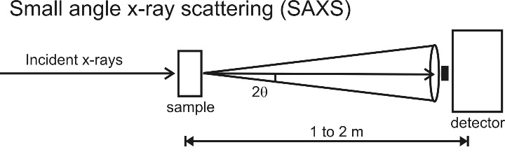
Figure S1. Conceptual representation of SAXS experiments.
In SAXS, incident x-rays encounter a liquid sample contained within a sample cell. The main beam passes through the sample unobstructed and encounters a highly absorbing beamstop. A small fraction of the photons are scattered by molecules within the sample, or by the sample cell. These scattered photons are collected by an area detector. An azimuthal average of the scattered intensity is used to create plots of scattering intensity as a function of scattering angle, or more commonly as a function of the momentum transfer $q={4π\sin{θ}}/λ$. Here, θ is half of the scattering angle and λ is the X-ray wavelength.
Scattering profiles must be acquired from both a solution containing the sample of interest, and from its corresponding buffer. Subtracting the buffer scattering profile from the sample profile removes scattering contributions from the beamline, the sample cell, and the buffer itself.
The buffer-subtracted scattering profile holds information about the overall size and shape of the molecule, as well as a measure of its compactness^{1,2}.

Ensuring SAXS data quality for RNA experiments
SAXS experiments are performed on liquid samples with molecules freely diffusing in the buffer solution. The basic assumption in any good and reliable SAXS measurement is sample homogeneity and before any size and shape parameters can be deduced from the scattering profile, that the diffusing molecules are free from interparticle interactions. This is especially true when working with DNA and RNA molecules because of the inherent negative charge of the nucleic acid phosphate backbone. At low salt concentrations, where the negative charge around the RNA is not fully locally charge compensated by monovalent and divalent ions, RNA molecules can experience repulsive interactions. At higher divalent ion concentration, RNA molecules can associate because some RNA helices have a tendency to stack on top of each other or to form dimers. We have taken advantage of this property of DNA and RNA in SAXS experiments to study charge screening and counterion distributions³. In doing so, we have also established experimental benchmarks to ensure that RNA samples for SAXS experiments are not affected by repulsive or attractive forces.
For the 60-nucleotide GAC RNA, we find no interparticle interactions for SAXS experiments in buffers containing 100 mM monovalent salt and for RNA concentrations at or below 100 micromolar. In the absence of these interactions, we can make accurate measurements of molecular size (through Radius of Gyration (Rg)) and shape (from Kratky plots of Intensity × q² vs. q). One way we ensure the absence of interparticle association is by doing an RNA concentration series as shown in Figure S2. We compare SAXS intensity profiles, I vs. q, of samples at two different GAC RNA concentrations, 30 and 60 micromolar RNA at 3 salt conditions: 100 mM KCl, 100 mM KCl + 1 mM MgCl₂, and 100 mM KCl + 10 mM MgCl₂. When the I vs. q curves coincide, there is no evidence of concentration-dependent interparticle interactions. However, in the case of the rightmost panel containing 100 mM KCl + 10 mM MgCl₂, we observe an upturn at low q for the higher RNA concentration. This is clear signature of micro-aggregates that affect the SAXS data. We did not include the Rg’s determined from this data set in Figure 2 of the main text.
Figure S2 Comparison of SAXS intensity profiles, I vs. q, of samples at two different GAC RNA concentrations, 30 and 60 micromolar and 3 salt conditions: 100 mM KCl, 100 mM KCl + 1 mM MgCl₂, and 100 mM KCl + 10 mM MgCl₂. Data shown is averaged raw data.
Only when the SAXS profiles are interaction-free, do we proceed to use Guinier fits, shown in Figure S3, to determine Rg.
Figure S3 A representative Guinier Fit demonstrates how we calculate Rg for each sample set
To ensure that our measurements are accurate, we double checked the Rg values under selected conditions, notably 100 mM KCl, and 100 mM KCl + 1 mM MgCl2, using in-line Size Exclusion Chromatography (SEC)-SAXS, as recommended by the 2017 SAXS publication guideline⁴. Not all Rg values are completely consistent with those previously reported by Grilley et al.⁵ A discrepancy exists between our study and theirs in the Rg value they reported at 40 mM KCl and 0.1 mM MgCl₂, taken at 15°C, which seems to match the Rg predicted from crystal structures. However, based on our measurements, the GAC RNA at 100 mM KCl and 0.1 mM MgCl₂ at room temperature is still mostly unfolded with an Rg of 24.7 ± 0.2 Å.

TR SAXS mixer design and data collection
Figure S4 a) shows a schematic of the mixer used in this experiment. The mixer design, fabrication, and operation are discussed in detail in the Supporting Information of Plumridge, et al.⁶ but a brief summary is provided here. Calvey et al.⁷ contains additional information about the device fabrication methods.
The mixer operates using coaxial flow-focusing^{8,9} to create a thin jet of RNA containing solution surrounded by Mg² buffer. The high diffusion coefficient of the Mg²⁺ allows these ions to rapidly diffuse across the thin sample jet to initiate the reaction, while the RNA which diffuses much more slowly, remains in the central stream.
Solutions are supplied to the mixer in concentric glass capillaries, with the RNA flowing in the inner capillary and the magnesium solution in the outer. These supply lines are held concentric with polyimide centering spacers cut with a femtosecond laser. In the mixer’s focusing region, the two solutions are coaxially combined into a single capillary with a reduced inner diameter, thinning the RNA-containing jet down to ~10 μm so that rapid diffusion can occur.
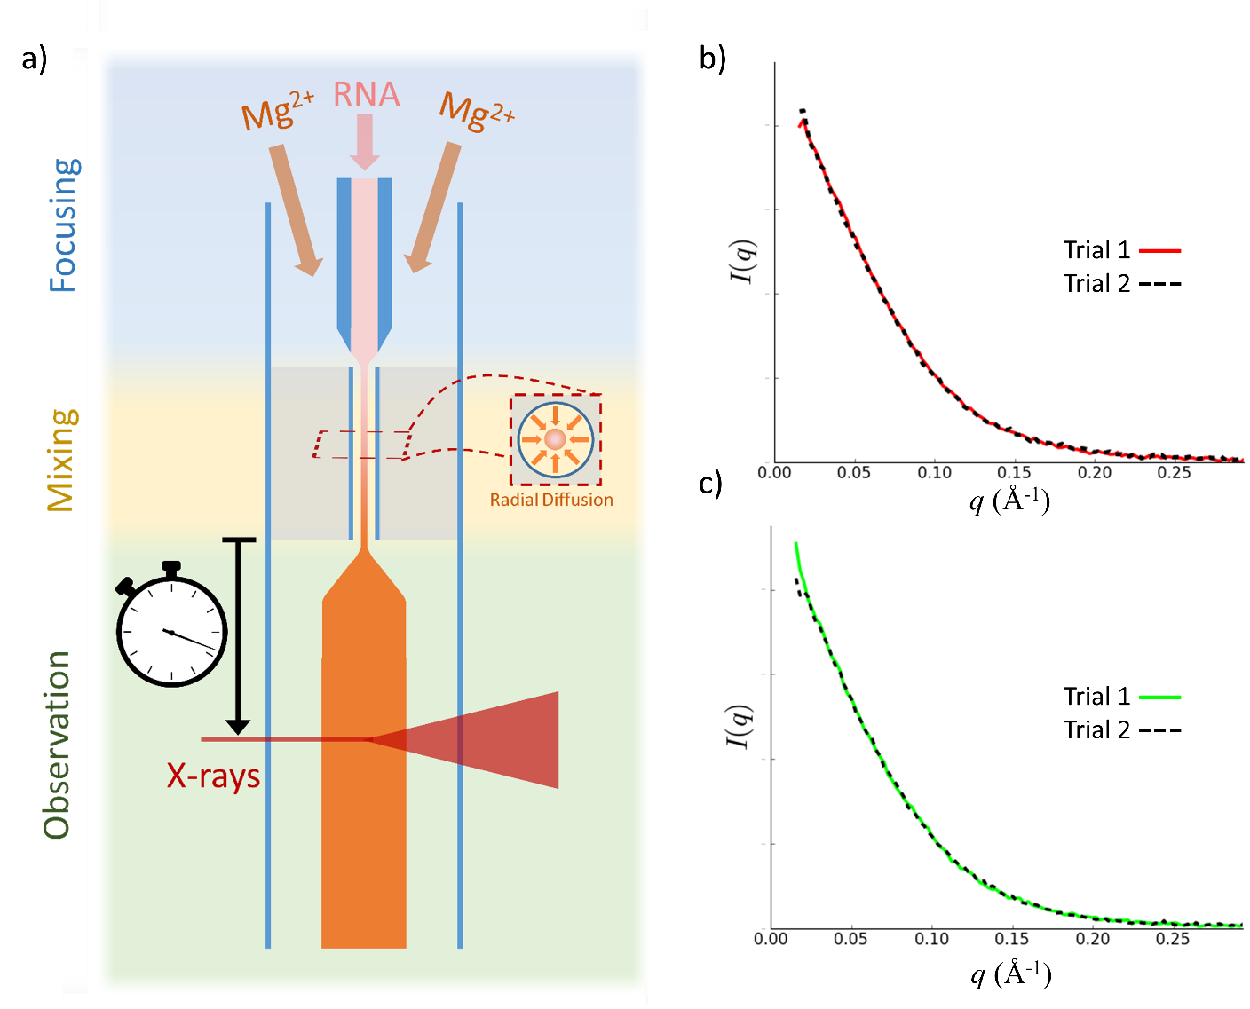
Figure S4 Schematic of microfluidic mixer and time resolved SAXS profiles. a) Cartoon showing the principle of operation for the microfluidic mixer. The different colors of the shaded background highlight the three functional regions of the device. Inset cross section shows the cylindrical geometry and diffusion of Mg²⁺ into the central stream of RNA. The color of the stream of RNA changes to represent the changing Mg²⁺ concentration: pink indicates 0 mM, orange indicates 10 mM. Plots of concentration across the sample stream are given in Plumridge et al. 2018. b) SAXS profiles from 30 ms timepoint and c) 300 ms timepoint. Buffer and sample measurements were repeated twice for each timepoint to ensure reproducibility.
The solutions leave the small inner diameter capillary and emerge into a larger diameter observation capillary made of thin-walled polyimide tubing (Microlumen, Oldsmar, FL). The mixer can be positioned so that the beam passes through this channel at different distances from the mixing point to probe the reaction at various times after mixing. In this observation region, the sample jet expands to ~120 μm, creating a larger X-ray path length that boosts the X-ray scattering signal, minimizing the data collection time and therefore sample consumption. Additionally, this expansion effectively halts Mg²⁺ diffusion, keeping the reactant concentration constant along the observation channel. Therefore, a range of time points can be probed with the same magnesium concentration, simplifying data analysis.
To collect background images, an injection valve was used to toggle the flow through the central capillary from RNA solution to a buffer solution containing no MgCl₂. New background images were acquired for each timepoint, as the background scattering from different positions along the observation capillary is slightly different. Figure S4 b) and c) shows background subtracted scattering profiles collected 30 ms and 300 ms after mixing.
Table S1 shows a summary of the flow conditions and mixer parameters used in this experiment. For all timepoints, the RNA concentration was 76uM. The concentration of Mg in the outer buffer (20mM) was chosen so that the final Mg concentration after mixing would be 10 mM. In addition to the flow conditions, this table details the sources of timing dispersion for each timepoint. Additional discussion of these sources are discussed in Plumridge et al. 2018.
 | Timepoint (ms)
 | 10 | 30 | 100 | 300 | 1000
Sample Flow Rate (µL/min) | 5 | 5 | 5 | 5 | 5
Total flow rate (µL/min) | 36.4 | 17 | 17 | 17 | 17
Time in constriction (ms) | 3.5 | 7.5 | 7.5 | 7.5 | 7.5
Flow Dispersion (ms) | 1.1 | 7.6 | 19.8 | 61.5 | 183.3
Beam Smearing (ms) | 2.5 | 5.4 | 5.4 | 5.4 | 5.4
Total dispersion (ms) | ±1.4 | ±4.7 | ±10 | ±30 | ±90
Sample Path Length (µm) | 80 | 148 | 148 | 148 | 148
Table S1 List of flow parameters and timing dispersion for each timepoint measured.

Fluorescence Data collection & pre-treatment:
Stopped flow time courses were collected on an applied Photophysics sx20 stopped flow spectrofluorometer. The buffer, referred henceforth as standard buffer, for all experiments was 100 mM KCl, 10 mM Sodium Cacodylate at pH 6.5, and any deviations are explicitly mentioned. Fluorescence from 2AP on 100 nM RNA constructs was recorded after rapidly mixing with differing concentrations of ions in the same standard buffer. Each measurement consisted of 15000 time points (the first five thousand taken at 1 ms intervals, and the subsequent 10,000 taken at 10 ms intervals). Each measurement condition (2AP position and ion concentration) was replicated at least 5 times. Data from each measurement condition were averaged and the standard deviations of the averages were calculated to be used as weights during fitting. The averaged data was normalized to percent signal change for easier interpretation, since direct comparison of the fluorescence intensities between data sets suffers from drift of the fluorescence detector, as well as slight changes in the absolute RNA concentration.

Data fitting:
The normalized data curves from the 1061AP, 1067AP, 1069AP, 1070AP, and 1095AP constructs were grouped by ion concentration and identity. Each group was globally fit to a sum of three exponentials (n=3) (DF1). Global fitting was accomplished by holding the observed rates constant for each construct and letting the amplitudes vary independently of construct. Goodness of fit was determined by the sum of square residuals (see Error/Method Comparison). Fitting was performed with nonlinear least squares, NLLS, Origin Pro software (Originlab).
(DF1)
$$data\left(t\right)=offset+\sum_{n=3}{A_{n}e^{-t*k_{observed n}}}$$

Primer
Chemical kinetics is a well-studied subject that can define the (inter)conversion of chemical species as a function of time. The following section provides a brief overview of chemical kinetics and introduces the concepts and symbols used in the subsequent sections.
A kinetic mechanism is a quantitative description of the conversion, or inter-conversion, of chemical states. We have opted to use the term state because chemical kinetics offers a mathematical frame work that is agnostic of the physical form of the molecules it describes. This allows us to describe the system in a pure form without having to worry about the further complication of representing our system in terms of discrete conformations or ensembles.
For the purposes of illustration we present a simple kinetic mechanism (P1) where a macromolecule binds to a ligand.
(P1)
$$A+L {}_{\overset{←}{k_{1r}}}^{\underset{→}{k_{1f}}}{ AL} {}_{\overset{←}{k_{2r}}}^{\underset{→}{k_{2f}}}{BL}$$
This mechanism describes a three state system where a macromolecule (A) binds to a ligand (L) to create a complex (AL) which can interconvert to a new species (BL). The rate of conversion and inter-conversion of these states are governed by the rate constants (k_{1f}, k_{1r}, k_{2f}, and k_{2r}) and the concentration of ligand (L). To discount the role of the concentration of ligand we assume that the concentration of L is much higher than the sum of concentrations of the three macromolecular species. The quantitative relationship between the concentrations of these states is shown in the chemical master equation which we can decompose into a set of linear equations that describe the concentration of each state (P2).
(P2)
$$\left[A\right]=-\left[L\right]\left[A\right]k_{1f}+\left[AL\right]k_{1r}$$
$$\left[AL\right]=\left[L\right]\left[A\right]k_{1f}-\left[AL\right]\left(k_{1r}+k_{2f}\right)+[BL]k_{2r}$$
$$\left[BL\right]=\left[AL\right]k_{2f}-\left[BL\right]k_{2r}$$
The system of equations in p2 can be shown in matrix format which is the representation that we will use henceforth. For the purpose of clarity capital letters will be used to denote matrices and vectors, and lower case letters will be used to denote scalars. The system in P2 can be seen as the product of the rate matrix, M, and the vector of state concentrations (C) (P3).
(P3)
$$M=\left[\begin{matrix}{-\left[L\right]k}_{1f} & k_{1r} & 0 \\ \left[L\right]k_{1f} & -\left(k_{1r}+k_{2f}\right) & k_{2r} \\ 0 & k_{2f} & -k_{2r}\end{matrix}\right]$$
$$C=\left[\begin{matrix}\left[A\right] \\ \left[AL\right] \\ \left[BL\right]\end{matrix}\right]$$
The rate of change of the concentrations of each state as a function of time is the product of the rate matrix M and the vector of the initial concentrations C₀ (at time = 0) (P4).
(P4)
$$C\left(t\right)= e^{Mt}C{}_{0}$$
We can relate the concentrations of each state to the spectroscopic signal observed during a kinetic time course by summing the product of the concentration of each species at a given time point by the state’s contribution to the spectroscopic signal (in our case the molar fluorescence intensity) shown in standard and matrix notation in figure P5. Lowercase f is the molar signal intensity of a single state, capital F is the vector of all individual molar intensities, and s is the total observable signal.
(P5)
$$\left[A\right]f_{A}+\left[AL\right]f_{AL}+\left[BL\right]f_{BL}=s$$
$$CF=s$$
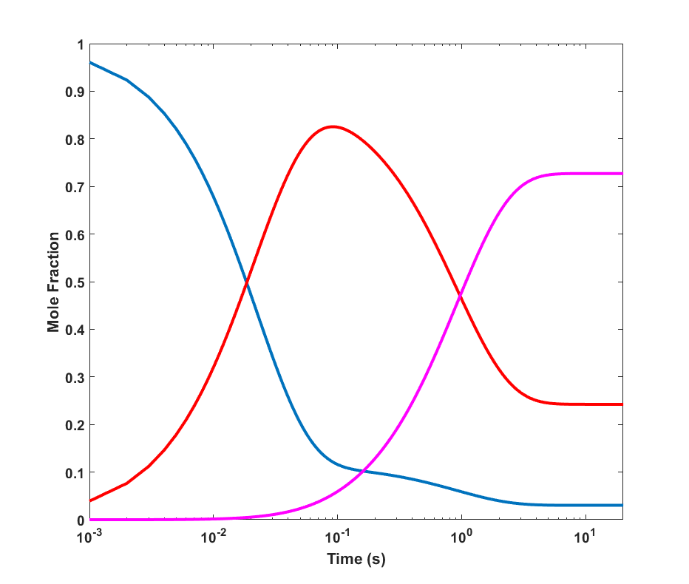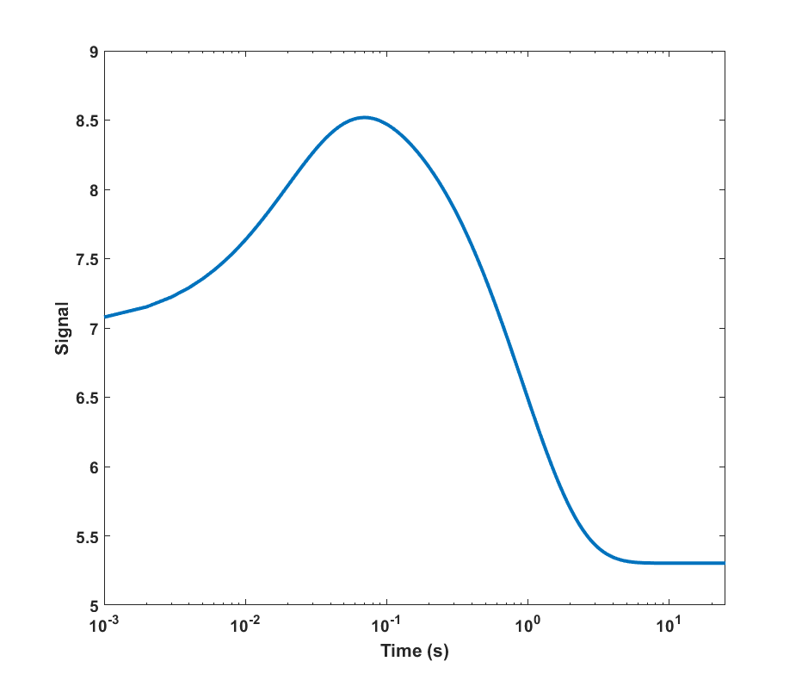
Figure S5. An example of a three-component signal decomposed into contributions from each species (left) and (right) what would be actually measured, following P5 formalism.

Modeling kinetic mechanisms
Traditionally, reports of the kinetics of non-trivial systems focuses on determining observed rates, as opposed to rate constants. The observed rates are, often complex, convolutions of the rate constants (please see table in ¹⁰) that can be calculated from spectroscopically measured kinetics data (see the section on data fitting). The rate constants for mechanisms with multiple (greater than 2) states cannot generally by obtained from fitting raw data, and can only be estimated by more advanced modeling.
There are 3 major challenges estimating rate constants:
- Comprehensively searching through the huge combinatory space of rate combinations.
- Finding a unique solution in an underdetermined problem.
- Meaningfully comparing models.
We have met these challenges by:
- Using novel computationally intensive search methodologies.
- Constraining possible solutions by using multiple labeled constructs that report on the same events.
- By only reporting on the simplest model that can explain the data.

Modeling algorithms: Comparing rates
The first part of the analysis pipeline is to get a rough estimate of the rate constants in a computationally efficient manner. We begin by choosing a mechanism we want to test (MA 1)
(MA1)
$$2^{°}+ion {}_{\overset{←}{k_{1r}}}^{\underset{→}{k_{1f}}}{ I_{1}} {}_{\overset{←}{k_{2r}}}^{\underset{→}{k_{2f}}}{{ I}_{2}}+ion {}_{\overset{←}{k_{3r}}}^{\underset{→}{k_{3f}}}{ I_{3}} {}_{\overset{←}{k_{4r}}}^{\underset{→}{k_{4f}}}{{ I}_{4}} {}_{\overset{←}{k_{5r}}}^{\underset{→}{k_{5f}}}{ 3^{°}}$$
The mechanism shown in MA 1 was selected (for multiple reasons which have been previously published (REF)). From the mechanism we can derive the model for rate matrix (MA2).
(MA2)
$$M=\left[\begin{matrix}-k_{1}*\left[ion\right] & k_{-1} & 0 & 0 & 0 & 0 \\ k_{-1}*\left[ion\right] & -\left(k_{-1}+k_{2}\right) & k_{-2} & 0 & 0 & 0 \\ 0 & k_{2} & -\left(k_{-2}+\left[ion\right]*k_{3}\right) & k_{-3} & 0 & 0 \\ 0 & 0 & \left[ion\right]*k_{3} & -\left(k_{-3}+k_{4}\right) & k_{-4} & 0 \\ 0 & 0 & 0 & k_{4} & -{(k}_{-4}+k_{5}) & k_{-5} \\ 0 & 0 & 0 & 0 & k_{5} & -k_{-5}\end{matrix}\right]$$
The k_{obs} values (see data fitting section) should be equal to the opposite sign of the eigenvalues, λ, of the rate matrix M (k_{obs} = -λ). For a given set of rate constants, K={k_{1f}, k_{1r}…k_{5f},K_{5r}} we can calculate the eigenvalues and then compare them to the calculated observed rates at each ion concentration. To compare the relative fitness of each set K we can write an objective function to calculate the sum of square residuals (θ), SSR, of each set (MA3) at every ion concentration, δ. When there are multiple measured observed rates (3 in our case) we order the eigenvalues by size and then compare each set of observed rates to the eigenvalues of similar magnitude. Lastly, we weight each point of the SSR by its value of k_{obs}; this prevents the function from biasing the larger magnitude eigenvalues (MA3).
(MA3)
$$θ(K)=\sum_{δ}{\sum_{n=3}{\sqrt{{\left(\frac{k_{obs, n}-λ_{n}\left(K\right)}{k_{obs, n}}\right)}^{2}}}}$$

Modeling algorithms: Genetic algorithm
With the objective function defined we can attempt to estimate the rate constants with a meta-optimization process, the genetic algorithm (GA). A GA is an optimization algorithm that mimics natural selection, below is its workflow for general, as well as our specific case.
- An initial population is created.
  - The population consists of individuals (sets of rates, K) made up of random elements (randomly generated rates)
- The fitness of each individual is tested
  - Each individual is evaluated by the fitness function (MA3)
- A subpopulation of individuals with the best fitness values are set aside.
  - The individuals with the lowest theta values are saved in memory.
- A new population is created by crossing and mutating the population from step three.
  - Crossover consists of randomly interchanging elements between two individuals, mutation consists of exchanging individual elements with randomly generated values.
- Steps 2 through 4 are iteratively repeated until stopped.
  - The stopping criterion is after the theta value of the fittest individual doesn’t change after a number of iterations.
All modeling was performed in MATLAB using inbuilt functions, eigenvalues were calculated using the ‘eigs’ function, the genetic algorithm used was the ‘ga’ function. Not only is this method relatively quick at estimating sets of rates, but can also be used to disprove kinetic mechanisms that cannot replicate the NLLS calculated observed rates.

Modeling algorithms: curve fitting and MOGA
After optimizing MA3 the search space is narrowed down. This allows us to start testing sets of rates against the actual data. To do this we need to make a new objective function that compares the models to the data. The new objective function can be broken down in to three steps.
- For a given set of K_{N} the concentration of the state at the experimentally measured time points is calculated with a non-stiff ordinary differential equation solver (we used the ‘ODE23’ function native to MATLAB)
- As shown in equation P5 the product of the matrix of state concentrations and the vector of molar fluorescence values of the states should equal the data. We use the MATLAB function ‘fmincon’ (a gradient descent optimization algorithm) to optimize the molar fluorescence intensity values that can simulate the data. We assume that the molar fluorescence intensities are agnostic of ion concentration, so all ion concentrations for a specific ion are fit simultaneously
- Once the molar fluorescence intensities are optimized for a given K_{N} the simulated data are subtracted from the experimental data weighted by the standard deviation, σ (see section data collection and pre-treatment) (MA4)
(MA4)
$$ϕ=\sum_{δ}{\sqrt{{\left(\frac{{data}_{δ}-C\left(K\right)F}{σ_{δ}}\right)}^{2}}}$$
This new objective function has a tendency to optimize to local minima when run alone, so to combat this we employed a multi-objective genetic algorithm (MOGA) (using the ‘gamultiobj’ MATLAB function). The difference between a GA and a MOGA is that a MOGA optimizes two or more objective functions simultaneously (in our case phi and theta). The MOGA finds what we believe is close to the global minima. We refine that set of rates through a GA using MA4 as the objective function to try to remove any bias introduced from the possible error in the k_{obs} determined from NLLS curve fitting.

Error/method Comparison:
Assessing the accuracy of a given model is a non-trivial problem. As previously mentioned we used SSR as the goodness of fit metric to see how well a given kinetic scheme could simulate our experimental data. Different kinetic models were compared both visually and by SSR. There was no significant improvement by having more than six states in a given kinetic model or by adding additional transitions between states. Repeating the analysis work flow, see supplemental flowchart, for a given kinetic model did not appreciably change any of the individual rate constants.
Some rate constants can be changed without having an effect on goodness of fit. This happens when there is no upper or lower limit for how fast a rate is, or when a transition state can reach equilibrium on a much faster timescale then the subsequent step. In our kinetic scheme the rates associated with steps 1 and 3 achieve equilibrium on a faster timescale than the steps following them so as long as their rate constants can compose the apparent equilibrium constants K₁ and K₃, there is no upper limit on how fast the rates are. To find the lower limit we simply calculate the SSR for increasingly slower rate constants until the goodness of fit becomes worse.
The last step is to check to see if the molar fluorescence intensities are unique. As shown in equation P5, when the concentration matrix, C, is multiplied by the vector of molar fluorescence intensities, F, it should equal the experimental data. A potential problem of relying on linear least squares or NLLS to solve for F is they only supply a single solution. In the event that the solution is not unique (if multiple vectors of F can adequately fit the data) we utilized MATLAB’s native particle swarm algorithm, “particleswarm”, to determine if there were multiple molar fluorescence values that could adequately fit the data. The algorithm was run independently 100 times on each data set (Each 2AP labeled RNA with a specific ion at all concentration) to ensure proper sampling. For all three ion types and 2AP labeled constructs we found that all solutions were in fact unique.

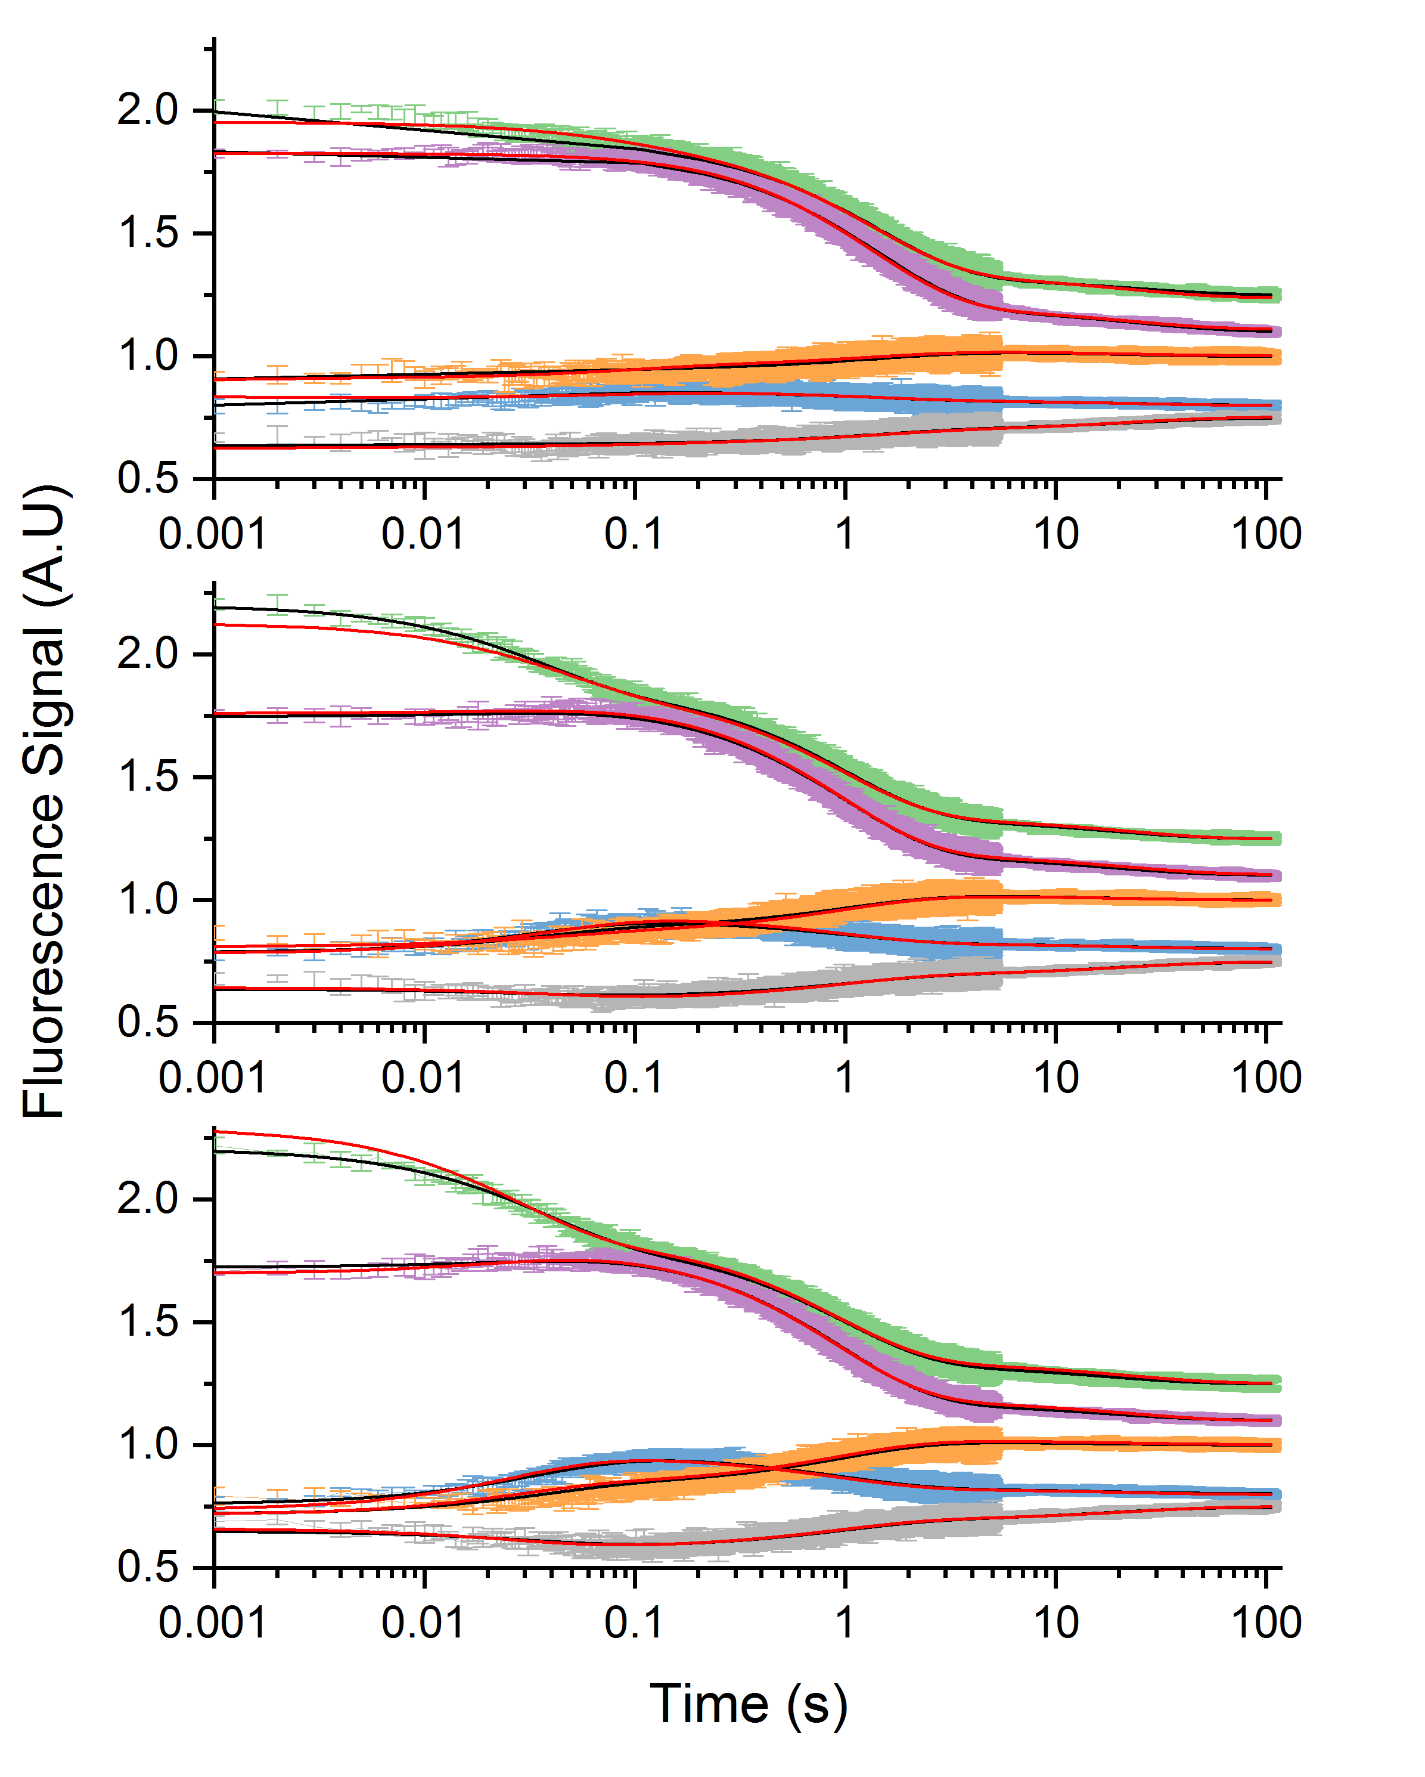
Figure S6A. Stopped-flow fluorescence data traces of 2AP-RNAs in MgCl₂. Three-exponential fits (black) and six-state fits (red). Top: 5 mM MgCl₂, mid: 20 mM MgCl₂, Bottom: 80 mM MgCl₂. 1061 blue, 1067 green, 1069 lavender,1070 yellow, and 1095 grey. [GAC] = 100 nM. 100 mM KCl, 10 mM sodium cacodylate pH 6.5, 22° C.

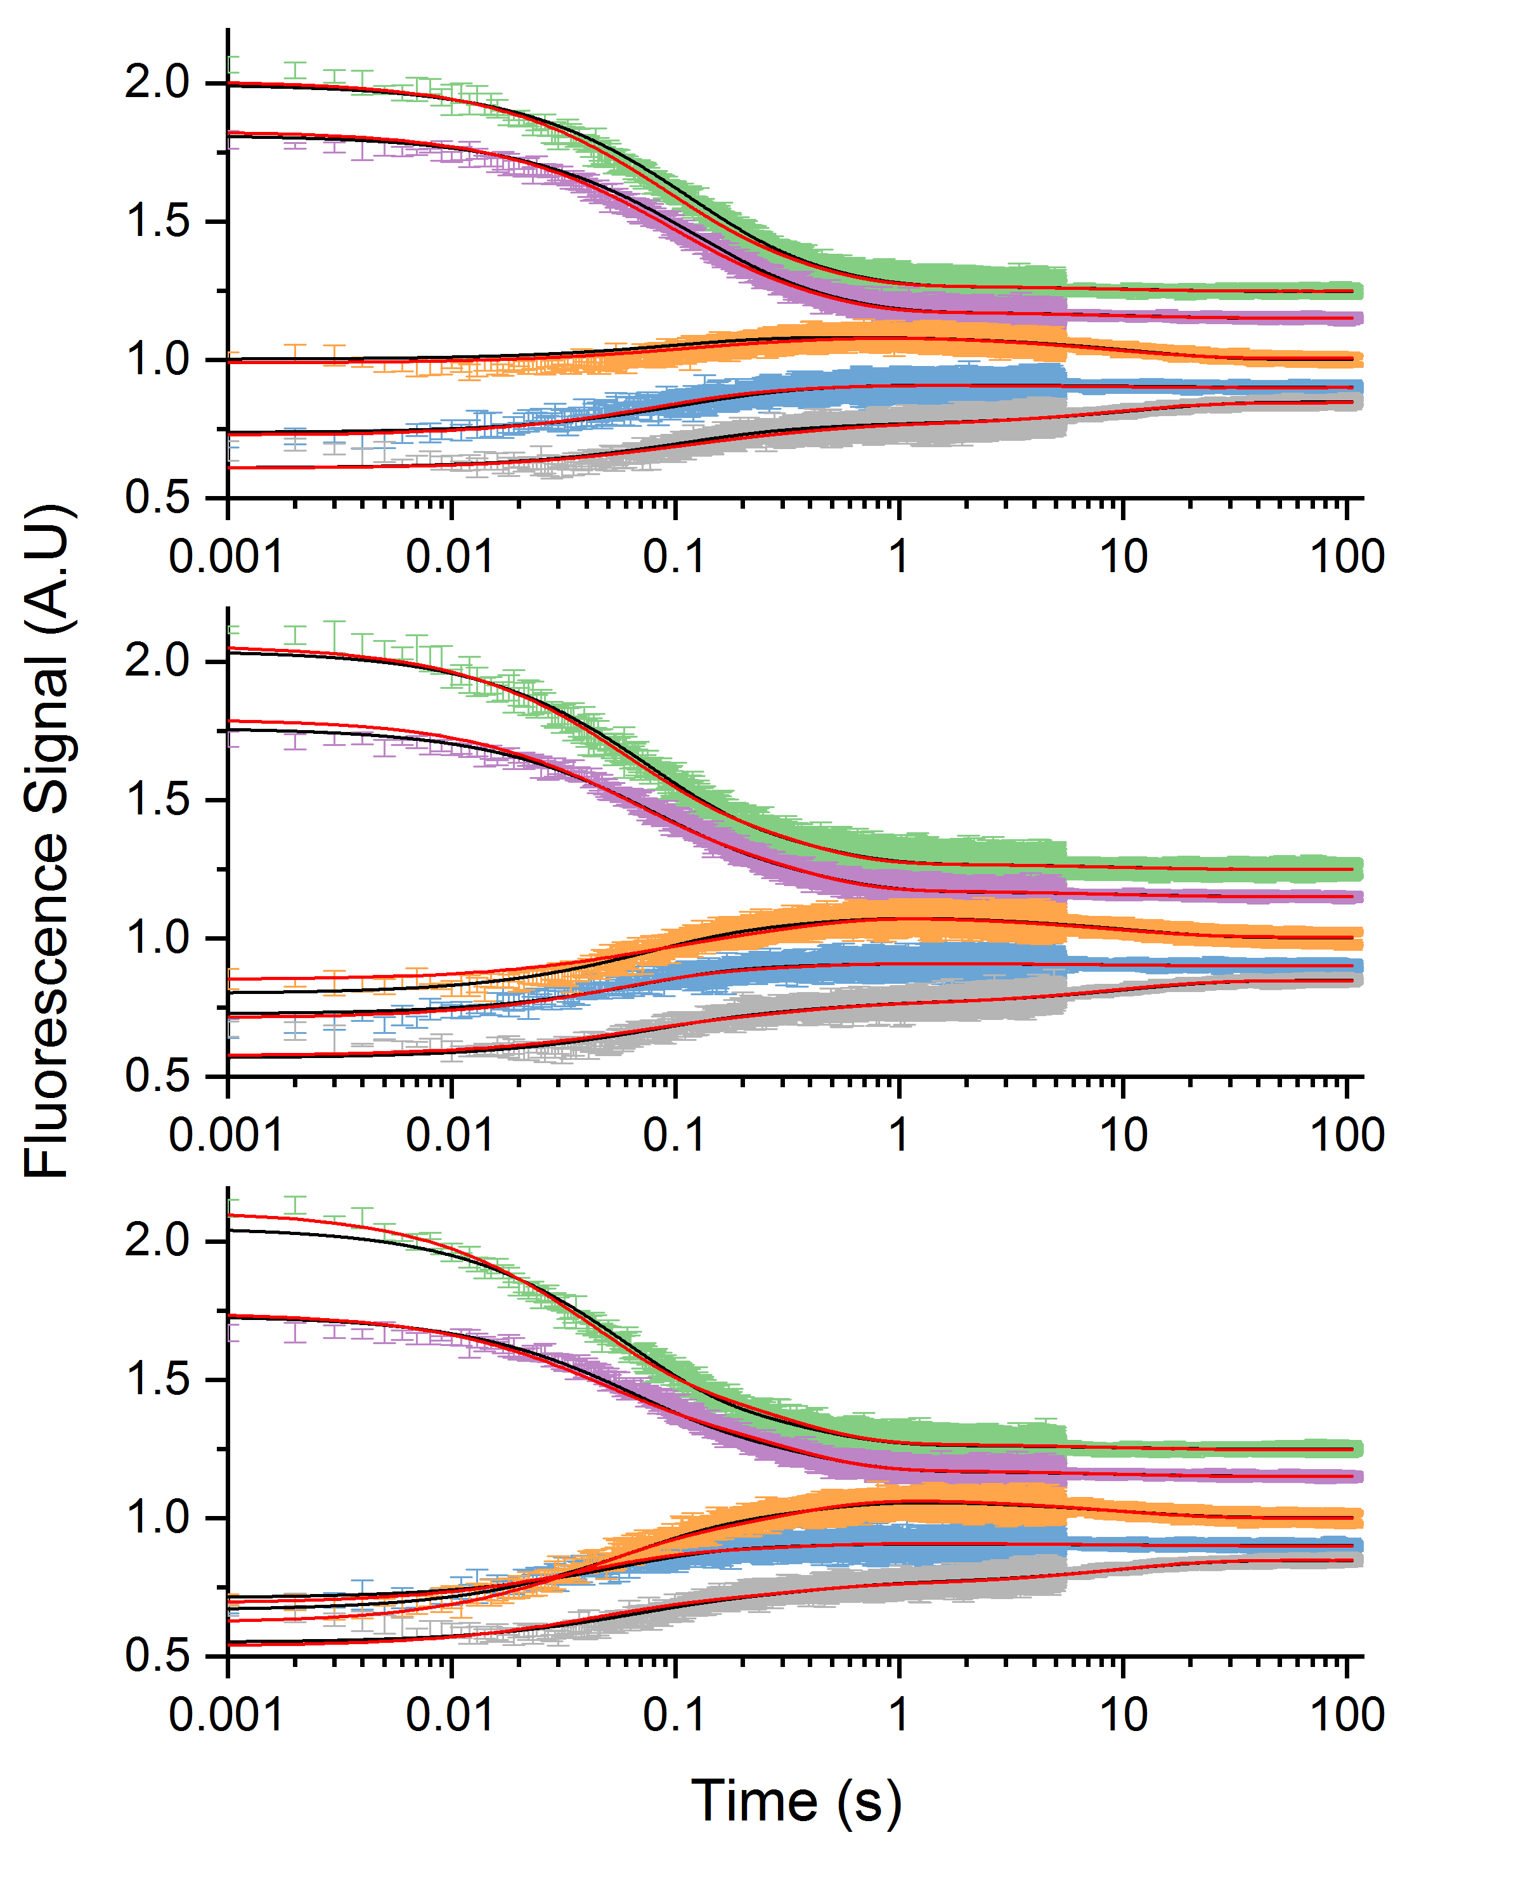
Figure S6B. Stopped-flow fluorescence data traces of 2AP-RNAs in CaCl₂. Three-exponential fits (black) and six-state fits (red). Top: Ca 10 mM MgCl₂, mid: 20 mM CaCl₂, Bottom: 50 mM CaCl₂. 1061 in blue, 1067 in green, 1069 in lavender,1070 in yellow, and 1095 in grey. [GAC] = 100 nM. 100 mM KCl, 10 mM sodium cacodylate pH 6.5, 22° C.

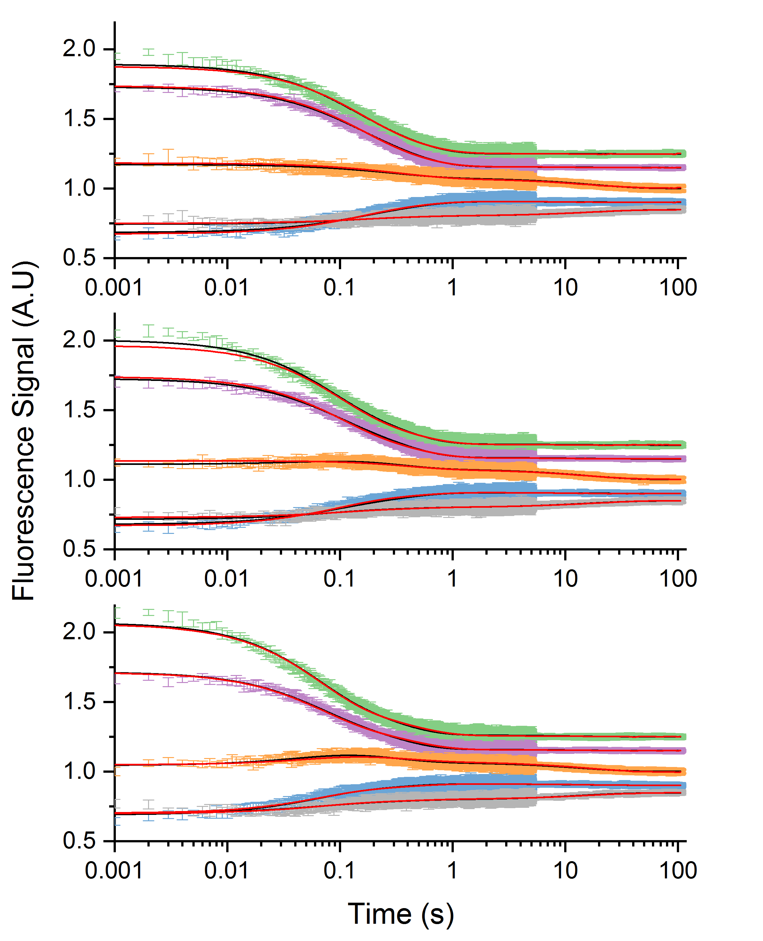
Figure S6C. Stopped-flow fluorescence data traces of 2AP-RNAs in SrCl₂. Three-exponential fits (black) and six-state fits (red). Top: 10 mM SrCl₂, mid: 20 mM SrCl₂, Bottom: 50 mM SrCl₂. 1061 blue, 1067 green, 1069 lavender,1070 yellow, and 1095 gray. [GAC] = 100 nM. 100 mM KCl, 10 mM sodium cacodylate pH 6.5, 22° C.

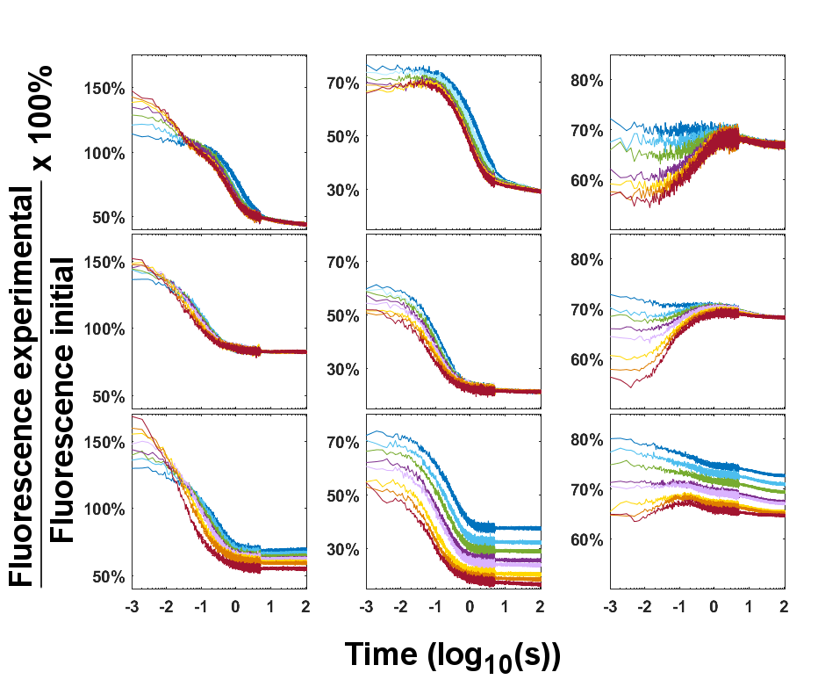
Figure S7: Fluorescence time courses for (columns from left to right) AP1067, AP1069, and AP1070 at 20° C. The rows from top to bottom show mixing with different divalent ions Mg²⁺, Ca²⁺ and Sr²⁺. Time courses are color coded from blue to red in increasing concentration of divalent ion (see main text). Time is reported as 10^{x}. ‘Fluorescence initial’ is fluorescence intensity of the RNA without divalent ion (i.e. in its secondary structure). The first measurement occurs ~1 ms after mixing of RNA with divalent ion, so this is the start of the reported trace.

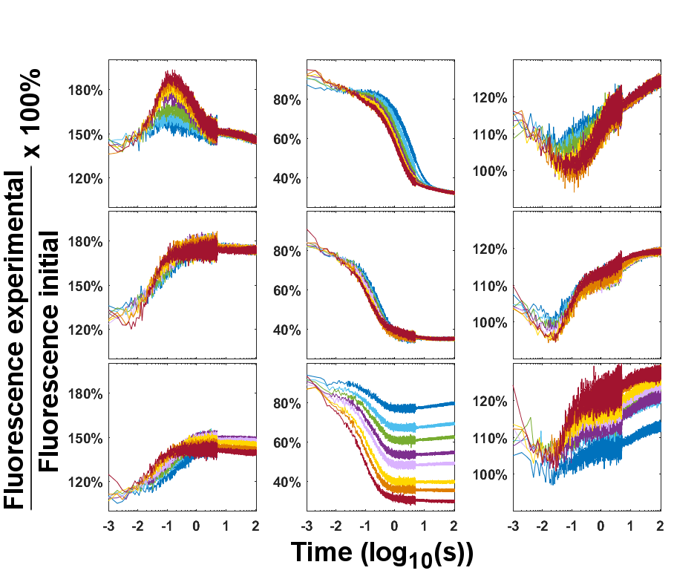
Figure S8: Fluorescence time courses for (columns from left to right) AP1061, AP1089, and AP1095 at 20° C. The rows from top to bottom show mixing with different divalent ions Mg²⁺, Ca²⁺ and Sr²⁺. Time courses are color coded from blue to red in increasing concentration of divalent ion (see main text). Time is reported as 10^{x}. ‘Fluorescence initial’ is fluorescence intensity of the RNA without divalent ion (i.e. in its secondary structure). The first measurement occurs ~1 ms after mixing of RNA with divalent ion, so this is the start of the reported trace.
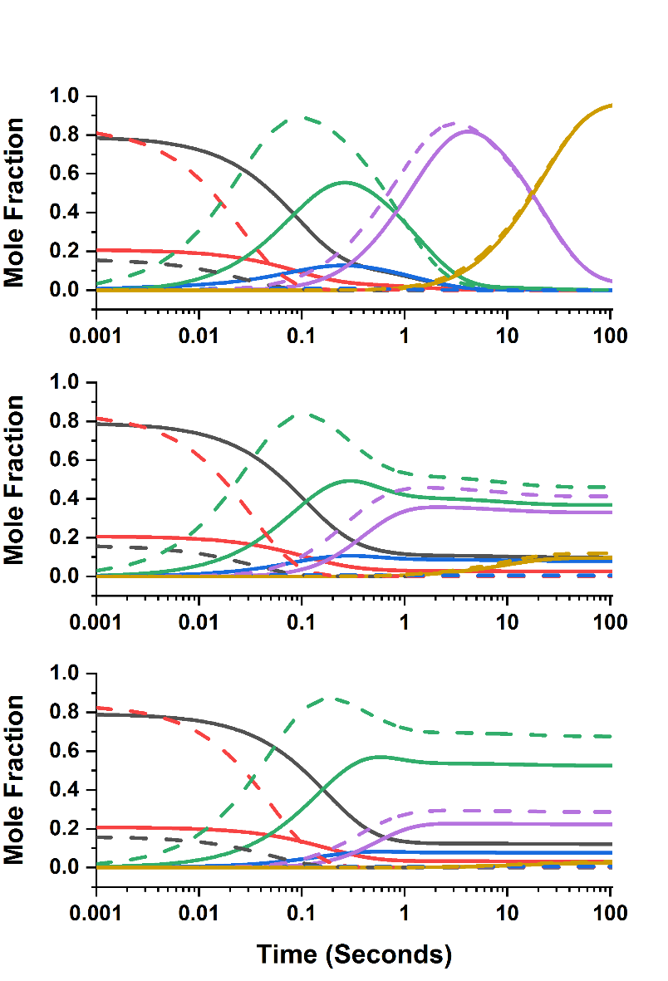
Figure S9. The concentrations of each state in the folding pathway of the GAC RNA calculated with rate constants in table 1.. States 2°, I1, I2, I3, I4 and 3°, are black, red, blue, green, purple and yellow respectively. Dashed lines are after mixing with 5 mM ion, and straight lines are after mixing with 100 mM ion. Mg, Ca,Sr plots are shown are shown top to bottom.

(1) Koch, M. H., Vachette, P., and Svergun, D. I. (2003) Small-angle scattering: a view on the properties, structures and structural changes of biological macromolecules in solution. Q. Rev. Biophys. 36, 147–227.
(2) Skou, S., Gillilan, R. E., and Ando, N. (2014) Synchrotron-based small-angle X-ray scattering of proteins in solution. Nat. Protoc. 9, 1727–39.
(3) Pabit, S. A., Qiu, X., Lamb, J. S., Li, L., Meisburger, S. P., and Pollack, L. (2009) Both helix topology and counterion distribution contribute to the more effective charge screening in dsRNA compared with dsDNA. Nucleic Acids Res. 37, 3887–96.
(4) Trewhella, J., Duff, A. P., Durand, D., Gabel, F., Guss, J. M., Hendrickson, W. A., Hura, G. L., Jacques, D. A., Kirby, N. M., Kwan, A. H., Pérez, J., Pollack, L., Ryan, T. M., Sali, A., Schneidman-Duhovny, D., Schwede, T., Svergun, D. I., Sugiyama, M., Tainer, J. A., Vachette, P., Westbrook, J., and Whitten, A. E. (2017) 2017 publication guidelines for structural modelling of small-angle scattering data from biomolecules in solution: an update. Acta Crystallogr. Sect. D, Struct. Biol. 73, 710–728.
(5) Grilley, D., Misra, V., Caliskan, G., and Draper, D. E. (2007) Importance of partially unfolded conformations for Mg(2+)-induced folding of RNA tertiary structure: structural models and free energies of Mg2+ interactions. Biochemistry 46, 10266–78.
(6) Plumridge, A., Katz, A. M., Calvey, G. D., Elber, R., Kirmizialtin, S., and Pollack, L. (2018) Revealing the distinct folding phases of an RNA three-helix junction. Nucleic Acids Res.
(7) Calvey, G. D., Katz, A. M., Schaffer, C. B., and Pollack, L. (2016) Mixing injector enables time-resolved crystallography with high hit rate at X-ray free electron lasers. Struct. Dyn. 3, 054301.
(8) Scampavia, L. D., Blankenstein, G., Ruzicka, J., and Christian, G. D. (1995) A coaxial jet mixer for rapid kinetic analysis in flow injection and flow injection cytometry. Anal. Chem. 67, 2743–9.
(9) Pabit, S. A., and Hagen, S. J. (2002) Laminar-flow fluid mixer for fast fluorescence kinetics studies. Biophys. J. 83, 2872–8.
(10) Vogt, A. D., and Di Cera, E. (2012) Conformational selection or induced fit? A critical appraisal of the kinetic mechanism. Biochemistry 51, 5894–902.

