Reconstitution of 30S ribosomal subunits in vitro using ribosome biogenesis factors
Daichi Tamaru^{1†}, Kazuaki Amikura^{1†*}, Yoshihiro Shimizu², Knud H. Nierhaus³ and Takuya Ueda¹
¹Department of Computational Biology and Medical Sciences, Graduate School of Frontier Sciences, The University of Tokyo, 5-1-5, Kashiwanoha, Chiba 277-8562, Japan
²Laboratory for Cell-Free Protein Synthesis, RIKEN Quantitative Biology Center, 6-2-3 Furuedai, Suita, Osaka 565-0874, Japan
³Institute for Medical Physics and Biophysics, Charité-Universitätsmedizin Berlin, Charitépl. 1, 10117, Berlin, Germany

*To whom correspondence should be addressed

Tel.: +81 4 7136 3648; Fax: +81 4 7136 3642; Email: amikura@edu.k.u-tokyo.ac.jp
†These authors equally contributed to the paper as first authors.

Supplementary Information
Submitted to ＲＮＡ

Supplementary Methods 3
Purification procedure of ribosomal proteins 3
Purification of 30S subunit biogenesis factors and r-protein modification enzymes 4
GTPase activities of Era and YjeQ 5
Supplementary Figures and Tables 6
Supplementary Figure 1. The influence of adding S1 to polyphenylalanine synthesis. 6
Supplementary Figure 2. Magnesium dependence of polyphenylalanine synthesis. 7
Supplementary Figure 3. Eight purified biogenesis factors. 8
Supplementary Figure 4. GTPase activities of YjeQ and Era. 9
Supplementary Table 1. Summary of ribosome biogenesis factors and r-protein modification enzymes. 10
Supplementary Table 2. Mass spectrum analysis of recombinant ribosomal proteins. 11
Supplementary Table 3. Buffer composition. 12
Reference 13

Supplementary Methods

Purification procedure of ribosomal proteins
All clones were transformed into the E.coli Rosetta (DE3) pLysS strain (Novagen), in which proteins were overexpressed from an inducible T7 promoter on the plasmid. For the overexpression of S2–S6, S8, S10, S15–S17 and S19–S21, strains harbouring the plasmids were grown to an approximate OD₆₀₀ of 0.4 at 37°C, IPTG was added to a final concentration of 0.1 mM and cultures were grown for an additional 4 h at 37°C prior to harvesting, and for the overexpression of S7, S9, S11–S14 and S18, strains harbouring the plasmids were grown to an approximate OD₆₀₀ of 0.4 at 30°C, IPTG was added to a final concentration of 0.1 mM and cultures were grown for an additional 12 h at 18°C prior to harvesting. Cells were washed once with HT buffer and stored at −80°C until further analysis.
Cells overexpressing S2–S6, S8, S15–S17 and S19–S21 were disrupted by sonication in HT buffer, those overexpressing S7, S9, S11–S14 and S18 were disrupted by sonication at 4°C in C buffer plus 6 M urea and those overexpressing S10 were disrupted by sonication at 4°C in C buffer. After sonication at 4°C, the protein-containing lysate was centrifuged at 15,000 rpm for 45 min at 4°C (TMA-27 rotor; TOMY) followed by filtration using 0.45-µm PVDF w/GMF (Whatman).
S2–S6, S8, S15–S17 and S19–S21 were purified at 4°C by Ni-column chromatography using two tandemly connected Ni-NTA superflow columns of 5 ml (Qiagen) with a 60-mL linear gradient of 95% A buffer and 5% B buffer to 40% A buffer and 60% B buffer; S10 was purified at 4°C by Ni-column chromatography using two tandemly connected Ni-NTA superflow columns of 5 ml with a 60-mL linear gradient from initial conditions of 95% C buffer and 5% D buffer to 40% C buffer and 60% D buffer and S7, S9, S11–S14 and S18 were purified at 4°C by Ni-column chromatography using two tandemly connected Ni-NTA superflow columns of 5 ml with a 60-mL linear gradient of 100% C buffer to 40% C buffer and 60% D buffer, starting in buffer exchange on the column with a 72-mL linear gradient of 95% C buffer plus 6 M urea and 5% C buffer to 100% C buffer. Protein-containing fractions were identified by SDS-PAGE and collected.
Ulp1 active domain (Δ1-402) was purified as previously reported (1). An appropriate amount of Ulp1 protease was added to the collected protein-containing fractions. For S2–S6, S8, S15–S17 and S19–S21, the collected protein-containing fractions were dialysed against 95% A buffer and 5% B buffer for >3 h at 4°C; for S10, the collected protein-containing fractions were dialysed against 95% C buffer and 5% D buffer for >3 h at 4°C; for S7, S9, S11–S14 and S18, the fractions were dialysed against E buffer for >3 h at 4°C.

S2–S6, S8, S16–S17 and S19–S21 were purified at 4°C by Ni-column chromatography using two tandemly connected Ni-NTA superflow columns of 5 ml; S15 was purified at 4°C by Ni-column chromatography using two tandemly connected Ni-NTA superflow columns of 5 ml with a 60-ml linear gradient of 100% A buffer to 70% A buffer and 30% B buffer because S15 has a strong affinity with the Ni-NTA superflow column; S10 was purified at 4°C by Ni-column chromatography using two tandemly connected Ni-NTA superflow columns of 5 ml; S7, S9 and S11–S14 were purified at 4°C by cation exchange chromatography using a Mono S column (GE Healthcare Life Sciences) with a 60-ml linear gradient of 100% E buffer to 40% E buffer and 60% F buffer and S18 was purified at 4°C by cation exchange chromatography using Mono S column with a 60-mL linear gradient of 100% E buffer plus 4 M urea to 40% E buffer plus 4 M urea and 60% F buffer plus 4 M urea. Protein-containing fractions flowing through the column were identified by SDS-PAGE and collected.
Each ribosomal protein fraction was concentrated by Amicon Ultra (3,000 or 5,000 MWCO) (Millipore) or precipitated by ammonium sulphate. Each step of the dialysis was performed for >3 h at 4°C. S2–S6, S8, S15 and S21 were dialysed against R buffer, R buffer plus 10% glycerol and R buffer plus 30% glycerol in sequence; S7 and S12–S14 were dialysed against S buffer, R buffer plus 600 mM KCl, R buffer plus 600 mM KCl and 10% glycerol and R buffer plus 600 mM KCl and 30% glycerol in sequence; S16, S17 and S19 were dialysed against R buffer plus 600 mM KCl, R buffer plus 600 mM KCl and 10% glycerol and R buffer plus 600 mM KCl and 30% glycerol in sequence; S9 was dialysed against E buffer, C buffer, C buffer plus 10% glycerol and C buffer plus 30% glycerol in sequence; S10 was dialysed against E buffer plus 4 M urea, S buffer plus 3 M urea, S buffer plus 3 M urea and 10% glycerol and S buffer plus 3 M urea and 30% glycerol in sequence; S11 was dialysed against C buffer plus 600 mM KCl, C buffer plus 600 mM KCl and 10% glycerol and C buffer plus 600 mM KCl and 30% glycerol in sequence; S18 was dialysed against S buffer plus 3 M urea, S buffer plus 3 M urea and 10% glycerol and S buffer plus 3 M urea and 30% glycerol in sequence and S20 was dialysed against HT buffer, HT buffer plus 10% glycerol and HT buffer plus 30% glycerol in sequence. Protein concentration was determined using the Bradford assay kit (Bio-Rad). Protein aliquots were frozen at −80°C.

Purification of 30S subunit biogenesis factors and r-protein modification enzymes
Era was subcloned into pQE30 using PCR. This plasmid was transformed into BL21 (DE3) pREP4. RbfA, RimM, RimP and tsaC were subcloned into pET15b using PCR. YjeQ was subcloned into pET29a. All proteins were overexpressed and purified by Ni-column chromatography. The homogeneity of all proteins was analysed by SDS-PAGE (Supplementary Figure 3).
All clones, except Era-coding plasmids, were transformed into E.coli BL21 (DE3) strain (Novagen), where the protein was overexpressed from an inducible T7 promoter on the plasmid, and Era-coding plasmids were transformed into E.coli BL21 (DE3) pREP4 strain (Novagen), where the proteins were overexpressed from an inducible T5 promoter on the plasmid. For overexpression, strains harbouring the plasmids were grown to an approximate OD₆₀₀ of 0.4 at 37°C, IPTG was added to a final concentration of 0.1 mM and cultures were grown for an additional 4 h at 37°C prior to harvesting. Cells were washed once with HT buffer and stored at −80°C. Cells containing the overexpressed protein were disrupted by sonication at 4°C in HT buffer. After sonication, the protein-containing lysate was centrifuged in TMA-27 (Tomy) (15,000 rpm, 4°C, 45 min), before filtration using 0.45-µm PVDF w/GMF. Proteins were purified at 4°C by Ni-column chromatography using two tandemly connected Ni-NTA superflow columns of 5 ml with a 60-mL linear gradient of 95% A buffer and 5% B buffer to 40% A buffer and 60% B buffer.
Proteins were concentrated on Amicon Ultra (1,000 or 3,000 MWCO). Each step of the dialysis was performed for >3 h at 4°C. RbfA, RimM, YjeQ and tsaC were dialysed against HT buffer, HT buffer plus 10% glycerol and HT buffer plus 30% glycerol in sequence; RimP was dialysed against HT buffer plus 900 mM KCl, HT buffer plus 900 mM KCl and 10% glycerol, HT buffer plus 900 M KCl and 30% glycerol and HT buffer plus 30% glycerol in sequence and other protein solutions were dialysed against HT buffer plus 500 mM NH₄Cl, HT buffer plus 500 mM NH₄Cl and 10% glycerol and HT buffer plus 500 mM NH₄Cl and 30% glycerol in sequence. Protein concentration was determined using the Bradford assay kit (Bio-Rad). Protein aliquots were frozen at −80°C. The DnaK, DnaJ, GrpE protein were kind gift from Dr. Takashi Kanamori (GeneFrontier Corporation).

GTPase activities of Era and YjeQ
Final concentrations of the components used in the reaction mixtures were usually 20 nM Hepes-KOH (pH 7.6), 100 mM potassium chloride, 4.5 mM Mg(OAc)₂, 2 mM spermidine, 0.05 mM spermine, 1 mM DTT, 73.5 pmol of Era or 45.6 pmol of YjeQ and 2.5 pmol of 30S, 50S or 70S subunit buffer (25 µL). These were mixed with 0.5 µL of 7.5 mM GTP containing ³²P-GTP, incubated for 7.5 min at 37°C, added to 125 µL of stop solution (40 mM H₂SO₄, 1.2 mM NaH₂PO₄ and 1% sodium molybdate) and mixed with 1-butanol. The solution was mixed well and centrifuged at 10,000g and 4°C for 1 min. Two hundred microlitres of the upper phase of 1-butanol was collected, mixed with 5 mL of Ultima Gold (PerkinElmer) and counted.

Supplementary Figures and Tables

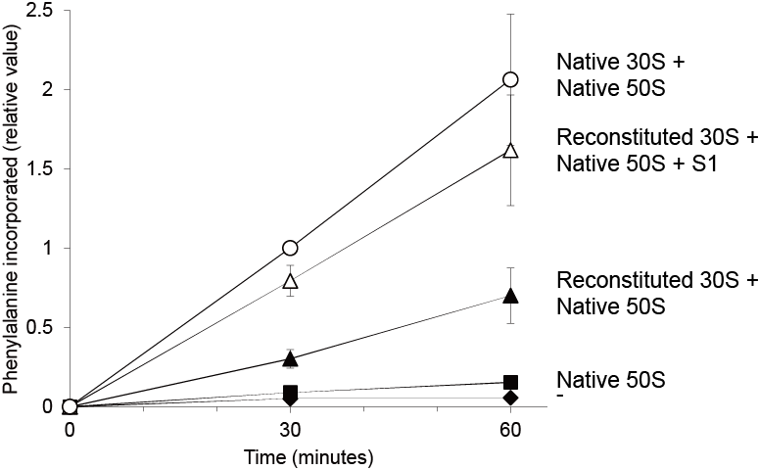

Supplementary Figure 1. The influence of adding S1 to polyphenylalanine synthesis.
Synthesised polyphenylalanine labelled with ¹⁴C was detected using a liquid scintillation counter. Values of ¹⁴C-phenylalanine incorporation were standardised (the value of ¹⁴C-phenylalanine incorporation by native 30S and 50S subunits after 30 min was determined to be 1).¹⁴C-phenylalanine incorporation by various subunits is denoted as follows: ○, native 30S and 50S subunits; ▲, reconstituted 30S and native 50S subunits; △, reconstituted 30S subunits, native 50S subunits and S1 protein; ■, native 50S subunits and ◆, no ribosomes. The bar shows standardised values.

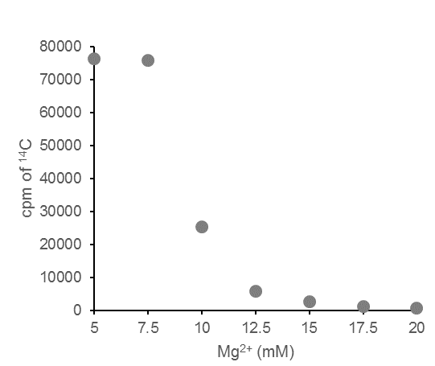

Supplementary Figure 2. Magnesium dependence of polyphenylalanine synthesis.

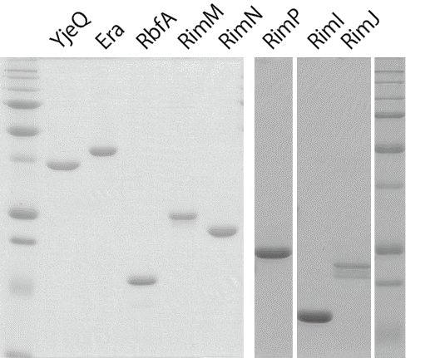

Supplementary Figure 3. Eight purified biogenesis factors.

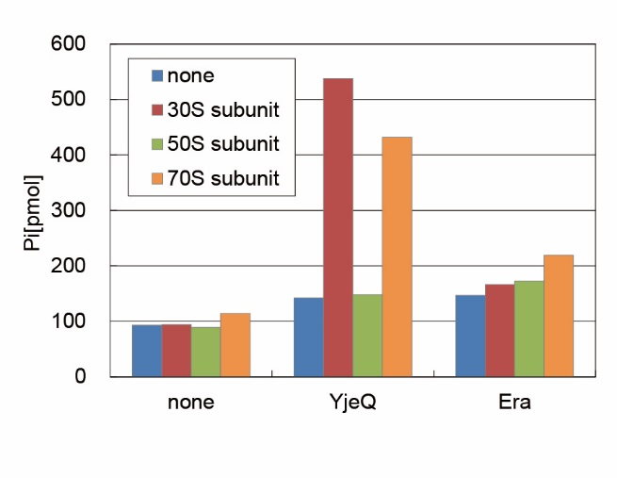

Supplementary Figure 4. GTPase activities of YjeQ and Era.

Gene | Synonymous | Features
YjeQ | RsgA | GTPase
Era | rbaA, sdgE | GTPase
RbfA | YhbB
RimM | YfjA
RimP | YhbC
RimI |  | N-acetyltransferase (S18)
RimJ | tcp | N-acetyltransferase (S5)
tsaC | RimN, YrdC | Threonylcarbamoyl-AMP synthase

Supplementary Table 1. Summary of ribosome biogenesis factors and r-protein modification enzymes.

Supplementary Table 2. Mass spectrum analysis of recombinant ribosomal proteins.

 | HT | A | B | C | D | E | F | R | S
Hepes-KOH (pH 7.6) (mM) | 50 |  |  |  |  |  |  | 50
Tris-HCl (pH 7.6) (mM) |  | 50 | 50 | 50 | 50 | 50 | 50 |  | 50
KCl (mM) | 100 |  | 400 | 400 | 400 | 20 | 1000 | 400 | 1000
NH₄Cl (mM) |  | 1000
MgCl₂ (mM) | 10 | 10 | 10 | 20 | 20 |  |  | 20 | 20
Imidazole (pH 7.6) (mM) |  |  | 500 |  | 500
Urea (mM) |  |  |  | 2000 | 2000 | 2000 | 2000 |  | 1000
β-mercaptoethanol (mM) | 7 | 7 | 7 | 7 | 7 | 7 | 7 | 7 | 7

Supplementary Table 3. Buffer composition.

Reference
1. Malakhov,M., Mattern,M., Malakhova,O., Drinker,M., Weeks,S. and Butt,T. (2004) SUMO fusions and SUMO-specific protease for efficient expression and purification of proteins. J. Struct. Funct. Genomics, 5, 75–86.

