Supplemental Material for:
Defining molecular interactions between Arabidopsis protein-only Ribonuclease Ps and pre-tRNA
Bradley P. Klemm,¹ Agnes Karasik,² Kipchumba J. Kaitany,¹ Aranganathan Shanmuganathan,² Matthew J. Henley,⁴ Adam Z. Thelen, ¹ Allison J.L. Dewar,³ Nathaniel D. Jackson,² Markos Koutmos,^{2,}* Carol A. Fierke^{1,3,}*

¹Department of Biological Chemistry, University of Michigan, Ann Arbor, MI, 48109, USA
²Department of Biochemistry and Molecular Biology, Uniformed Services University of the Health Sciences, Bethesda, MD, 20814, USA
³Department of Chemistry, University of Michigan, Ann Arbor, MI, 48109, USA
⁴Program in Chemical Biology, University of Michigan, Ann Arbor, MI, 48109, USA
*Corresponding Authors. E-mail: markos.koutmos@usuhs.edu; fierke@umich.edu.

Supplemental Methods
Reagents. Reagents used in this manuscript include 3-morpholinopropane-1-sulfonic acid (MOPS; Acros Organics), tris(2-carboxyethyl)phosphine (TCEP; Gold Biotechnology, Inc.), 1,4-dithio-D-threitol (DTT; Gold Biotechnology, Inc.) 5-iodoacetamidofluorescein (5-IAF; Life Technologies), ethylenediaminetetraacetic acid (EDTA; Acros Organics), tris(hydroxymethyl)aminomethane (Tris; Fisher Scientific), magnesium chloride (MgCl₂; Fisher Scientific), calcium chloride (CaCl₂; Sigma-Aldrich), sodium chloride (NaCl; Sigma-Aldrich), sodium acetate (NaAc; Fisher Scientific), sodium bromide (NaBr; Sigma-Aldrich), sodium iodide (NaI; Sigma-Aldrich), sodium nitrate (NaNO₃; Sigma-Aldrich), sodium sulfate (Na₂SO₄; Fisher Scientific), 5’-O-monophosphorothioate guanosine (GMPS, synthesized), nucleoside triphosphates (NTPs; Sigma-Aldrich), kanamycin (Acros Organics), chloramphenicol (Acros Organics), urea (MP Biochemicals), bromophenol blue (BPB; Fisher Scientific), xylene cyanol (XC; United States Biochemical Corporation), SYPRO® Orange Protein Gel Stain (Invitrogen), bulk yeast tRNA (Fisher Scientific), and the SequaGel UreaGel system (National Diagnostics).
Protein-nucleic acid interactions. Equation S1 was adapted from Equation 18 of deHaseth, et al. 1977 and describes the effects of solution ions on the binding affinity between proteins and nucleic acids (deHaseth et al. 1977). Variables potentially affecting the measured affinity include pH (K_{H}[H⁺]), anion concentration (K_{X}[X⁻]), monovalent cation concentration ([M⁺]), and divalent cation concentration ([S]/[S₀]). Parameters include a “standard affinity” under 1 M M⁺ (K₀), the number of proton donating groups on the protein directly interacting with substrate phosphates (r), the number of specifically-occupied anion binding sites on the protein (a), the number of phosphates on the substrate directly interacting with the protein (Z), the fraction of phosphates in the nucleic acid that thermodynamically associate with a monovalent ion (𝜑), and the competition of M⁺ with M²⁺ for occupancy on backbone phosphates given by the total concentration of nucleotides [S] and the concentration of nucleotides that are bound as they would with no M²⁺ in solution [S₀]. The term [S]/[S₀] is described by Equation S2.
$-log{K_{D}}=\log{K_{0}}–r•log\left(\frac{1+K_{H}\left[H^{+}\right]}{K_{H}\left[H^{+}\right]}\right)–a•log\left(1+K_{X}\left[X^{-}\right]\right)–Zφ•log\left[M^{+}\right]–Z•log\left(\frac{\left[S\right]}{\left\lceil S_{0}\right\rceil }\right)$ (S1)
$\frac{\left[S\right]}{\left[S_{0}\right]}=\frac{1}{2}\left(1+\sqrt{1+4K_{A}^{M}\left[M^{2+}\right]}\right)$ (S2)
Anion variation. Binding affinity was measured in various sodium salts at 330 mM Na⁺ (Table S1). Binding affinity was also measured with varying CaCl₂ (alone) and Na₂SO₄. The pre-tRNA^{Asp} anisotropy in the absence of PRORP and Na⁺ displays a hyperbolic dependence on CaCl₂ (K_{D,app} = 11 ± 3 mM, Figure 3A). This behavior is likely due to stabilization of the tRNA structure upon addition of divalent cations (Leroy et al. 1977), as the 5'-fluorescein likely has less rotational freedom when the tRNA structure is compact (Liu et al. 2014). The anisotropy of free pre-tRNA increased less than 20% above 50 mM Ca²⁺, so CaCl₂ was varied from 50 to 125 mM.
Thermofluor assays. Melting curves for each variant at 5 μM enzyme were measured in 30 mM MOPS, pH 7.8, 150 mM NaCl, and 1 mM TCEP, with 20X SYPRO® Orange. Fluorescence intensity (I) was monitored using λ_{Ex} = 485 nm and λ_{Em} = 625 nm. The melting temperature (T_{m}) was determined by fitting equation S3 was fit to the data to the maximum intensity, as previously described (Ericsson et al. 2006), for which A is the initial intensity, B is the maximum intensity, T is the temperature in Celsius, and C is a slope factor.
$I=\left(A+\frac{\left(B-A\right)}{\left(1+e^{\left(T_{m}-T\right)/C}\right)}\right)$ (S3)
Circular dichroism assays. Far UV-CD spectra are presented as the average of 5 accumulations for 10 μM enzyme measured at 25°C in 10 mM phosphate buffer, pH 7.2. The CD measurements were carried out on a Jasco J-815 spectropolarimeter equipped with a circulating water bath and peltier temperature controller. Spectra were converted to mean molar residue ellipticity (θ) using equation S4 as previously described (Jayasimha et al. 2012), for which M_{r} is the mean molar mass per residue, l is the path-length, and c is the protein concentration. Overall, the characteristic features of the far UV-CD of WT AtPRORP2 were retained in Y74S, suggesting that there are no major conformational changes when compared to WT.
$\left[θ\right]=\frac{θ•M_{r}}{10•l•c}$ (S4)

Supplemental Tables
Table S1. Effects of anion identity on affinity for pre-tRNA^{Asp}.
Na⁺ Saltª | K_{D} (nM)^{b} | Lyotropic series
Ac⁻ | 32 ± 7 | More kosmotropic  More chaotropic
SO₄²⁻ | 70 ± 10 | More kosmotropic  More chaotropic
Cl⁻ | 155 ± 20 | More kosmotropic  More chaotropic
Br⁻ | 450 ± 160 | More kosmotropic  More chaotropic
NO₃⁻ | 490 ± 60 | More kosmotropic  More chaotropic
I⁻ | 2900 ± 500 | More kosmotropic  More chaotropic
a: Supplied as the sodium salt at 330 mM Na⁺.
b: Value and error reported are from fitting a hyperbola to the results of two independent experiments plotted together.

Table S2. Effects of mutation to AtPRORP2 PPRs on affinity for pre-tRNA.
AtPRORP1 Residue | AtPRORP2 Residue | Position (PPR / Residue) | pre-tRNA^{Gly} |  |  | pre-tRNA^{Asp} | Highest Fold-WT
AtPRORP1 Residue | AtPRORP2 Residue | Position (PPR / Residue) | K_{D} (nM)^{a,b} | K_{D} (nM)^{a,c} |  | K_{D} (nM)^{a,b} | Highest Fold-WT
– | WT | – | 58 ± 8 | 260 ± 30 |  | 24 ± 5 | 1.0
A98 | T31A | 1 / 3 | 60 ± 8 | 530 ± 50 |  |  | 2.0
K101 | L34A | 1 / 6 | 28 ± 6 | 170 ± 10 |  |  | 0.7
D105 | N38A | 1 / 10 | 160 ± 40 | 1410 ± 150 |  | 70 ± 20 | 5.4
S131 | S65A | 2 / 1 | 100 ± 20 | 590 ± 80 |  | 35 ± 8 | 2.3
Y133 | Q67A | 2 / 3 | 70 ± 10 | 390 ± 70 |  | 30 ± 5 | 1.5
Y140 | Y74S | 2 / 10 | 1340 ± 170 |  |  | 110 ± 30 | 23
Y140 | Y74F | 2 / 10 | 170 ± 20 |  |  | 45 ± 9 | 2.9
N175 | N108A | 3 / 1 | 190 ± 30 | 720 ± 50 |  | 70 ± 20 | 3.3
T180 | T113A | 3 / 6 | 70 ± 20 | 900 ± 130 |  | 30 ± 3 | 3.5
R210 | R145A^{d} | 4 / 1 | > 2000 |  |  |  | > 34
F119 | L154A | 4 / 10 | 60 ± 10 | 230 ± 20 |  |  | 1.0
E245 | E180A | 5 / 1 | 35 ± 4 | 150 ± 20 |  |  | 0.6
A250 | S185A | 5 / 6 | 40 ± 6 | 350 ± 40 |  |  | 1.3
K254 | K189A | 5 / 10 | 52 ± 9 | 350 ± 30 |  |  | 1.3
S280 | S215A | α11 / 1 | 66 ± 21 | 360 ± 60 |  |  | 1.4
S282 | E217A | α11 / 3 | 56 ± 14 | 260 ± 20 |  |  | 1.0
D285 | K220A | α11 / 6 | 129 ± 64 | 250 ± 40 |  |  | 2.2
E289 | E224A | α11 / 10 | 55 ± 7 | 310 ± 35 |  |  | 1.2
a: Value and error reported are from fitting a hyperbola to the results of three independent experiments plotted together.
b: Measured in 30 mM MOPS pH 7.8, 1 mM DTT, 150 mM NaCl, and 6 mM CaCl₂.
c: Measured in 30 mM MOPS pH 7.8, 1 mM DTT, 330 mM NaCl, and 6 mM CaCl₂.
d: Low protein yield for R145A limited us to two binding assays, neither of which reached saturation up to 7500 nM. A lower limit for the K_{D} was estimated from the available data.

Table S3. Effects of B. subtilis pre-tRNA^{Asp} mutants on affinity for AtPRORP1.
Variant | K_{D} (nM)ª | Fold-WT
WT | 155 ± 20 | 1.00
U16A | 140 ± 20 | 0.90
U17A | 100 ± 10 | 0.65
U20A | 200 ± 10 | 1.29
U21A | 300 ± 30 | 1.94
a: Value and error reported are from fitting a hyperbola to the results of two independent experiments in 330 mM NaCl plotted together.

Table S4. Effects of mutations on AtPRORP1 affinity for pre-tRNA.
Variant | pre-tRNA^{Cys} |  |  |  |  | pre-tRNA^{Asp}
Variant | K_{D} (nM)ª | Fold-WT | K_{D} (nM)^{b} | Fold-WT |  | K_{D} (nM)ª | Fold-WT
WT | 200 ± 40 | 1 | 1720 ± 160 | 1 |  | 155 ± 20 | 1
Y140A^{c} | 150 ± 20 | 0.75 | >160000 | >93 |  | 29700 ± 7000 | 192
R184A | 170 ± 40 | 0.85 | >6500 | >3.8 |  | 10400 ± 2400 | 67
a: Value and error reported are from fitting a hyperbola to the results of two independent experiments plotted together in 30 mM MOPS pH 7.8, 1 mM TCEP, 100 mM NaCl, and 1 mM CaCl₂.
b: Value and error reported are from fitting a hyperbola to the results of two independent experiments plotted together in 30 mM MOPS pH 7.8, 1 mM TCEP, 330 mM NaCl, 20 mM CaCl₂.
c: We could not reach saturating enzyme conditions for Y140A binding to pre-tRNA^{Cys} in 330 mM NaCl and 20 mM CaCl₂. A lower limit for K_{D} was estimated from the available data, assuming the saturating anisotropy was the same as for WT.

Supplemental Figures
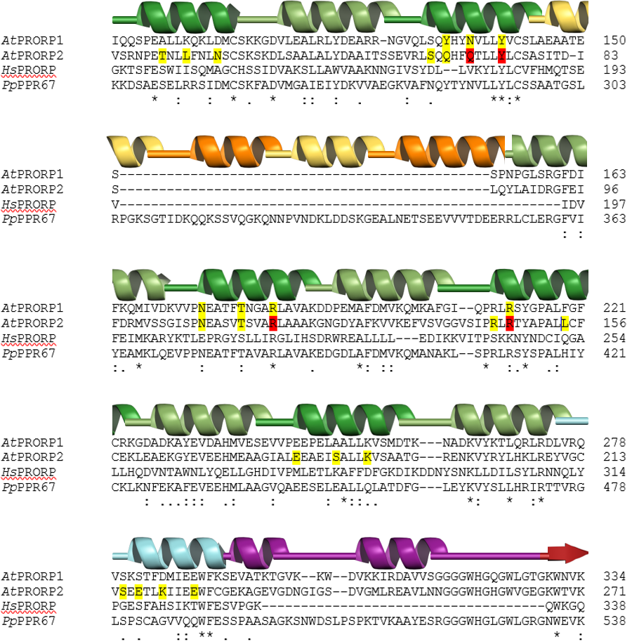
Figure S1. Alignment of PRORP PPR domains (Clustal Omega) (Goujon et al. 2010; Sievers et al. 2011). The three Arabidopsis thaliana PRORPs (AtPRORP1-3) were aligned to the human PRORP (HsPRORP) and PRORPs from the moss Physcomitrella patens (PpPPR63, PpPPR67, and PpPPR104). For clarity, AtPRORP3, PpPPR67, and PpPPR104 are excluded from the figure. The boundaries of additional PPR helices in P. patens PRORPs were assigned using models generated with AtPRORP1 (PDB 4g23) and chloroplast PPR protein 10 (PDB 4m59) as templates in the SWISS-MODEL ExPASy server (Arnold et al. 2006; Guex et al. 2009; Kiefer et al. 2009; Biasini et al. 2014). PPR A helices, which were targeted for mutation, are colored dark green, while PPR B helices are colored pale green. Additional putative PPR A helices in PpPPR67 are colored orange, while putative PPR B helices are colored beige. PPR helix 11 (numbered as in AtPRORPs) is colored cyan, while a plant-specific helical insert is purple and the first β-strand of the central domain is red. AtPRORP1 and AtPRORP2 residues mutated in this manuscript are highlighted in yellow. AtPRORP2 residues for which alanine mutants were insoluble are highlighted in red.

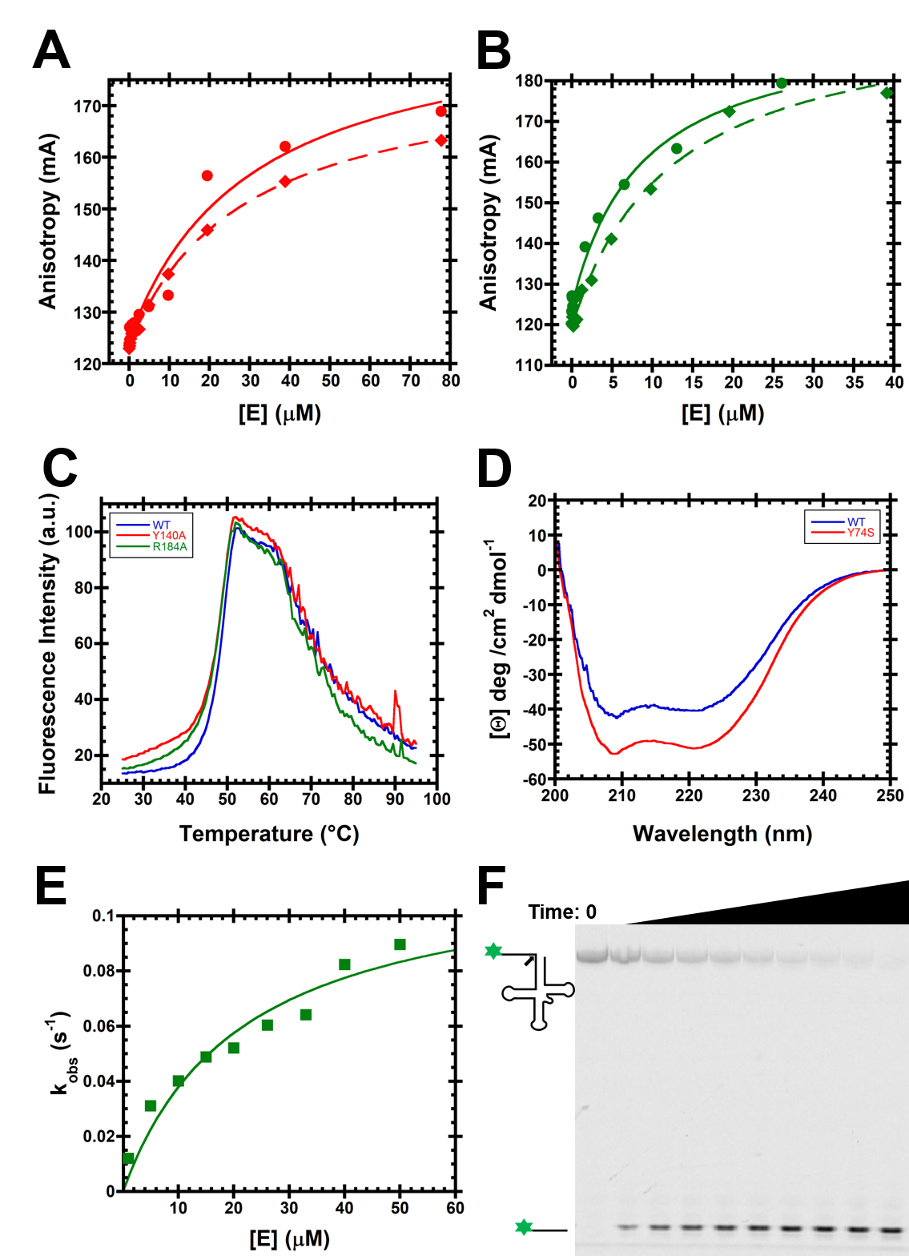
Figure S2. Stability of Y140A and R184A AtPRORP1 or Y74S AtPRORP2. (A) Binding curves for Y140A AtPRORP1 collected at 330 mM NaCl, as described in the Materials and Methods. (B) Binding curves for R184A AtPRORP1 collected at 330 mM NaCl, as described in the Materials and Methods. (C) Thermofluor melting curves for WT, Y140A, and R184A AtPRORP1, collected and analyzed as described in the Supplemental Methods. The T_{m} values are 48.3 ± 0.1 (WT), 47.7 ± 0.2 (Y140A), and 47.4 ± 0.2 (R184A). (D) Circular dichroism data for WT and Y74S AtPRORP2, collected and analyzed as described in the Supplemental Methods. (E) Single turnover kinetic analysis of R184A AtPRORP1 with B. subtilis pre-tRNA^{Asp}, collected at 25°C in 30 mM MOPS, pH 7.8, 150 mM NaCl, 20 mM MgCl₂, and 1 mM TCEP. Fitting a hyperbola to the data, we obtain k_{max}^{E} = 0.12 ± 0.01 s⁻¹ and K_{1/2}^{E} = 21 ± 7 μM. The WT enzyme value under these conditions is ~ 0.1 s⁻¹ (Howard et al. 2015). (F) A representative gel from the experiments described in panel E, at 40 μM enzyme. Time points (left to right) are 0, 6 sec, 16 sec, 26 sec, 40 sec, 1 min, 2.5 min, 5 min, 10 min, and 30 min.

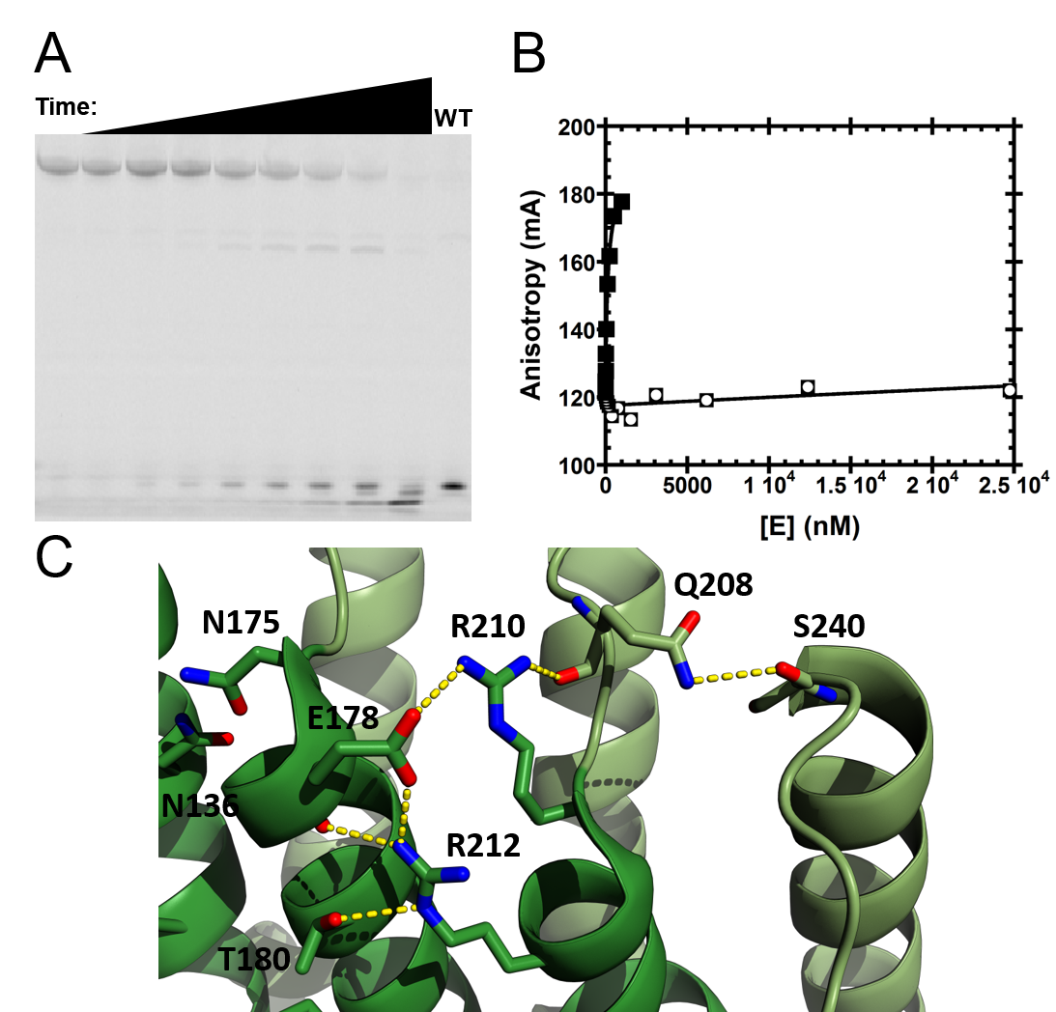
Figure S3. Defects in R212A AtPRORP1 catalysis and substrate binding with B. subtilis pre-tRNA^{Asp}. (A) Single turnover assay with 37 μM R212A and 30 nM substrate. Time points (left to right) are 0, 1 min, 5 min, 10 min, 30 min, 1 hr, 2 hr, 4 hr 20 min, and 20 hr 40 min. 5 μM WT enzyme at 30 minutes (at right) was included for comparison. (B) Anisotropy pre-tRNA^{Asp} binding to R212A (◘) or WT () AtPRORP1. A hyperbola (Equation 1, Materials and Methods) was fit to the data (K_{D,app} > 300000 nM; lower limit estimated assuming the change in anisotropy for fully-bound substrate is the same as WT). (C) Arg 212 in AtPRORP1 takes part in an extended series of interactions involving both main chain and side chain atoms, beginning with Thr 180 (PPR 3 helix A) and terminating with Ser 240 (PPR 4 helix B). Generated in PyMOL (PDB 4g24) (Schrödinger 2010).

Supplemental References

Arnold K, Bordoli L, Kopp J, Schwede T. 2006. The SWISS-MODEL workspace: a web-based environment for protein structure homology modelling. Bioinformatics 22: 195-201.
Biasini M, Bienert S, Waterhouse A, Arnold K, Studer G, Schmidt T, Kiefer F, Gallo Cassarino T, Bertoni M, Bordoli L et al. 2014. SWISS-MODEL: modelling protein tertiary and quaternary structure using evolutionary information. Nucleic Acids Res 42: W252-258.
deHaseth PL, Lohman TM, Record MT, Jr. 1977. Nonspecific interaction of lac repressor with DNA: an association reaction driven by counterion release. Biochemistry 16: 4783-4790.
Ericsson UB, Hallberg BM, Detitta GT, Dekker N, Nordlund P. 2006. Thermofluor-based high-throughput stability optimization of proteins for structural studies. Anal Biochem 357: 289-298.
Goujon M, McWilliam H, Li W, Valentin F, Squizzato S, Paern J, Lopez R. 2010. A new bioinformatics analysis tools framework at EMBL-EBI. Nucleic Acids Res 38: W695-699.
Guex N, Peitsch MC, Schwede T. 2009. Automated comparative protein structure modeling with SWISS-MODEL and Swiss-PdbViewer: a historical perspective. Electrophoresis 30 Suppl 1: S162-173.
Howard MJ, Klemm BP, Fierke CA. 2015. Mechanistic Studies Reveal Similar Catalytic Strategies for Phosphodiester Bond Hydrolysis by Protein-only and RNA-dependent Ribonuclease P. J Biol Chem 290: 13454-13464.
Jayasimha P, Shanmuganathan A, Suladze S, Makhatadze GI. 2012. Contribution of buried aspartic acid to the stability of the PDZ2 protein. The Journal of Chemical Thermodynamics 52: 64-68.
Kiefer F, Arnold K, Kunzli M, Bordoli L, Schwede T. 2009. The SWISS-MODEL Repository and associated resources. Nucleic Acids Res 37: D387-392.
Leroy JL, Gueron M, Thomas G, Favre A. 1977. Role of divalent ions in folding of tRNA. Eur J Biochem 74: 567-574.
Liu X, Chen Y, Fierke CA. 2014. A real-time fluorescence polarization activity assay to screen for inhibitors of bacterial ribonuclease P. Nucleic Acids Res 42: e159.
Schrödinger, LLC. 2010. PyMOL Molecular Graphics System, Version 1.5.
Sievers F, Wilm A, Dineen D, Gibson TJ, Karplus K, Li W, Lopez R, McWilliam H, Remmert M, Soding J et al. 2011. Fast, scalable generation of high-quality protein multiple sequence alignments using Clustal Omega. Mol Syst Biol 7: 539.

