Supplemental Material
Structure-Function Relationships of Archaeal Cbf5 During In Vivo RNA-Guided Pseudouridylation

Mrinmoyee Majumder, Michael S. Bosmeny and Ramesh Gupta

METHODS

Western blot analyses to check the expression of inactive mutant HvCbf5 proteins
Custom made polyclonal rabbit antibodies (Cocalico Biologicals) against N-terminal His-tagged full-length HvCbf5 protein expressed in E. coli were used for Western analysis. For this purpose, H. volcanii cbf5 gene was cloned in a modified pET30a (Novagen) vector. The protein was expressed in E. coli Rosetta (DE3) pLysS (Novagen). The cells were grown to an A₆₀₀ of approximately 0.6 and induced by 0.3 mM IPTG at 16°C for about 16 hr. Recombinant protein was purified by Nickel-affinity chromatography and then further separated by SDS-PAGE. A gel slice containing recombinant HvCbf5 was used to raise antibodies. 1:4000 dilution of the third bleed was used for Western analysis. No commercial antibody against any H. volcanii protein is available. A band for an unidentified protein of about 55 kDa was always observed in cell extracts when we used anti-HvCbf5 antibody in our analyses. Its amount did not appear to vary in any strain containing mutant Cbf5. It was present even in the Δcbf5 cells (Supplemental_Fig._S2, panel B). We used this protein as a loading control. H. volcanii cells from the same culture were used to prepare both Western blot to determine the presence of HvCbf5 in the cells and total RNA to determine the presence or absence of Ψ in 23S rRNA. For this purpose, a fraction of H. volcanii cell pellet was stored frozen every time total RNA was prepared. When the RNA did not show the presence of Ψ, corresponding frozen cells were used for Western analysis. In all such cases antibody detected HvCbf5 in cell extracts (Supplemental_Fig._S2). Quantitation of HvCbf5 protein in cell (band intensity relative to "control" protein of 55kDa) was done using ImageJ (1.47v). In most cases the amount of mutant protein in the cell was approximately the same as in the cell containing WT protein expressed from a plasmid-borne copy of the gene. This analysis does not tell whether the mutant protein folded into the correct conformation.

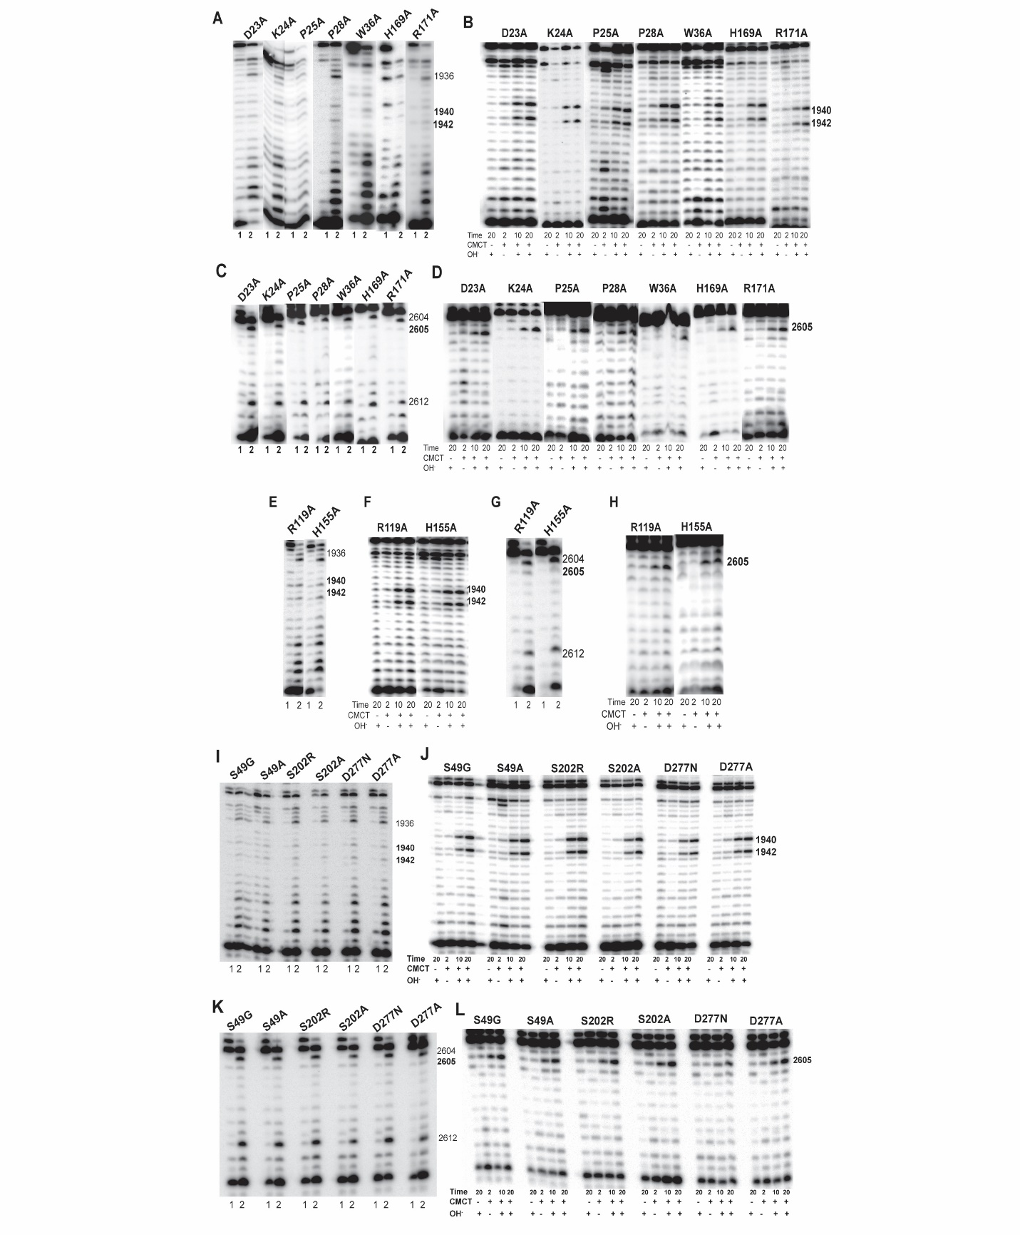
Supplementary Figure S1. Mutations of several residues (marked above each panel) of HvCbf5 did not affect Ψ formation at positions 1940, 1942 and 2605. Primer extensions analyses following U-specific (A, C, E, G, I and K) and CMCT reactions (B, D, F, H, J and L). The reactions were done as in Fig. 3.

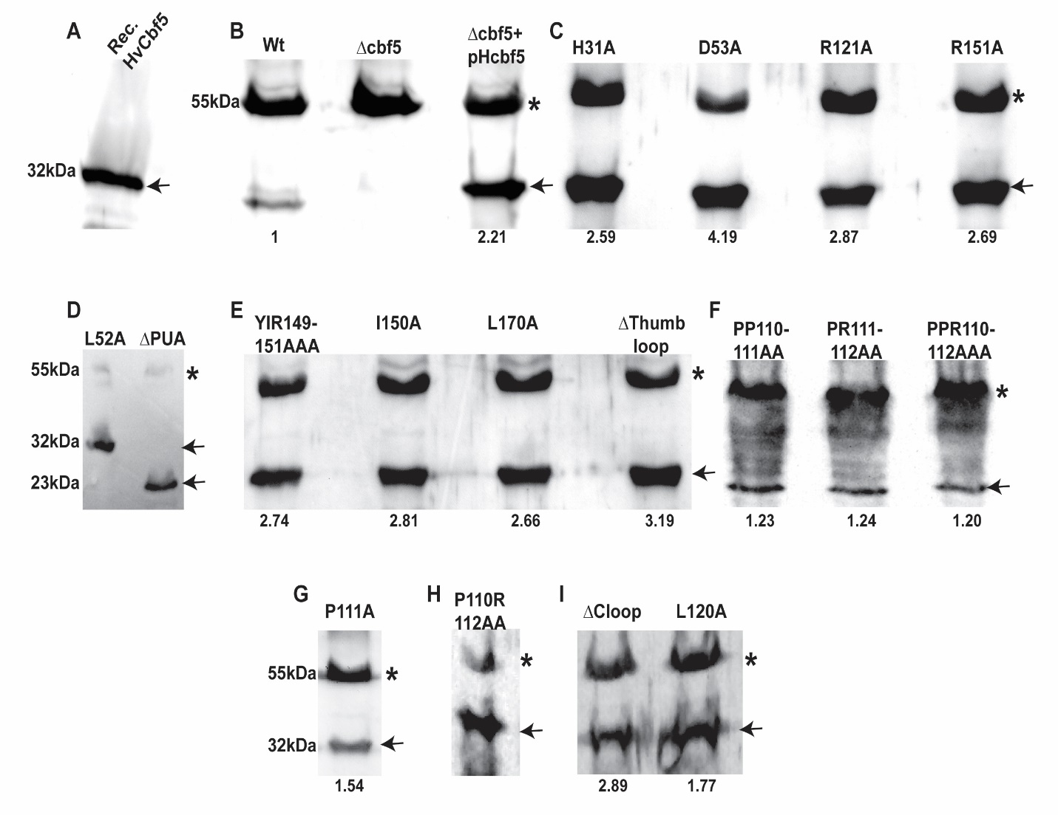
Supplementary Figure S2. Western blot analyses to check the expression of inactive mutant HvCbf5. Analyses of proteins that either failed to modify U at any of the three positions (1940, 1942, and 2605) of 23S rRNA or modified U1940 and U2605, but not U1942. Anti-HvCbf5 antibody was used to probe the blots. 10% polyacrylamide gels were used for SDS-PAGE. Each panel (A-I) is from an independent Western blot. (A) Recombinant protein used to raise antibodies. (B) Extracts of H. volcanii cells: WT - wild type, Δcbf5 - genomic cbf5 gene deleted, and Δcbf5+pHcbf5 - Δcbf5 containing plasmid-borne copy of WT cbf5 gene. (C-I) Extracts of Δcbf5 cells containing plasmid-borne copy of mutant cbf5 gene. Labels above each lane indicate the mutation. Positions of Cbf5 protein bands (full-length about 32 kDa) are marked with arrows. A band (marked with asterisks) for an unidentified protein (approximately 55 kDa) was always observed in H. volcanii cell extracts. It is used here as a loading control and band intensity of HvCbf5 is calculated relative to this protein. Calculated amounts are indicated below each lane. (Calculations are not done for panels D and H, because transfer of proteins from the gel was not uniform.)

Supplementary Table S1 - List of Oligonucleotides used in this work and their functions

Oligonucleotide | Sequence | Purpose
In vivo assay for Catalytic core mutation

VCBF-D53A-F | CCC ACT CGG GAA CGC TCG CCC CGA AGG TGA CCG GCT G | Forward primer to change catalytic Asp53 (GAC) of HvCbf5 gene to Ala (GCC)
VCBF-D53A-R | CAG CCG GTC ACC TTC GGG GCG AGC GTT CCC GAG TGG G | Reverse primer to change catalytic Asp53 (GAC) of HvCbf5 gene to Ala (GCC)
VCBF-Y81A-F | CCT CGA AGG CTC GAA AGA GGC CGT CTC CGT GCT CGA ACT CCA C | Forward primer to change Tyr81 (TAC) of HvCbf5 gene to Ala (GCC)
VCBF-Y81A-R IDT (10/11) | GTG GAG TTC GAG CAC GGA GAC GGC CTC TTT CGA GCC TTC GAG G | Forward primer to change Tyr81 (TAC) of HvCbf5 gene to Ala (GCC)
VCBF-I150A-F IDT (10/11) IDT (10/11) | CTG TGA GTC GGG CAC GTA CGC CCG CAA GCT GTG TCA CGA CC | Forward primer to change Ile150 (ATC) of HvCbf5 gene to Ala (GCC)
VCBF-I150A-R | GGT CGT GAC ACA GCT TGC GGG CGT ACG TGC CCG ACT CAC AG | Reverse primer to change Ile150 (ATC) of HvCbf5 gene to Ala (GCC)
VCBF-R151A-F | GTG AGT CGG GCA CGT ACA TCG CCA AGC TGT GTC ACG ACC TCG G | Forward primer to change Arg151 (CGC) of HvCbf5 gene to Ala (GCC)
VCBF-R151A-R | CCG AGG TCG TGA CAC AGC TTG GCG ATG TAC GTG CCC GAC TCA C | Reverse primer to change Arg151 (CGC) of HvCbf5 gene to Ala (GCC)
VCBF-L170A-F IDT (10/11) | GCG GCC ACA TGG GCC ACG CGC GCC GGA CCG CGA CCG AC | Forward primer to change Leu170 (CTG) of HvCbf5 gene to Ala (GCG)
VCBF-L170A-R IDT (10/11) | GTC GGT CGC GGT CCG GCG CGC GTG GCC CAT GTG GCC GC | Reverse primer to change Leu170 (CTG) of HvCbf5 gene to Ala (GCG)
In vivo assay for RNA-Protein Interaction

VCBF-D23A-F | CGG CGT CGT CAA CCT CGC CAA GCC GCC GGG GC | Forward primer to change Asp23 (GAC) of HvCbf5 gene to Ala (GCC)
VCBF-D23A-R | GCC CCG GCG GCT TGG CGA GGT TGA CGA CGC CG | Reverse primer to change Asp23 (GAC) of HvCbf5 gene to Ala (GCC)

Supplementary Table S1 (Continued)

VCBF-H31A-F IDT (10/1 | CGC CGG GGC CGT CGG CCG CCC AGG TCA CCG GCT GGG TC | Forward primer to change His31(CAC) of HvCbf5 gene to Ala (GCC)
VCBF-H31A-R | GAC CCA GCC GGT GAC CTG GGC GGC CGA CGG CCC CGG CG | Reverse primer to change His31(CAC) of HvCbf5 gene to Ala (GCC)
VCBF-H48A-F | GAC GTC GAC CGC GCC GCC GCC TCG GGA ACG CTC GAC CCG | Forward primer to change His48 (CAC) of HvCbf5 gene to Ala (GCC)
VCBF-H48A-R | CGG GTC GAG CGT TCC CGA GGC GGC GGC GCG GTC GAC GTC | Reverse primer to change His48 (CAC) of HvCbf5 gene to Ala (GCC)
VCBF-L52A-F | GCC CAC TCG GGA ACG GCC GAC CCG AAG GTG ACC | Forward primer to change Leu52 (CTC) of HvCbf5 gene to Ala (GCC)
VCBF-L52A-R | GGT CAC CTT CGG GTC GGC CGT TCC CGA GTG GGC | Reverse primer to change Leu52 (CTC) of HvCbf5 gene to Ala (GCC)
VCBF-D53E-F | CCC ACT CGG GAA CGC TCG AGC CGA AGG TGA CCG GCT G | Forward primer to change catalytic Asp53 (GAC) of HvCbf5 gene to Ala (GCC)
VCBF-D53E-R | CAG CCG GTC ACC TTC GGC TCG AGC GTT CCC GAG TGG G | Reverse primer to change catalytic Asp53 (GAC) of HvCbf5 gene to Ala (GCC)
VCBF-Y149A-F | CCG CTG TGA GTC GGG CAC GGC CAT CCG CAA GCT GTG TCA CG | Forward primer to change Tyr149 (TAC) of HvCbf5 gene to Ala (GCC)
VCBF-Y149A-R | CGT GAC ACA GCT TGC GGA TGG CCG TGC CCG ACT CAC AGC GG | Reverse primer to change Tyr149 (TAC) of HvCbf5 gene to Ala (GCC)
VCBF-YIR149/51R | CCG CTG TGA GTC GGG CAC GGC CGC CGC GAA GCT GTG TCA CGA CCT CGG CC | Forward primer to change Tyr149, Ile150 and Arg151 (TACATCCGC) of HvCbf5 gene to three Ala (GCCGCCGCG)
VCBF-YIR149/51-R | GGC CGA GGT CGT GAC ACA GCT TCG CGG CGG CCG TGC CCG ACT CAC AGC GG | Reverse primer to change Tyr149, Ile150 and Arg151 (TACATCCGC) of HvCbf5 gene to three Ala (GCCGCCGCG)
VCBFdPUA-F IDT (2/13 | CGC CCG CCG AGC GAG CGC TGT CGC ACC ATC ATC ATC ATC ATC ACT AGT GAG AAT TCC TGC | Forward primer to delete PUA domain in HvCbf5 gene already cloned in pBluescript KS⁺, contains His-tag
VCBFdPUA-R | GCA GGA ATT CTC ACT AGT GAT GAT GAT GAT GAT GGT GCG ACA GCG CTC GCT CGG CGG GCG | Reverse primer to delete PUA domain in HvCbf5 gene already cloned in pBluescript KS⁺, contains His-tag

Supplementary Table S1 (Continued)

MJCBFdPUA-F IDT (2/13) | GTT ATA AAG CCA ATG GAG TAT GGG TTA AGG CAT AAG AGG AAG AAG TAA TGA ATT CGA GC | Forward primer to delete PUA domain in M. jannaschii cbf5 gene already cloned in pET-28a
MJCBFdPUA-R | GCT CGA ATT CAT TAC TTC TTC CTC TTA TGC CTT AAC CCA TAC TCC ATT GGC TTT ATA AC | Reverse primer to delete PUA domain in M. jannaschii cbf5 gene already cloned in pET-28a
In vivo assay for Protein-Protein Interaction

VCBF-K24A-F IDT (3/13) | GCG TCG TCA ACC TCG ACG CGC CGC CGG GGC CG | Forward primer to change Lys24 (AAG) of HvCbf5 gene to Ala (GCG)
VCBF-K24A-R | CGG CCC CGG CGG CGC GTC GAG GTT GAC GAC GC | Reverse primer to change Lys24 (AAG) of HvCbf5 gene to Ala (GCG)
VCBF-P25A-F IDT (10/11) | CGT CGT CAA CCT CGA CAA GGC GCC GGG GCC GTC GGC CC | Forward primer to change Pro25 (CCG) of HvCbf5 gene to Ala (GCG)
VCBF-P25A-R IDT (10/11) IDT (10/11) | GGG CCG ACG GCC CCG GCG CCT TGT CGA GGT TGA CGA CG | Reverse primer to change Pro25 (CCG) of HvCbf5 gene to Ala (GCG)
VCBF-P28A-F | CTC GAC AAG CCG CCG GGG GCG TCG GCC CAC CAG GTC ACC | Forward primer to change Pro28 (CCG) of HvCbf5gene to Ala (GCG)
VCBF-P28A-R | GGT GAC CTG GTG GGC CGA CGC CCC CGG CGG CTT GTC GAG | Reverse primer to change Pro28 (CCG) of HvCbf5 gene to Ala (GCG).
VCBF-W36A-F | CCA CCA GGT CAC CGG CGC GGT CCG CGA CAT GG | Forward primer to change Trp36 (TGG) of HvCbf5 gene to Ala (GCG)
VCBF-W36A-R | CCA TGT CGC GGA CCG CGC CGG TGA CCT GGT GG | Reverse primer to change Trp36 (TGG) of HvCbf5 gene to Ala (GCG)
VCBF-P54A-F | CCA CTC GGG AAC GCT CGA CGC GAA GGT GAC CGG CTG TCT ACC | Forward primer to change Pro54 (CCG) of HvCbf5gene to Ala (GCG)
VCBF-P54A-R | GGT AGA CAG CCG GTC ACC TTC GCG TCG AGC GTT CCC GAG TGG | Reverse primer to change Pro54 (CCG) of HvCbf5 gene to Ala (GCG)
VCBF-P110A-F IDT (7/12) | CGA AGC TCT ACC AGA AGG CCC CGC GGA AGT CCG C | Forward primer to change Pro110 (CCC) of HvCbf5 gene to Ala (GCC)

Supplementary Table S1 (Continued)

VCBF-P110A-R | GCG GAC TTC CGC GGG GCC TTC TGG TAG AGC TTC G | Reverse primer to change Pro110 (CCC) of HvCbf5 gene to Ala (GCC)
VCBF-P111A-F | GCT CTA CCA GAA GCC CGC GCG GAA GTC CGC CGT CTC G | Forward primer to change Pro111 (CCG) of HvCbf5 gene to Ala (GCG)
VCBF-P111A-R | CGA GAC GGC GGA CTT CCG CGC GGG CTT CTG GTA GAG C | Reverse primer to change Pro111 (CCG) of HvCbf5 gene to Ala (GCG)
VCBF-R112A-F IDT (7/12 | CTA CCA GAA GCC CCC GGC GAA GTC CGC CGT CTC GC | Forward primer to change Arg112 (CGG) of HvCbf5 gene to Ala (GCG)
VCBF-R112A-R | GCG AGA CGG CGG ACT TCG CCG GGG GCT TCT GGT AG | Reverse primer to change Arg112 (CGG) of HvCbf5 gene to Ala (GCG)
VCBF-PP 110/11AA-F IDT (7/12). | CGA AGC TCT ACC AGA AGG CCG CGC GGA AGT CCG CCG TCT C | Forward primer to change Pro110 and Pro111 (CCCCCG) of HvCbf5 gene to two Ala (GCCGCG)
VCBF-PP 110/11AA-R | GAG ACG GCG GAC TTC CGC GCG GCC TTC TGG TAG AGC TTC G | Reverse primer to change Pro110 and Pro111 (CCCCCG) of HvCbf5 gene to two Ala (GCCGCG)
VCBF-PR111/12AA-F | GCT CTA CCA GAA GCC CGC GGC GAA GTC CGC CGT CTC GC | Forward primer to change Pro111 and Arg112 (CCGCGG) of HvCbf5 gene to two Ala (GCGGCG)
VCBF-PR 111/12AA-R | GCG AGA CGG CGG ACT TCG CCG CGG GCT TCT GGT AGA GC | Reverse primer to change Pro111 and Arg112 (CCGCGG) of HvCbf5 gene to two Ala (GCGGCG)
VCBF-PR 110/12AA-F IDT (9/12) | CGA AGC TCT ACC AGA AGG CCC CGG CGA AGT CCG CCG TCT CGC | Forward primer to change Pro110 and Arg112 (CCC/CGG) of HvCbf5 gene to two Ala (GCC/GCG)
VCBF-PR 110/12AA-R | GCG AGA CGG CGG ACT TCG CCG GGG CCT TCT GGT AGA GCT TCG | Reverse primer to change Pro110 and Arg112 (CCC/CGG) of HvCbf5 gene to two Ala (GCC/GCG)
VCBF-PPR 110/12A-F IDT (4/12) | CGA ATC GAA GCT CTA CCA GAA GGC CGC GGC GAA GTC CGC CGT CTC GCG C | Forward primer to change Pro110, Pro111 and Arg112 (CCCCCGCGG) of HvCbf5 gene to three Ala (GCCGCGGCG)
VCBF-PPR 110/12A-R | GCG CGA GAC GGC GGA CTT CGC CGC GGC CTT CTG GTA GAG CTT CGA TTC G | Reverse primer to change Pro110, Pro111 and Arg112 (CCCCCGCGG) of HvCbf5 gene to three Ala (GCCGCGGCG)

Supplementary Table S1 (Continued)

VCBF-d115/117-F IDT (10/12). | GCC CCC GCG GAA GTC CCG CCG CCT CCG CGT CCG | Forward primer to delete aa 115-117 (AVS) from HvCbf5 gene
VCBF-d115/117-R | CGG ACG CGG AGG CGG CGG GAC TTC CGC GGG GGC | Reverse primer to delete aa 115-117 (AVS) from HvCbf5 gene
VCBF-VS 116/17AA-F | GCG GAA GTC CGC CGC CGC GCG CCG CCT CCG CG | Forward primer to change Val116 and Ser117 (GTCTCG) of HvCbf5 gene to two Ala (GCCGCG)
VCBF-VS 116/17AA-R | CGC GGA GGC GGC GCG CGG CGG CGG ACT TCC GC | Reverse primer to change Val116 and Ser117 (GTCTCG) of HvCbf5 gene to two Ala (GCCGCG)
VCBF-L120A-F IDT (4/12 | CCG TCT CGC GCC GCG CCC GCG TCC GCG AAA TCC ACG | Forward primer to change Leu120 (CTC) of HvCbf5 gene to Ala (GCC)
VCBF-L120A-R | CGT GGA TTT CGC GGA CGC GGG CGC GGC GCG AGA CGG | Reverse primer to change Leu120 (CTC) of HvCbf5 gene to Ala (GCC)
VCBF-R121A-F | CCG TCT CGC GCC GCC TCG CGG TCC GCG AAA TCC ACG ACC | Forward primer to change Arg121 (CGC) of HvCbf5 gene to Ala (GCG)
VCBF-R121A-R | GGT CGT GGA TTT CGC GGA CCG CGA GGC GGC GCG AGA CGG | Reverse primer to change Arg121 (CGC) of HvCbf5 gene to Ala (GCG)
VCBF-H169A-F IDT (4/ | GCG GCC ACA TGG GCG CCC TGC GCC GGA CCG C | Forward primer to change His169 (CAC) of HvCbf5 gene to Ala (GCC)
VCBF-H169A-R | GCG GTC CGG CGC AGG GCG CCC ATG TGG CCG C | Reverse primer to change His169 (CAC) of HvCbf5 gene to Ala (GCC)
VCBF-R171A-F | CCA CAT GGG CCA CCT GGC CCG GAC CGC GAC CG | Forward primer to change Arg171 (CGC) of HvCbf5 gene to Ala (GCC)
VCBF-R171A-R | CGG TCG CGG TCC GGG CCA GGT GGC CCA TGT GG | Reverse primer to change Arg171 (CGC) of HvCbf5 gene to Ala (GCC)
VCBF-d108/123-F IDT (7/11) | CGC CGA GTT CGA ATC GAA GCT CTA CGA AAT CCA CGA CCT CGA CCT CC | Forward primer to delete aa 108-123 from HvCbf5 gene
VCBF-d108/123-R | GGA GGT CGA GGT CGT GGA TTT CGT AGA GCT TCG ATT CGA ACT CGG CG | Reverse primer to delete aa 108-123 from HvCbf5 gene

Supplementary Table S1 (Continued)

In vivo assay for DC mutations in Cbf5

VCBF-S49G-F2 IDT (3/12) IDT (3/12) | CGA CCG CGC CGC CCA CGG TGG AAC GCT CGA CCC G | Forward primer to change Ser49 (TCG) of HvCbf5 gene to Gly (GGT)
VCBF-S49G-R2 | CGG GTC GAG CGT TCC ACC GTG GGC GGC GCG GTC G | Reverse primer to change Ser49 (TCG) of HvCbf5 gene to Gly (GGT)
VCBF-S49A-F IDT (3/12) | CGA CCG CGC CGC CCA CGC GGG AAC GCT CGA CCC G | Forward primer to change Serine49 (TCG) of HvCbf5 gene to Ala (GCG)
VCBF-S49A-R | CGG GTC GAG CGT TCC CGC GTG GGC GGC GCG GTC G | Reverse primer to change Serine49 (TCG) of HvCbf5 gene to Ala (GCG)
VCBF-S202A-F IDT (3/12) IDT (3/12) | GCG GAG GGC GAC GAG GCG TGG CTG CGC GAC G | Forward primer to change Serine202 (TCG) of HvCbf5 gene to Ala (GCG)
VCBF-S202A-R | CGT CGC GCA GCC ACG CCT CGT CGC CCT CCG C | Reverse primer to change Serine202 (TCG) of HvCbf5 gene to Ala (GCG)
VCBF-S202R-F | GCG GAG GGC GAC GAG CGG TGG CTG CGC GAC G | Forward primer to change Serine202 (TCG) of HvCbf5 gene to Arg (CGG)
VCBF-S202R-R | CGT CGC GCA GCC ACC GCT CGT CGC CCT CCG C | Reverse primer to change Serine202 (TCG) of HvCbf5 gene to Arg (CGG)
VCBF-D277A-F | GGC GAC GCC GAC GCC GCC TCC GGC GAG GTC GTC TCG | Forward primer to change Asp277 (GAC) of HvCbf5 gene to Ala (GCC)
VCBF-D277A-R | CGA GAC GAC CTC GCC GGA GGC GGC GTC GGC GTC GCC | Reverse primer to change Asp277 (GAC) of HvCbf5 gene to Ala (GCC)
VCBF-D277N-F IDT (3/12) | GGC GAC GCC GAC GCC AAC TCC GGC GAG GTC GTC TCG | Forward primer to change Asp277 (GAC) of HvCbf5 gene to Asn (AAC).
VCBF-D277N-R | CGA GAC GAC CTC GCC GGA GTT GGC GTC GGC GTC GCC | Reverse primer to change Asp277 (GAC) of HvCbf5 gene to Asn (AAC).

Supplementary Table S1 (Continued)

In vivo assay for residues found only in archaea

VCBF-R119Q-F | GTC CGC CGT CTC GCG CCA GCT CCG CGT CCG CGA AAT CC |  | Forward primer to change Arg119 (CGC) of HvCbf5 gene to Gln (CAG)
VCBF-R119Q-R | GGA TTT CGC GGA CGC GGA GCT GGC GCG AGA CGG CGG AC |  | Reverse primer to change Arg119 (CGC) of HvCbf5 gene to Gln (CAG)
VCBF-R119A-F | GTC CGC CGT CTC GCG CGC CCT CCG CGT CCG CGA AAT CC |  | Forward primer to change Arg119 (CGC) of HvCbf5 gene to Ala (GCC)
VCBF-R119A-R | GGA TTT CGC GGA CGC GGA GGG CGC GCG AGA CGG CGG AC |  | Reverse primer to change Arg119 (CGC) of HvCbf5 gene to Ala (GCC)
VCBF-H155A-F IDT (7/12) | GTA CAT CCG CAA GCT GTG TGC CGA CCT CGG CCT CGC GCT C |  | Forward primer to change His155 (CAC) of HvCbf5 gene to Ala (GCC)
VCBF-H155A-R | GAG CGC GAG GCC GAG GTC GGC ACA CAG CTT GCG GAT GTA C |  | Reverse primer to change His155 (CAC) of HvCbf5 gene to Ala (GCC)
Primer extension

HVLSUR1 |  | GCAAGGTACTACGCTACC | To characterize Ψ1940 and  Ψ1942 of 23S rRNA
HVLSUR2 |  | GCAGCCGACCTGTCTC | To characterize Ψ2605 of  23S rRNA

