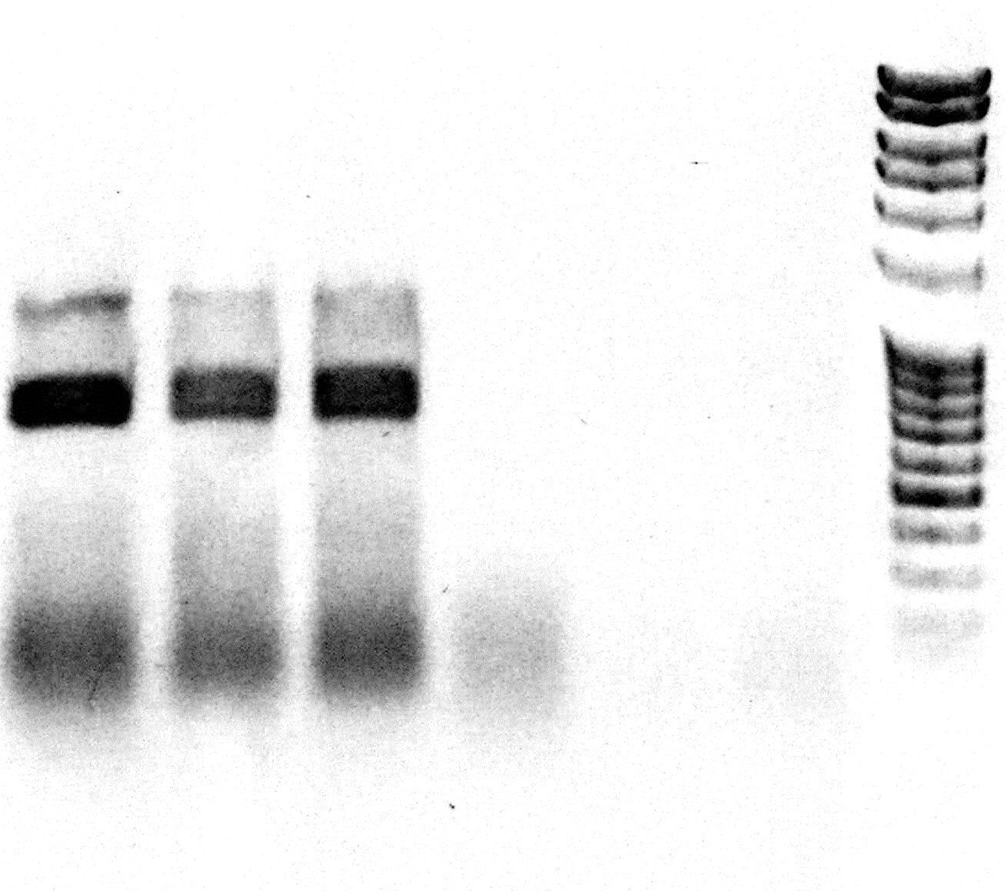
Supplementary figure 3
1500 bp
500 bp
1000 bp
57 °C 59 °C 61 °C -RT H₂0 DNA

Supplementary figure 3. PCR amplification of the spliced out and retrotranscribed rpl2i846g2 lariat of Anemia phyllitidis. The RT-PCR was performed with three different annealing temperatures. As negative controls samples without Maxima Reverse Transcriptase (-RT), water instead of template (H₂O) and with DNA as template were used. Negative controls were incubated at 59°C annealing temperature.

