SUPPLEMENTAL FIGURES FOR:

mRNA bound to the 30S subunit is a HigB toxin substrate

Content:
Supplemental figures S1 & S2
Marc A. Schureck, Tatsuya Maehigashi, Stacey J. Miles, Jhomar Marquez and Christine M. Dunham*

Emory University School of Medicine, Department of Biochemistry, 1510 Clifton Road NE,
Room G223, Atlanta, GA 30322 USA
*Correspondence to christine.m.dunham@emory.edu, phone +1 404-712-1756,
fax +1 404-727-2738

Data deposition: Crystallography, atomic coordinates, and structure factors have been deposited in the Protein Data Bank, www.pdb.org (PDB code 4YY3)

Running title: 30S-HigB toxin interactions

Keywords: toxin-antitoxin modules, stringent response, RNase, ribosome, protein synthesis, mRNA

SUPPLEMENTAL FIGURES & LEGENDS

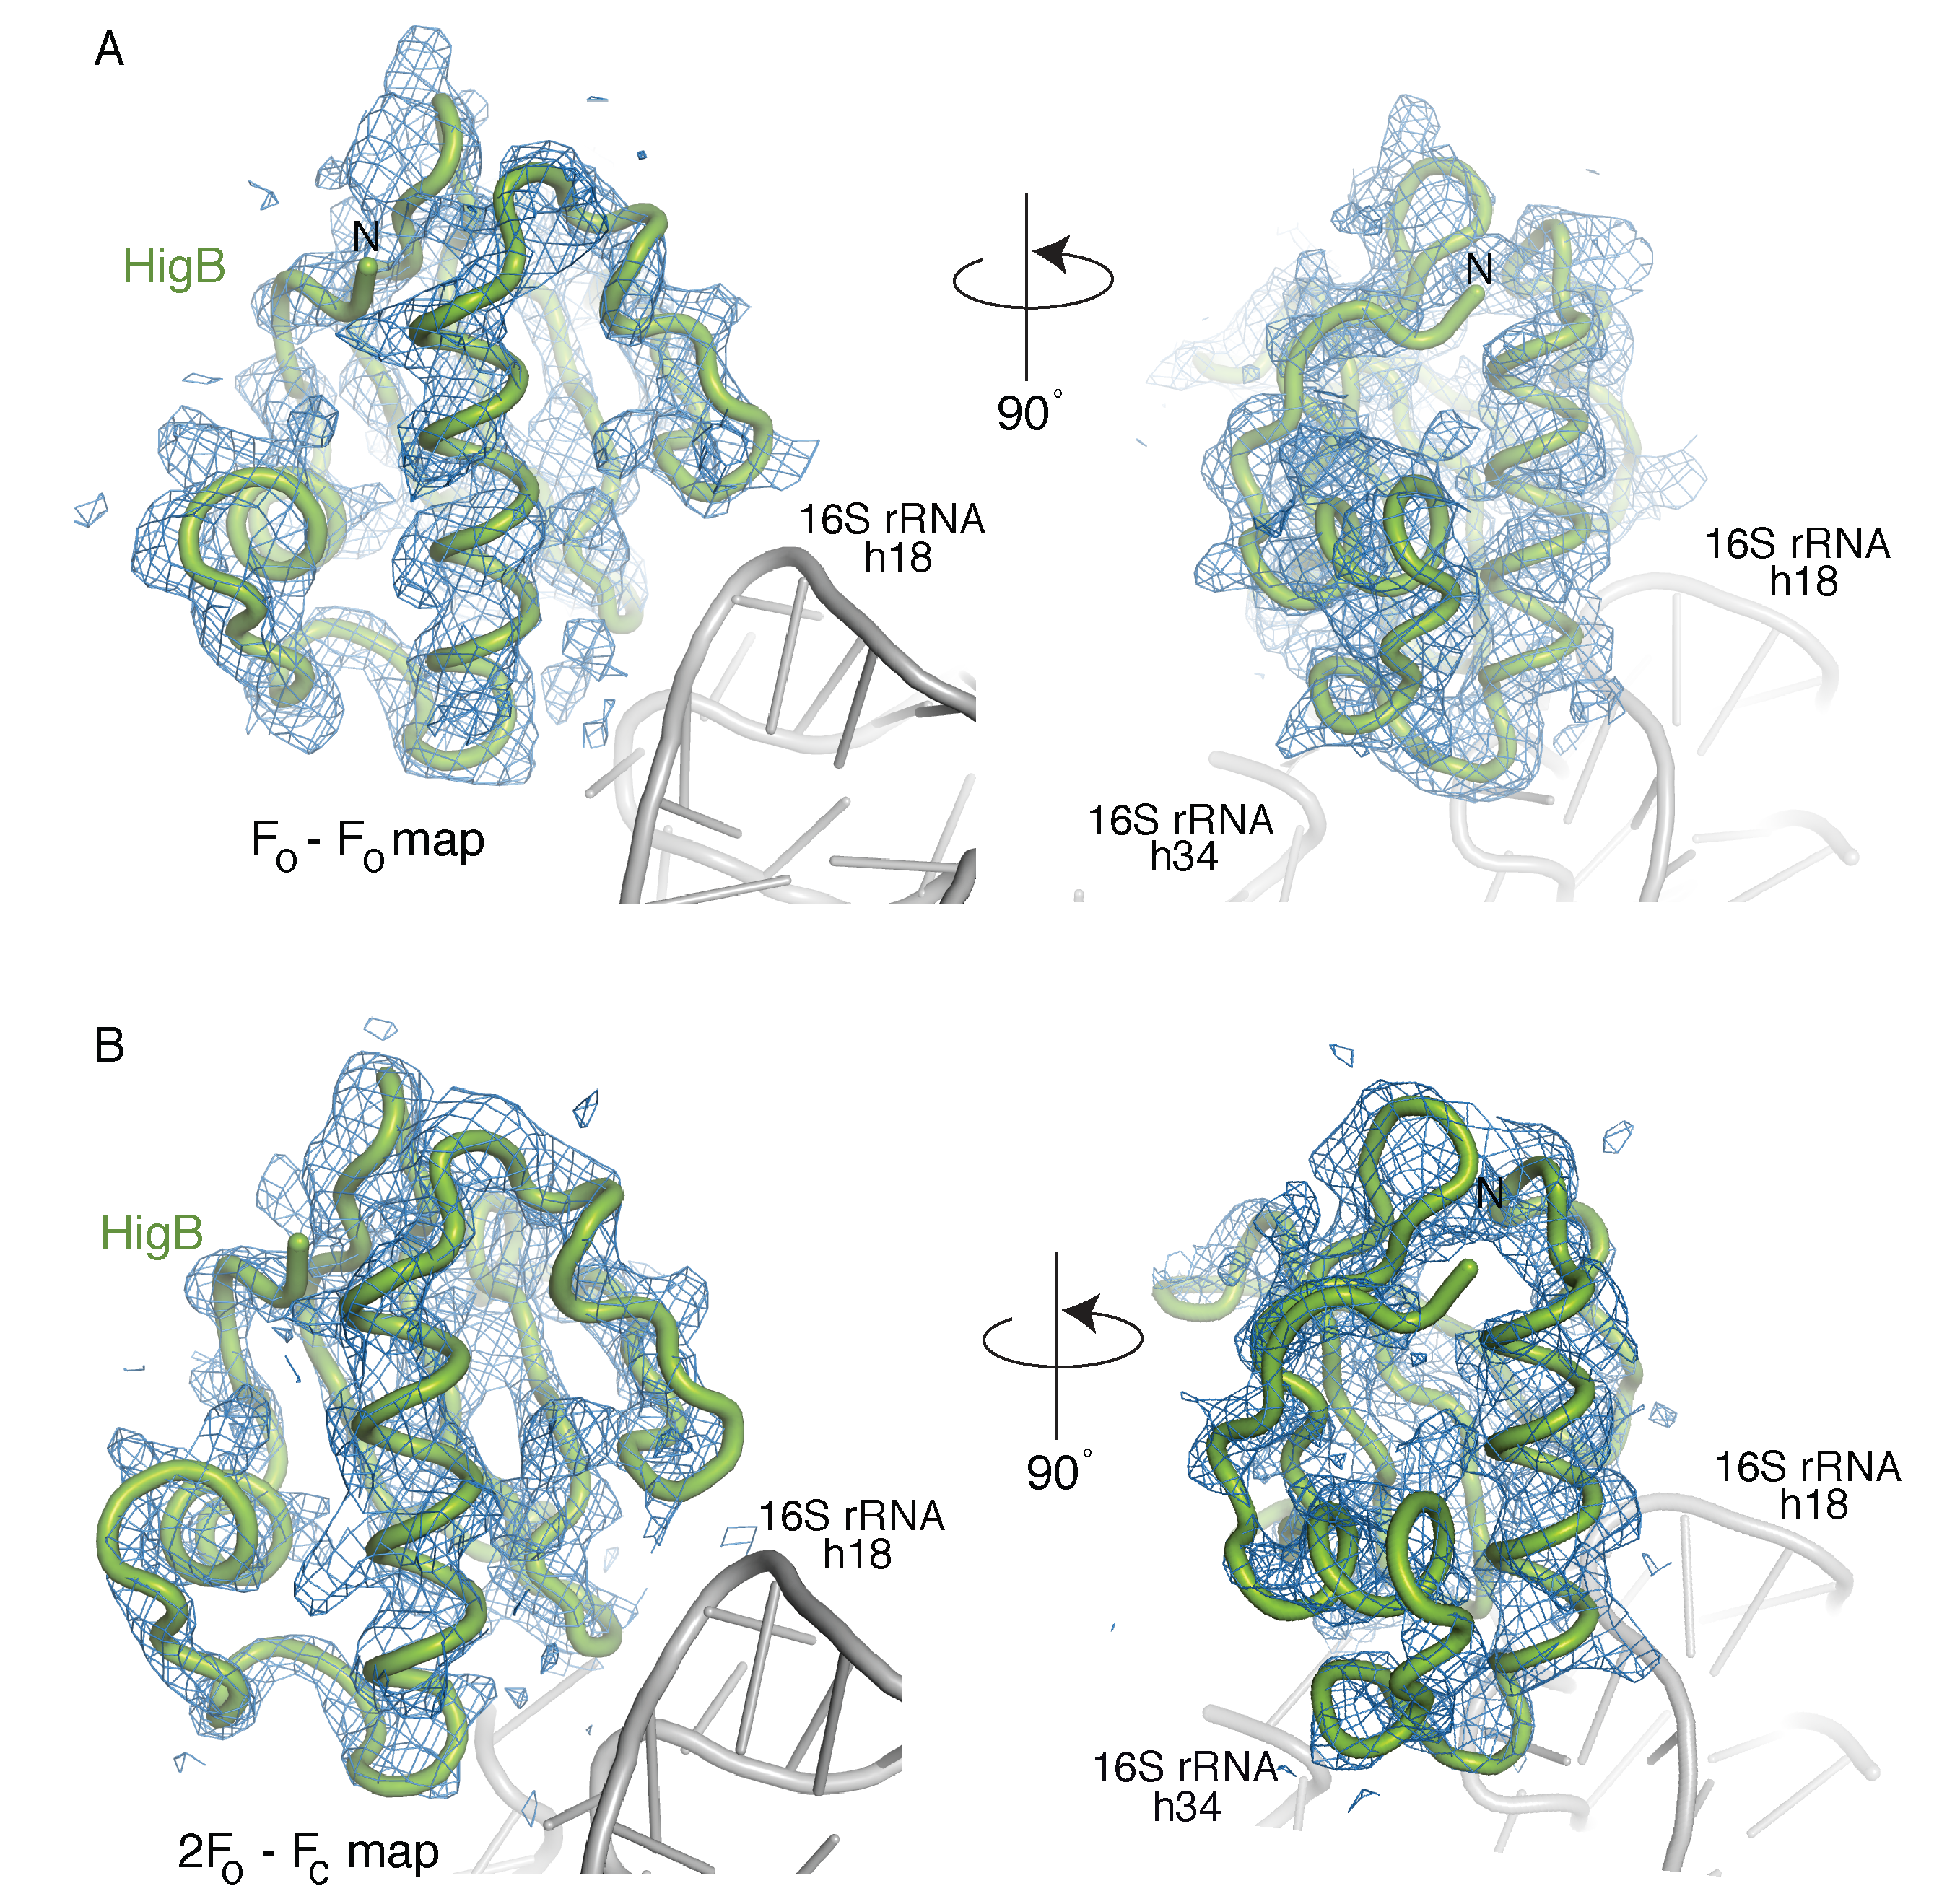
Supplementary Fig. S1. Electron density maps of HigB bound to the 30S subunit. A 3.6-Å X-ray crystal structure of the 30S-HigB toxin. A) Unbiased F_{obs}-F_{obs} difference electron density (contoured to 1.5σ) of the HigB toxin with a 90° rotation (right panel). B) 2F_{obs}-F_{calc} electron density for HigB (contoured to 1.0σ) with a 90° rotation (right panel).

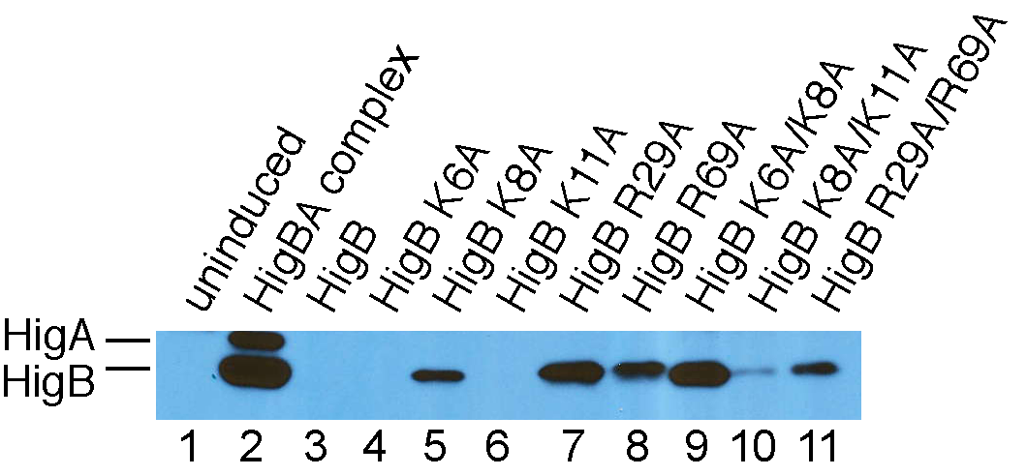

Supplementary Fig. S2. Western blot analysis of the soluble fraction from E. coli growth assays upon overexpression of wild-type HigB and HigB variants. Aliquots at 4 hrs postinduction of wild-type HigB or HigB variants were collected, cells were lysed, debris was removed by centrifugation, and the soluble fraction were resolved by SDS-PAGE. The expression of HigB was determined by using polyclonal antibodies against the HigBA toxin-antitoxin complex. Overexpression of wild-type HigB halts cell growth and no soluble HigB protein is detected (lane 3) likely due to the effect of HigB-mediated translational repression similar to overexpression of the MqsR toxin (Brown et al. 2009). Recombinant HigBA complex is shown as a standard in lane 2 where HigA(His)6 and HigB are 13.5 and 10.7 kDa, respectively.

REFERENCES
Brown BL, Grigoriu S, Kim Y, Arruda JM, Davenport A, Wood TK, Peti W, Page R. 2009. Three dimensional structure of the MqsR:MqsA complex: a novel TA pair comprised of a toxin homologous to RelE and an antitoxin with unique properties. PLoS Pathog 5: e1000706.

