SUPPORTING INFORMATION
Profiling ribonucleotide modifications at full-transcriptome level: a step towards MS-based epitranscriptomics
Rebecca E. Rose, Ryan Quinn, Jackie L. Sayre, and Daniele Fabris*
The RNA Institute, University at Albany (SUNY)

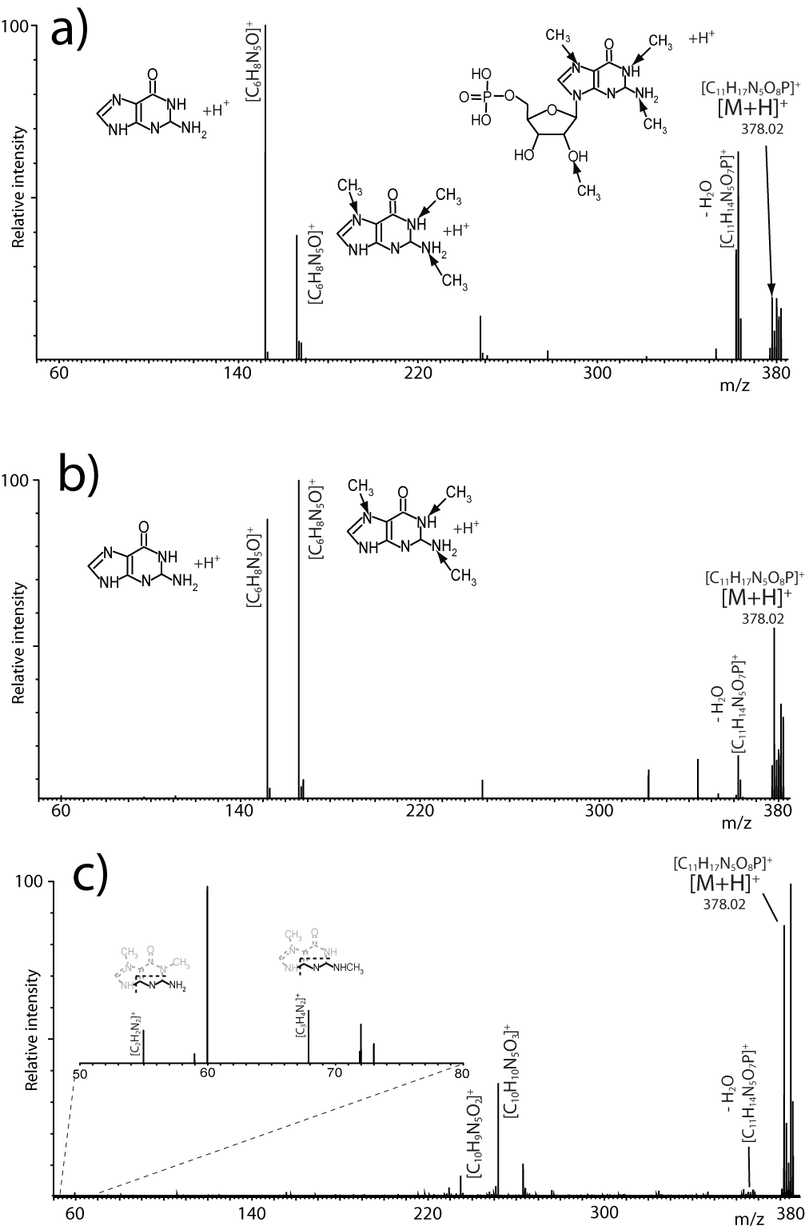
Figure S1. Product ion spectra obtained at the a) 3.672, b) 3.825, and c) 4.246 ms intervals of a mass-selected time-resolved dissociation experiment in which the precursor ion at m/z 378 was isolated in the mass-selective quadrupole, dispersed in the ion mobility element, and activated before final mass analysis. As described earlier for the LTQ-orbitrap experiments, the facile cleavage of the N-glycosidic bond enabled the discrimination of the Gm isomer with methylation on the ribose moiety, which provided an unmethylated purine fragment, from the remaining isomers that produced methylated purine fragments. Weaker signals characteristic of further cleavage of the purine system confirmed the presence of the remaining isomers. It should be noted that the selected time intervals displayed different abundances for the signals corresponding to methylated/unmethylated purine moieties, which were consistent with partial overlap between isomers on the time scale. The contributions of the individual isomers were recognized by employing reconstructed ion chromatograms (RICs) of unique diagnostic fragments (see Fig. 4).

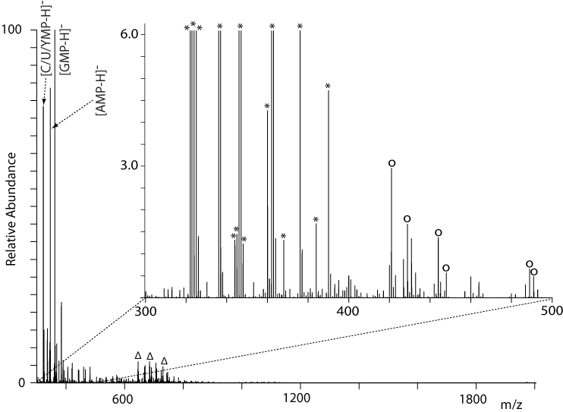Figure S2. ESI-MS spectrum of digestion mixture obtained in negative ion mode from S. cerevisiae tRNA^{Phe}. The enlargement shows the region containing the majority of the PTMs. Signals marked with * are hits from our custom modifications registry; Δ proton-bound dimers of the most abundant species in the spectrum; o species detected also in the blank. No undigested tRNA^{Phe} was observed in the high m/z range.

Species | Exp. mass (u) | Equivalent per mole | ¹Detection limit (mol) | ²Response  (m, q) | ³Theoretical AvP (%) | ³Experimental AvP (%)
C | 323.0519 | 15 | 3.44 x10⁻¹⁷ | 1.61 x10¹¹, 5.01 | 24.7 | 24.6
U/Ѱ | 323.0279 | 14 | 2.68 x10⁻¹⁷ | 1.53 x10¹¹, 2.03 x10¹ | 21.9 | 21.6
D | 326.0514 | 2 | 1.80 x10⁻¹⁷ | 1.82 x10¹¹, 3.01 x10¹ | 3.73 | 3.75
m³C, m⁵C, Cm | 337.0674 | 3 | 5.50 x10⁻¹⁷ | 1.41 x10¹¹, 8.00 x10¹ | 4.33 | 4.34
A | 347.0630 | 17 | 9.58 x10⁻¹⁷ | 1.31 x10¹¹, 9.20 | 22.8 | 22.1
m¹A | 361.0787 | 1 | 9.29 x10⁻¹⁷ | 3.52 x10¹⁰, 3.03 x10¹ | 3.60 x10⁻¹ | 3.75 x10⁻¹
G | 363.0579 | 18 | 1.55 x10⁻¹⁷ | 1.71 x10¹¹, 3.78 x10¹ | 31.5 | 31.7
m²G, Gm | 377.0718 | 3 | 5.29 x10⁻¹⁸ | 1.24 x10¹¹, 5.88 x10¹ | 3.81 | 3.61
m²₂G | 391.0892 | 1 | 2.44 x10⁻¹⁷ | 1.71 x10¹¹, 2.07 x10¹ | 1.75 | 1.60
yW | 588.1571 | 1 | 4.14 x10⁻¹⁷ | 1.10 x10¹¹, 1.71 x10¹ | 1.13 | 1.16
Table S1. Figures of merit obtained from the analysis of isolated tRNA^{Phe} from S. cerevisiae (Fig. 2S). The abbreviation for each ribonucleotide is provided together with the corresponding monoisotopic neutral mass in mass units (u) and the number of equivalents present in each mole of initial tRNA^{Phe}.
¹The limit of detection (LOD) was obtained by calculating the moles of each ribonucleotide, which provided at least a 3:1 signal to noise ratio. The results are the average of five repeat determinations. The calculation accounted for an average of ~0.093 μL sample consumption during ESI-MS analysis and a ~25% sample recovery for the entire work flow (see Materials and Methods).
²The response for each ribonucleotide was calculated by averaging the signals of five repeat determinations for samples with decreasing concentration of tRNA^{Phe}. Each signal average was plotted against the respective concentration to obtain signal/concentration curves with the indicated slopes (m in counts/M) and intercepts (q in counts).
³For each ribonucleotide, the value of abundance versus proxy (AvP) was calculated by dividing the respective intensity by the sum of the intensities of the four canonic ribonucleotides (see Materials and Methods). The experimental AvP was calculated directly from the ESI-MS data. The theoretical value was obtained from the intensity that would be expected from the analysis of exactly 1 M of tRNA^{Phe}, which was calculated by substituting the equivalents per mole of each species into the respective response curve. The excellent match between theoretical and experimental justifies the utilization of AvP to monitor fluctuations of PTM expression (see Results and Discussion).

Hit | Exp. mass (u) | Average AvP (%) | Deviation (%)¹
C | 323.0519 | 21.4 | +2.40 x10⁻¹
Ѱ, U | 324.0357 | 22.1 | -15.0
D | 326.0510 | 2.27 x10⁻¹ | +1.68 x10²
m³C, m⁵C, Cm, m⁴C | 337.0673 | 8.08 x10⁻² | 173
m³Ѱ, Um, m⁵U, m¹Ѱ, Ѱm, m³U | 338.0513 | 2.44 x10⁻¹ | 134
A | 347.0628 | 25.7 | -7.95
I | 348.0468 | 3.54 x10⁻³ | 190
m⁵Cm, m⁴Cm, m⁴₄C | 351.0830 | 1.31 x10⁻² | NA
mo⁵U | 354.0463 | 3.53 x10⁻³ | NA
G | 363.0575 | 30.8 | -5.61
ac⁴C, f⁵Cm | 365.0617 | 4.95 x10⁻¹ | 14.3
mnm⁵U | 367.0776 | 2.86 x10⁻³ | NA
m¹G, m²G, m⁷G, Gm | 377.0720 | 2.26 x10⁻¹ | 141
cmo⁵U, chm⁵U | 398.0362 | 1.58 x10⁻¹ | NA
Table S2. Hits provided by a total RNA extract from E. coli grown in synthetic complete medium (SC).
¹ Deviation from the average AvP obtained for the same PTM in S. cerevisiae grown in SC under identical conditions.

