SUPPLEMENTAL INFORMATION

SNAP reaction kinetics
Since the assay is intended to measure kinetics of translation, it must be confirmed that the rate of reaction between SNAP_{f} and its substrate is much more rapid than the rate of ribosome turnover. To this end, 5 μM of SNAP purified protein was reacted with 60 μM of CBG-549-QSY7 or CBG-488-TQ2 at 37 °C in the PURExpress ΔRibosome reaction mixture supplemented with 1 μM kit-supplied control ribosomes. The fluorescence data was normalized to the maximum detected fluorescence for each substrate and standard first-order kinetics curves were obtained (Fig. S7; Tbl. S3). The data was normalized to each curve’s maximum value and fitted to the pseudo-first-order kinetics model
$$f\left(t\right)=a\left(1-e^{{-k}^{'}t}\right)+ct$$
where a is a normalization parameter, k´ is the pseudo-first-order constant of the reaction, and c corresponds to slow, time-dependent nonenzymatic dequenching of the substrates. These fits indicated pseudo-first-order rate constants of 1.9×10⁻³ s⁻¹ and 3.4×10⁻³ s⁻¹ for CBG-549-QSY7 and CBG-488-TQ2, respectively. These values compare favorably to EmGFP’s maturation rate measured at 1.4×10⁻³ s⁻¹ (Iizuka et al. 2011), and EmGFP has been reported as an effective translation product signal (Rosenblum et al. 2012). Normalizing the pseudo-first-order rate constants to the concentration of substrate in the samples gives second-order rate constants of 31 M⁻¹s⁻¹ and 56 M⁻¹s⁻¹, respectively. These values are approximately 5- and 15-fold lower than those reported previously for CBG-549-QSY7 and CBG-488-TQ2, respectively (Sun et al. 2011), reflecting moderate loss of reactivity upon moving SNAP_{f} into an in vitro translation system containing high concentrations of protein and RNA. In addition, the nonenzymatic dequenching rates were 2-3 orders of magnitude slower than the pseudo-first-order reaction constants, so background fluorescence unrelated to translation was sufficiently low so as to be negligible for most applications.

Nonenzymatic, reductive dequenching was further examined for substrate CBG-549-QSY7. 10 μM CBG-549-QSY7 was incubated at 37 °C in each of four select buffers. PURExpress Solution A and Tris-Polymix* buffer supplemented with 2-mercaptoethanol (Blanchard et al. 2004) represented reducing buffers, while Tris-Polymix* without 2-mercaptoethanol (Marshall et al. 2008) and HEPES-Recon* without dithiothreitol (Nanda et al. 2013) served as nonreducing buffers. Fluorescence data was fitted to the first-order kinetics function,
$$f\left(t\right)=a\left(1-e^{{-k}^{'}t}\right)+c$$
and CBG-549-QSY7 fluorescence was found to vary little across buffers and over time (Fig. S8; Tbl. S4). Dequenching rates were calculated at 14.89±0.91, 12.73±0.55, 11.80±0.87, and 17.18±1.44 RFU/min, respectively, indicating that reducing agents do not affect dequenching in fluorogenic SNAP substrates. Furthermore, in the previous kinetics experiment, normalized parameter c, which was assigned to represent nonenzymatic dequenching, is given as 2.61×10⁻⁴ RFU/min, or 4.33 RFU/min without normalization. This value is reasonably similar to the direct dequenching measurements, and together, these parameters strongly suggest that nonenzymatic fluorescence is a negligible component of the fluorescence detected in the SNAP assay.

*Buffer compositions. Tris-Polymix: 50 mM Tris-OAc (pH 7.5), 100 mM KCl, 5 mM NH₄OAc, 0.5 mM Ca(OAc)₂, 5 mM putrescine, 1 mM spermidine, and (if reducing) 6 mM 2-mercaptoethanol. HEPES-Recon: 30 mM HEPES-KOH (pH 7.3), 100 mM KCl, and 3 mM MgCl₂.

TABLES
TBL. S1. Fit parameters for fitting fluorescence curves of wild-type and mutant ribosomes in the SNAP assay and the resultant relative activities.
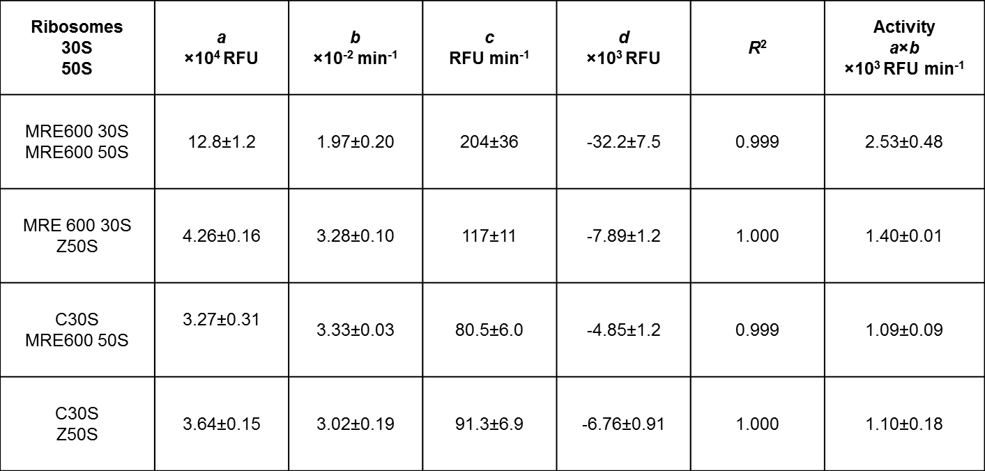

TBL. S2. Fit parameters for the synthesis of SNAP_{f} by wild-type ribosomes and specific activities for wild-type and mutant ribosomes.
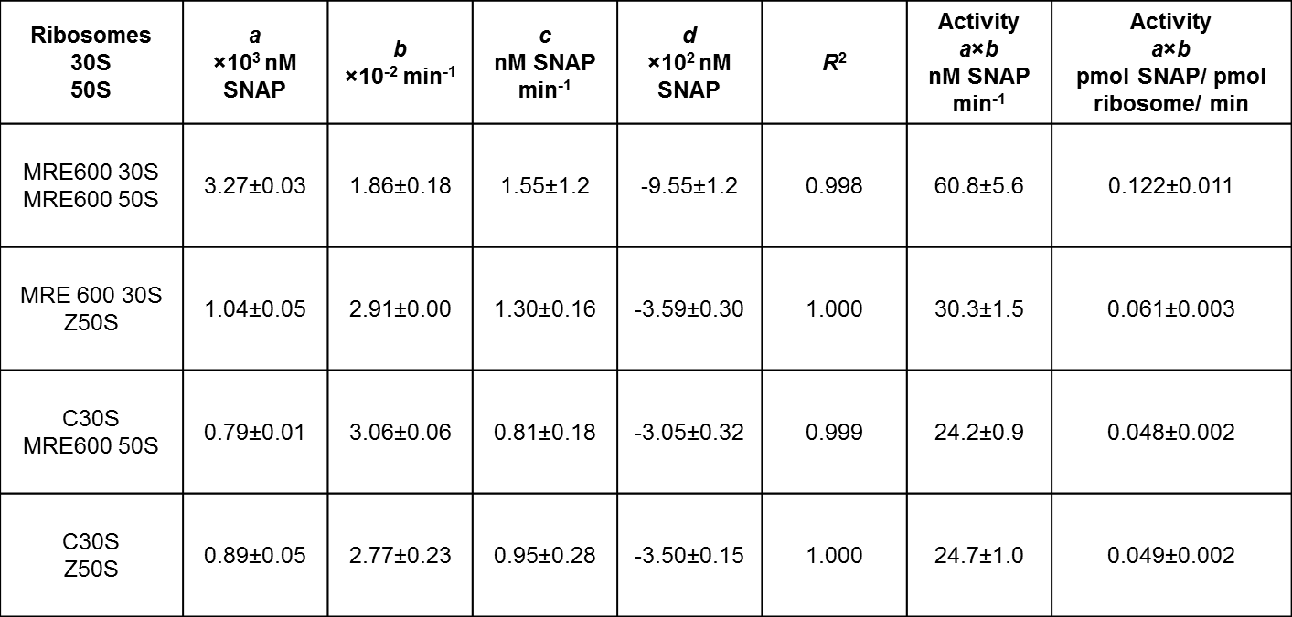

TBL. S3. Fit parameters for the SNAP_{f} reaction kinetics and the resultant pseudo-first-order (k´) and second-order (k) reaction constants.
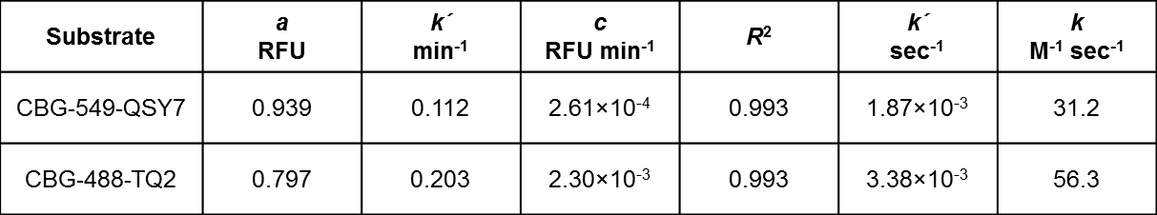

TBL. S4. Fit parameters for the dequenching reaction of CBG-549-QSY7 in two reducing and two nonreducing translation buffers.
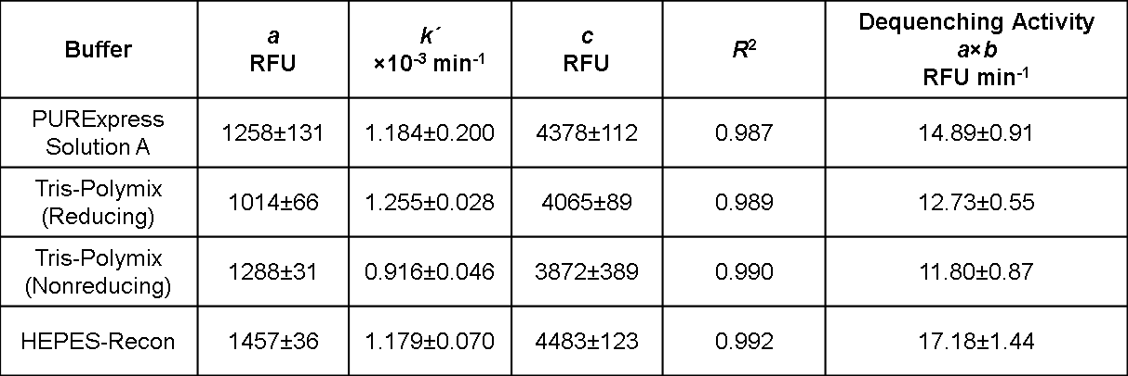
FIGURES
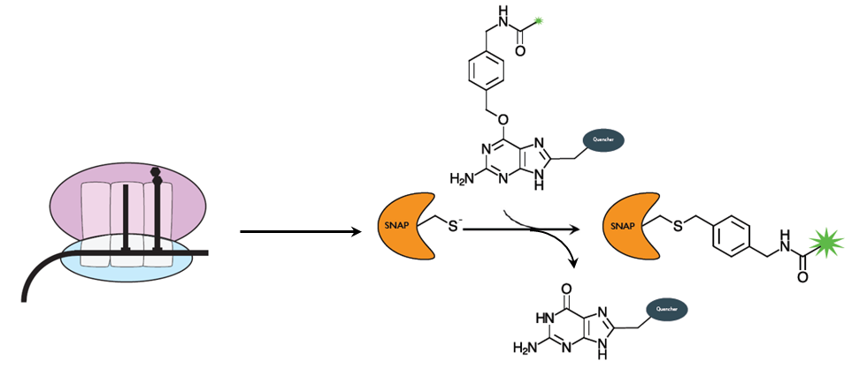
FIG. S1. Schematic of the SNAP assay. (Left to right) Translation of the SNAP_{f} mRNA generates an active SNAP_{f} enzyme, which then reacts irreversibly with the substrate to remove the quencher and produce fluorescence.

FIG. S2. Fluorescence curves for in vitro SNAP_{f} synthesis with and without (A) clarithromycin or (B) roxithromycin treatment. Reaction conditions: 100 nM ribosomes, 100 nM mRNA, and 500 nM CBG-549-QSY7.

Promoter
TAATACGACTCACTATAGGGGAATTGTGAGCGGATAACAATTCCCCTCTAGAAATAATTTTGTTTAACTTTAAGAAGGAGA
SNAP_{f}
TATACATATGGATAAAGACTGTGAAATGAAACGCACCACGCTGGACTCGCCGCTGGGCAAACTGGAACTGTCGGGCTGTG
AACAAGGTCTGCATCGTATTATCTTTCTGGGCAAAGGTACCAGTGCAGCAGATGCAGTTGAAGTCCCGGCACCGGCAGCT
GTGCTGGGCGGTCCGGAACCGCTGATGCAGGCAACGGCTTGGCTGAACGCATATTTTCATCAACCGGAAGCTATTGAAGA
ATTCCCGGTGCCGGCGCTGCATCACCCGGTTTTTCAGCAAGAATCCTTCACCCGCCAGGTGCTGTGGAAACTGCTGAAAG
TGGTTAAATTCGGCGAAGTTATCAGCTATTCTCATCTGGCAGCACTGGCAGGTAACCCGGCAGCTACCGCAGCAGTCAAA
ACGGCACTGAGCGGTAATCCGGTGCCGATTCTGATCCCGTGCCACCGTGTCGTGCAAGGTGATCTGGACGTTGGCGGTTA
GlySer linker
CGAAGGCGGTCTGGCCGTCAAAGAATGGCTGCTGGCACATGAAGGTCACCGTCTGGGTAAACCGGGTCTGGGCGGTAGT
SecM stall
GGCGGTGGCTCCGGTGGCGGTTCAGGCGGTGGCTCGGGTGGCGGTAGCGGCGGTGGCTCTGGTGGCGGTTCAGGTTTTA
6xHis tag
GTACGCCGGTTTGGATTTCACAAGCCCAGGGTATCCGTGCAGGTCCGCCGCACCACCACCACCACCACTGAGATCCGGCT
BlpI
GCTAACAAAGCCCGAAAGGAAGCTGAGTTGGCTGCTGCCACCGCTGAGCAATAACTAGCATAACCCCTTGGGGCCTCTAA
ACGGGTCTTGAGGGGTTTTTTGACGTC

FIG. S3. Sequence of the SNAP_{f} construct used in cell-free protein synthesis experiments. The T7 promoter is highlighted in green, the SNAP_{f} protein is uncolored, the GlySer repeat linker is orange, the 17-residue SecM stall is red, and the BlpI restriction site is underlined.

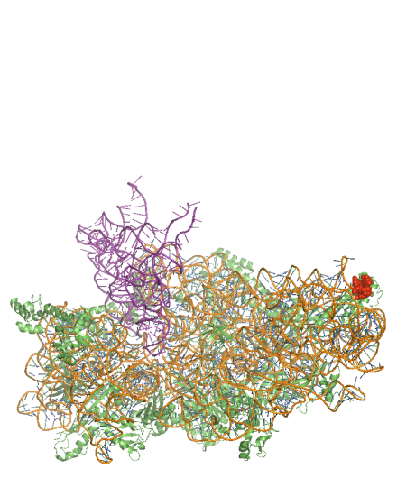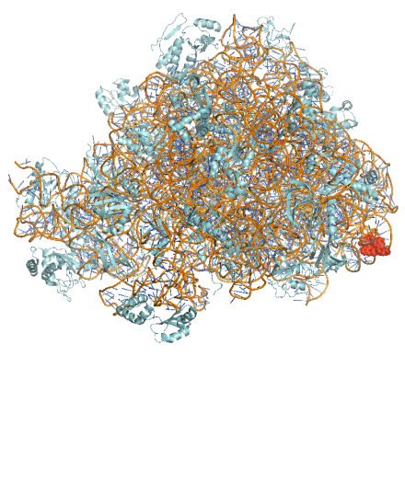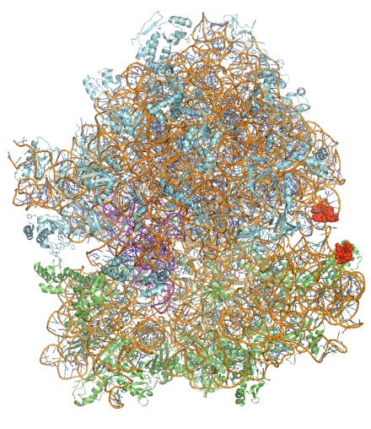
FIG. S4. (Left to right) Structures of 30S (with A-, P-, and E-site tRNAs), 50S, and 70S ribosomes. The positions of the extended hairpins are shown in red. Extended helices 44 and 101 are located distal to the peptidyltransferase center (tRNA in purple) on C30S and Z50S mutant subunits, respectively. Structure modified from Protein Data Bank files 2WRN and 2WRO (Schmeing et al. 2009).

FIG. S5. Excitation and emission spectra of Cy3B, Cy5, and ATTO488. Cy3B and ATTO488 exhibit limited spectral overlap. While these fluorophores could undergo FRET (detectable when dyes are while located close then 50Å), molecular motions of freely-diffusing SNAP_{f}-ATTO488 would only be within FRET distance for infinitesimal periods of time.

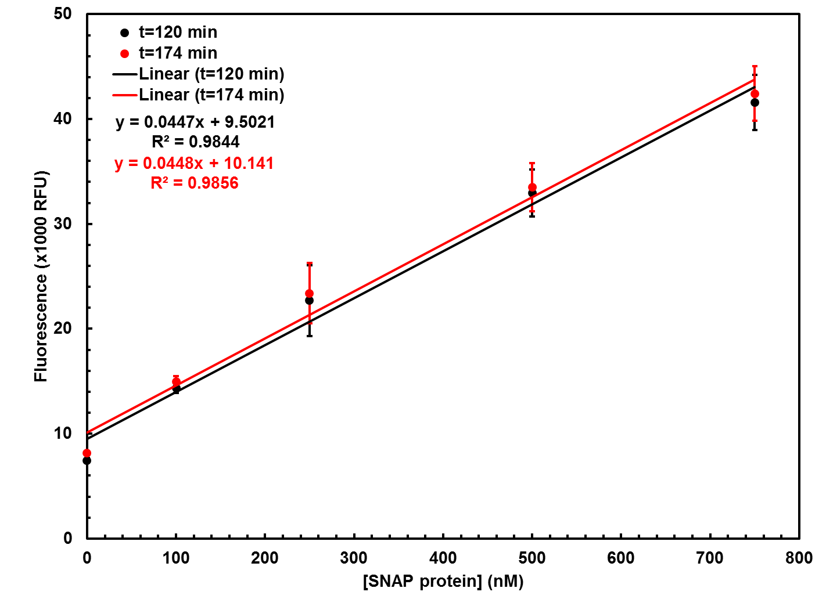
FIG. S6. Standard curves of SNAP_{f} fluorescence at two representative time points. Fluorescence backgrounds are 9502 RFU and 10141 at t=120 and t=174 min, respectively, and the response rate is approximately 45 RFU/nM at all times.

FIG. S7. Normalized fluorescence curves of SNAP_{f} purified proteins reacting with excess (A) CBG-549-QSY7 or (B) CBG-488-TQ2. Black points are fluorescent data and red lines are fits to a first-order kinetics model. Reaction conditions: 5 μM SNAP purified protein, 1 μM ribosomes, and 60 μM CBG-549-QSY7 or CBG-488-TQ2.

FIG. S8. Fluorescence curves of CBG-549-QSY7 incubated in two reducing (black and blue curves) and two nonreducing (green and red curves) translation buffers. Points with error bars are fluorescent data and lines are fits to a first-order kinetics model.

REFERENCES
Blanchard SC, Kim HD, Gonzalez, Jr, RL, Puglisi, JD, Chu S. 2004. tRNA dynamics on the ribosome during translation. Proc Natl Acad Sci US 101: 12893-12898.
Nanda JS, Saini AK, Muñoz AM, Hinnebusch AG, Lorsch JR. 2013. Coordinated movement of eukaryotic translation initiation factors eIF1, eIF1A, and eIF5 trigger phosphate release from eIF2 in response to start codon recognition by the ribosomal preinitiation complex. J Biol Chem 288: 5316-5329.
Schmeing TM, Voorhees RM, Kelley AC, Gao YG, Murphy FV, Weir JR, Ramakrishnan V. 2009. The crystal structure of the ribosome bound to EF-Tu and aminoacyl-tRNA. Science 326: 688-694.

