Supplementary material for

Cellular MicroRNAs Upregulate Transcription via Interaction with Promoter TATA-Box Motifs

Yijun Zhang, Miaomiao Fan, Xue Zhang, Feng Huang,
Kang Wu, Junsong Zhang, Jun Liu, Zhuoqiong Huang, Haihua Luo, Liang Tao, and Hui Zhang*

This file includes:
Supplemental Data (Fig. S1 to S5)
Supplemental Methods

Fig. S1 (A) Quantification of miRNAs in the input sample with or without DNase treatment of the RNA-ChIP assay. The miRNAs expressions were determine with stem-loop qRT-PCR. (B) The let-7i passenger strand (let-7i*) associated with Pol II and TBP was determined with RNA-ChIP followed by stem-loop RT-PCR. The relative enrichments of let-7i* by Pol II and TBP or in the input have been normalized to IgG. (C) The fractions of the cellular miRNAs that are associated with Pol II and TBP relative to the nuclear RNA input were determined with RNA ChIP assay.

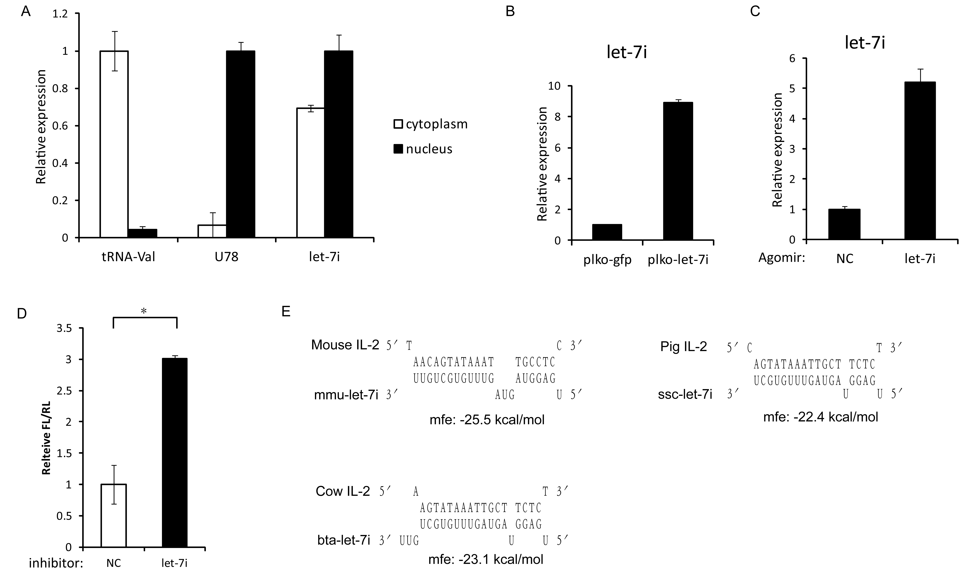

Fig. S2 (A) The subcellular distribution of let-7i miRNA in Sup-T1 cells was determined by qRT-PCR. Valine tRNA and U78 snoRNA are the control for subcellular fractions. (B) Let-7i miRNA expressions in the Jurkat cells that was infected with the PLKO-GFP or the PLKO-let-7i lentiviruses. Let-7i miRNA expression was determined with stem-loop RT-PCR and normalized to U6 snRNA. (C) The let-7i miRNA expression in CD4+ cells treated with agomir-let-7i or the negative control. Let-7i miRNA expression was determined as described above. (D) Dual-luciferase assay of CD4+ cells co-transfected with a reporter containing let-7i binding site in the 3’ UTR of luciferase gene (let-7i-PBS) and let-7i miRNA inhibitor or negative control. Renilla luciferase was used as transfection control. (E) Predicted binding between the let-7i miRNA and the TATA box core promtoer of IL-2 in other mammals. The MFE value of the predicted bindings was listed. P-values were calculated using the two tailed unpaired Student’s t-test with equal variances, n=3 biological replicates. * p<0.05.

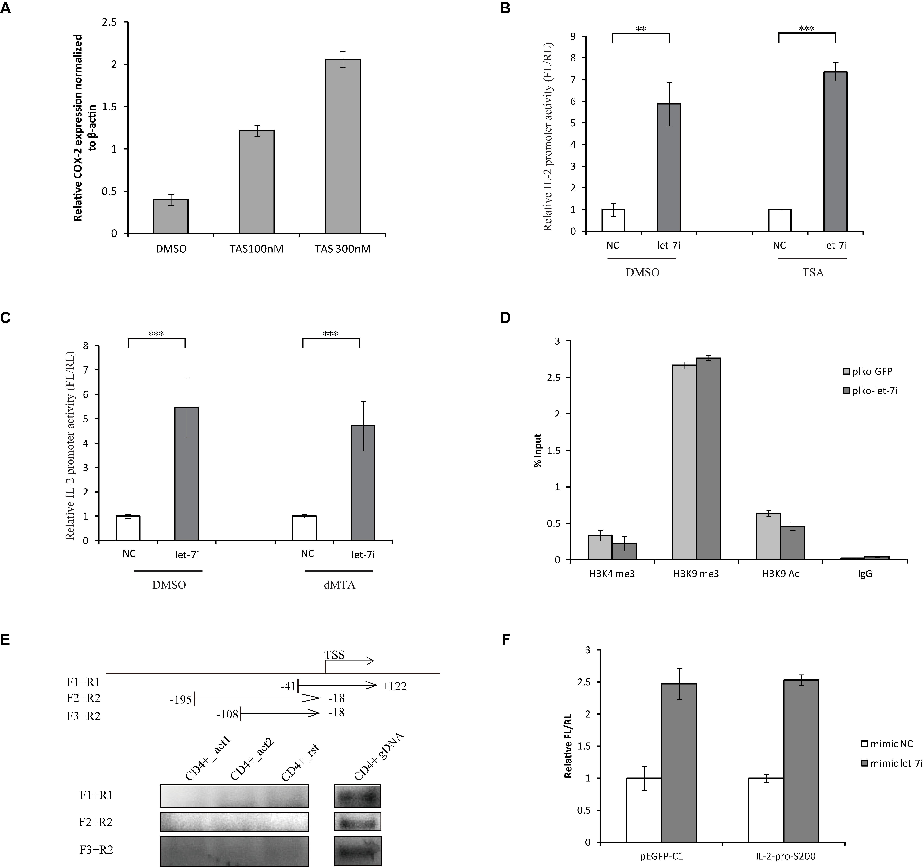
Fig. S3 (A) Treatment of HEK293T cells with TSA yields increased COX-2 expression. Upon treating HEK293T cell with the histone deacetylase inhibitor (HDAC) trichostatin-A (TSA) with indicated concentrations for 48 hrs, the mRNA expression of cyclooxygenase-2 (COX-2) were determined with qRT-PCR and normalized with β-actin. Effects of TSA (B) or dMTA (C) on the activation of IL-2 promoter by let-7i. HEK293T cells were co-transfected with IL-2 promoter-driven reporter and let-7i mimic or negative control as described above. The cells were then treated with 100 nM TSA or 300 mM dMTA (Sigma) in the completed medium at 24 hrs before harvest. The promoter activities were determined by dual-luciferase assay. (D) ChIP assay to detect the H3K4 tri-methylation, H3K9 tri-methylation and H3K9 acetylation level of IL-2 promoter upon the overexpression of let-7i. The promoter sequence corresponding to -146 to -8 relative to the TSS of IL-2 promoter were examined with qRT-PCR. (E) Detection of possible promoter-associated transcripts of IL-2 gene. Total RNA was isolated from activated and resting CD4+ T cells and amplified by RT-PCR using distinct primer sets shown in the top panel. In parallel, genomic DNA from CD4+ T-cells was amplified by PCR with the same primer sets as positive control. Act, actaviated CD4+ T-cell; rst, resting CD4+ T-cell; gDNA, genomic DNA. (F) Effect of the overexpression of IL-2 paRNA on the let-7i-induced enhancement of IL-2 promoter activity. The fragment containing -200 to +1 relative to the TSS of IL-2 was cloned and inserted into the downstream of CMV promoter in the pEGFP-C1 vector. Then this construct was transfected into HEK293T cells for overexpressing a putative paRNA. At 24 hrs post-transfection, IL-2 promoter-driven reporter was co-transfected with let-7i or negative control mimics. The IL-2 promoter activity was determined by a dual-luciferase assay at 24 hrs after the second transfection. P-values were calculated using the two tailed unpaired Student’s t-test with equal variances, n=3 biological replicates. * p<0.05, ** p<0.01,*** p<0.001.

Fig. S4 (A) The relative expression of let-7i, let-7i-Mtsd1 or let-7i-Mtsd2 in the nucleus of the HEK293T cells transfected with the let-7i, let-7i-Mtsd1, let-7i-Mtsd2 or negative control miRNA mimics. The miRNAs were determined with stem-loop RT-PCR. (B) Other members of the let-7 family were co-transfected respectively with IL-2 promoter to HEK293T cells for promoter activity analysis. Let-7i served as a positive control. The sequence differences between let-7i and other let-7 family members were indicated in red. (C) QRT-PCR assay for IL-2 initiated and elongated transcripts in the CD4⁺ T-cells treated with agomir-let-7i or negative control, followed by activation. (D) Silencing efficiency of Ago1 and Ago2 by siRNAs. The siRNA smartpool (100 nM) was transfected into HEK293T cells. Fourty-eight hrs later, mRNAs for these proteins were quantitated with real-time qRT-PCR. All data were normalized to β-actin. Error bars represent standard deviations, calculated from 3 biological replicates. D-si-Glo, negative control. (E) ChIP assay of the binding of AGO proteins to the DNA sequence downstream of IL-2 gene. The ChIP assay was performed as in Fig. 3G, then the primers (IL-2 downstream-F/R) covering an intergenic region downstream of IL-2 gene were used to determine the AGO proteins associated DNA. P-values were calculated using the two tailed unpaired Student’s t-test with equal variances, n=3. *, p<0.05.

Fig. S5 The subcellular distribution of let-7c, miR-92a in Sup-T1 cells (left panel) and miR-138, miR-181d in H9 cells (right panel). MiRNAs were determined with stem-loop RT-PCR. Valine tRNA and U78 snoRNA are the control for subcellular fraction. N, nuclear; C, cytoplasmic.

Supplemental Methods
Quantitative real-time RT-PCR primers:
IL2RT-F, 5′-GAACTAAAGGGATCTGAAACAACATTC-3′;
IL2RT-R, 5′-TGTTGAGATGATGCTTTGACAAAA-3′;
IL-2mRNAINT-F, 5′-ACTCACAGTAACCTCAACTC-3′;
IL-2mRNAINT-R, 5′-GTAGAACTTGAAGTAGGTGC-3′;
IL-2mRNAE2I2-F, 5′-AACTCACCAGGATGCTCACA-3′;
IL-2mRNAE2I2-R, 5′-GTGCAAATTTTCATATTACTTTGA-3′;
IL-2mRNAE3-F, 5′-AACCTCTGGAGGAAGTGCTA-3′;
IL-2mRNAE3-R, 5′-ATTGCTGATTAAGTCCCTGG-3′;
IL-2mRNAE4-F, 5′-TGCTGATGAGACAGCAACCA-3′;
IL-2mRNAE4-R, 5′-TCAAGTCAGTGTTGAGATGATGCT-3′;
IL15RT-F, 5′-TGGGTGAATGTAATAAGTGATTTGAAA-3′;
IL15RT-R2, 5′-AACTCCAAGAGAAAGCACTTCATTG-3′;
IL7RT-F, 5′-TCCCCTGATCCTTGTTCTGT-3′;
IL7RT-R, 5′-CAATTGCTACCAATTTCTTTC-3′;
β-actin-F, 5′-GCATGGAGTCCTGTGGCA-3′;
β-actin-R, 5′-CAGGAGGAGCAATGATCTTGA-3′;
GAPDH-F, 5′-TGCACCACCAACTGCTTAGC-3′;
GAPDH-R, 5′-GGCATGGACTGTGGTCATGAG-3′.
Primers for IL-2 paRNA test:
IL-2paRNA1-F, 5′-TCCAGAATTAACAGTATAAATTGC-3′;
IL-2paRNA1-R, 5′-GAAGTAGGTGCACTGTTTGTG-3′;
IL-2paRNA2-F, 5′-TCACCTACATCCATTCAGTCA-3′;
IL-2paRNA2-R, 5′-GCAATTTATACTGTTAATTCTGGA-3′;
IL-2paRNA3-F, 5′-TCAGACAGGTAAAGTCTTTGA-3′;
Primers for IL-2 promoter ChIP assay:
IL2-146-8-F, 5′-AGAGTCATCAGAAGAGGAAAA-3′;
IL2-146-8-R, 5′-TGATAGGGAACTCTTGAACA-3′;
IL-2 downstream F, 5′-ATTCCCCTCAGTTCACTGGC-3′;
IL-2 downstream R, 5′-ACCTGTGTCTTCTCAGCACG-3′;
Stem-loop RT-PCR primers for miRNA detection:
hsa-let-7i F, 5′- GCGGCGGTGAGGTAGTAGTTTGT-3′;
hsa-let-7i RT, 5′- GTCGTATCCAGTGCAGGGTCCGAGGTATTCGCACTGGATACGACAACAGC-3′;
let-7i Mtsd1 F, 5′-GCGGCGGTCTGGTAGTAGTTTGT-3′;
let-7i Mtsd2 F, 5′-GCGGCGGTGAGCAAGTAGTTTGT-3′;
hsa-mir-138 F, 5′-GCGGCGGAGCTGGTGTTGTGAAT-3′;
hsa-mir-138 RT, 5′-GTCGTATCCAGTGCAGGGTCCGAGGTATTCGCACTGGATACGACCGGCCT-3′;
hsa-mir-92a F, 5′-GCGGCGGTATTGCACTTGTCCCG-3′;
hsa-mir-92a RT, 5′- GTCGTATCCAGTGCAGGGTCCGAGGTATTCGCACTGGATACGACACAGGC-3′;
hsa-let-7c F, 5′- GCGGCGGTGAGGTAGTAGGTTGT-3′;
hsa-let-7c RT, 5′- GTCGTATCCAGTGCAGGGTCCGAGGTATTCGCACTGGATACGACAACCAT-3′;
hsa-mir-181d F, 5′- GCGGCGGAACATTCATTGTTGTC-3′;
hsa-mir-92a RT, 5′- GTCGTATCCAGTGCAGGGTCCGAGGTATTCGCACTGGATACGACACCCAC-3′;
UniReverse, 5′- GTGCAGGGTCCGAGGT-3′;

Probes for northern blot:
Let-7i 5′- AACAGCACAAACTACTACCTCA-3′;
U78 5′- GTGTAATGATGTTGATCAAAT -3′;
tRNA-Val 5′- TCAGAGCGGTCAAGTTAAGTT -3′;

