Supplemental Table S3. Over-represented motifs upstream of RP and box C/D snoRNA genes.

Species | Motif | RP | snoRNA | Annotation
Y.lip | 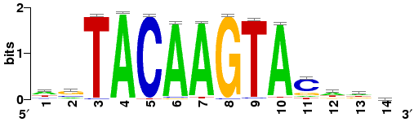 | 60.47% | 66.67% | NA, N1 in Fig. 4
Y.lip | 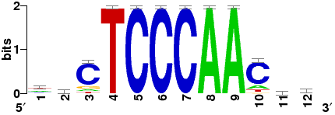 | 67.44% | 41.67% | NA, N2 in Fig. 4
Y.lip | 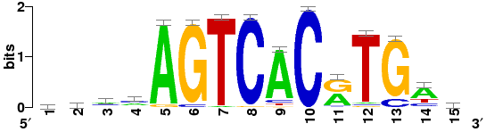 | 55.81% | 37.50% | Putative TYE7/CBF1/ARG81 binding sites
Z.rou | 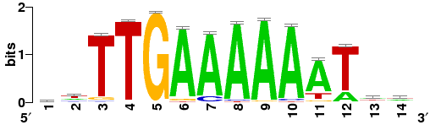 | 62.26% | 60.00% | Putative STB3/SUM1 binding sites
Z.rou | 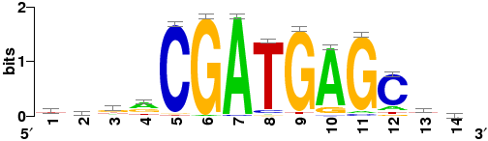 | 50.94% | 46.67% | Putative DOT6/TOD6/DAL80 binding sites
C.alb | 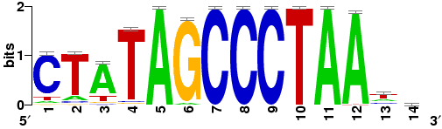 | 78.79% | 36.67% | Putative TBF1/RPH1 binding sites
C.alb | 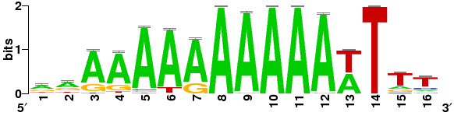 | 72.73% | 76.67% | Putative SFP1/SUM1/AZF1 binding sites
C.alb | 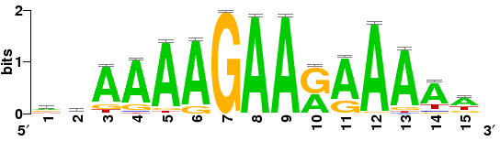 | 71.21% | 80.00% | Putative AZF1/SFL1 binding sites
C.alb | 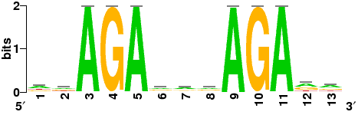 | 66.67% | 76.67% | NA
C.alb | 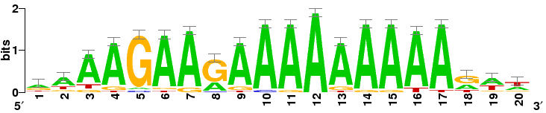 | 65.15% | 76.67% | NA
C.alb | 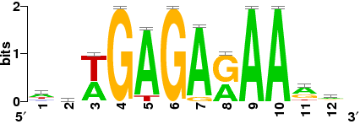 | 63.64% | 46.67% | NA
C.alb | 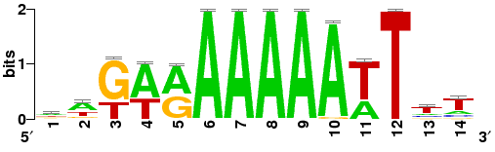 | 56.06% | 60.00% | Putative SFP1/SUM1/STB3 binding sites
C.alb | 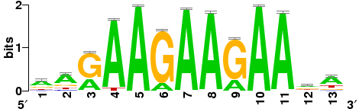 | 53.03% | 83.33% | Putative AZF1 binding sites
D.han | 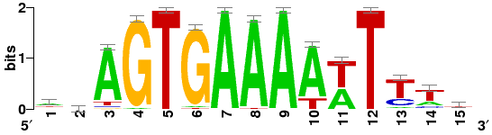 | 69.33% | 46.43% | Putative STB3/SUM1 binding sites
D.han | 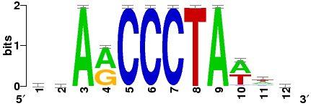 | 44.00% | 57.14% | Putative TBF1/RPH1 binding sites
S.jap | 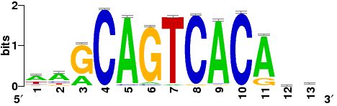 | 51.54% | 62.07% | Homol-D box
S.pom | 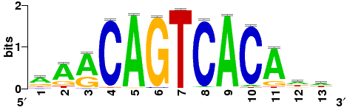 | 52.24% | 48.28% | Homol-D box
S.cry | 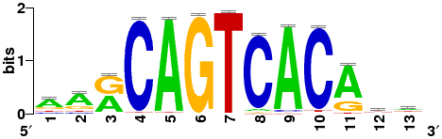 | 57.03% | 41.38% | Homol-D box
S.cry | 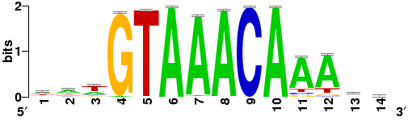 | 44.53% | 65.52% | Putative FKH2/FKH1/HCM1 binding sites
S.oct | 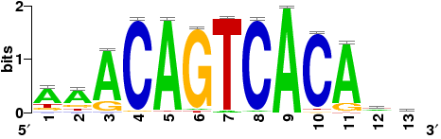 | 51.13% | 41.38% | Homol-D box
S.oct | 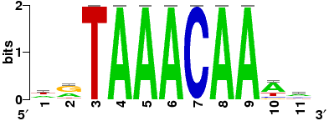 | 46.62% | 58.62% | Putative FKH2/FKH1/HCM1 binding sites
The percentages of RP genes and snoRNA genes containing motifs are listed in columns RP and snoRNA, respectively.

