The central role of protein S12 in organizing the structure of
the decoding site of the ribosome

Hasan Demirci¹, Leyi Wang², Frank V. Murphy IV³, Eileen L. Murphy¹, Jennifer F. Carr¹, Scott C. Blanchard², Gerwald Jogl¹, Albert E. Dahlberg¹ and Steven T. Gregory¹ *

Affiliations:
¹Department of Molecular Biology, Cell Biology and Biochemistry, Brown University, Providence, RI 02912 USA
²Department of Physiology and Biophysics, Weill Cornell Medical College of Cornell University, New York, NY 10021 USA
³NE-CAT/Cornell University, Argonne, IL 60439
*Correspondence to: steven_gregory@brown.edu

Supplementary Figures And Table

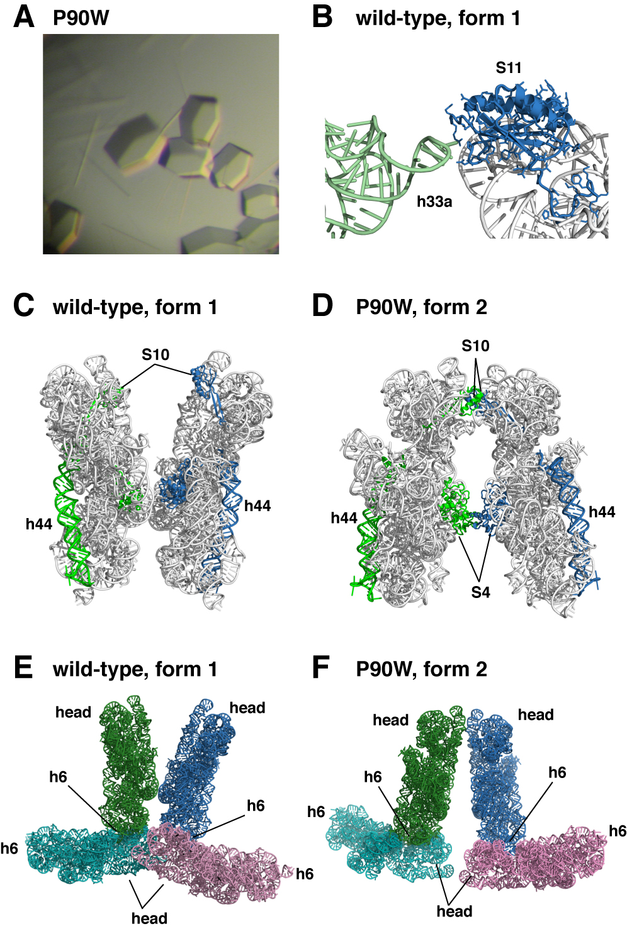

FIGURE S1. SmD mutations induce the formation of a new 30S subunit crystal form. (A) Crystals of the P90W SmD mutant in a mixture of both forms. Long needles are in form 1 (space group P4₁2₁2, cell dimensions ~403 Å x 403 Å x 176 Å) and hexagonal crystals (space group P4₁2₁2, cell dimensions ~400 Å x 400 Å x 215 Å) are in form 2. (B) Crystal contact between h33a of one subunit and ribosomal protein S11 of an adjacent subunit in crystal form 1. (C) Packing interactions between neighboring subunits in crystal form 1. Helix 44 and ribosomal proteins are colored either green or blue in different subunits. (D) Packing between neighboring subunits in crystal form 2, including new contacts between ribosomal proteins. Colors are as in panel (D). (E) Packing arrangement of wt 30S subunits in crystal form 1 and (F) P90W SmD 30S subunits in crystal form 2.

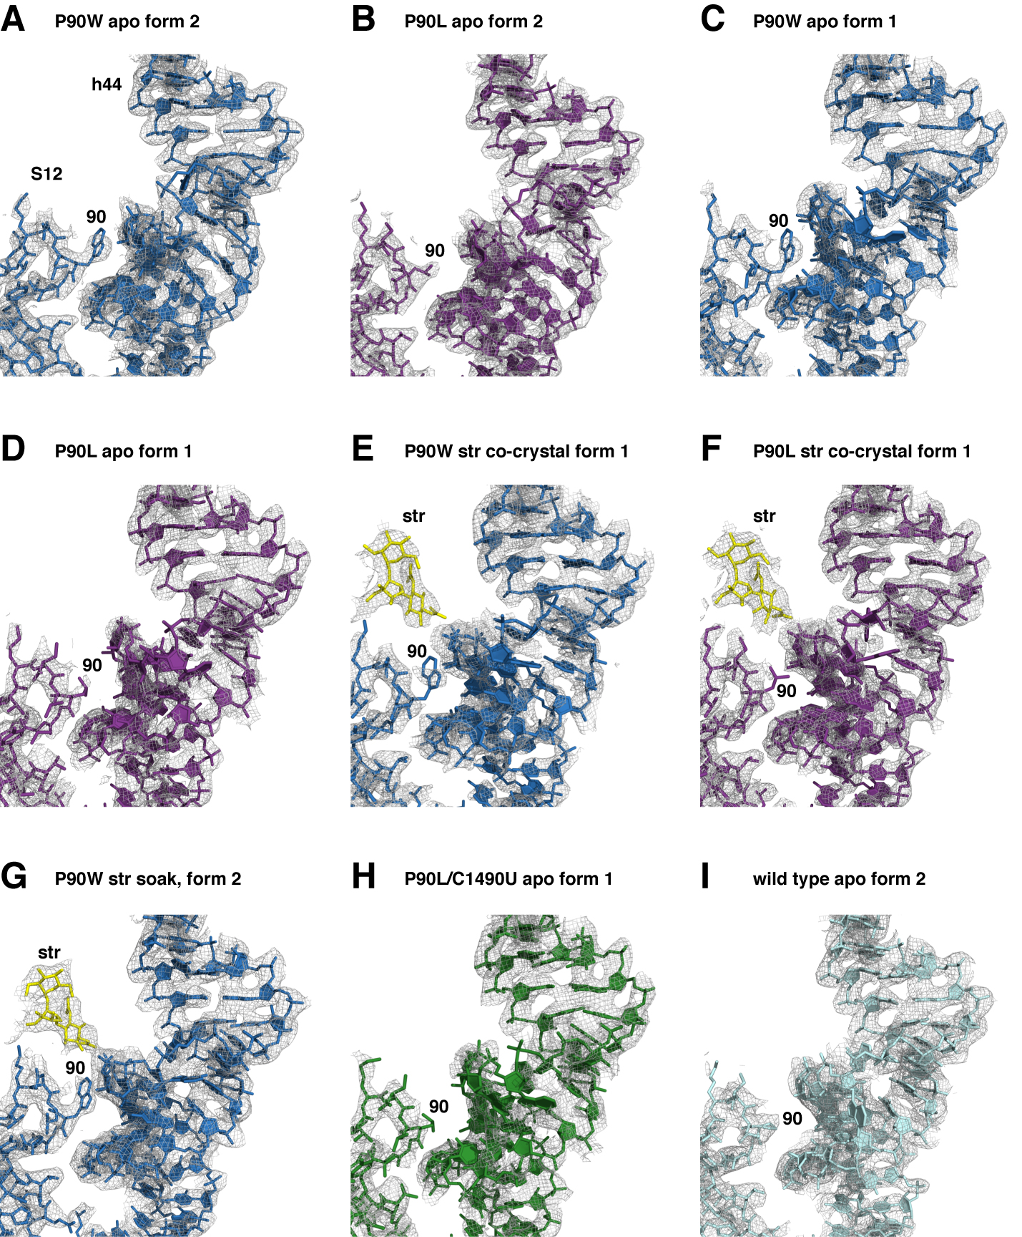

FIGURE S2. Composite omit density maps at 1σ of 16S rRNA helix 44 in wild-type and mutant crystal structures. (A) P90W apo, crystal form 2; (B) P90L apo, crystal form 2; (C) P90W crystal form 1; (D) P90L crystal form 1; (E) P90W streptomycin co-crystal, form1; (F) P90L streptomycin co-crystal, form 1; (G) P90W streptomycin soak, crystal form 2; (H) P90L/C1490U apo, crystal form 1; (I) wild-type apo, crystal form 2. Streptomycin is shown as yellow sticks.
Table S1. Data collection and refinement statistics.
 | P90L Apo | P90L Str Cocrystal | P90W Apo | P90W Str  Cocrystal
PDB ID | 4JI0 | 4JI1 | 4JI2 | 4JI3
 | Crystal form 1 | Crystal form 1 | Crystal form 1 | Crystal form 1
Data collection¹
Beamline | APS (ID-24-C) | APS (ID-24-C) | APS (ID-24-C) | APS (ID-24-C)
Space group | P4₁2₁2 | P4₁2₁2 | P4₁2₁2 | P4₁2₁2
Cell dimensions
a, b, c (Å) | 403.7, 403.7, 174.3 | 403.2, 403.2, 173.3 | 402.4, 402.4, 174.4 | 403.0, 403.0, 173.1
α, β, γ (°) | 90, 90, 90 | 90, 90, 90 | 90, 90, 90 | 90, 90, 90
Resolution (Å)² | 50.0-3.50  (3.69-3.50) | 35.0-3.15  (3.25-3.15) | 50-3.65  (3.85-3.65) | 35.0-3.35  (3.47-3.35)
R_{merge} | 0.159 (0.949) | 0.069 (0.627) | 0.183 (0.903) | 0.072 (0.624)
I / σI | 11.70 (1.71) | 16.65 (1.96) | 10.15 (1.84) | 14.66 (1.94)
Completeness (%) | 99.1 (96.4) | 99.0 (97.7) | 98.9 (95.2) | 88.2 (92.3)
Redundancy | 3.7 (3.7) | 3.4 (3.4) | 4.1 (4,2) | 4.4 (4.3)
Refinement
Resolution (Å) | 50-3.50  (3.53-3.50) | 35-3.15  (3.18-3.15) | 50-3.65  (3.68-3.65) | 34-3.35  (3.38-3.35)
No. reflections | 179494 (4692) | 241726 (6294) | 157539 (3813) | 178313 (5150)
R_{work} / R_{free} | 0.167/0.212  (0.307/0.360) | 0.165/0.207 (0.295/0.329) | 0.155/0.211 (0.283/0.335) | 0.168/0.215 (0.285/0.339)
No. atoms
Protein | 19091 | 19171 | 19095 | 19095
RNA | 32644 | 32507 | 32644 | 32487
Ligand/Ion/Water | 581 | 1098 | 568 | 519
B-factors
Protein | 176.92 | 127.21 | 160.62 | 150.2
RNA | 163.72 | 118.45 | 150.56 | 141.2
Ligand/Ion/Water | 141.83 | 137.36 | 123.90 | 121.8
Coordinate errors | 0.40 | 0.33 | 0.40 | 0.35
R.m.s deviations
Bond lengths (Å) | 0.006 | 0.007 | 0.013 | 0.006
Bond angles (°) | 1.044 | 1.212 | 1.92 | 1.034
Ramachandran plot
Favored (%) | 1808 (88.2) | 1830 (88.8) | 1791 (87.2) | 1834 (89.3)
Allowed (%) | 218 (10.6) | 197 (9.6) | 235 (11.4) | 195 (9.5)
Generously allowed (%) | 23 (1.1) | 27(1.3) | 27 (1.3) | 24 (1.2)
Disallowed (%) | 2 (0.1) | 6 (0.3) | 1 (0.0) | 1 (0.0)

¹One crystal was used for each dataset.
²The highest resolution shell is shown in parenthesis.

Table S1. Data collection and refinement statistics (cont'd).
 | P90L/C1490U Apo | Wild-type Apo | P90L Apo | P90W Apo | P90W Str  Soak
PDB ID | 4JI4 | 4JI5 | 4JI6 | 4JI7 | 4JI8
 | Crystal form1 | Crystal form 2 | Crystal form 2 | Crystal form 2 | Crystal form2
Data collection¹
Beamline | APS (ID-24-C) | NSLS (X25) | APS (ID-24-C) | SLS (X06SA) | SLS (X06SA)
Space group | P4₁2₁2 | P4₁2₁2 | P4₁2₁2 | P4₁2₁2 | P4₁2₁2
Cell dimensions
a, b, c (Å) | 401.9, 401.9, 174.6 | 399.6, 399.6, 215.9 | 401.6, 401.6, 217.1 | 398.5, 398.5, 214.8 | 400.7, 400.7, 214.8
α, β, γ (°) | 90, 90, 90 | 90, 90, 90 | 90, 90, 90 | 90, 90, 90 | 90, 90, 90
Resolution (Å)² | 50.0-3.70  (3.90-3.70) | 50-3.85  (3.94-3.85) | 50.0-3.55  (3.75-3.55) | 50.0-3.5  (3.70-3.50) | 50.0-3.75  (3.96-3.75)
R_{merge} | 0.157(0.921) | 0.142 (0.976) | 0.151 (0.776) | 0.144 (0.821) | 0.122 (0.810)
I / σI | 13.21 (1.79) | 11.37 (1.90) | 9.77 (1.77) | 11.36 (2.01) | 18.11 (1.87)
Completeness (%) | 98.4 (96.5) | 99.3 (99.9) | 98.3 (96.9) | 99.6 (97.6) | 99.7 (98.3)
Redundancy | 4.9 (4.9) | 9.0 (9.2) | 6.1 (6.2) | 7.6 (7.2) | 18.1 (18.4)
Refinement
Resolution (Å) | 50-3.70  (3.69-3.65) | 50-3.85  (3.89-3.85) | 50-3.55  (3.59-3.55) | 50-3.50  (3.54-3.50) | 50-3.75  (3.78-3.75)
No. reflections | 150242 (3979) | 162952 (5050) | 209597 (5955) | 214519 (6208) | 177681 (5103)
R_{work} / R_{free} | 0.156/0.214 (0.289/0.326) | 0.153/0.202 (0.259/0.338) | 0.151/0.201 (0.282/0.339) | 0.158/0.201 (0.297/0.355) | 0.137/0.187  (0.267/0.316)
No. atoms
Protein | 19091 | 19090 | 19091 | 19095 | 19095
RNA | 32644 | 32687 | 32687 | 32687 | 32550
Ligand/Ion/Water | 546 | 451 | 1666 | 2028 | 1918
B-factors
Protein | 193.2 | 166.9 | 147.0 | 119.6 | 158.2
RNA | 178.4 | 160.8 | 138.7 | 112.9 | 150.4
Ligand/Ion/Water | 150.8 | 152.7 | 178.5 | 153.0 | 189.6
Coordinate errors | 0.42 | 0.38 | 0.39 | 0.37 | 0.40
R.m.s deviations
Bond lengths (Å) | 0.012 | 0.013 | 0.020 | 0.009 | 0.022
Bond angles (°) | 1.78 | 1.97 | 2.78 | 1.44 | 2.95
Ramachandran plot
Favored (%) | 1800 (87.8) | 1781 (86.9) | 1759 (85.8) | 1827 (88.9) | 1756 (85.5)
Allowed (%) | 224 (10.9) | 242 (11.8) | 261 (12.7) | 201 (9.8) | 266 (13.0)
Generously allowed (%) | 26 (1.3) | 26 (1.3) | 28 (1.4) | 22 (1.1) | 29 (1.4)
Disallowed (%) | 1 (0.0) | 1 (0.0) | 3 (0.1) | 4 (0.2) | 3 (0.1)

¹One crystal was used for each dataset.
²The highest resolution shell is shown in parenthesis.

