Supplemental Table 1
Constitutive | Alternative 5'ss | Upstream | Downstream | p-Value
45.61% | 49.91% | - | - | 4.31E-10
8.03% | 10.59% | - | SRSF7 | 6.48E-11
14.94% | 14.49% | SRSF7 | - | 0.373439
2.50% | 2.41% | SRSF7 | SRSF7 | 0.723674
14.53% | 11.20% | - | TIA | 1.38E-12
4.41% | 2.99% | SRSF7 | TIA | 1.44E-07
2.54% | 2.84% | TIA | - | 0.161849
0.61% | 0.52% | TIA | SRSF7 | 0.476338
1.79% | 1.37% | TIA | TIA | 0.018555

The occurrence of putative SRSF7 and/or TIA-1 binding sites was determined by word searches across 30 nt upstream or downstream of constitutive and alternative 5’ss (see Supplemental Experimental Procedures). For both TIA and SRSF7, increased representation of activating positions is observed for constitutive exons. Similarly, increased representation of repressive positions is observed for alternative exons.

Supplemental Table 2
Splicing factor | Motif | 30nt up | 30nt down
PTB | CTCTCT | 832 | 1359
Fox1/2 | TGCATG | 613 | 904
hnRNP H/F | AGGGA | 2970 | 4518
hnRNP A1 | TTAGGG | 120 | 456
TIA-1 | 2x TTT or 1x TTTTT  *TTT*TTT* or *TTTTT* | 6618 | 24856
SRSF7 | [A/T]C[A/T][A/T]C | 23978 | 14867

The occurrence of putative splicing factor binding sites was determined by word searches across 30 nt upstream or downstream of constitutive exons (see Supplemental Experimental Procedures). For all hnRNP-like proteins increased representation is observed in the activating intronic position while SRSF7 protein binding sites are overrepresented in the exon.

Supplemental Table 3
Abbrev. | PDE | Sequence | Ref.
N1 | GAR– | AGGCATTAGCGGCGACTTCGCTTAA | (Caputi et al., 2004)
N2 | neutral | CCAAACAA | (Zhang et al., 2009)
SRSF2 | SC35-1 | GTTCCAGATAAGTTCCAGCC | (Cavaloc et al., 1999)
SRSF7 | 9G8-66a | AGACAACGAUUGAUCGACUA | (Cavaloc et al., 1999)
F/H | hnRNP F/H | AGGGA | (Schaub et al., 2007)
TIA | TIA-1 | UCUUUUUAAGUCGUACCUAA | (Dember et al., 1996)
IAS | TIA-1 (IAS-1) | GCUUUCAUUUUUGUCUUUUUUUUAA | (Del Gatto-Konczak et al., 2000)
PTB | PTB | CUCUCU | (Perez et al., 1997)
A1 | hnRNP A1 | UUAGGG | (Han et al., 2005)
Fox | Fox1/2 | UGCAUG | (Lim and Sharp, 1998)
MS2 | MS2 | CGUACACCAUCAGGGUACG | (Villemaire et al., 2003)
PP7 | PP7 | UAAGGAGUUUAUAUGGAAACCCUUA | (Lim and Peabody, 2002)
High affinity RNA binding sites for splicing regulatory proteins and bacteriophage coat binding RNA stem-loop sequences (MS2, PP7).

Supplemental Figure 1
Supplemental Figure 1: Positioning of splicing regulatory sequences determines their effect on 5’ss activation.
HeLa cells were transiently transfected with each of the reporter constructs and expression of eGFP was monitored 30h later by fluorescence microscopy.

Supplemental Figure 2
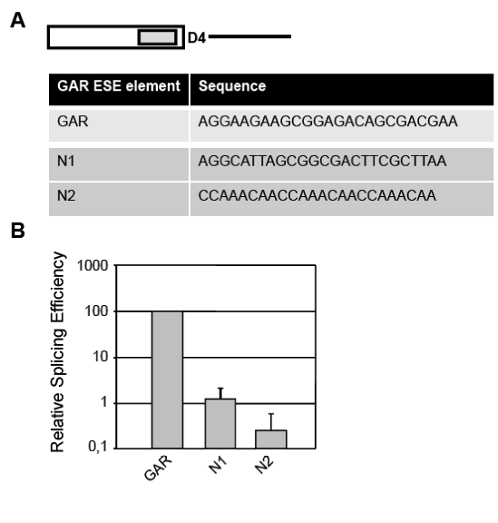
Supplemental Figure 2: Functional analysis of GAR-derived control sequences.
(A) Table of the sequences that were placed upstream of 5´ss D4 to determine their effect on splicing. (B) Each reporter construct was transiently transfected into HeLa cells. 30h later total RNA was extracted and analyzed by quantitative real-time PCR.

Supplemental Figure 3
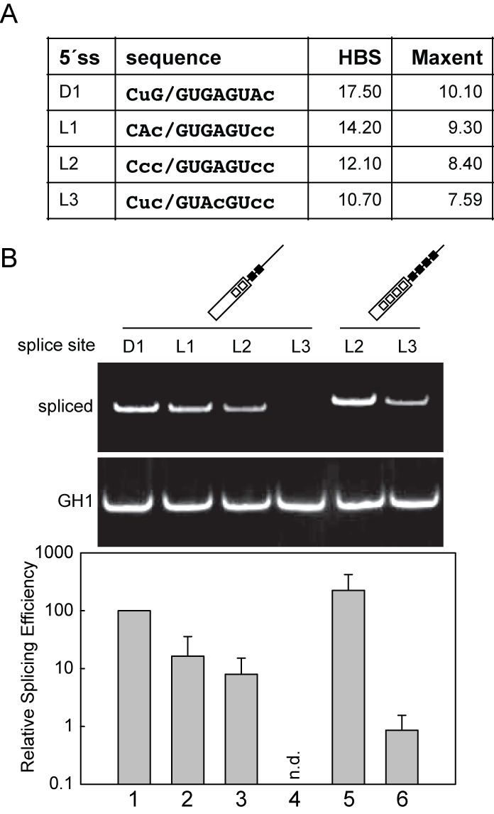
Supplemental Figure 5: MS2 fusion proteins are properly expressed within the transfected cells.
Expression of the splicing factor-derived MS2 fusion proteins was controlled by extraction of from transfected HeLa cells, resolution by 10% SDS-PAGE and Western Blot analysis using specific antibodies directed against the HA-tag or cellular β actin.
Supplemental Figure 4
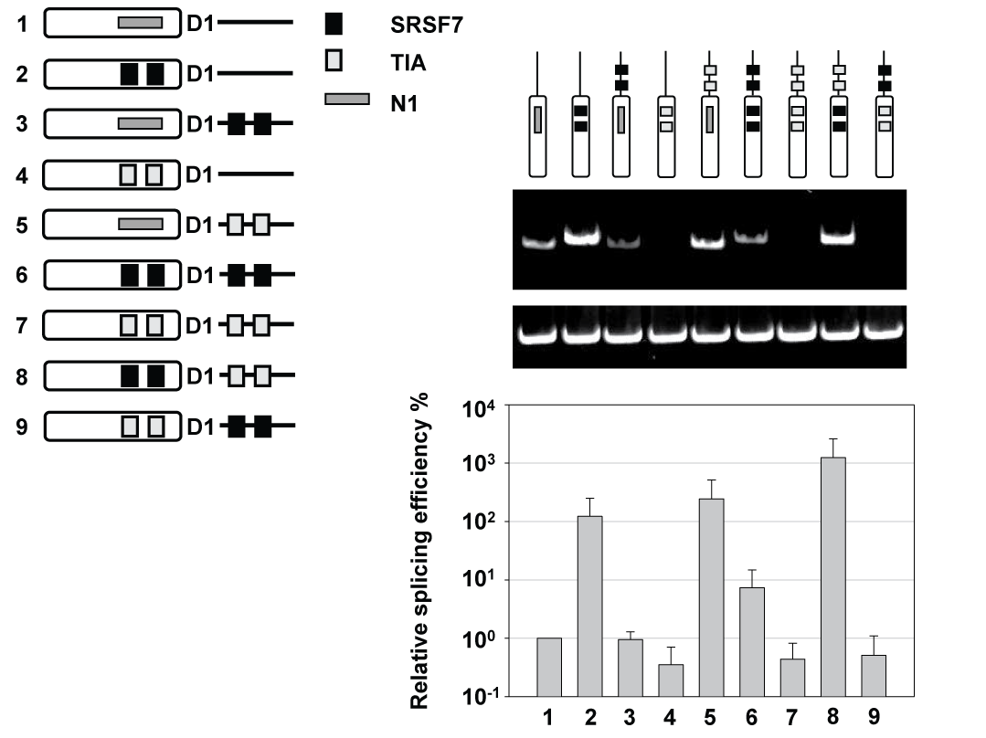
Supplemental Figure 4: Position dependent activation or repression of 5´ss selection by PDEs
Semi-quantitative and quantitative RT-PCR experiments were used to determine the effects of SRSF7 and TIA-1 binding sites in the upstream and downstream positions. (n.d.) refers to not detected above background.

Supplemental Figure 5
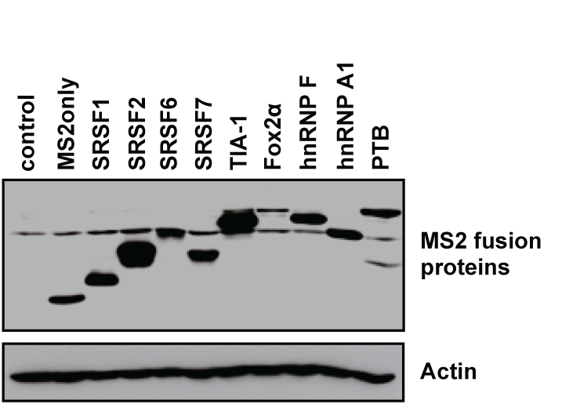
Supplemental Figure 5: MS2 fusion proteins are properly expressed within the transfected cells.
Expression of the splicing factor-derived MS2 fusion proteins was controlled by extraction of from transfected HeLa cells, resolution by 10% SDS-PAGE and Western Blot analysis using specific antibodies directed against the HA-tag or cellular β actin.

Supplemental Figure 6
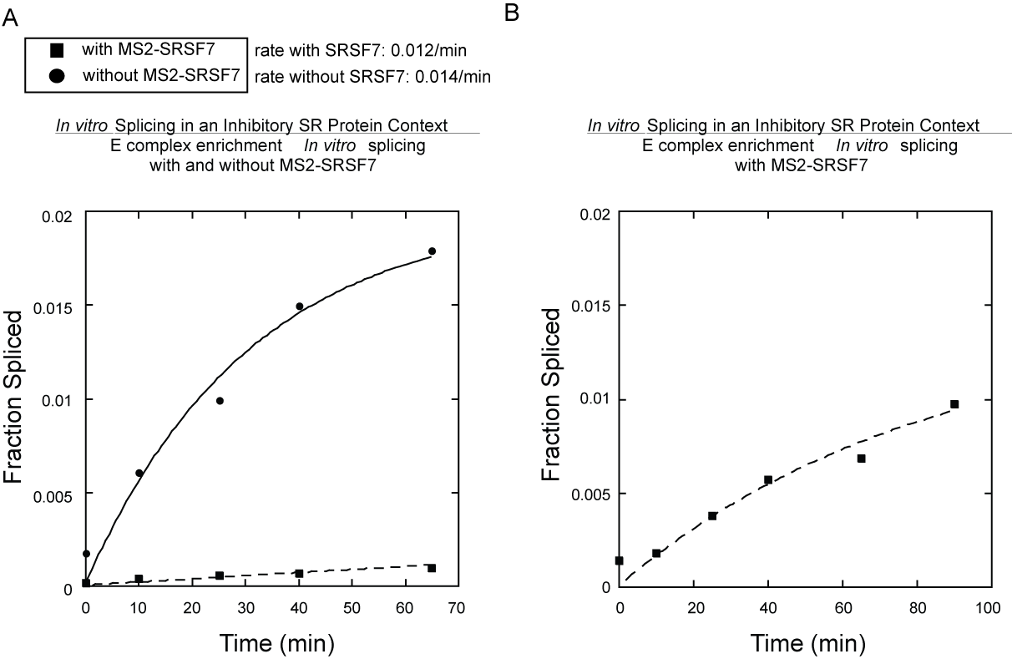
Supplemental Figure 6: Results from E-complex pulse chase experiments in the presence or absence of MS-SRSF7.
E-complex was enriched in the absence of ATP, and the reaction was then chased as described in the Supplemental Materials and Methods. (A) Kinetic profiles for both reactions are shown, demonstrating that the presence of MS2-SRSF7 reduces splicing efficiency. (B) Blow-up of the reaction in the presence of MS-SRSF7 demonstrating approach to endpoint kinetics. Thus, the reduced kinetics are not due to a drop in the rate of splicing, but due to the drop in the fraction of enriched E-complexes that progress to active spliceosomes.

