SUPPLEMENTARY INFORMATION

Post-developmental microRNA expression is required for normal physiology, and regulates ageing in parallel to Insulin/IGF-1 signaling in C. elegans.

Nicolas J. Lehrbach^{1,2}, Cecilia Castro², Kenneth J. Murfitt^{1,2}, Cei Abreu-Goodger³, Julian L. Griffin^{2,4,5} and Eric A. Miska^{1,2,*}

¹ Wellcome Trust Cancer Research UK Gurdon Institute, University of Cambridge, The Henry Wellcome Building of Cancer and Developmental Biology, Tennis Court Rd, Cambridge CB2 1QN, UK

² Department of Biochemistry, University of Cambridge, Tennis Court Rd, Cambridge CB2 1GA, UK

³ Langebio Cinvestav, Km 9.6 Libramiento Norte Carretera León
36821 Irapuato, Guanajuato, México

⁴The Medical Research Council Human Nutrition Research, Elsie Widdowson Laboratory, Fulborn Road, Cambridge, CB1 9NL, UK.

⁵Cambridge Systems Biology Centre, University of Cambridge, 80 Tennis Court Road, Cambridge, CB2 1GA, UK

* Corresponding author: e.miska@gurdon.cam.ac.uk

SUPPLEMENTAL DATA

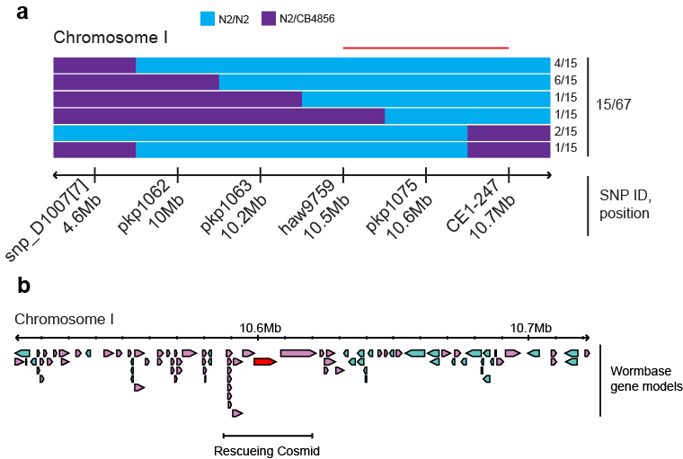

Figure S1. Mapping and rescue of pash-1(mj100). (a) SNP mapping of mj100 to a 200kb interval on chromosome I. After outcross to CB4856/Hawaii, 67 mutant F2 animals were genotyped for SNPs covering a ~6 Mb region of chromosome I, identifying 15 animals carrying informative recombinant chromosomes. The frequency each recombinant genotype is indicated on the left. Blue and purple indicate loci homozygous and heterozygous for the N2 sequence, respectively. The Red line indicates the mj100 linked interval revealed by this analysis. (b) The mj100 linked interval, showing the region covered by the rescuing cosmid. The pash-1 gene is highlighted in red.

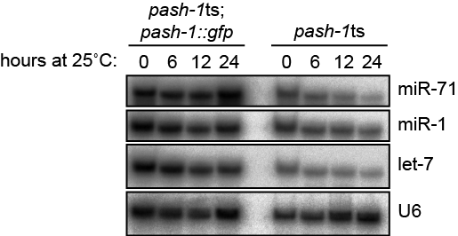

Figure S2. Reduced miRNA levels upon upshift of pash-1ts, but not pash-1ts; pash-1::gfp animals to 25oC. Northern blot comparing miRNA levels in pash-1ts; pash-1::gfp and pash-1ts animals over 24 hours following upshift from 15ºC to 25ºC.

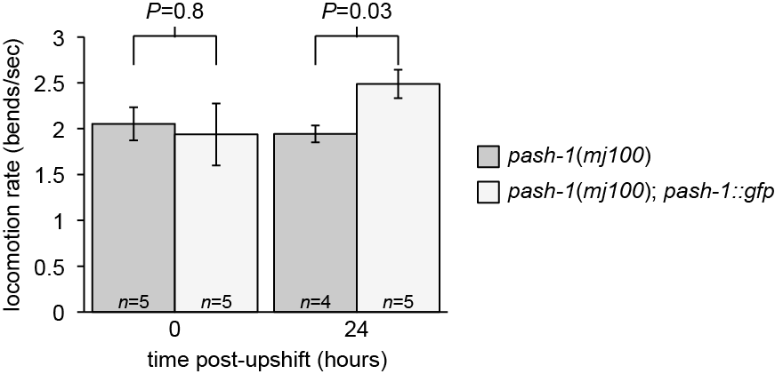

Figure S3. Locomotion is acutely reduced in pash-1(mj100) animals at 25ºC. Swimming assays comparing locomotion rate of pash-1ts animals and control pash-1ts; pash-1::gfp rescued animals maintained at 15ºC, and after 24 hours at 25ºC. The same animals were used in both assays. Rate of locomotion is reduced in pash-1ts compared to control after 24 hours at 25ºC (p=0.03, Student’s t-test).

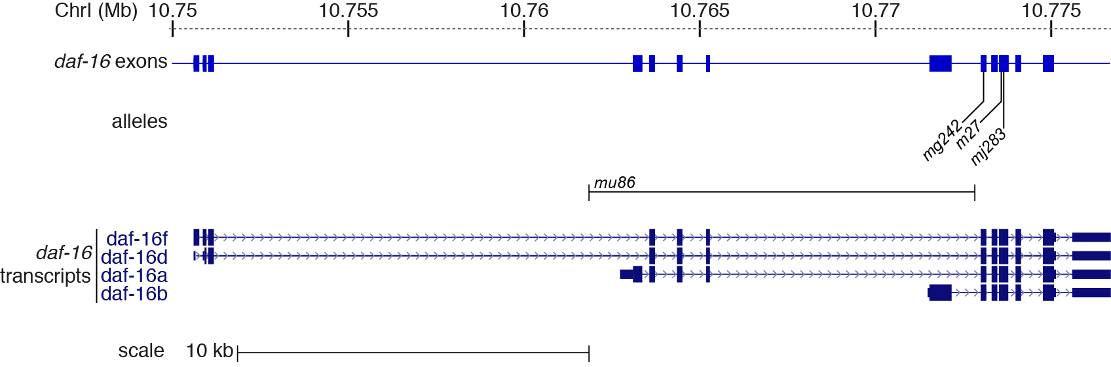

Figure S4. mj283 is a new null allele of daf-16, by molecular criteria. The daf-16 locus, showing the position of the mu86 deletion, and the premature stop codons in mg242, m27 and mj283 mutants. These alleles affect exons that are shared between all daf-16 transcripts.

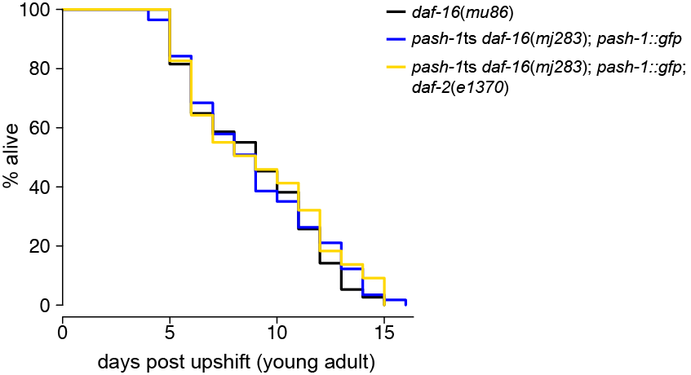

Figure S5. mj283 is a new null allele of daf-16, by phenotypic criteria. Average lifespan of pash-1ts daf-16(mj283); pash-1::gfp animals the same as that of daf-16(mu86) mutants (P=0.6, log rank test). daf-2(e1370) does not extend lifespan of animals carrying the daf-16(mj283) allele (P=0.8, log rank test).

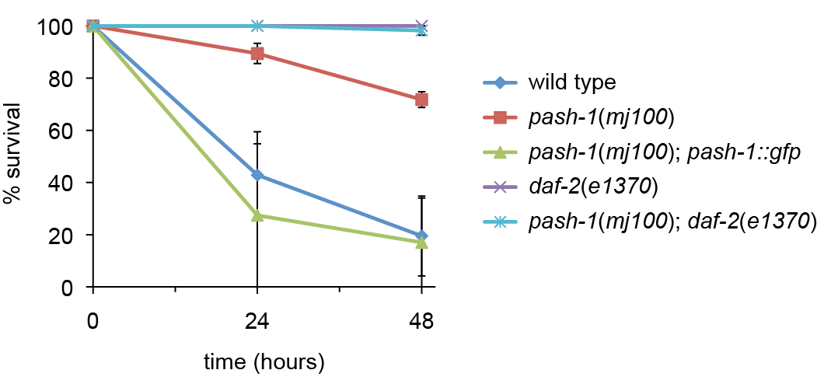
Figure S6. miRNA synthesis is not required for the osmotic stress resistance of daf-2 mutants.
The resistance of daf-2(e1370) mutants to osmotic stress does not require miRNA synthesis. Survival curves show the average +/- SD from three trails for each genotype, n>20 for each trial.

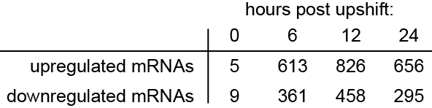

Table S1. Number of genes misregulated upon upshift of pash-1(mj100) animals to 25ºC.

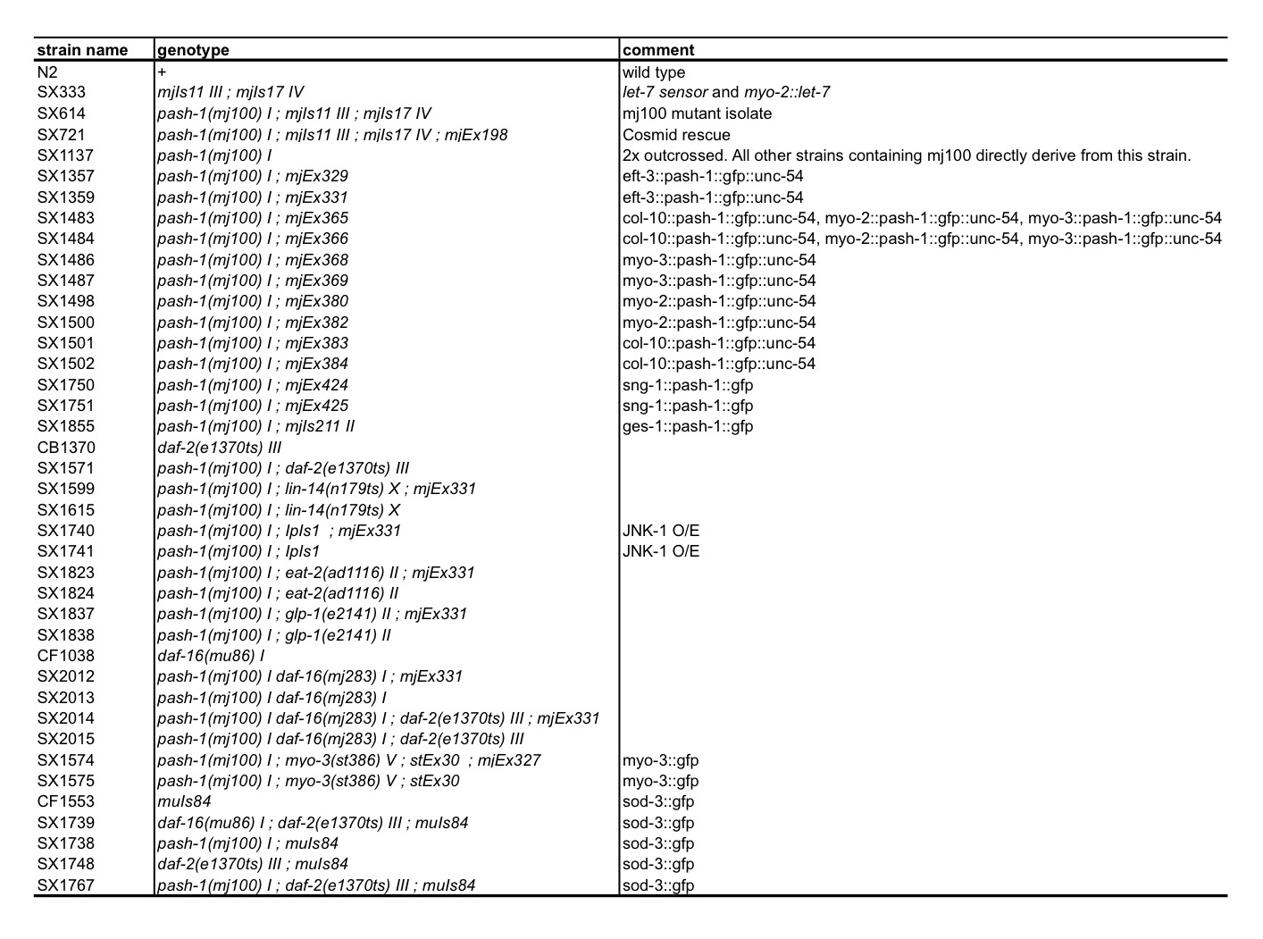Table S2. Strains used in this study.

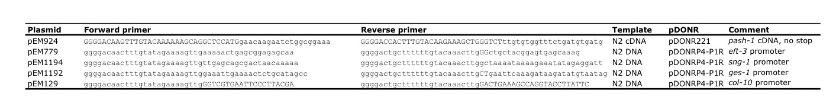
Table S3. Gateway entry vectors generated in this study.
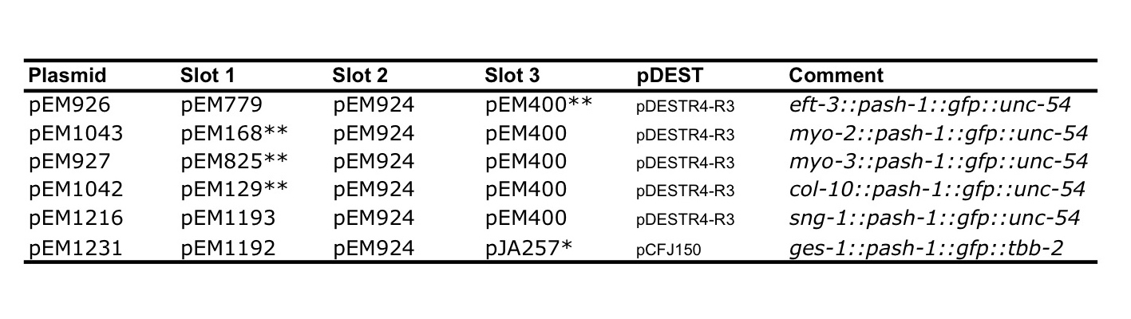
Table S4. Gateway Three Fragment constructs generated in this study.
* (Zeiser et al., 2011); **(Lehrbach et al., 2009).

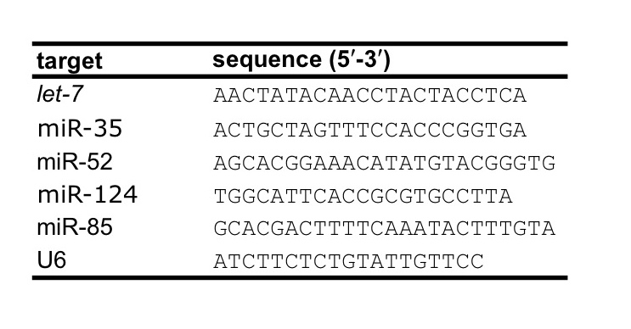
Table S5. DNA oligonucleotides used for northern blotting.

SUPPLEMENTAL EXPERIMENTAL PROCEDURES

A genetic screen for mutants defective in miRNA function. We previously described a simple assay for miRNA function in C. elegans (Lehrbach et al., 2009). This assay indicates miRNA function by expression of GFP in the pharynx; in wild type worms GFP expression is reduced by the action of the let-7 miRNA. We anticipated mutants in which miRNA function is impaired would show increased expression of GFP. We performed large scale EMS mutagenesis screens for such mutants, screening for GFP expression under a fluorescence dissecting microscope. A description of other mutants isolated in this screen will be published elsewhere.

Isolation of daf-16(mj283). The pash-1 and daf-16 genes are closely linked on chromosome I (~0.02 cM apart), so it was not practical to generate a pash-1 daf-16 double mutant in a cross between pash-1(mj100) and an existing daf-16 mutant. We therefore sought to isolate a new daf-16 allele by mutagenesis of a pash-1(mj100) mutant strain. We performed a screen for suppressors of the Daf-c and sod-3::gfp expression phenotype of pash-1(mj100); daf-2(e1370); sod-3::gfp(muIs84); eft-3::pash-1::gfp(mjEx331). This strain is viable, but Daf-c at 25ºC. We isolated a suppressor that does not form dauers or express high levels of sod-3::gfp at 25oC. We confirmed that the suppressor was daf-16(-) in a complementation cross with daf-16(mu86); daf-2(e1370); muIs84 animals. We sequenced daf-16 in the mutant isolate and a GG-TT dinucleotide substitution in the 3rd from last exon of daf-16. This was not present in the parental strain, and results in a premature stop codon in all isoforms of the daf-16 mRNA (Figure S4). Based on molecular criteria, and its similarity to previously described null alleles, mj283 should be a null allele of daf-16. We outcrossed the mutant isolate 3 times to generate the strains we used for analysis of lifespan. The lifespan of pash-1(mj100) daf-16(mj283); eft-3::pash-1::gfp(mjEx331) animals is mildly reduced compared to wild type, and similar to that of daf-16(mu86) mutants. Importantly, the increased lifespan of daf-2(e1370) mutants is completely lost in a daf-16(mj283) background, as expected in a daf-16 null mutant (Figure S6).

Fosmid rescue of pash-1(mj100). The mj100 mutant isolate was co-injected with fosmid WRM0621aA07, and a myo-3::mcherry construct as a marker of transformation. All stable transgenic lines isolated restored downregulation of GFP in the pharynx, and viability at 25ºC.

pash-1::gfp rescue constructs. pash-1(mj100) animals were co-injected with 5-20 ng/ul of a pash-1::gfp rescue construct, 5 ng/ul of myo-2::mcherry marker, and carrier DNA (Invitrogen 1 kb ladder) to a final DNA concentration of 100 ng/ul. Once stable transgenic lines had been isolated, expression of PASH-1-GFP was confirmed by fluorescence microscopy, and at least three lines showing robust expression in the expected tissue were kept for future analysis. In the case of ges-1::pash-1::gfp, all transgenic strains showed expression in the gut, as expected, but also in other tissues. A mosSCI integrated ges-1::pash-1::gfp transgene, which shows expression only in gut cells, was therefore used for analysis.

Locomotion analysis. Locomotion analysis was performed using criteria described previously (Herndon et al., 2002). Assays were initiated as described above for lifespan analysis, but checked daily for survival and to score locomotion.

Swimming assay. Wild type and control animals were raised to young adult (24 hours after late L4) stage at 15ºC. Using an eyelash, animals were transferred to a dish containing M9, and filmed for the following 2-3 minutes using a Leica M165-FC microscope and Q Imaging QICAM Fast-1394 camera. The animals were then returned to fresh NGM plates, and placed at 25ºC, and the filming repeated after 24 hours. The number of thrashes performed over at least 1.5 minutes was counted for each filming of each animal. The swimming assay was performed in a temperature-controlled room at 20ºC.

Osmotic stress assay. Animals were raised at 15°C, on modified NGM media containing reduced NaCl (20 mM). Late L4 stage animals were moved to new low-NaCl plates and kept for 24 hours at 15°C. The animals, now young adults, were shifted to 25°C. After 24 hours at 25°C, the animals were shifted to fresh plates prepared with increased NaCl (400 mM), and kept at 25°C. Survival was checked 24 and 48 hours after shift to the high-NaCl plates.

Microscopy. Differential interference contrast (DIC) and fluorescence imaging was performed using standard methods using an AxioImager A1 upright microscope (Zeiss, Jena, Germany). Images were captured using an ORCA-ER digital camera (Hamamatsu, Hamamatsu, Japan) and processed using OpenLabs 4.0 software (Improvision, Coventry, UK). For analysis of sod-3::gfp transgene expression, images used for direct comparison were obtained and processed under identical conditions.

Northern Blotting. 5-20 μg total RNA was used for each sample. 1-ethyl-3-[3-dimethylaminopropyl]carbodimide hydrochloride (EDC, Perbio Science, Erembodegem, Belgium) crosslinking reactions were carried out for 2 h at 60°C. Otherwise blots were UV-crosslinked. Northern hybridisations were performed as follows; membranes were pre-hybridised at 50°C for at least 4 h in hybridisation buffer (0.36 M Na₂HPO₄, 0.14 M NaH₂PO₄, 7% (w/v) SDS and 1 mg of sheared, denatured salmon sperm DNA) and hybridised at 50°C overnight using 20 pmole of γ-³²P-ATP-radiolabelled DNA oligonucleotide probes (Table S5). After hybridisation, membranes were washed three times with 0.5x SSC, 0.1 % SDS at 50 °C for 10 min and once with 0.1 xSSC, 0.1 % SDS at 50 °C for 5min. Radioactivity was detected by phosphoimager (GE Healthcare, Amersham, UK).

miRNA microarray analysis. Synchronised cultures of pash-1(mj100) animals were grown to the late L4 stage at 15°C. At this time a fraction of the animals in each sample were harvested, and the remainder either placed at 25°C or 15°C, to be harvested at 2, 6, 11, 24 and 34 hours subsequently. This experiment was repeated three times for each condition. The quality of the total RNA was verified by an Agilent 2100 Bioanalyzer profile. 1000 ng total RNA from sample and reference was labelled with Hy3™ and Hy5™ fluorescent label, respectively, using the miRCURY™ LNA Array power labelling kit (Exiqon, Denmark) following the procedure described by the manufacturer. The Hy3™-labeled samples and a Hy5™-labeled reference RNA sample were mixed pair-wise and hybridized to the miRCURY™ LNA Array version Other species v.11 (Exiqon, Denmark), which contains capture probes targeting miRNAs for various species registered in the miRBASE version 16.0 at the Sanger Institute. The hybridization was performed according to the miRCURY™ LNA array manual using a Tecan HS4800 hybridization station (Tecan, Austria). After hybridization the microarray slides were scanned and stored in an ozone free environment (ozone level below 2.0 ppb) in order to prevent potential bleaching of the fluorescent dyes. The miRCURY™ LNA array microarray slides were scanned using the Agilent G2565BA Microarray Scanner System (Agilent Technologies, Inc., USA) and the image analysis was carried out using the ImaGene 9.0 software (BioDiscovery, Inc., USA). The quantified signals were background corrected (Normexp with offset value 10) (Ritchie et al., 2007) and normalized using the global Lowess (LOcally WEighted Scatterplot Smoothing) regression algorithm. A summary of all microarray data can be found in Supplemental Data File 1.

Calculation of miRNA half-life. Half-life was only calculated for miRNAs corresponding to probes that gave a signal in at least 75% of samples. For each timecourse (15ºC and 25ºC), the experiment was split into 4 overlapping time periods consisting of 3 consecutive timepoints each, and the rate of change of each miRNA’s expression calculated. The time period with the most negative rate of change of expression was then selected and used to calculate half-life for each miRNA in each timecourse. We used this approach as we noticed some miRNAs that initially dropped rapidly, but expression stabilized after 24 hours at 25ºC. This approach therefore avoids overestimating the half-life of these miRNAs.

mRNA microarray analysis. Synchronised cultures of pash-1(mj100) and pash-1(mj100); pash-1::gfp animals were grown to the late L4 stage at 15°C. At this time a fraction of the animals in each sample were harvested, and the remainder placed at 25°C, to be harvested at 6, 12 and 24 hours subsequently. This experiment was repeated three times for each genotype. Microarray samples were prepared and hybridised to Affymetrix C. elegans genome arrays by the GeneCore facility at the EMBL in Heidelberg. The Affymetrix raw expression CEL files were processed using R and Bioconductor (R Development Core team, 2011; Gentleman, 2004). All files were first normalized together using RMA (Bolstad et al., 2003), and control probes were excluded for further analysis. Each type of sample was treated as a factor (2 genotypes x 4 time points) for differential expression analysis. For this purpose, we used limma to fit linear models to every probeset, using an empirical Bayes approach to shrink the estimated variance (Smythe, 2004). In addition, weights for individual arrays were estimated using the arrayWeightsSimple function in limma. Annotation for all probes was obtained from the celegans.db package in Bioconductor. Probes that were not mapped to any Entrez Gene ID were excluded and for those probes that mapped to the same ID, only one was kept. Differential expression p-values were adjusted for multiple testing by the Benjamini-Hochberg method (Benjamini and Hochberg, 2995), and a cutoff corresponding to a 5% False Discovery Rate (FDR) was selected.

Gene Set Enrichment tests. All Gene Set tests were performed using the roast and romer functions of the limma package (Smythe, 2004; Wu et al., 2010). These tests are specifically designed for microarray analysis using linear models, since they use a parametric resampling method called rotation instead of permutations. The lists of genes to test were obtained from the KEGG.db package (Kanehisa et al., 2011) or directly from WormBase (Yook et al., 2011). For consistency, all genes were mapped to their WormBase ID, and duplicates were removed. For all the gene sets that were selected due to prior knowledge of their involvement in aging or since they were targets of miRNAs, mroast was used with the “floormean” statistic and 9999 rotations. For the exploratory analysis of KEGG pathways, the competitive gene set test romer was employed, also using the “floormean” statistic and 9999 rotations. The colour scale of all heatmaps was always defined using the proportion of genes that were estimated as up or down regulated according to mroast, while the p-value was obtained from the previously mentioned tests.

TargetScan predictions. TargetScanWorm (release 6.0) data was downloaded from the website http://targetscan.org (Jan et al., 2011). The Probability of Conserved Targeting (PCT) was taken for each Gene Symbol, and for those genes with sites for more than one conserved miRNA a total PCT was derived, using the formula 1-prod(1-x), where x represents the vector of individual PCT scores. All the genes represented on the Affymetrix array that had a PCT score, were split into 3 sets of equal size (high, medium and low) according to the total PCT. For the analysis of Figure 6d, “miRNA targets” consist of all genes in both high and medium sets, while “not miRNA targets” are the rest of the genes, excluding the low set.

Extraction of metabolites. Metabolites were extracted using a methanol–chloroform procedure. 600 μl of methanol–chloroform mix (2:1 v:v) was added to the frozen nematodes and samples were sonicated for 15 min at room temperature. 200 μl each of chloroform and water were added, the samples centrifuged and the separated aqueous and lipid phases collected. The procedure was repeated twice, and the aqueous and lipid fractions from each extraction pooled. The aqueous layer was dried overnight in an evacuated centrifuge, while the lipid fraction was dried overnight in a fumehood.

NMR analysis of aqueous extracts. The dried extracts were rehydrated in 550 μl D₂O, containing 0.05 mM sodium-3-(tri-methylsilyl)-2,2,3,3-tetradeuteriopropionate (TSP) (Cambridge Isotope Laboratories, MA, USA) as an internal standard. The samples were analysed using an AVANCE II+ NMR spectrometer operating at 500.13 MHz for the ¹H frequency (Bruker, Germany) using a 5 mm TXI probe. Spectra were collected using a solvent suppression pulse sequence based on a one-dimensional nuclear Overhauser effect spectroscopy (NOESY) pulse sequence to saturate the residual ¹H water signal (relaxation delay = 2 s, t₁ increment = 3 us, mixing time = 150 ms, solvent presaturation applied during the relaxation time and the mixing time). One hundred and twenty-eight transients were collected into 16 K data points over a spectral width of 12 ppm at 27 ºC. In addition, representative C. elegans samples were also examined by two-dimensional spectroscopy, including Correlation Spectroscopy (COSY), in conjunction with reference to previous literature and databases (Atherton et al., 2008; Fuchs et al., 2010) and the Chenomix spectral database contained in Chenomix NMR Suite 5.0 (Chenomx, Alberta, Canada)) for spectral assignment.

Amino acid analysis of aqueous extracts. The samples used for NMR were dried overnight in an evacuated centrifuge, rehydrated in 100 μl of water and analysed by EZ:faast Free (Physiological) Amino Acid Analysis by GC-MS (Phenomenex, USA). The samples were analysed according to the procedure described by the manufacturer, using a Trace GC Ultra coupled to a Trace DSQ II mass spectrometer (Thermo Scientific, Hemel Hempstead, UK).

GC-MS analysis of lipid extracts. 50 μl of D-25 tridecanoic acid (200 μM in chloroform), 650 μl of chloroform/methanol (1:1 v/v) and 250 μl BF₃/methanol (Sigma-Aldrich) was added to 100 μl lipid extract dissolved in chloroform/methanol (1:1 v/v) (half of the organic material extracted for each sample). The samples were then incubated at 80 ºC for 90 min. 500 μl H₂O and 1 ml hexane were added and each vial mixed by vortexing for 1 min. The organic layer was evaporated to dryness before reconstitution in 100 μl hexane for analysis. Using the GC-MS instrument mentioned above, the derivatised organic metabolites were injected onto a TR-fatty acid methyl ester (FAME) stationary phase column (Thermo Electron; 30 m × 0.25 mm ID × 0.25 μm; 70% cyanopropyl polysilphenylene-siloxane) with a split ratio of 20. The injector temperature was 230°C and the helium carrier gas flow rate was 1.2 ml/min. The column temperature was 60°C for 2 min, increased by 15°C/min to 150°C, and then increased at a rate of 4°C/min to 230°C (transfer line = 240°C; ion source = 250°C, EI = 70 eV). The detector was turned on after 240 s, and full-scan spectra were collected using 3 scans/s over a range of 50–650 m/z. Peaks were assigned using Food Industry FAME Mix (Restek 6098) and Bacterial Acid Methyl Ester (BAME) Mix solution (Supelco 47080).

LC-MS analysis of lipid extracts. 2 μl of each sample (equivalent to 1% of the total organic material) was injected onto a 2.1x100 mm Acquity HSS T3 column (1.8 μm) (Waters Corporation, Milford, USA) held at 55°C. The binary solvent system (flow rate 0.400 ml/min) included A. HPLC grade water/acetonitrile 40:60 (1% 1 M NH₄Ac, 0.1% HCOOH) and B. LC/MS grade acetonitrile/isopropanol 90:10 (1% 1 M NH₄Ac, 0.1% HCOOH). The gradient started from 60%A/40% B, reached 100% B in 10 minutes, went back to the initial conditions in 0.1 minutes and remained there for the following 2 minutes. An Acquity UPLC (Waters Ltd. Elstree, UK) was coupled online to a Waters Q-Tof Xevo mass spectrometer (Waters MS Technologies, Ltd., Manchester, UK) acquiring first in positive and then negative ionization mode. Data was collected in centroid mode over the mass range of m/z 50–1200 with a scan duration of 0.2 sec. Nitrogen was used a desolvation gas (600 L/h) at 300°C. For the positive mode experiment, the source temperature was set at 120°C, the voltages of the sampling cone and capillary were 50 V and 3 kV respectively, and collision energy 6 V; for the negative mode experiment, the source temperature was set at 80°C, the voltages of the sampling cone and capillary were 30 V and 2.5 kV respectively, and collision energy 6 V. As lockmass, a solution of 2ng/μl (50:50 acetonitrile:water) leucine enkephaline (m/z 556.2771) was infused into the instrument at 3 μl/min.

Metabolomic data processing. NMR spectra were processed using ACD one-dimensional NMR processor (vers. 12, ACD, Toronto, Canada). Free induction decays were Fourier transformed following multiplication by a line broadening of 1 Hz, and referenced to TSP at 0.0 ppm. Spectra were phased and baseline corrected manually. Each spectrum was integrated using 0.01 ppm integral regions between 0.5 and 4.5, and 5.5–9.5 ppm. The spectral region for each sample was scaled such that the total sum of integrals for each sample was equal. GC–MS chromatograms were analysed using Xcalibur, version 2.0 (Thermo Fisher), integrating each peak individually. Peaks were scaled such that the sum of peaks was equal for all samples. LC-MS chromatograms were analysed using Micromass Markerlynx Applications Manager Version 4.1 (Waters Corporation). Peaks were scaled such that the sum of peaks was equal for all samples.

Multivariate analysis of metabolite profiles. Each set of metabolic profiles obtained were analysed by multivariate analysis. Datasets were imported into SIMCA-P 12.0 (Umetrics, Umea˚, Sweden) for processing using PCA and PLS-DA (a regression extension of PCA used for supervised classification). ¹H NMR data were Pareto scaled, in which each variable was centred and multiplied by 1/(S_{k})^{1/2} where S_{k} is the standard deviation of the variable. GC–MS data were scaled to unit variance by dividing each variable by 1/(S_{k}). LC–MS data obtained for both the positive and negative mode were Pareto scaled.

SUPPLEMENTAL REFERENCES

Benjamini, Y., and Hochberg, Y. (1995). Controlling the false discovery rate: a practical and powerful approach to multiple testing. Journal of the Royal Statistical Society Series B, 57, 289-300.
Bolstad, B.M., Irizarry, R.A., Astrand, M. & Speed, T.P. A comparison of normalization methods for high density oligonucleotide array data based on variance and bias. Bioinformatics 19, 185-193 (2003).
Gentleman, R.C. et al. Bioconductor: open software development for computational biology and bioinformatics. Genome Biol 5, R80 (2004).
Herndon, L. A., Schmeissner, P. J., Dudaronek, J. M., Brown, P. A., Listner, K. M., Sakano, Y., Paupard, M. C., Hall, D. H., and Driscoll, M. (2002). Stochastic and genetic factors influence tissue-specific decline in ageing C. elegans. Nature 419, 808–814.
Jan, C.H., Friedman, R.C., Ruby, J.G. & Bartel, D.P. Formation, regulation and evolution of Caenorhabditis elegans 3'UTRs. Nature. 469(7328), 97-101 (2011).
Kanehisa M, Goto S, Sato Y, Furumichi M, Tanabe M. KEGG for integration and interpretation of large-scale molecular data sets. Nucleic Acids Res. (2011)
Lehrbach, N. J., Armisen, J., Lightfoot, H. L., Murfitt, K. J., Bugaut, A., Balasubramanian, S., and Miska, E. A. (2009). LIN-28 and the poly(U) polymerase PUP-2 regulate let-7 microRNA processing in Caenorhabditis elegans. Nat Struct Mol Biol 16, 1016–1020.
R Development Core Team (2011). R: A language and environment for statistical computing. R Foundation for Statistical Computing, Vienna, Austria. ISBN 3-900051-07-0, URL http://www.R-project.org.
Ritchie, M. E., Silver, J., Oshlack, A., Holmes, M., Diyagama, D., Holloway, A., and Smyth, G. K. (2007). A comparison of background correction methods for two-colour microarrays. Bioinformatics 23, 2700–2707.
Smyth, G.K. Linear models and empirical bayes methods for assessing differential expression in microarray experiments. Stat Appl Genet Mol Biol 3, Article3 (2004).
Yook K, et al. WormBase 2012: more genomes, more data, new website. Nucleic Acids Res. (2011)
Wu, D., et al. ROAST: rotation gene set test for complex microarray experiments. Bioinformatics, 26, 2176-2182 (2010).
Zeiser, E., Frøkjaer-Jensen, C., Jorgensen, E., and Ahringer, J. (2011). MosSCI and gateway compatible plasmid toolkit for constitutive and inducible expression of transgenes in the C. elegans germline. PLoS ONE 6, e20082.

