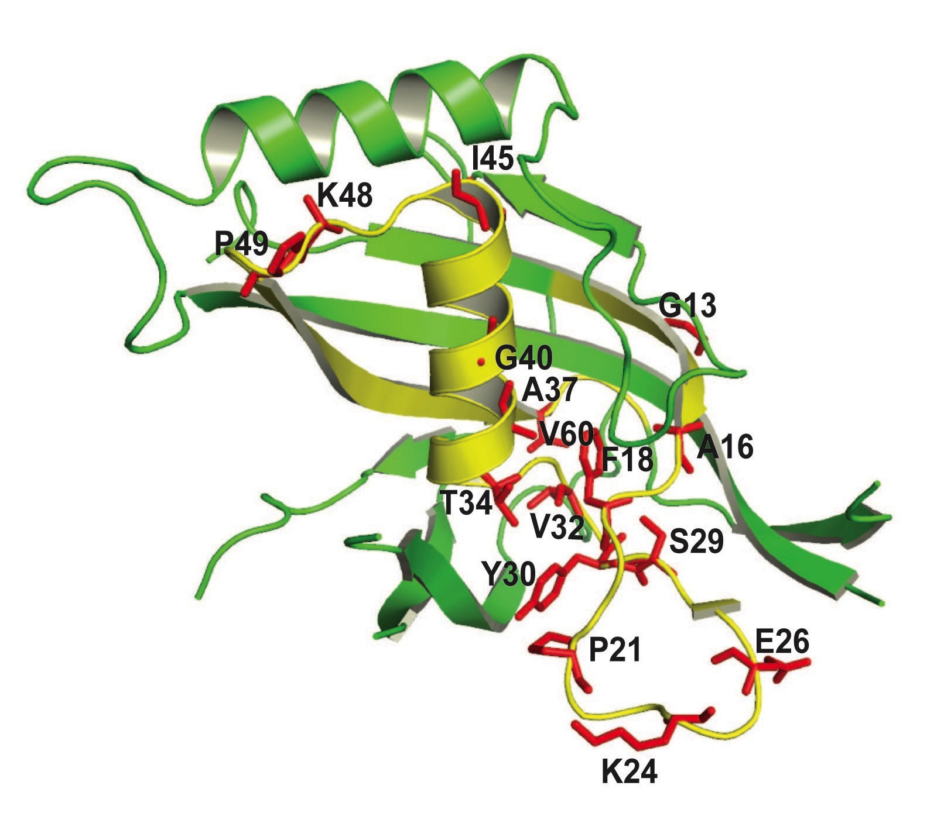

Supplemental Figure 2. Structural context of Cas5 N-terminal domain. The Cas5 family was originally partly defined on the basis of a conserved N-terminal sequence shown on the MS0988 X-ray structure in yellow. Side-chains of absolutely conserved residues are indicated in red.

