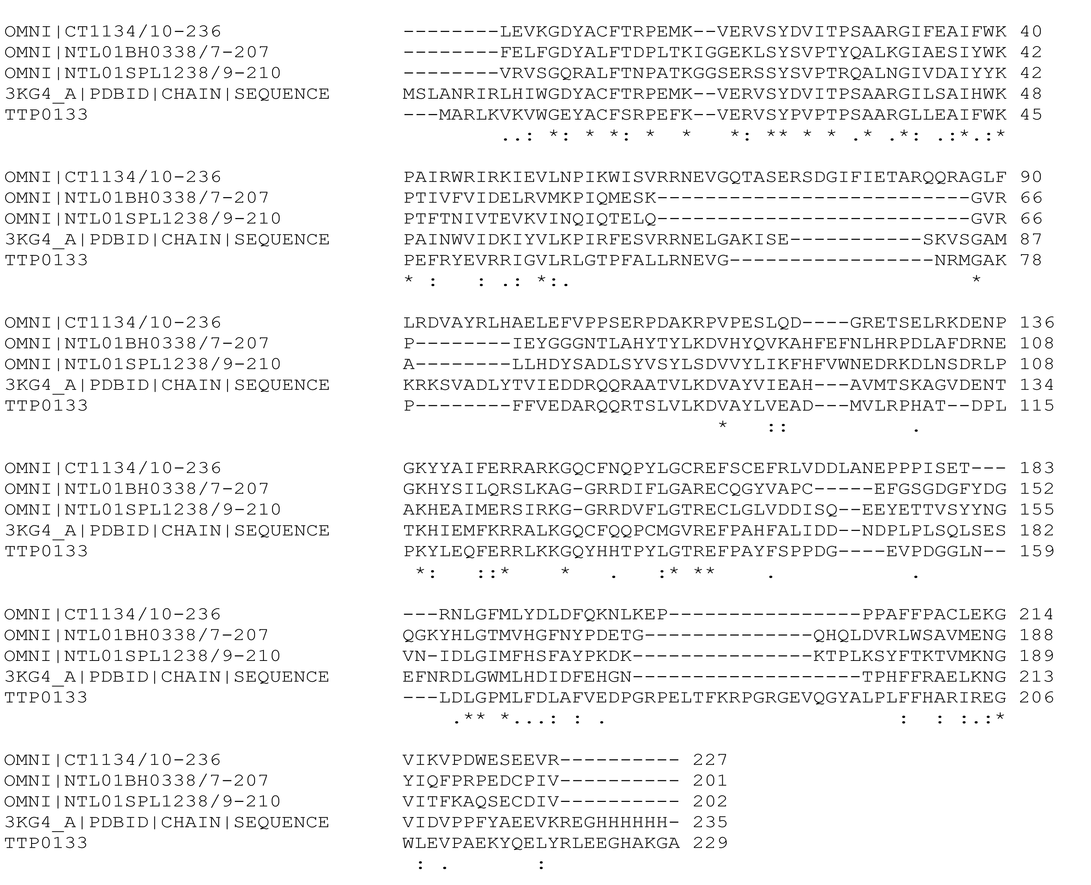

Supplemental Figure 1. Alignment of Cas5d sequences. Shown are the TIGRFAM (http//www.jcvi.org/cgi-bin/tigrfams/index.cgi) seed sequences aligned with M. succiniciproducens MS0988 (PDB: 3KG4) and T. thermophilus TTP0133. Also indicated are sequence identity (*), conservation (:), and partial conservation (.).

