A strategy for developing a hammerhead ribozyme for selective RNA cleavage depending on substitutional RNA editing

Masatora Fukuda, Kei Kurihara, Yasusoshi Tanaka, Masanobu Deshimaru

Department of Chemistry, Faculty of Science, Fukuoka University, Nanakuma 8-19-1, Jonan-ku, Fukuoka 814-0180, Japan

Supplementary Information

Figure S1.
Time course of cleavage reaction and kinetic analysis for HR-APOB against unedited- and edited-APOB RNA fragments under single-turnover conditions. (A) Denaturing PAGE (15%) showing time course of cleavage of HR-APOB-edit against APOB-ade (upper) and APOB-ino (lower).

Figure S2.
A-to-I editing-specific cleavage of ribozyme against FLNA mRNA fragment. (A) Sequences of ribozymes and substrates of synthetic FLNA mRNA fragment. HR-FLNA-edit was generated by introducing C as the recognition base for A-to-I editing recognition. Unedited- and edited-substrate were denoted as FLNA-ade and FLNA-ino, respectively. (B) Analysis of A-to-I editing-specific cleavage by ribozyme using denaturing PAGE (15%). The cleavage reaction was performed with FLNA-ade (left) and FLNA-ino (right) in the presence of an excess of ribozyme at 37°C for 1 h. Positions of the 5′-labeled substrates (S) and of the resulting 5′-cleavage products (P) are indicated. (C) Summary of the cleavage ratios obtained from experiment (B) for HR-FLNA and HR-FLNA-edit against FLNA-ade and FLNA-ino. Intensities of the substrate band (S) and cleavage product band (P) were quantified, and the cleavage ratios were calculated using the expression P/(S + P). All data were obtained from 2 independent experiments. Fitting to a single-exponential equation generated progress curves for the cleavage reactions of HR-FLNA/FLNA-ino and HR-FLNA-edit/FLNA-ade, and the data obtained for HR-FLNA/FLNA-ade and HR-FLNA-edit/FLNA-ino were fitted to a double-exponential equation. Kinetic parameters obtained in this experiment are summarized in Table 1.

Figure S3.
Quantification of editing ratio of FLNA mRNA after the ribozyme reaction. Bar graph shows the editing ratios at Q/R site with HR-FLNA-edit reaction (dark gray bars) and without reaction (light gray bars) from chromatograms, which generated with using forward FLNA specific primer. Editing ratios were quantified by measuring the peak heights of A and G and calculated on the basis of the peak height of G divided by A+G. Results are presented as an average editing ratio and standard deviation from 2 independent experiments.

FIGURE S1.
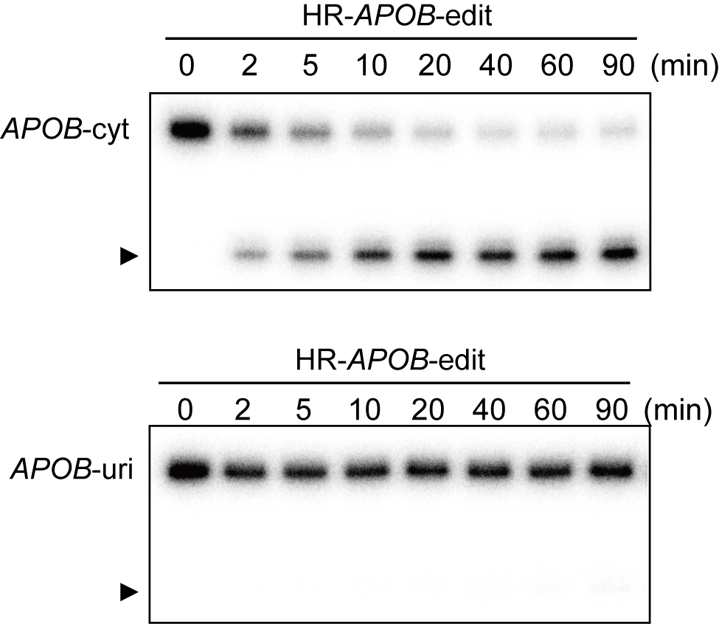

FIGURE S2.
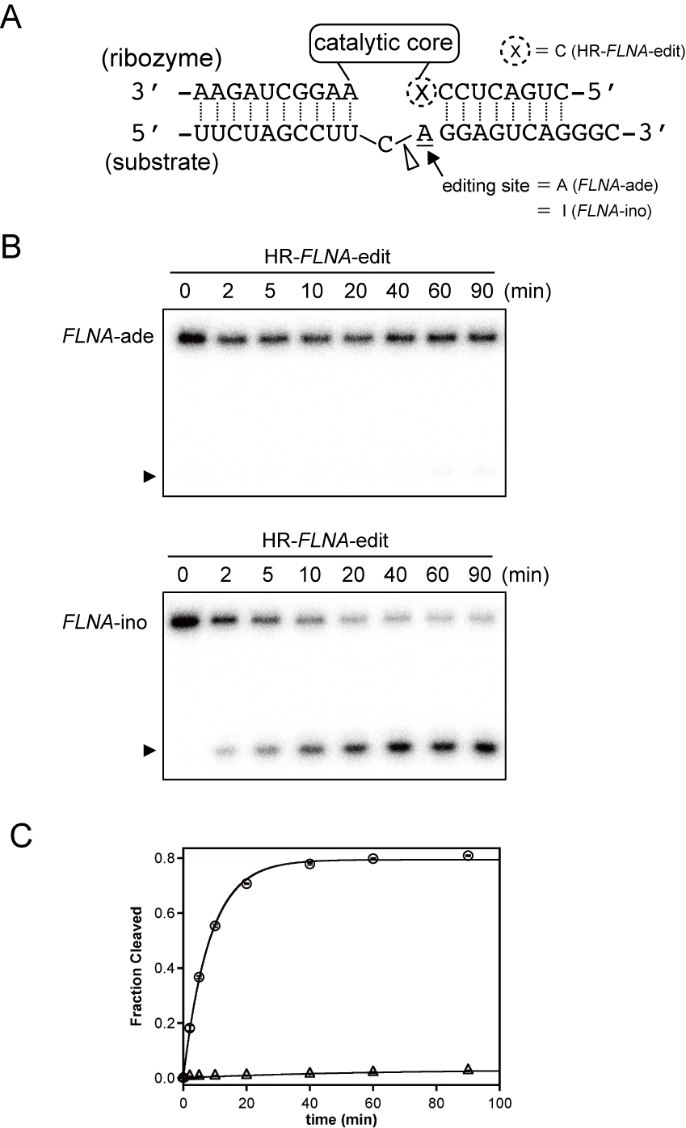

FIGURE S3.

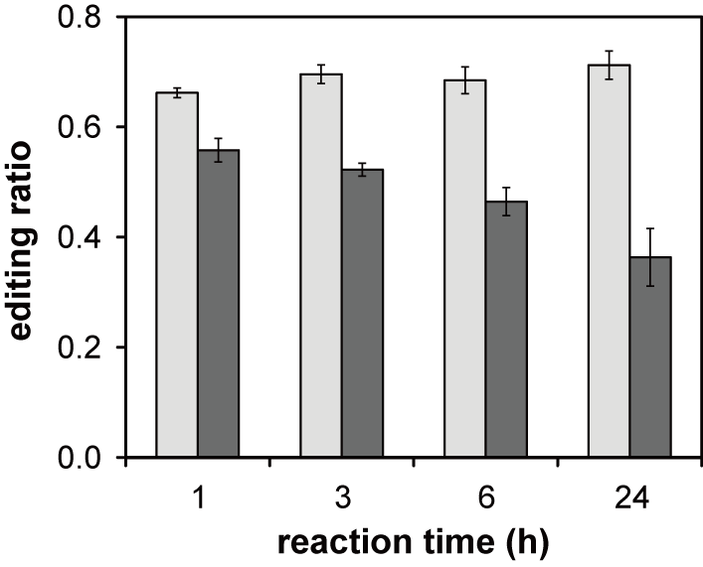

Table S1. List of the sequences of synthetic oligonucleotide using in this paper.

Designation | Sequences of oligonucleotide and deoxyoligonucleotide (5' → 3')
HR-HTR2C | AGCAATACGTTTCGGCCTTTCGGCCTCATCAGATCCTATTCTATAGTGAGTCGTATTAG
HR-HTR2C-edit | AGCAATACGTTTCGGCCTTTCGGCCTCATCAGGTCCTATTCTATAGTGAGTCGTATTAG
HR-APOB-edit_F | CTAATACGACTCACTATAGGGATCAAATTAC
HR-APOB-edit_R | CATATATGATTTCGGCCTTTCGGCCTCATCAGTAATTTGATCCCTATAG
HR-FLNA-edit_F | CTAATACGACTCACTATAGGGCTGACTCC
HR-FLNA-edit_R | TTCTAGCCTTTTCGGCCTTTCGGCCTCATCAGGGGAGTCAGCCCTATAG
HR-FLNA-mut_R | TTCTAGCCTTTTCGGCCTTTCGGCCTCATTAGGGGAGTCAGCCCTATAG
HTR2C-ino | GGAUCGGUAUGUAGCAAUACGUAIUCCUAUUGAGCAUAGCC
APOB-uri | GCAGACAUAUAUGAUAUAAUUUGAUCAG
APOB-cyt | GCAGACAUAUAUGAUACAAUUUGAUCAG
FLNA-ade | UUCUAGCCUUCAGGAGUCAGGGC
FLNA-ino | UUCUAGCCUUCIGGAGUCAGGGC

