Supplementary Information

Design of Cassette Strategy for Production of self-cleaving RNA Transcripts

To produce templates for RNA transcription, the following DNA oligonucleotide sequences were added to a PCR reaction for the first stage of the cassette strategy.

5’ GGT TCT TAT CAA GAG AAG CAG AGG GAC TGG CCC GAC GAA GCT TCA GCA ACC GGT GTA ATG GCG ATC AGC CAT GAC CAA GGT GCT AAA TCC AGC AAG CTC GAA 3’

5’ AAA GTC CTC TTA AGA AGA AGA CTT TGT CAG TGA TTT TGT CTC TTC TTA TCT TCC AAG CTG TTC GAG CTT GCT GGA TTT AGC ACC TTG GTC ATG GCT GAT CGC CAT3’

The supplementary table (2) shows the forward and reverse primers used for each riboswitch construct used in the first round of PCR.

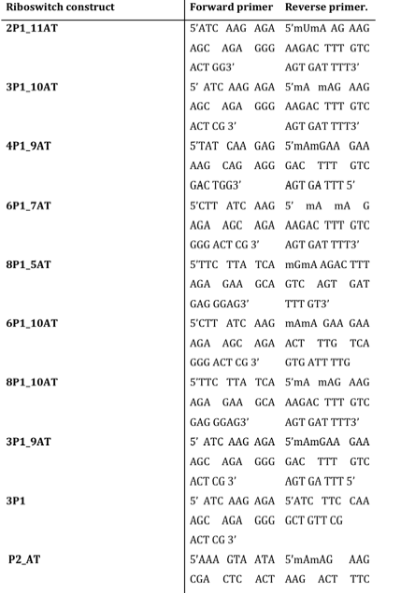
Supplementary Table 1: List of forward and reverse primers used for each riboswitch construct.

Supplementary Table 2. Comparison of K_{d} measurements reported in this study for the yitJ SAM-I riboswitch aptamer with literature reports. Different dissociation constants within the range of 4nM to 200nM have been reported with the yitJ SAM-I riboswitch sequence(Heppell and Lafontaine, 2008, Lu, et al., 2010). The addition of residues on the 5’ and/or 3’ end results in varied SAM binding affinity. Supplementary Table (2) is a list of the reported K_{d} values (from literature) for SAM-I riboswitch sequences and the techniques used for K_{d} measurement.

Riboswitch name | Length of the riboswitch used to measure K_{d} | Method used to determine K_{d} | K_{d} value (reference)
B. subtilis yitJ SAM-I | 251 | In-line probing | ~200 nM (Winkler, et al., 2003)
B. subtilis yitJ SAM-I aptamer | 124 | In-line probing | ~4 nM (Winkler, et al., 2003)  5 nM (Lim, et al., 2006)
B. subtilis yitJ SAM-I aptamer | 124 | Scatchard analysis with equilibrium dialysis | 10 nM (Winkler, et al., 2003)
B. subtilis yitJ SAM-I aptamer | 124 | Fluorescence | 5.3 nM (Heppell and Lafontaine, 2008)
B. subtilis yitJ SAM-I aptamer | 124 | SHAPE probing | 19 nM (Lu, et al., 2010)
B. subtilis yitJ SAM-I | 165 | Filter Binding | 20 nM (Tomsic, et al., 2008)
T. tengcongensis metF aptamer | 111 | Fluorescence | 36 nM (Hennelly and Sanbonmatsu, 2011)
T. tengcongensis metF SAM-I | 95 | Isothermal titration calorimetry | 130 nM (Montange, et al., 2010)  1.35 μM (Baird and Ferré-D'Amaré, 2010)

Supplementary Table 3: Tabular representation of single concentration point equilibrium dialysis measurements displayed in Figures 4-6. The average ratio of counts in chamber b (with RNA) to chamber a (no RNA) and standard deviation for ³H-SAM to B. subtilis yitJ SAM-I riboswitch constructs is shown.

 | Mean B/A | stdevB/A

2p1_11AT | 2.46 | 0.14
3P1_10AT | 4.42 | 1.29
4p1_9AT | 3.70 | 0.14
6p1_7AT | 4.07 | 0.08
8P1_5AT | 4.67 | 0.07
P2_AT | 1.03 | 0.05
6p1_10AT | 4.06 | 0.16
8P1_11AT | 4.32 | 0.11
3p1_10AT_5'GCC | 1.41 | 0.01
4P1_9AT_5'GAC | 1.95 | 0.03
3P1_10AT | 4.42 | 1.29
3p1 only | 1.31 | 0.06
3p1_9at | 1.17 | 0.13
Aptamer Mg snap cooled | 9.82 | 0.94
3p1_10AT Mg snap cooled | 4.42 | 1.29
Aptamer No Mg | 4.28 | 1.07
3p1_10AT No Mg | 1.40 | 0.02
Aptamer No Mg snap cooled | 4.67 | 0.1
3p1_10AT No Mg snap cooled | 1.59 | 0.56
3P1_10AT_P2 MUTANT | 1.64 | 0.04
3P1_10AT_P2 COMP_MUTANT | 2.98 | 0.20
3p1_10AT_G11 | 1.04 | 0.04
SAM only | 0.99 | 0.0003

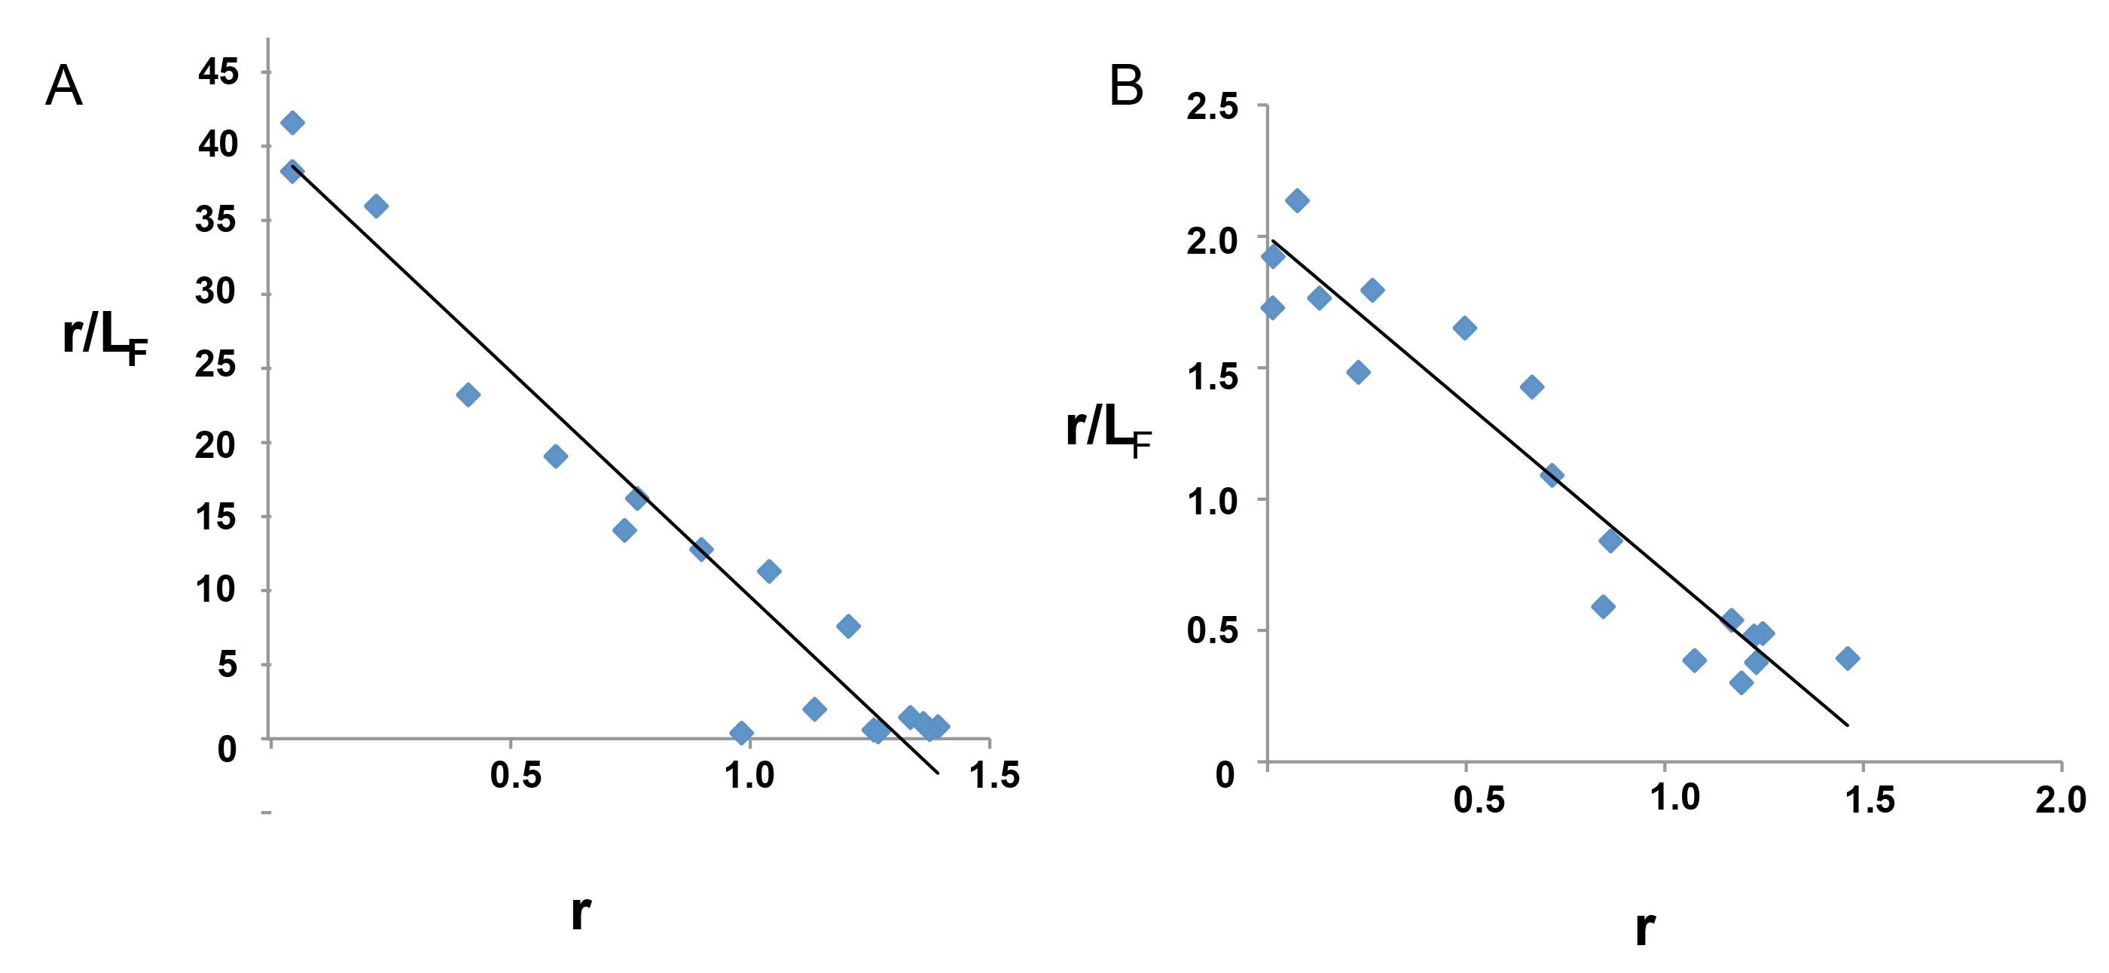

Supplementary Figure 1: Scatchard analysis for A) SAM binding to the B. subtilis yitJ SAM-I riboswitch aptamer. The sequence used for this analysis contain residues 1 to 119 in Figure 1A. B) SAM binding to the B.subtilis yitJ SAM-I riboswitch 3P1_10AT hybrid shown in Figure 2C. The variable r is the ratio of bound ligand to total RNA concentration. The variable L_{F} represents free ligand(Winkler, et al., 2003).

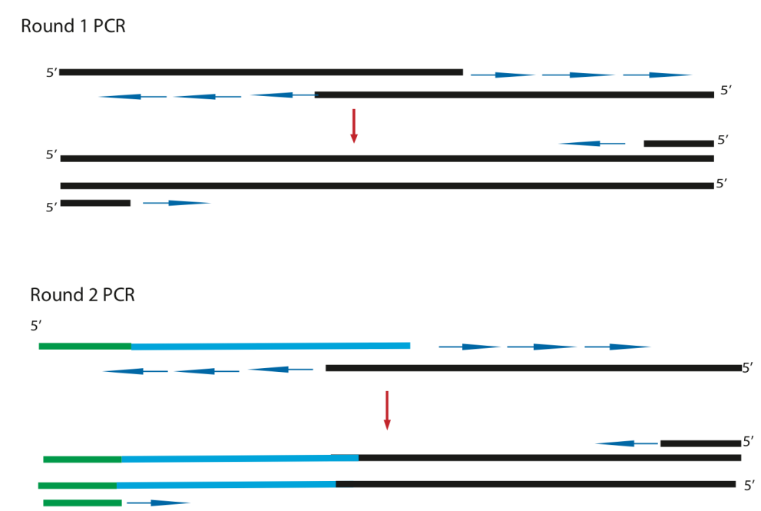

Supplementary Figure 2: Schematic representation of cassette PCR strategy. The first round of PCR cycles generates the riboswitch coding sequence represented in black color. The second round of PCR cycles generates riboswitch (black), hammerhead ribozyme (cyan) and T7 promoter coding regions (green).

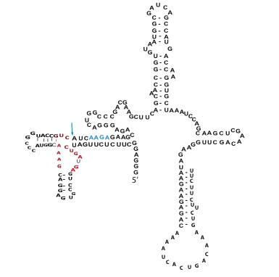

Supplementary Figure 3: Secondary structure representation of hammerhead ribozyme integrated B.subtilis yitJ SAM-I riboswitch 3P1_10AT hybrid construct. The residues in blue represent J1/2 region. The arrow indicates the ribozyme cleavage point. Similar hammerhead ribozyme integrated hybrid constructs are generated for SAM binding experiments.

References

Baird, NJ, Ferré-D'Amaré, AR. 2010. Idiosyncratically tuned switching behavior of riboswitch aptamer domains revealed by comparative small-angle X-ray scattering analysis. RNA 16: 598-609.
Hennelly, SP, Sanbonmatsu, KY. 2011. Tertiary contacts control switching of the SAM-I riboswitch. Nucleic Acids Research 39: 2416-2431.
Heppell, B, Lafontaine, DA. 2008. Folding of the SAM aptamer is determined by the formation of a K-turn-dependent pseudoknot. Biochemistry 47: 1490-1499.
Lim, J, Winkler, WC, Nakamura, S, Scott, V, Breaker, RR. 2006. Molecular-recognition characteristics of SAM-binding riboswitches. Angewandte Chemie Int. Ed. 45: 964-968.
Lu, C, Ding, F, Chowdhury, A, Pradhan, V, Tomsic, J, Holmes, WM, Henkin, TM, Ke, A. 2010. SAM recognition and conformational switching mechanism in the Bacillus subtilis yitJ S Box/SAM-I Riboswitch. Journal of Molecular Biology 404: 803-818.
Montange, RK, Mondragón, E, van Tyne, D, Garst, AD, Ceres, P, Batey, RT. 2010. Discrimination between closely related cellular metabolites by the SAM-I riboswitch. Journal of Molecular Biology 396: 761-772.
Tomsic, J, McDaniel, BA, Grundy, FJ, Henkin, TM. 2008. Natural variability in S-Adenosylmethionine (SAM)-dependent riboswitches: S-Box elements in Bacillus subtilis exhibit differential sensitivity to SAM in vivo and in vitro. Journal of Bacteriology 190: 823-833.
Winkler, WC, Nahvi, A, Sudarsan, N, Barrick, JE, Breaker, RR. 2003. An mRNA structure that controls gene expression by binding S-adenosylmethionine. Nature Struct. Biology 10: 701-707.

