- Supplemental Material for Exploring Purine N7 Interactions via Atomic Mutagenesis: The Group I Ribozyme as a Case Study

Marcello Forconi,° Tara Benz-Moy,‡ Kristin Rule Gleitsman,† Eliza Ruben,† Clyde Metz,° Daniel Herschlag. †,‡,*

° Department of Chemistry and Biochemistry, College of Charleston, Charleston, South Carolina, USA
‡Department of Chemistry, Stanford University, Stanford, California, USA.
† Department of Biochemistry, Stanford University, Stanford, California, USA.
* e-mail: herschla@stanford.edu

- SUPPLEMENTAL TABLE 1. Calculated molecular properties of guanosine analogs.

Compound | Relative k_{cat}/K_{M} ª | Dipole moment (D)^{b} | Quadrupole moment, zz component (D•Å)^{b} | Polarizability^{b} | 1-Octanol/water partition coefficient (ALOGP)^{c}
G | (1) | 7.0 | -70.9 | 42.5 | -2.4
7cG | 0.08 | 5.2 | -73.4 | 43.1 | -1.5
7mG | 1.9 | 3.8 | -74.6 | 48.6 | -2.3
8n7cG | 0.9^{d} | 5.8 | -71.0 | 42.1 | -2.3

ª Relative to G; from Tables 1 and 2.
^{b} From Gaussian calculations using N-9 methylated bases.
^{c} From Virtual Computational Chemistry Laboratory (http://www.vcclab.org/lab/alogps/)
^{d} Assuming that k_{cat}/K_{M} of 8-aza-7-deazaguanosine (8n7cG) relative to G is the same as 8-aza-7-deazainosine (8n7cI) relative to I; see text for discussion.

SUPPLEMENTAL TABLE 2. Assigned metal ions near to N7 atoms in the Azoarcus group I ribozyme (PDB ID: 1U6B).

Metal ion | N7 atom (distance in Å)
M1 | None
M2 | None
M3 | A174 (4.6)  G175 (5.1)  G206 (3.7)
M4 | A150 (4.7)  G151 (2.9)  G152 (4.7)
M5 | G125 (5.3)
M6 | A2 (4.9)  G10 (3.9)
M7 | G23 (3.6)  G24 (4.4)
M8 | G53 (4.0)  G54 (4.5)
M9 | None
M10 | G67 (6.1)  G76 (5.8)  G77 (5.8)
M11 | G83 (5.2)  G84 (4.3)
M12 | None
M13 | G38 (5.8)  A39 (4.7)
M14 | A150 (4.7)  G151 (2.9)  G152 (4.7)
M15 | G75 (4.3)
M16 | A127 (5.1)  A172 (5.5)
M17 | G184 (4.8)
M18 | None

SUPPLEMENTAL FIGURE 3. Affinity of G and 7mG for the ribozyme as a function of [Mg²⁺]. Dissociation constants of 7mG (A) and G (B), and the ratio of these affinities (C). Values measured at pH 6.9 are shown as open symbols; values at pH 5.9 as filled symbols.

(A)
(B)
(C)

SUPPLEMENTAL FIGURE 2. Total charge density on guanosine analogs. Calculated total charge density, corresponding to the HOMO molecular orbital, with positive density in red and negative density in blue, for 9-methylguanine and its analogs. 9-Methylguanine, which is identical to guanosine except for the methyl group that replaces the ribose ring, was used to simplify the calculations.

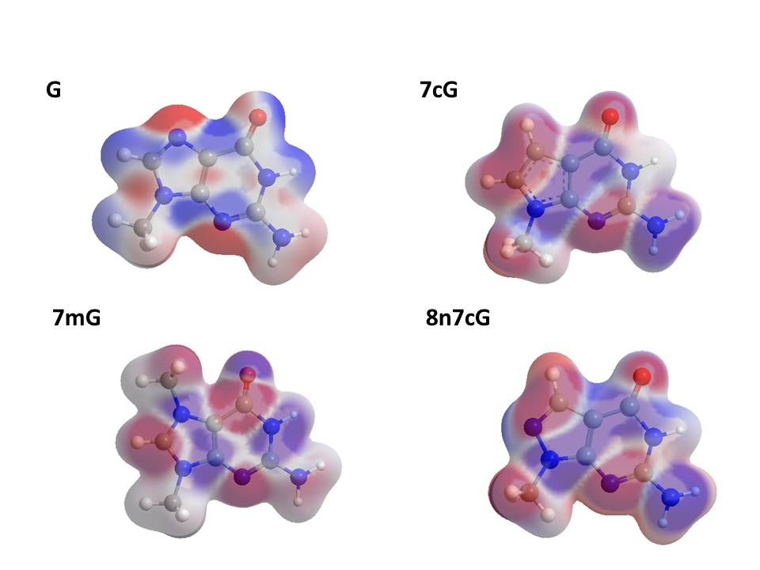

SUPPLEMENTAL FIGURE 3. Total charge density on inosine analogs. Calculated total charge density, corresponding to the HOMO molecular orbital, with positive density in red and negative density in blue, for 9-methylhypoxanthine and its analogs. 9-Methylhypoxanthine, which is identical to inosine except for the methyl group that replaces the ribose ring, was used to simplify the calculations.
